**== LogicCircuit ==**

**Report**

**<Assignment#5>**

**학과 :** 컴퓨터공학과

**학번 :** 20201100

**이름 :** 김태현

5-1. Half-Adder(반가산기)

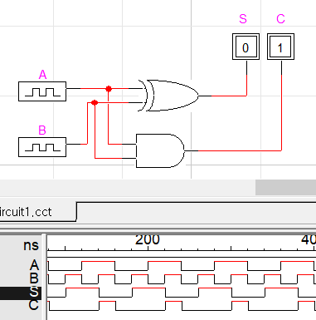

<논리식>

S = A⊕B = A’B + AB’ (합)

C = AB (캐리)

<진리표>

|  |  |  |  |
| --- | --- | --- | --- |
| A | B | S | C |
| 0 | 0 | 0 | 0 |
| 0 | 1 | 1 | 0 |
| 1 | 0 | 1 | 0 |
| 1 | 1 | 0 | 1 |

5-2. Half-Subtractor(반감산기)

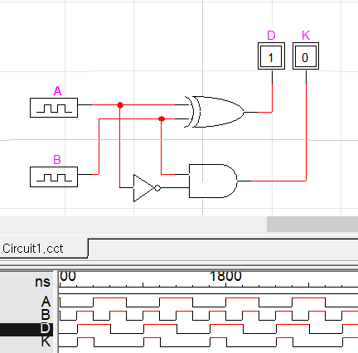

<논리식>

D = A⊕B = A’B + AB’ (차)

K = A’B (빌림수, Borrow)

<진리표>

|  |  |  |  |
| --- | --- | --- | --- |
| A | B | D | K |
| 0 | 0 | 0 | 0 |
| 0 | 1 | 1 | 1 |
| 1 | 0 | 1 | 0 |
| 1 | 1 | 0 | 0 |

5-3. full-Adder(전가산기)

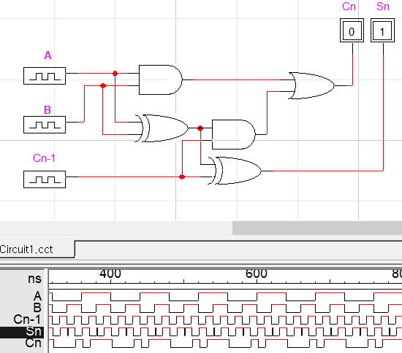

<논리식>

Sn = A⊕B⊕Cn-1

Cn = ACn-1 + AB + BCn-1

<진리표>

|  |  |  |  |  |
| --- | --- | --- | --- | --- |
| A | B | Cn-1 | Sn | Cn |
| 0 | 0 | 0 | 0 | 0 |
| 0 | 0 | 1 | 1 | 0 |
| 0 | 1 | 0 | 1 | 0 |
| 0 | 1 | 1 | 0 | 1 |
| 1 | 0 | 0 | 1 | 0 |
| 1 | 0 | 1 | 0 | 1 |
| 1 | 1 | 0 | 0 | 1 |
| 1 | 1 | 1 | 1 | 1 |

5-4. full-Subtractor(전감산기)

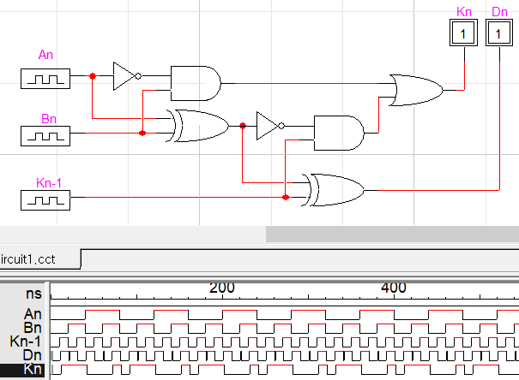

<논리식>

Dn = An⊕Bn⊕Kn-1

Kn = An’Kn-1 + An’Bn + BnKn-1

<진리표>

|  |  |  |  |  |
| --- | --- | --- | --- | --- |
| An | Bn | Kn-1 | Dn | Kn |
| 0 | 0 | 0 | 0 | 0 |
| 0 | 0 | 1 | 1 | 1 |
| 0 | 1 | 0 | 1 | 1 |
| 0 | 1 | 1 | 0 | 1 |
| 1 | 0 | 0 | 1 | 0 |
| 1 | 0 | 1 | 0 | 0 |
| 1 | 1 | 0 | 0 | 0 |
| 1 | 1 | 1 | 1 | 1 |