**== LogicCircuit ==**

**Report**

**<Assignment#2>**

**학과 :** 컴퓨터공학과

**학번 :** 20201100

**이름 :** 김태현

3-1.

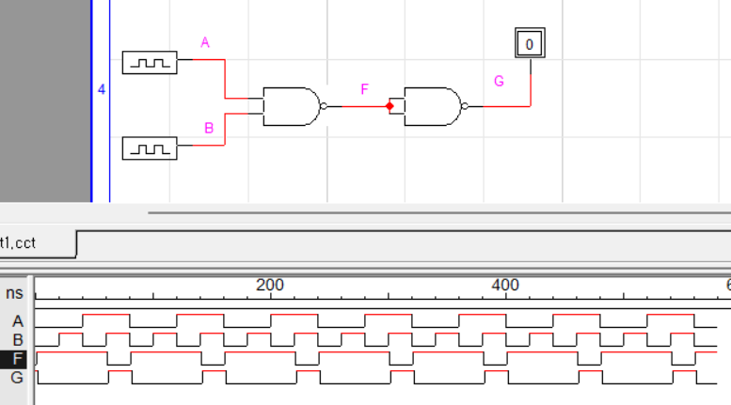

<논리식>

((A*B)’)’ = A*B

<진리표>

|  |  |  |  |
| --- | --- | --- | --- |
| A | B | F | G |
| 0 | 0 | 1 | 0 |
| 0 | 1 | 1 | 0 |
| 1 | 0 | 1 | 0 |
| 1 | 1 | 0 | 1 |

3-2.

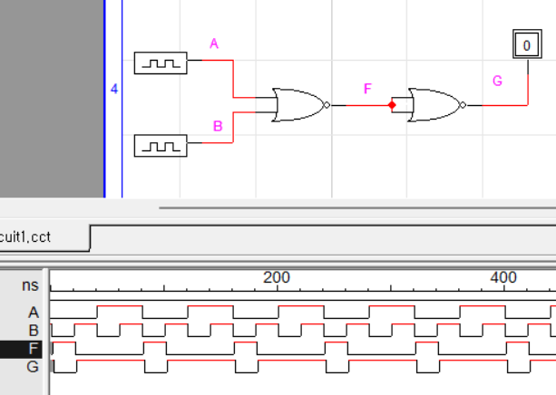

<논리식>

((A+B)’)’ = A+B

<진리표>

|  |  |  |  |
| --- | --- | --- | --- |
| A | B | F | G |
| 0 | 0 | 1 | 0 |
| 0 | 1 | 0 | 1 |
| 1 | 0 | 0 | 1 |
| 1 | 1 | 0 | 1 |

3-3.

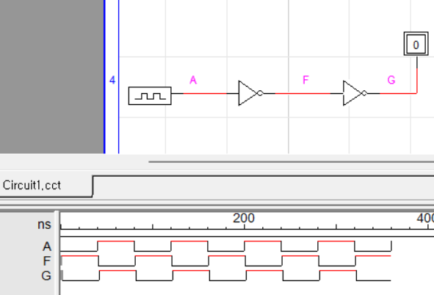

<논리식>

(A’)’ = A

<진리표>

|  |  |  |
| --- | --- | --- |
| A | F | G |
| 0 | 1 | 0 |
| 1 | 0 | 1 |

3-4.

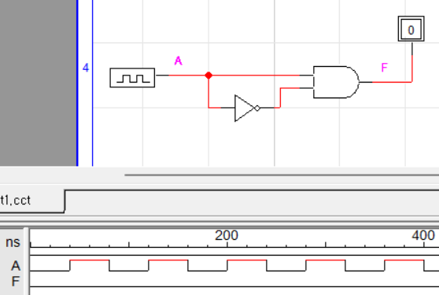

<논리식>

A*A’ = 0

<진리표>

|  |  |
| --- | --- |
| A | F |
| 0 | 0 |
| 1 | 0 |

3-5.

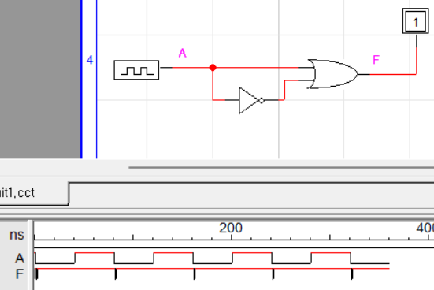

<논리식>

A+A’ = 1

<진리표>

|  |  |
| --- | --- |
| A | F |
| 0 | 1 |
| 1 | 1 |

3-6.

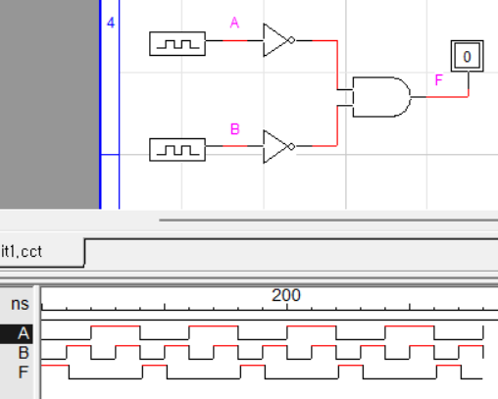

<논리식>

(A’*B’) = (A*B)’

<진리표>

|  |  |  |
| --- | --- | --- |
| A | B | F |
| 0 | 0 | 1 |
| 0 | 1 | 0 |
| 1 | 0 | 0 |
| 1 | 1 | 0 |