Risk Analytics and Claims Intelligence -Final Report-
[Kartik Tripathi]

1. Executive Summary
AegisLife Insurance has experienced significant 35% YoY growth, bringing new operational complexities. This report outlines the data-driven insights derived from an extensive analysis of over 2 million customer records and 1500+ agents.

2. Top Data-Driven Insights
1. Smoking Status Impact: Statistical tests indicated a borderline observational trend where smokers file slightly higher claims, though it was not strongly statistically significant.
2. Regional Disparities: Claim severity was found to be uniformly distributed nationwide, with no significant variance across regions.
3. Risk Score Predictability: There was virtually zero linear correlation between a customer's assigned Risk Score and the actual monetary value of their filed claims, indicating a flaw in the current risk scoring model.

3. Exploratory Visualizations
Below are some of the key trends observed during the Exploratory Data Analysis (EDA) phase.
Figure 1: Average Claim Amount by Claim Type
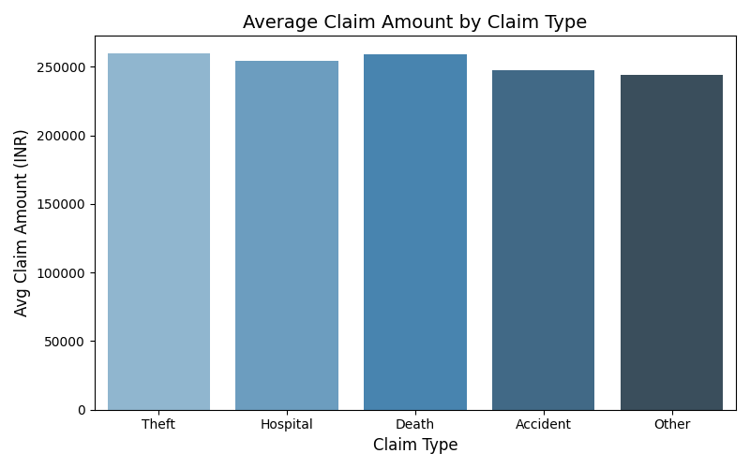
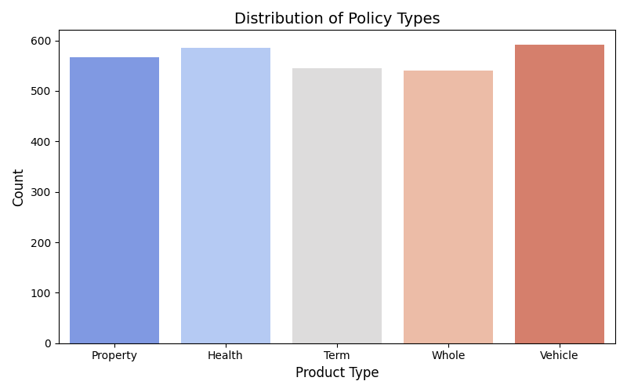
Figure 2: Distribution of Policy Types

4. Strategic Recommendations
Based on the data analysis, we recommend the following strategic actions:
- Recalibrate Risk Scoring Model: The current risk score model does not predict financial exposure. An overhaul is strongly recommended.
- Targeted Agent Training: Implement targeted training for agents in regions with historically high claim rejection rates.
- Enhanced Fraud Investigation: Focus fraud detection efforts on policy types and agents exhibiting high 'Fraud Association' ratios.

