class05.R

katielam

Thu Jan 24 09:35:39 2019

# Class 05 R graphic intro  
  
# My first boxplot  
x <- rnorm(1000,0)  
boxplot(x)

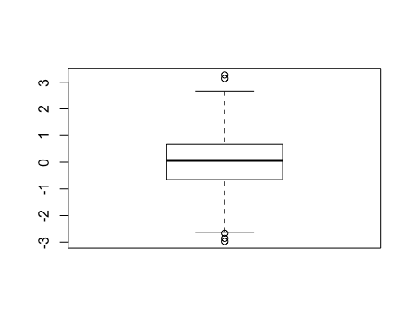

summary(x)

## Min. 1st Qu. Median Mean 3rd Qu. Max.   
## -2.97234 -0.65251 0.06464 0.02112 0.67603 3.27154

hist(x)

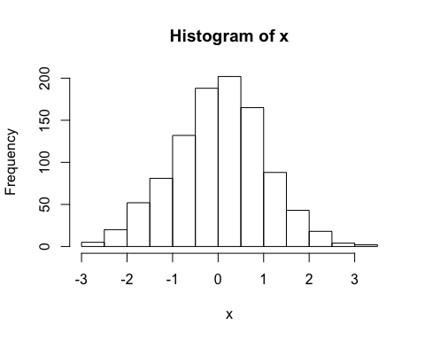

boxplot(x, horizontal = TRUE)

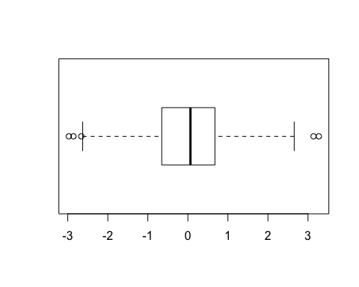

# Hands on session 2  
  
# Plot  
weight <- read.table("bimm143_05_rstats/weight_chart.txt", header = TRUE)  
plot(weight, typ="o", col="blue", pch=15, cex=1.5, lwd=2, ylim=c(2,10), xlab="Age (months)", ylab="Weight (kg)", main="Baby weight with age")

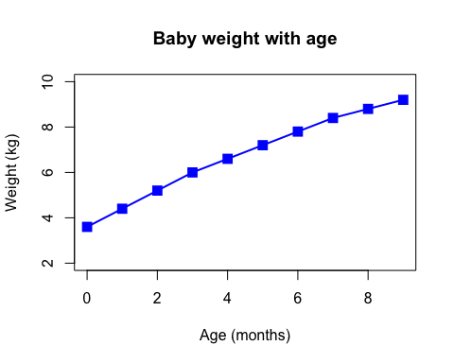

# Barplot  
mouse <- read.table("bimm143_05_rstats/feature_counts.txt", header=TRUE, sep="\t")  
barplot(mouse$Count, horiz=TRUE, col=rainbow(9), xlim=c(0,80000), ylab=" ", names.arg=mouse$Feature, main="Number of features in the mouse GRCm38 genome", las=1)

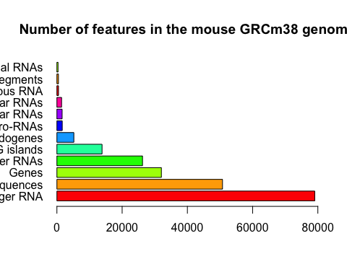

par(mar=c(4,12,4,4))  
  
# Histogram  
par(mar=c(5,5,4,2))  
x <- c(rnorm(10000), rnorm(10000)+4)  
hist(x, breaks=80)

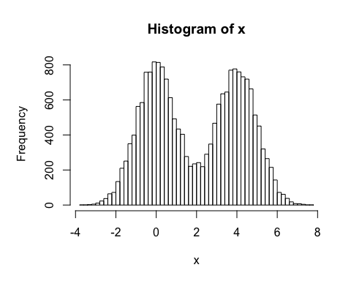

# Colors in plot  
mf <- read.delim("bimm143_05_rstats/male_female_counts.txt")  
barplot(mf$Count, names.arg=mf$Sample, col=rainbow(nrow(mf)), ylab="Counts", las=2)

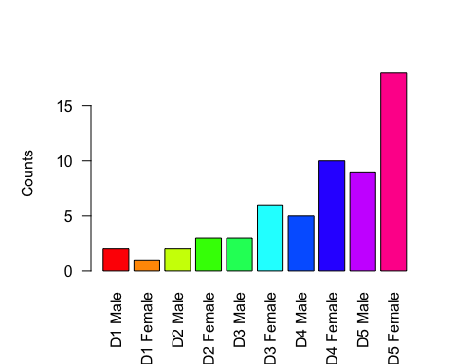

barplot(mf$Count, names.arg=mf$Sample, col=c("blue2","red2"), ylab="Counts", las=2)

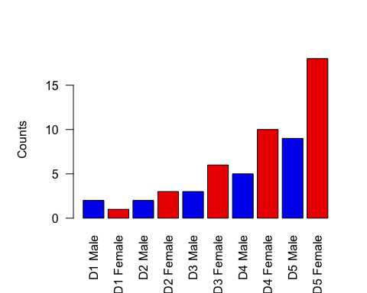

# Coloring by value  
genes <- read.delim("bimm143_05_rstats/up_down_expression.txt")  
table(genes$State)

##   
## down unchanging up   
## 72 4997 127

palette(c("blue","gray","red"))  
plot(genes$Condition1, genes$Condition2, col=genes$State, xlab="Expression condition 1", ylab="Expression condition 2")

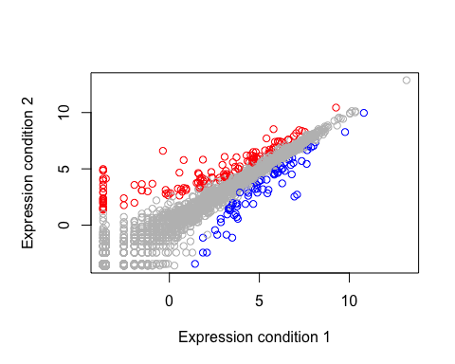

# Dynamic use of color  
meth <- read.delim("bimm143_05_rstats/expression_methylation.txt")  
plot(meth$gene.meth, meth$expression)

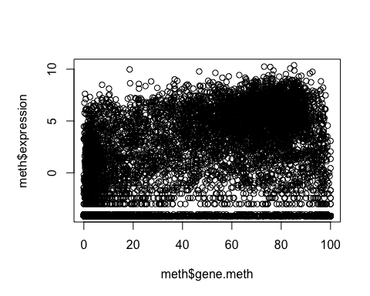

dCols <- densCols(meth$gene.meth, meth$expression)  
plot(meth$gene.meth, meth$expression, col=dCols, pch=20)

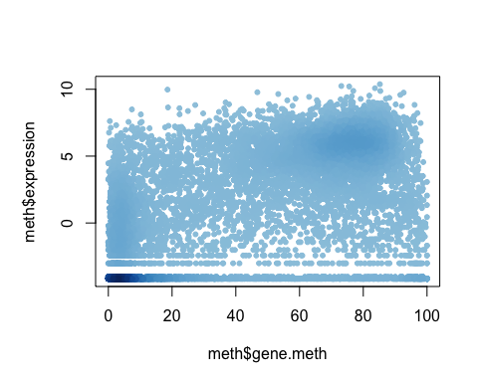

# Find the indices of genes with above 0 expression  
inds <- meth$expression > 0  
# Plot just these genes  
plot(meth$gene.meth[inds], meth$expression[inds])

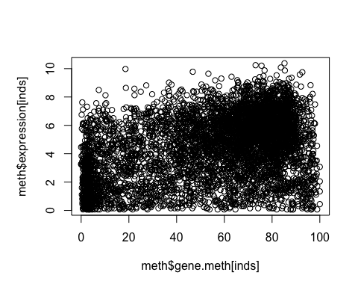

dCols2 <- densCols(meth$gene.meth[inds], meth$expression[inds])  
plot(meth$gene.meth[inds], meth$expression[inds], col=dCols2, pch=20)

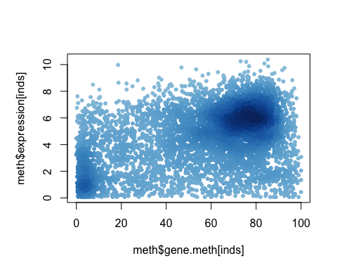

dcols.custom <- densCols(meth$gene.meth[inds], meth$expression[inds], colramp = colorRampPalette(c("blue2","green2","red2","yellow")))  
plot(meth$gene.meth[inds], meth$expression[inds], col=dcols.custom, pch=20)

