# Travel

You need to add 25 things to this document. (Make sure to number them just as I did in the example.) It may be helpful to copy and paste this list and then fill it in as you go along. All image names must start with your location, e.g yellowstone_sunset.jpg unless you are using a link from the internet.

[Link to Travel Files](https://drive.google.com/drive/folders/1q5vIvE3hqb4EL_0czgf-xbAWGyGAP2fc)

## Location: Chiangmai, Thailand

1. Primary Image of Location as a gif



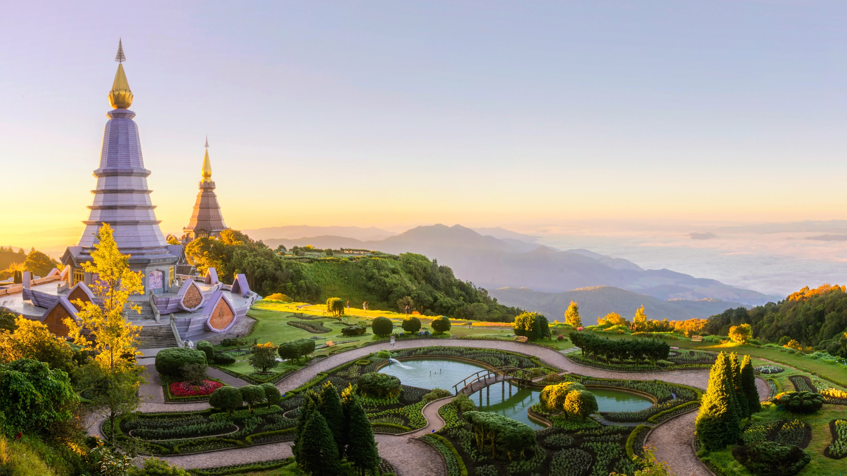

1. Name of file with gif file (make sure to add the picture to the proper Google Drive!): chiangmaigif.gif
2. Name of file with non gif file (make sure to add the picture to the proper Google Drive!): chiangmai.
3. **Geographical Location**: Asia
4. Paragraph One about the location: Chiang Mai, nestled in the lush hills of northern Thailand, is a city that captivates with its unique blend of cultural richness and natural beauty. Situated approximately 700 kilometers north of Bangkok, Chiang Mai is the largest city in the region and serves as the capital of the province of the same name. Its geographical location is nothing short of enchanting, surrounded by forested mountains and picturesque landscapes. This charming city, often referred to as the "Rose of the North," offers visitors a delightful escape from the bustling urban life, inviting them to explore a realm where tradition meets modernity amidst a backdrop of stunning scenery.
5. Paragraph Two about the location: The heart of Chiang Mai beats with a rich history that dates back over 700 years. Founded in 1296, the city was originally the capital of the ancient Lanna Kingdom. Today, remnants of its storied past are scattered throughout the city, from the ancient temples that dot the landscape to the preserved city walls and moats that harken back to a bygone era. Among the city's treasures is the revered Wat Phra Singh, a 14th-century temple known for its intricate architecture and revered Buddha image. Chiang Mai's historical sites provide a captivating glimpse into its heritage, making it a destination that seamlessly weaves together the past and present for visitors to explore and appreciate.

For the next five pictures you can just put the names of the files, you don't have to include the files in this drive, but you do need to add them to the [proper Google Drive](https://drive.google.com/drive/folders/1sroWta5PKm63E3V2KWSUE-uYkPd_v6T5?usp=sharing).

1. **Photo Gallery – (Just write Photo Gallery)**
2. file name: chiangmai1
3. Visual description of the image (leave image for movies): colorful hot balloons in the heart of Chiang Mai
4. Caption of the image/movie: You can see hot balloons in Chiang Mai as well.
5. file name: chiangmai2
6. Visual description of the image (leave image for movies): several elephants and smiley volunteers in the forest
7. Caption of the image/movie: You can see cute elephants in Chiang Mai! Isn’t that fun?!
8. file name: chiangmai3
9. Visual description of the image (leave image for movies): ancient temple of Chiang Mai
10. Caption of the image/movie: There are so many beautiful temples in Chiang Mai.
11. file name: chiangmai4
12. Visual description of the image (leave image for movies): several monks walk by the street
13. Caption of the image/movie: Be respectful to the monks.
14. file name: chiangmai5
15. Visual description of the image (leave image for movies): several delicious dishes from Chiang Mai
16. Caption of the image/movie: And don’t forget to treat yourself with delicious Thai food!
17. Your Name(s): Cindy Ye