AN INDUSTRIAL INTERNSHIP REPORT ON
Prediction of Agriculture Crop Production in India Using Machine Learning
Submitted in partial fulfilment of the requirements of the
Data Science & Machine Learning Winter Internship Programme
Submitted by
KADIVA THERASAL MARY S
Department of Computer Science and EngineeringUniversity College of Engineering, BIT Campus, Trichy
Internship Domain: Data Science & Machine Learning
Duration: 4 Weeks
Organization: upSkill Campus
Training Partner: UniConverge Technologies Pvt. Ltd.

TABLE OF CONTENTS

Executive Summary3
1. Introduction ----------------------------------------------- 4
2. Objectives. -----------------------------------------------4
3. About the Internship. -----------------------------------------------5
4. Problem Statement. -----------------------------------------------6
5. Existing System. -----------------------------------------------6
6. Proposed System. -----------------------------------------------6
7. Dataset Description. -----------------------------------------------8
8. Software and Hardware Requirement -----------------------------9
9. Methodolog. --------------------------------------------10
10. Implementation. -----------------------------------------------12
11. Results. -----------------------------------------------14
12. Conclusion. -----------------------------------------------18
13. Future Scope. -----------------------------------------------18
14. References. -----------------------------------------------19

EXECUTIVE SUMMARY
This report presents the work carried out during a four-week industrial internship undertaken in the domain of Data Science and Machine Learning at upSkill Campus, in collaboration with UniConverge Technologies Pvt. Ltd. The internship was designed to build a strong practical foundation in Python programming, data preprocessing, exploratory data analysis, statistical reasoning, and machine learning model development, through a combination of weekly guided modules and a capstone project.
The capstone project undertaken was titled "Prediction of Agriculture Crop Production in India Using Machine Learning." Agricultural datasets published on the Government of India Open Data Portal were used to study the relationship between cultivation cost, production cost, crop type, state, and the resulting crop yield. After data cleaning and exploratory analysis, categorical variables were label-encoded and the dataset was split into training and testing subsets. A Random Forest Regression model was then trained to predict crop yield (measured in Quintal per Hectare) from the available cost- and category-based features.
The trained model achieved a Mean Absolute Error (MAE) of 28.43 and an R² Score of 0.9463 on the test set, indicating that the model was able to explain approximately 94.6% of the variance in crop yield using the available features. Supporting visualizations — including a correlation heatmap, crop-wise record and yield distribution charts, and an actual-versus-predicted scatter plot — were generated to interpret the dataset and validate model behaviour.
Beyond the technical outcome, the internship strengthened practical skills in the end-to-end machine learning workflow: problem framing, data wrangling, visualization, model selection, training, evaluation, and communication of results. This report documents the internship structure, the problem addressed, the methodology followed, the implementation details, the results obtained, and the conclusions drawn, along with suggestions for extending the project in the future.

1. INTRODUCTION
Agriculture continues to be one of the most significant sectors of the Indian economy, providing direct and indirect employment to a large share of the population and forming the backbone of rural livelihoods. The productivity of agricultural land, commonly expressed as crop yield, is influenced by a wide range of factors including soil quality, weather conditions, irrigation availability, cultivation practices, and the economics of production — namely the cost incurred in cultivating and producing a crop.
Accurately predicting crop yield ahead of the harvesting season is of substantial value to multiple stakeholders. Farmers can use such predictions to plan resource allocation and financial decisions; agricultural policymakers can use them to anticipate supply and plan procurement or subsidy programmes; and researchers can use them to identify the economic factors most strongly associated with productivity. Traditional approaches to yield estimation have relied heavily on historical averages, field surveys, and manual extrapolation, all of which are labour-intensive and often fail to capture non-linear relationships between multiple contributing factors.
Machine Learning offers a data-driven alternative to these traditional approaches. By learning patterns directly from historical data, machine learning models can capture complex, non-linear relationships between input variables — such as cultivation cost and production cost — and the target variable of interest, namely crop yield. This internship project applies one such technique, Random Forest Regression, to the problem of predicting agricultural crop yield in India using publicly available government data.
This report documents the complete process followed during the internship: the learning modules covered, the problem addressed by the final project, the dataset used, the methodology and tools applied, the implementation carried out in the accompanying Jupyter Notebook (crop_prediction.ipynb), the results obtained, and the conclusions and future directions arising from the work.

2. OBJECTIVES
The internship and the associated project were guided by the following objectives:
- To gain a working understanding of the Data Science workflow, from raw data to actionable insight.
- To build proficiency in Python and its data science libraries — Pandas, NumPy, Matplotlib, Seaborn, and Scikit-learn.
- To understand and apply core concepts of probability and statistics relevant to data analysis.
- To study agricultural production data sourced from the Government of India Open Data Portal.
- To perform data cleaning, preprocessing, and exploratory data analysis (EDA) on the chosen dataset.
- To visualize relationships between crop-related variables using appropriate charts and graphs.
- To design, train, and evaluate a machine learning model capable of predicting crop yield.
- To interpret model performance using standard regression evaluation metrics such as MAE and R² Score.
- To document the entire process in a structured, professional internship report.

3. ABOUT THE INTERNSHIP
The internship was a four-week Winter Internship Programme organized by upSkill Campus in collaboration with UniConverge Technologies Pvt. Ltd., focused on the domain of Data Science and Machine Learning. The programme combined structured weekly learning modules with a hands-on capstone project, allowing theoretical concepts to be immediately reinforced through practical implementation.

3.1 Weekly Structure
The internship was organized into four weekly modules, each building upon the previous week's concepts and culminating in the final project. The structure followed is summarized below.
Week | Module Covered | Key Learning Outcomes
Week 1 | Introduction to Data Science & Python Foundations | Python syntax, data structures, Pandas & NumPy basics, working with Jupyter Notebook
Week 2 | Probability, Statistics & Data Visualization | Descriptive statistics, probability distributions, Matplotlib and Seaborn plotting techniques
Week 3 | Introduction to Machine Learning | Supervised vs unsupervised learning, regression concepts, train-test splitting, model evaluation metrics
Week 4 | Final Project Implementation | End-to-end implementation of the crop yield prediction project using Random Forest Regression

3.2 Mode of Learning
Learning was delivered through a combination of recorded lecture sessions, reading material, and hands-on coding assignments. Each module concluded with practical exercises that reinforced the concepts taught, and the final week was dedicated entirely to the design, implementation, and evaluation of the capstone project described in this report.

3.3 Skills Gained
- Proficiency in Python for data analysis and scripting.
- Ability to clean and preprocess real-world, imperfect datasets.
- Competence in exploratory data analysis and data visualization.
- Practical understanding of supervised machine learning, particularly regression techniques.
- Experience evaluating and interpreting machine learning model performance.
- Improved technical documentation and reporting skills.

4. PROBLEM STATEMENT
Agricultural crop production in India is influenced by a combination of economic and geographic factors, including the cost of cultivation, the cost of production, the type of crop grown, and the state in which it is cultivated. Because these factors interact in complex ways, manually estimating crop yield from raw cost data is difficult and prone to error.
The problem addressed in this project can be stated as follows: given historical data on the cost of cultivation, cost of production, crop type, and state, can a machine learning model accurately predict the yield (in Quintal per Hectare) of a given crop? Solving this problem would allow yield to be estimated directly from readily available economic indicators, without requiring more complex agronomic or environmental data.
The success of the project is measured using standard regression metrics, primarily the Mean Absolute Error (MAE), which indicates the average magnitude of prediction error in the same units as the target variable, and the R² Score, which indicates the proportion of variance in the target variable that is explained by the model.

5. EXISTING SYSTEM
Conventional approaches to estimating agricultural crop production in India rely primarily on historical yield averages, field-level surveys conducted by agricultural departments, and manual extrapolation based on past seasons. State agricultural departments and the Ministry of Agriculture periodically publish yield estimates derived from sample surveys and expert assessment.
While these methods are grounded in domain expertise, they suffer from several limitations. They are time-consuming to compile, given the scale of manual data collection required across India's diverse agro-climatic zones. They also tend to rely on simple averaging techniques that do not adequately capture the non-linear and interacting effects of multiple variables, such as the joint influence of cultivation cost and production cost on yield. As a result, existing estimation methods can lack the granularity and responsiveness needed for timely, data-driven decision-making at the level of individual crops and states.

6. PROPOSED SYSTEM
The proposed system applies a supervised machine learning approach to predict crop yield directly from structured, tabular agricultural data. Unlike traditional survey-based estimation, the proposed system learns patterns from historical records and can generate predictions for new input combinations of crop, state, and cost figures without requiring a fresh survey.
The overall workflow implemented in the project consists of the following stages:
- Data Collection — acquiring the agricultural dataset from the Government of India Open Data Portal.
- Data Cleaning — checking for and handling missing values and inconsistent entries.
- Exploratory Data Analysis (EDA) — understanding the distribution and relationships of variables through summary statistics and visualizations.
- Label Encoding — converting categorical variables (Crop, State) into numerical form suitable for the model.
- Train-Test Split — dividing the dataset into training and testing subsets to allow unbiased evaluation.
- Model Training — fitting a Random Forest Regression model on the training data.
- Prediction — generating yield predictions on the held-out test data.
- Model Evaluation — assessing performance using MAE and R² Score.
This pipeline mirrors standard industry practice for supervised regression problems and was chosen for its balance of simplicity, interpretability, and robustness given the limited size of the available dataset.

7. DATASET DESCRIPTION
The dataset used in this project was obtained from the Government of India Open Data Portal, which publishes agricultural statistics including cultivation costs, production costs, and yield figures for major crops across Indian states. The dataset used for this project contains 49 records across 6 features, covering ten crop categories, and contains no missing values, simplifying the preprocessing stage.

7.1 Feature Description
Feature | Description | Type
Crop | Name of the agricultural crop | Categorical
State | Indian state where the crop is cultivated | Categorical
Cost of Cultivation (₹/Hectare) A2+FL | Actual paid-out cost plus imputed value of family labour | Numerical
Cost of Cultivation (₹/Hectare) C2 | Comprehensive cost including rental value of owned land | Numerical
Cost of Production (₹/Quintal) C2 | Comprehensive cost per unit of output | Numerical
Yield (Quintal/Hectare) | Target variable — crop yield to be predicted | Numerical

7.2 Dataset Summary
Attribute | Value
Total Records | 49
Total Features | 6
Missing Values | 0
Number of Unique Crops | 10
Target Variable | Yield (Quintal/Hectare)

As shown in the record-count chart in the Results section, most crops in the dataset are represented by five records each, with wheat represented by four, giving a reasonably balanced dataset across crop categories despite its overall small size.

8. SOFTWARE AND HARDWARE REQUIREMENTS

8.1 Software Requirements
- Python 3.13
- Jupyter Notebook
- Visual Studio Code
- GitHub (for version control and submission)
Python Libraries Used:
- Pandas — data loading, cleaning, and manipulation
- NumPy — numerical computation
- Matplotlib — data visualization
- Seaborn — statistical data visualization
- Scikit-learn — machine learning model implementation and evaluation

8.2 Hardware Requirements
- Windows Laptop
- 4 GB RAM or above
- Intel Processor (or equivalent)

9. METHODOLOGY
The methodology followed in this project reflects the standard supervised machine learning pipeline, adapted to a small, clean, tabular agricultural dataset. Each stage is described below in the order it was implemented in the accompanying notebook, crop_prediction.ipynb.

9.1 Data Import and Loading
The required Python libraries — Pandas, NumPy, Matplotlib, Seaborn, and Scikit-learn — were imported at the start of the notebook. The dataset was then loaded into a Pandas DataFrame for inspection and processing.

9.2 Data Exploration
Initial exploration was carried out using Pandas functions to inspect the shape, column names, data types, and summary statistics of the dataset. This step confirmed that the dataset contained 49 records across 6 columns with no missing values, meaning no imputation was required.

9.3 Exploratory Data Analysis (EDA)
Exploratory analysis was performed to understand the structure and relationships within the data. Bar charts were used to examine the number of records available per crop and the average yield associated with each crop, while a correlation heatmap was generated to study the linear relationships between the numerical features — cost of cultivation (A2+FL and C2), cost of production (C2), and yield.

9.4 Label Encoding
Since the Crop and State columns are categorical (text-based) variables, they were converted into numerical form using label encoding, a preprocessing step that assigns a unique integer to each category. This transformation is necessary because Scikit-learn's Random Forest implementation, like most machine learning algorithms, requires numerical input.

9.5 Train-Test Split
The dataset was split into training and testing subsets using Scikit-learn's train_test_split function. The training subset was used to fit the model, while the testing subset — kept unseen during training — was used to evaluate the model's ability to generalize to new data.

9.6 Model Selection: Random Forest Regression
A Random Forest Regression model was selected for this task. Random Forest is an ensemble learning method that builds multiple decision trees during training and outputs the average prediction of the individual trees for regression tasks. It was chosen for its ability to model non-linear relationships, its robustness to a small number of features and records, and its resistance to overfitting compared to a single decision tree.

9.7 Model Training and Prediction
The Random Forest Regressor was trained (fit) on the training data using the encoded Crop and State values along with the cost-related features as inputs, and Yield as the target variable. Once trained, the model was used to generate yield predictions on the test set.

9.8 Model Evaluation
The predictions generated by the model were compared against the actual yield values in the test set using two standard regression metrics: Mean Absolute Error (MAE), which measures the average absolute difference between predicted and actual values, and R² Score, which measures the proportion of variance in the target variable explained by the model. These metrics are discussed further, with the actual results obtained, in the Results section of this report.

10. IMPLEMENTATION
The implementation was carried out entirely in Python within a Jupyter Notebook (crop_prediction.ipynb). This section summarizes the key implementation stages in the order they appear in the notebook.

10.1 Importing Libraries
The notebook begins by importing Pandas and NumPy for data handling, Matplotlib and Seaborn for visualization, and the relevant modules from Scikit-learn — including train_test_split, RandomForestRegressor, LabelEncoder, and the metrics module — for model building and evaluation.

10.2 Loading and Inspecting the Dataset
The agricultural dataset was loaded into a Pandas DataFrame using pd.read_csv(). Initial inspection functions such as .head(), .info(), and .describe() were used to understand the structure, data types, and summary statistics of the dataset.

10.3 Data Cleaning
A check for missing values was performed using .isnull().sum(), which confirmed that the dataset had zero missing values across all six columns, meaning no rows needed to be dropped or imputed.

10.4 Exploratory Data Analysis and Visualization
Several visualizations were generated to explore the dataset before modelling:
- A bar chart showing the number of records available for each crop, confirming a broadly balanced dataset.
- A bar chart showing the average yield (Quintal/Hectare) for each crop, which highlighted sugarcane as a substantial outlier with far higher yield than other crops.
- A correlation heatmap of the numerical features, which revealed a strong positive correlation between the two cultivation cost measures (A2+FL and C2) and a moderate positive correlation between cultivation cost and yield.

10.5 Encoding Categorical Variables
The Crop and State columns were transformed using Scikit-learn's LabelEncoder, converting each unique category into an integer identifier that could be used as model input.

10.6 Splitting the Dataset
The encoded dataset was split into training and testing sets using train_test_split, with the input features (Crop, State, and the cost variables) separated from the target variable, Yield.

10.7 Model Training
A RandomForestRegressor was instantiated and trained (.fit()) on the training data. The trained model was then used to generate predictions on the test set using .predict().

10.8 Evaluation and Visualization of Results
The model's predictions were evaluated using mean_absolute_error and r2_score from Scikit-learn's metrics module. Finally, a scatter plot of actual versus predicted yield values was generated to visually assess how closely the model's predictions matched the true values.

11. RESULTS
The Random Forest Regression model was successfully trained and evaluated on the held-out test set. The performance metrics obtained are summarized below.
Metric | Value
Mean Absolute Error (MAE) | 28.43
R² Score | 0.9463

An R² Score of 0.9463 indicates that the model was able to explain approximately 94.6% of the variance in crop yield using only the crop type, state, and cost-related features available in the dataset. The Mean Absolute Error of 28.43 quintals per hectare reflects the average magnitude of prediction error, which — given the very large yield values of outlier crops such as sugarcane — represents a reasonably tight fit for the majority of crops in the dataset.

11.1 Number of Records per Crop
The chart below shows the distribution of records across the ten crops in the dataset. Most crops are represented by five records each, with wheat represented by four, indicating a broadly balanced dataset given its overall size.
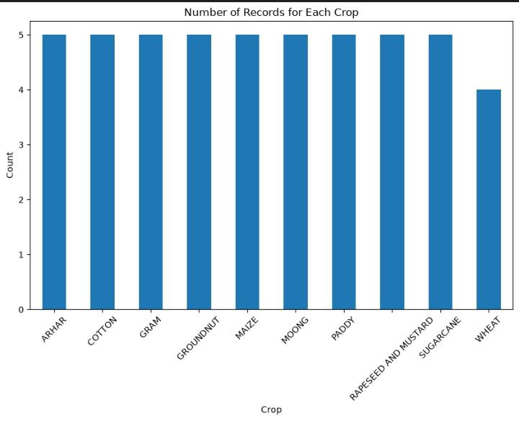
Figure 1: Number of Records for Each Crop

11.2 Average Yield by Crop
The average yield chart highlights a substantial difference in scale between sugarcane and the other nine crops. Sugarcane's average yield of roughly 790 Quintal/Hectare vastly exceeds that of crops such as paddy, maize, and wheat, which cluster well below 50 Quintal/Hectare. This scale difference is an important consideration when interpreting both the correlation analysis and the actual-versus-predicted plot.
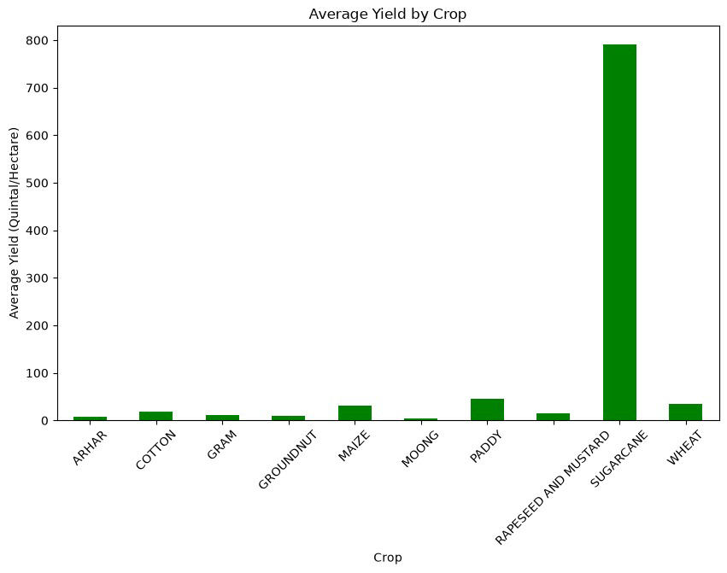
Figure 2: Average Yield by Crop (Quintal/Hectare)

11.3 Correlation Heatmap
The correlation heatmap illustrates the linear relationships between the numerical features. Cost of Cultivation (A2+FL) and Cost of Cultivation (C2) show a very strong positive correlation of 0.98, which is expected since both measures are derived from overlapping cost components. Both cultivation cost measures also show a fairly strong positive correlation with Yield (0.86 and 0.87 respectively), suggesting that crops with higher cultivation costs tend to have higher yields in this dataset. In contrast, Cost of Production (C2) shows a moderate negative correlation with Yield (-0.49), which may reflect the fact that higher-yielding crops can spread fixed costs over more output, lowering the per-unit cost of production.
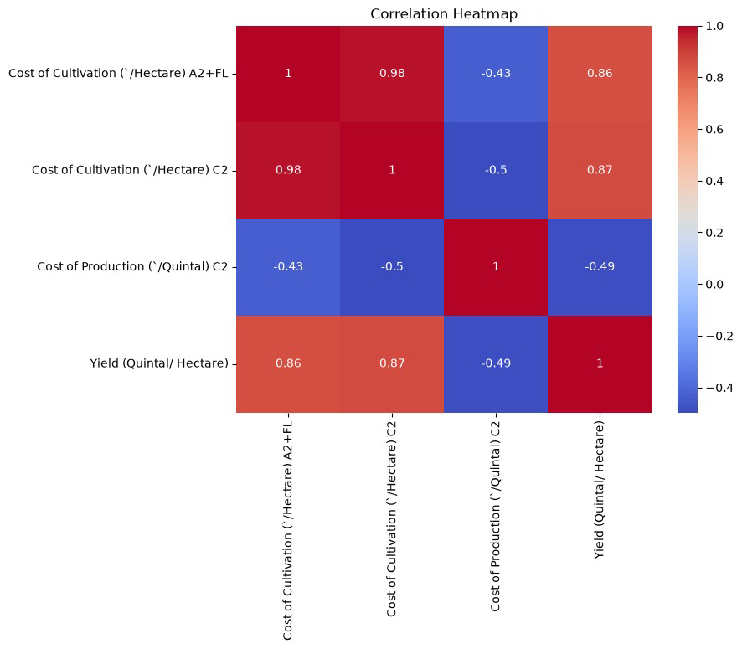
Figure 3: Correlation Heatmap of Numerical Features

11.4 Actual vs Predicted Yield
The scatter plot below compares actual yield values against the model's predicted yield values on the test set. The single point in the upper right corresponds to sugarcane, whose actual yield of roughly 1,000 Quintal/Hectare was predicted by the model as approximately 800 Quintal/Hectare — the largest individual deviation observed, though still in the correct order of magnitude. The remaining points, corresponding to the other crops with much lower yield values, cluster closely near the origin and show the model tracking actual values reasonably closely at that scale.
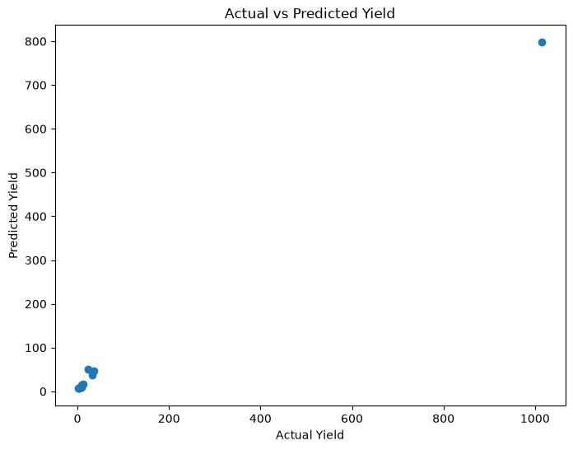
Figure 4: Actual vs Predicted Yield (Quintal/Hectare)

11.5 Discussion of Results
Overall, the results confirm that a Random Forest Regression model can achieve strong predictive performance (R² of 0.9463) on this agricultural dataset using only cost- and category-based features. The largest source of prediction error stems from sugarcane, whose yield is an order of magnitude larger than that of the other crops in the dataset. This is a common challenge in regression tasks involving skewed target variables, and is noted as a direction for future improvement in Section 13.

12. CONCLUSION
This internship provided a comprehensive, hands-on introduction to the field of Data Science and Machine Learning, progressing from foundational Python and statistics concepts in the early weeks to the design and implementation of a complete machine learning pipeline in the final project.
The capstone project, "Prediction of Agriculture Crop Production in India Using Machine Learning," successfully demonstrated the application of Random Forest Regression to predict crop yield from cultivation cost, production cost, crop type, and state data sourced from the Government of India Open Data Portal. The model achieved a Mean Absolute Error of 28.43 and an R² Score of 0.9463, reflecting strong predictive accuracy despite the small size of the dataset.
Beyond the specific technical result, the project reinforced the complete applied machine learning workflow — data cleaning, exploratory analysis, feature encoding, model training, prediction, and evaluation — and strengthened practical skills in Python programming, data visualization, and the interpretation of model performance metrics. These skills form a strong foundation for further study and work in data science and machine learning.

13. FUTURE SCOPE
While the current project demonstrates strong predictive performance on the available dataset, several extensions could further improve its accuracy, robustness, and real-world applicability:
- Incorporating weather and rainfall data, which are known to significantly influence crop yield, to capture environmental effects not present in the current feature set.
- Including soil quality parameters such as soil type, pH, and nutrient content to improve the model's understanding of agronomic conditions.
- Integrating satellite imagery and remote sensing data (e.g., vegetation indices) for more granular, field-level yield estimation.
- Expanding the dataset to include a larger number of records and a wider range of years, states, and crops, which would improve the statistical reliability of the model and reduce the influence of outlier crops such as sugarcane.
- Applying feature scaling or log-transformation to the target variable to reduce the impact of large-scale outliers like sugarcane on model error.
- Experimenting with additional regression algorithms — such as Gradient Boosting or XGBoost — and comparing their performance against the current Random Forest baseline.
- Deploying the trained model as a web application or API, allowing farmers and policymakers to obtain yield predictions interactively.

14. REFERENCES
- Government of India Open Data Portal — https://data.gov.in
- Pandas Documentation — https://pandas.pydata.org/docs/
- NumPy Documentation — https://numpy.org/doc/
- Scikit-learn Documentation — https://scikit-learn.org/stable/documentation.html
- Matplotlib Documentation — https://matplotlib.org/stable/contents.html
- Seaborn Documentation — https://seaborn.pydata.org/
- Python Official Documentation — https://docs.python.org/3/

