Plague in Denmark (1000-1800)

A longitudinal study of *Yersinia pestis*

## Authors

**Katherine Eaton**\*1,2, **Ravneet Sidhu**\*1,3, Jennifer Klunk1,4, Julia Gamble5, Jesper Boldsen6, Ann G. Carmichael7, Nükhet Varlık8, Sebastian Duchene9, Leo Featherstone9, Vaughan Grimes10, G. Brian Golding3, Sharon DeWitte11, Hendrik N. Poinar1,2,12,13,14

*Contributed equally.

1McMaster Ancient DNA Centre, McMaster University, Hamilton, Canada.  
2Department of Anthropology, McMaster University, Hamilton, Canada.  
3Department of Biology, McMaster University, Hamilton, Canada.  
4Daicel Arbor Biosciences, Ann Arbor, USA.  
5Department of Anthropology, University of Manitoba, Winnipeg, Canada.  
6Department of Forensic Medicine, Unit of Anthropology (ADBOU), University of Southern Denmark, Odense, Denmark.  
7Department of History, Indiana University Bloomington, Bloomington, USA.  
8Department of History, Rutgers University-Newark, Newark, USA.  
9The Peter Doherty Institute for Infection and Immunity, University of Melbourne, Melbourne, Australia.  
10Department of Archaeology, Memorial University of Newfoundland, St. Johns, Canada.  
11Department of Anthropology, University of South Carolina, Columbia, USA.  
12Department of Biochemistry, McMaster University, Hamilton, Canada.  
13Michael G. DeGroote Institute of Infectious Disease Research, McMaster University, Hamilton, Canada.  
14Canadian Institute for Advanced Research, Toronto, Canada.

## Abstract

The epidemiology of plague in the past is highly controversial, owing to the scarcity and ambiguity of historical evidence. A frequent source of debate is the re-emergence and continuity of plague in Europe during the 14th to 18th centuries CE. Scandinavia is particularly underrepresented in the historical archives, despite having a uniquely long history of plague (5000 years) as revealed through ancient DNA analysis. To better understand the historical epidemiology of plague in this region, we performed in-depth (N=298), longitudinal screening (800 years) for the plague bacterium, *Yersinia pestis*, across 13 archaeological sites in Denmark. We captured the emergence and continuity of *Y. pestis* in this region over a period of 400 years (14th - 17th century CE), for which the plague-positivity rate was 8.3% (3.3% - 14.3% by site). These results deepen the epidemiological link between the plague bacterium, *Y. pestis*, and the unknown *pestilence* that afflicted medieval and early modern Europe. Furthermore, this study paves the way for the next generation of historical disease research, in which hypotheses concerning mortality can be tested using population-scale, genomic evidence from ancient pathogens.

## Introduction

Europe endured a 500-year long pandemic from the 14th to 18th centuries CE1. During this period, mysterious outbreaks reoccurred every 10 years with mortality estimates as high as 50% during the infamous Black Death (1346-1353)2. Paleogeneticists have increasingly identified the plague bacterium *Yersinia pestis* as the most likely agent, although the epidemiology of this pandemic remains controversial3. The major source of debate concerns two aspects: mortality and spread. The ecology of *Y. pestis* is highly complex, and involves both zoonotic “spillover” from rodent populations as well as inter-human transmission4. As a result, both disease exposure and spread are known to vary between regions and over time3. These differences are challenging to reconcile, and have led to significant controversy concerning the location of plague reservoirs in the past5.

Recent studies have explored this question by synthesizing genetic evidence5 and historical records6,7 across Europe. These sources have significant geographic gaps, such as the complete lack of evidence from Scandinavia in digitized databases8. This gap has been attributed to the sparseness of historical sources and ambiguity with regards to disease terminology during the medieval period2. However, recent ancient DNA research9 has revealed that the history of plague in Scandinavia is among the oldest in the world, and established the presence of *Y. pestis* in Sweden 5000 years ago. This raises the possibility of long-term persistence of plague in Scandinavia, with *Y. pestis* re-emerging as a local, endemic disease.

To evaluate the possibility of undocumented plague persistence, we screened for the presence of *Y. pestis* in the Anthropological DataBase Odense University (ADBOU) collection. This extraordinary collection includes preserved and curated skeletal remains from over 16,000 Danish individuals, dated from the Viking Age to the Early Modern period. To ensure a wide variety of locations were represented, we sampled 298 individuals across 13 archaeological sites from the mainland (Jutland), as well as two islands (Funen and Lolland). Based on the skeletal dates, these individuals represent 800 years of population history (1000-1800 CE) which includes both the known pandemic period in Denmark (1350-1657) and the quiescent periods (1000-1350 CE, 1658-1800) for which no outbreaks of plague are historically documented3.

## Results and Discussion

We detected *Y. pestis* in 7 archaeological sites using PCR assays and targeted sequencing (Figure 1 A). Across the 7 sites, 8.3% of individuals (13/157) tested positive for *Y. pestis*, ranging from 3.3% at Ribe Lindegärden to 14.3% at Hågerup. This positivity rate could be considered an underestimate of the ‘true’ prevalence of *Y. pestis* in Danish populations, due to variable DNA preservation. On the other hand, it may be an overestimate due to the osteological paradox10, in which mortality is selective and the deceased are not representative of the living population. While the exact extrapolation is unclear, our *Y. pestis* positivity rate (3.3 - 14.3%) does align with mortality estimates (5 - 20%) during the later epidemics of the medieval and early modern period11,12.

Of the 13 plague-positive individuals, 9 had sufficient sequencing depth (>3X) of the *Y. pestis* chromosome for phylogenetic analysis (Figure 2 C). To estimate a time-scaled phylogeny and dates for these 9 samples, we fit a relaxed molecular clock to an alignment of *Y. pestis* genomes which included 40 other isolates (Figure 1 B). We observed that all Danish strains clustered strongly (posterior: 1.0) within the known diversity of medieval and early modern *Y. pestis* in Europe (Figure 3). We found no evidence to suggest that Neolithic lineages of *Y. pestis* in Scandinavia (5000 YBP)9 left descendants in medieval Danish populations. If long-term persistence of *Y. pestis* did occur in this region, it fell outside the geographic and temporal scope of this study.

We found no evidence of *Y. pestis* in Denmark between 1000 and 1300 CE. The factors influencing the preservation of ancient DNA are wide-ranging and complex, thus the absence of evidence cannot prove evidence of absence. That being said, we sampled a minimum of 85 individuals and a maximum of 165 individuals that pre-date the 14th century (Figure 2 A). Taking the mean positivity rate observed in this study (8.3%), we would expect to detect *Y. pestis* in 7 to 13 individuals from this time frame if it were present. We therefore interpret our negative results from this period as tentative evidence that *Y. pestis* was a relatively new pathogen in medieval Denmark, that did not become abundant and/or widespread until at least the 14th century.

The earliest evidence of *Y. pestis* in Denmark was found in the town of Ribe. Two individuals were associated with *Y. pestis* from the first half of the 14th century, dated to 1333 (1301-1366) and 1350 (1319-1383). These estimates are highly congruent with the historical record, as the first documented appearance of plague in Denmark was at Ribe in 134913. Furthermore, these strains fell within an unresolved cluster (posterior: 0.15) of samples from Northern and Western Europe (Figure 3) which has previously been linked to clonal spread of the Black Death (1343-1356)1. Our molecular dates support this historical association, albeit only weakly, as the precise epidemic period cannot be resolved due to the large confidence intervals of our estimates (>50 years).

The next period in which we identified *Y. pestis* was in the latter half of the 14th century. A third isolate from Ribe was dated to 1370 (1336-1408) and strongly clustered (posterior: 0.99) with post-Black Death samples from The Netherlands and Russia. These samples have previously been attributed to the *pestis secunda* (1357-1366)14, although we find the *pestis tertia* (1364-76)12 to be an equally likely candidate. This clade also has broader epidemiological significance, as it is directly ancestral to the Third Pandemic of plague (19th-20th century)1. Our results therefore reveal new global connections, as the same lineage that afflicted medieval Danish populations would later re-emerge to cause modern epidemics of plague, including the recent outbreaks in Madagascar15.

We observed a gap in the continuity of plague at Ribe, as no *Y. pestis* was detected there between 1408 and 1484. This was surprising, as 86% of individuals (43/50) from this site were archaeologically dated to between 1400 and 1536. Instead, the distribution of *Y. pestis* appeared to shift during this period from the eastern coast of Jutland to the western coast. We recovered 3 distinct, and possibly contemporaneous, isolates of *Y. pestis* from 3 sites near Horsens dated to 1429 (1392-1467), 1433 (1403-1464) and 1457 (1427-1487). These genomes were most closely related to individuals sampled in Germany, Lithuania, Poland, and England (Figure 3). This geographic association parallels the historical record, in which outbreaks in Denmark coincided with those in the Baltic region12. However, recent studies have demonstrated that the directionality and spread of zoonotic diseases cannot be robustly inferred from genomic data alone16,17. Instead, our results establish an epidemiological link between *Y. pestis* and historical case records in Denmark, which could be jointly modeled with greater resolving power18 in future work.

In the 16th century, we once again observed *Y. pestis* at Ribe. We dated two *Y. pestis* isolates from this region to 1513 (1484-1546) and 1525 (1494-1560). Furthermore, we also found evidence of *Y. pestis* in the northern site of Faldborg dated to 1594 (1550-1649). As an estimate of plague’s disappearance (1649), this is congruent with the historical record which documents the last recorded outbreak of plague in Jutland to last from 1654-16573. We found no evidence of *Y. pestis* in Denmark after this point, specifically between 1649 and 1800 CE. However, no individuals definitively post-date 1649 CE, although this period could include a maximum of 70 individuals (Figure 2 A). We would therefore expect to detect *Y. pestis* in 0 to 2 individuals (3.3%) from this time frame if it were present. Our results do not differ from this expectation, and are therefore not informative with regards to the disappearance of *Y. pestis* in Denmark. To address this question, additional samples would be required from the 17th and 18th centuries.

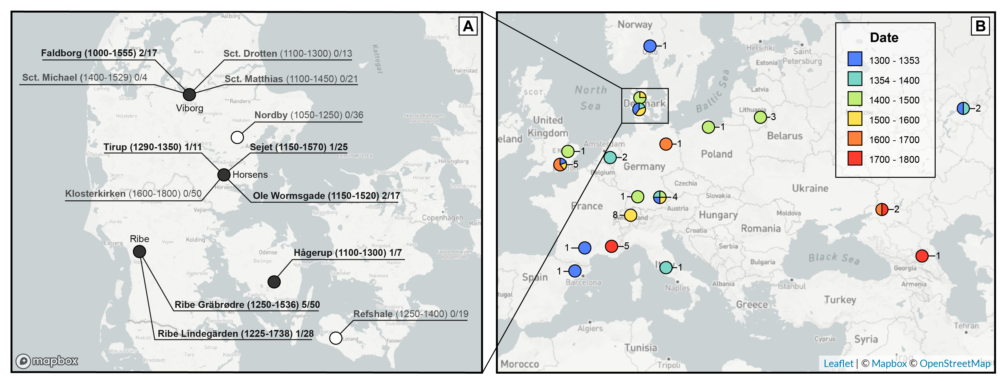

Figure 1: Geographic distribution of 298 archaeological samples used in this study. **A**. Map of 6 municipalities sampled in Denmark encompassing 13 archaeological sites. Site labels indicate: Archaeological Site (Earliest Date Sampled - Latest Date Sampled) *Y. pestis* positive individuals / total individuals. Plague positive sites are bolded. **B**. Map of 49 *Y. pestis* genomes used for phylogenetic analysis. The sampling locations were standardized to the centroid of the associated province/state. Colors indicate the sampling dates as estimated from the Bayesian molecular clock analysis. Numbered labels indicate the number of genomes sampled from each location.

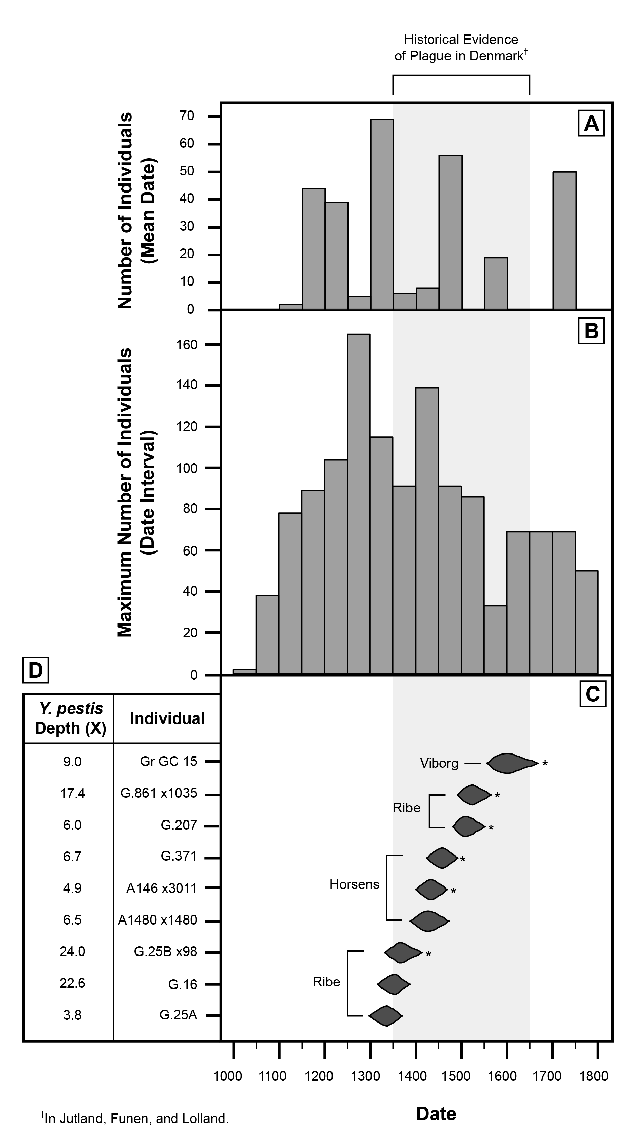

Figure 2: Temporal distribution of archaeological samples used in this study. **A**. Mean skeletal dates for all individuals (N=298). **B**. Skeletal date intervals for all individuals (N=298) using a bin width of 50 years. **C**. Distribution of *Y. pestis* tip-dates for plague-positive individuals (N=9) according to the 95% highest posterior density (HPD) from the Bayesian molecular clock analysis. Asterisks indicate the phylogenetic placement had strong posterior support (>= 0.95). **D**. Mean sequencing depth of the *Y. pestis* chromosome.

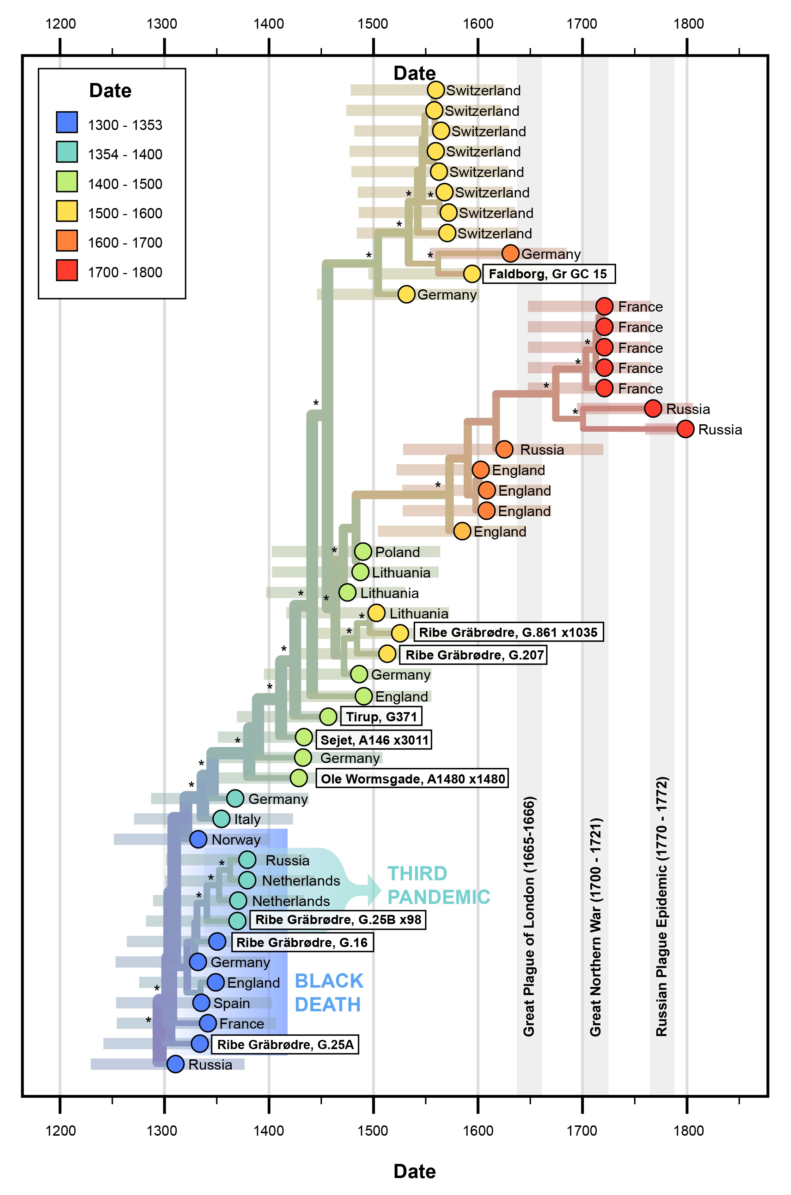

Figure 3: Maximum-clade credibility (MCC) tree depicting a time-scaled phylogeny of 49 European *Y. pestis* genomes. Asterisks indicate clades with strong posterior support (>=0.95). Colors indicate the mean sampling dates as estimated from the Bayesian molecular clock analysis. Bars indicate tip-dating uncertainty, as represented by the 95% highest posterior density (HPD) interval.

## Conclusion

This study marks the first population-level analysis of ancient *Y. pestis*, where we performed in-depth (N=298), longitudinal sampling (800 years) within a single country (Denmark). We describe the earliest known appearance of *Y. pestis* in Denmark (14th century), and document the continuity of this pathogen in Scandinavia over a period of 400 years (17th century). Furthermore, we provide the first positivity rates of historical plague from molecular evidence, as we detected *Y. pestis* in 8.3% of Danish individuals. Our phylogenetic analysis was highly congruent with the sparse textual evidence of *pestilence* in Denmark, with regards to the timing of outbreaks and geographic ties to the Baltic region. We also provide novel evidence of plague exposure among Danish populations, such as the site of Tirup, where there is no surviving historical evidence. These results are of importance for both researchers of plague and other infectious diseases, as they (1) illuminate undocumented pathogens in the historical record, (2) reveal new connections between our past and present experience of plague, (3) broaden our understanding of the epidemiology of re-emerging diseases.

## Materials and Methods

We sampled 298 individuals across 13 archaeological sites in Denmark (Figure 2 A, Dataset S1). Site occupation dates spanned from the 11th to the 19th century CE. We estimated individual date ranges based on burial position, which was categorized according to cultural shifts that occurred in Denmark throughout the medieval and early modern period19. When the original stratigraphic context was preserved, we refined these individual estimates further. For individuals with ambiguous or conflicting archaeological estimates, we performed radiocarbon dating when additional destructive sampling was permitted.

DNA was extracted from teeth and dental pulp according to a specialized protocol for ancient DNA20. Reagent blanks were introduced as negative controls to monitor DNA contamination in subsequent steps. We screened for plague using a PCR assay that targets the *pla* virulence gene in *Yersinia pestis*21. Extracts showing amplification in at least 4/6 replicates were converted into paired-end sequencing libraries22. Targeted capture of the *Y. pestis* genome was performed using previously designed probes21 and sequenced on an Illumina platform.

Sequenced molecules were aligned to a reference genome using the *nf-core/eager* pipeline23. To phylogenetically place these new samples, we downloaded a comparative dataset of 40 high-coverage *Y. pestis* genomes (>3X) dated between the 14th and 18th centuries. We then constructed a multiple alignment with the snippy pipeline (https://github.com/tseemann/snippy), which included 356 variation positions and 4,289,810 constant sites.

To tip-date each genome, we performed a Bayesian Evaluation of Temporal Signal (BETS)24 with BEAST225. We assumed a constant population size and compared the use of a strict clock and an uncorrelated lognormal (UCLN) relaxed clock. Diffuse normal priors were constructed for all tip-dates, using the mean radiocarbon/mortuary date and half the uncertainty as the standard deviation. All Danish samples were assigned equivalent priors with a mean date of 1330 CE and a standard deviation of 115 years. Bayes factors were calculated by comparing the marginal likelihoods of each candidate model, as estimated with a generalized stepping stone (GSS) computation. The model with the highest marginal likelihood was then run for 100,000,000 generations to ensure the effective sample size (ESS) of all relevant parameters was greater than 200.

Data visualization was performed using the python package *seaborn* and *auspice*, a component of the Nextstrain visualization suite26.

## Data Availability

Raw sequence reads have been deposited in NCBI BioProject PRJNAXXXXX. Archaeological metadata is provided in the supplementary information (Dataset SI).

## Acknowledgments

This work was supported by the Social Sciences and Humanities Research Council of Canada (#20008499) and the MacDATA Institute (McMaster University, Canada). This research was enabled in part by support provided by Compute Ontario (<https://www.computeontario.ca/>) and Compute Canada (<https://www.computecanada.ca>). We would like to thank Julianna Stangroom, Michael Klowak, Dr. Emil Karpinski, Dr. Matthew Emery, and Dr. Stephanie Marciniak for their assistance in laboratory procedures. We also thank Dr. Ana Duggan for her insight regarding Bayesian methods for phylogenetic analysis. We thank members of the Sherman Centre for Digital Scholarship, including Dr. Andrea Zeffiro, Dr. John Fink, Dr. Matthew Davis, and Dr. Amanda Montague, for their assistance in developing the underlying genomic database. Finally, we would like to thank all past and present members of the McMaster Ancient DNA Centre and the Golding Lab at McMaster University.

## Author Contributions

K.E, R.S, J.K, and H.N.P designed the study. J.G, J.B, and S.D provided access to archaeological sites and materials. V.G performed radiocarbon dating. K.E, R.S, and J.K performed laboratory analysis. A.G.C and N.V. provided historical sources and interpretation. S.D and L.F critiqued and revised the computational methods and discussion. G.B.G provided access to computational resources and data storage. H.N.P and G.B.G supervised the study. K.E wrote the manuscript with contributions from all co-authors.

## Competing Interests Statement

The authors declare no competing interests.

## References

1. Spyrou, M. A. *et al.* [Phylogeography of the second plague pandemic revealed through analysis of historical Yersinia pestis genomes](https://doi.org/10.1038/s41467-019-12154-0). *Nature Communications* **10**, 4470 (2019).

2. Christensen, P. [“In these perilous times”: Plague and plague policies in early modern Denmark](https://doi.org/10.1017/S0025727300057331). *Medical History* **47**, 413–450 (2003).

3. Benedictow, O. J. [*The Black Death and Later Plague Epidemics in the Scandinavian Countries: Perspectives and Controversies*](https://www.degruyter.com/document/doi/10.1515/9788376560472/html). (De Gruyter Open Poland, 2016).

4. Perry, R. D. & Fetherston, J. D. [Yersinia pestis - etiologic agent of plague](https://www.ncbi.nlm.nih.gov/pmc/articles/PMC172914). *Clin. Microbiol. Rev.* **10**, 35–66 (1997).

5. Bramanti, B., Wu, Y., Yang, R., Cui, Y. & Stenseth, N. C. [Assessing the origins of the European Plagues following the Black Death: A synthesis of genomic, historical, and ecological information](https://doi.org/10.1073/pnas.2101940118). *PNAS* **118**, (2021).

6. Schmid, B. V. *et al.* [Climate-driven introduction of the Black Death and successive plague reintroductions into Europe](https://doi.org/10.1073/pnas.1412887112). *PNAS* **112**, 3020–3025 (2015).

7. Yue, R. P. H., Lee, H. F. & Wu, C. Y. H. [Trade routes and plague transmission in pre-industrial Europe](https://doi.org/10.1038/s41598-017-13481-2). *Sci Rep* **7**, (2017).

8. Roosen, J. & Curtis, D. R. [Dangers of noncritical use of historical plague data](https://doi.org/10.3201/eid2401.170477). *Emerg Infect Dis* **24**, 103–110 (2018).

9. Rascovan, N. *et al.* [Emergence and spread of basal lineages of Yersinia pestis during the Neolithic Decline](https://doi.org/10.1016/j.cell.2018.11.005). *Cell* **176**, 295–305.e10 (2019).

10. Wood, J. W. *et al.* [The Osteological Paradox: Problems of Inferring Prehistoric Health from Skeletal Samples](https://www.jstor.org/stable/2743861). *Current Anthropology* **33**, 343–370 (1992).

11. DeWitte, S. N. & Kowaleski, M. [Black Death Bodies](http://hdl.handle.net/2027/spo.9772151.0006.001). *Fragments: Interdisciplinary Approaches to the Study of Ancient and Medieval Pasts* **6**, (2017).

12. Slavin, P. [Out of the West: formation of a permanent plague reservoir in south-central Germany (1349–1356) and its implications](https://doi.org/10.1093/pastj/gtaa028). *Past & Present* **252**, 3–51 (2021).

13. Lenz, K. & Hybel, N. [The Black Death](https://doi.org/10.1080/03468755.2015.1110533). *Scandinavian Journal of History* **41**, 54–70 (2016).

14. Namouchi, A. *et al.* [Integrative approach using Yersinia pestis genomes to revisit the historical landscape of plague during the Medieval Period](https://doi.org/10.1073/pnas.1812865115). *Proceedings of the National Academy of Sciences* **115**, E11790–E11797 (2018).

15. Nguyen, V. K., Parra-Rojas, C. & Hernandez-Vargas, E. A. [The 2017 plague outbreak in Madagascar: Data descriptions and epidemic modelling](https://doi.org/10.1016/j.epidem.2018.05.001). *Epidemics* **25**, 20–25 (2018).

16. Kalkauskas, A. *et al.* [Sampling bias and model choice in continuous phylogeography: getting lost on a random walk](https://doi.org/10.1371/journal.pcbi.1008561). *PLOS Computational Biology* **17**, e1008561 (2021).

17. Eaton, K. *et al.* [Plagued by a cryptic clock: Insight and issues from the global phylogeny of Yersinia pestis](https://www.researchsquare.com/article/rs-1146895). *Nature Communications* (Submitted, 2021).

18. Featherstone, L. A., Di Giallonardo, F., Holmes, E. C., Vaughan, T. G. & Duchêne, S. [Infectious disease phylodynamics with occurrence data](https://doi.org/10.1111/2041-210X.13620). *Methods in Ecology and Evolution* **12**, 1498–1507 (2021).

19. Boldsen, J. L. [Leprosy in Medieval Denmark — Osteological and epidemiological analyses](http://www.jstor.org/stable/29543069). *Anthropologischer Anzeiger* **67**, 407–425 (2009).

20. Dabney, J. *et al.* [Complete mitochondrial genome sequence of a Middle Pleistocene cave bear reconstructed from ultrashort DNA fragments](https://doi.org/10.1073/pnas.1314445110). *Proceedings of the National Academy of Sciences* **110**, 15758–15763 (2013).

21. Wagner, D. M. *et al.* [Yersinia pestis and the Plague of Justinian 541–543 AD: a genomic analysis](https://doi.org/10.1016/S1473-3099(13)70323-2). *The Lancet Infectious Diseases* **14**, 319–326 (2014).

22. Kircher, M., Sawyer, S. & Meyer, M. [Double indexing overcomes inaccuracies in multiplex sequencing on the Illumina platform](https://doi.org/10.1093/nar/gkr771). *Nucleic Acids Research* **40**, e3–e3 (2012).

23. Yates, J. A. F. *et al.* [Reproducible, portable, and efficient ancient genome reconstruction with nf-core/eager](https://doi.org/10.7717/peerj.10947). *PeerJ* **9**, e10947 (2021).

24. Duchene, S. *et al.* [Bayesian evaluation of temporal signal in measurably evolving populations](https://doi.org/10.1093/molbev/msaa163). *Molecular Biology and Evolution* **37**, 3363–3379 (2020).

25. Bouckaert, R. *et al.* [BEAST 2.5: An advanced software platform for Bayesian evolutionary analysis](https://doi.org/10.1371/journal.pcbi.1006650). *PLOS Computational Biology* **15**, e1006650 (2019).

26. Hadfield, J. *et al.* [Nextstrain: real-time tracking of pathogen evolution](https://doi.org/10.1093/bioinformatics/bty407). *Bioinformatics* **34**, 4121–4123 (2018).