## Authors

## Introduction

This is

In this paragraph I am discussing Figure 1 and Figure S1.

Also let’s cite myself [1] and [2].

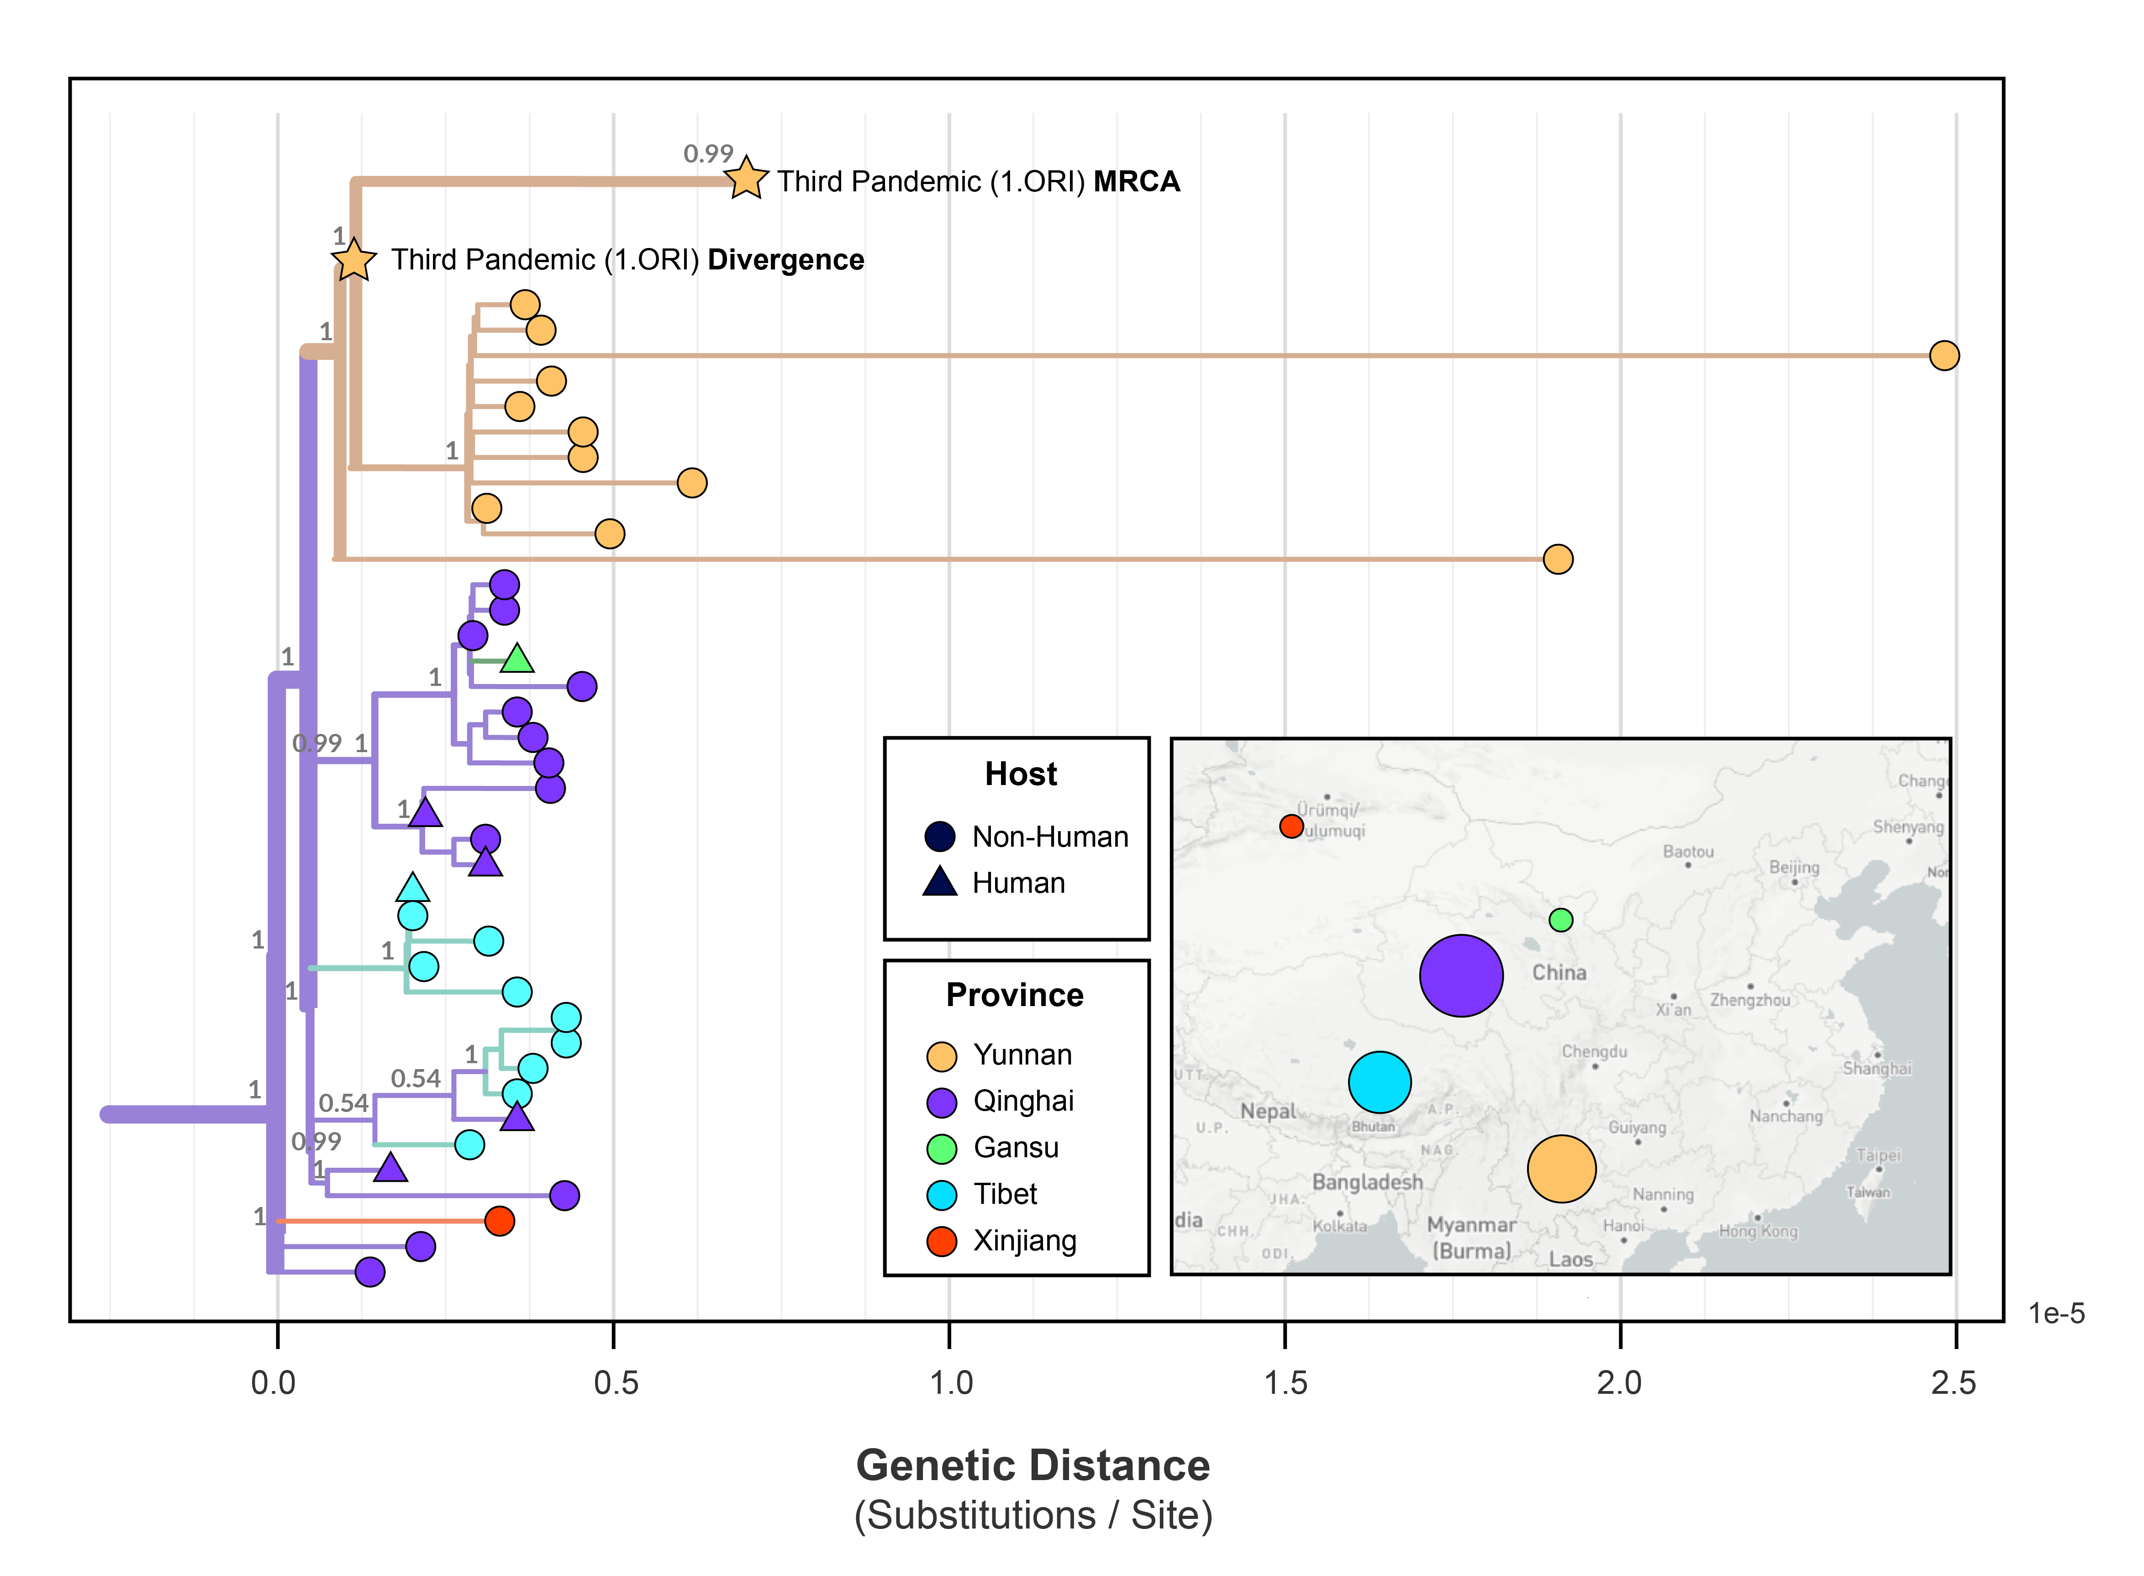

Figure 1: Caption

## SI



Figure S1: Caption

## References

1. **NCBImeta: efficient and comprehensive metadata retrieval from NCBI databases** Katherine Eaton *Journal of Open Source Software* (2020) <https://doi.org/10.21105/joss.01990> DOI: [10.21105/joss.01990](https://doi.org/10.21105/joss.01990)

2. **Yersinia pestis--etiologic agent of plague** RD Perry, JD Fetherston *Clinical Microbiology Reviews* (1997-01) <https://doi.org/gf2tk7> DOI: [10.1128/cmr.10.1.35](https://doi.org/10.1128/cmr.10.1.35) · PMID: [8993858](https://www.ncbi.nlm.nih.gov/pubmed/8993858)