Supplementary Information

# Administrative Matching Robustness Check

Our models exploring the turnout effects of traffic stops in Hillsborough County, Florida, require that we merge administrative records using the identifiers in the data. This runs the risk of identifying false positives. To test the prevalence of false positives in our administrative matching procedure, we use the test developed by Meredith and Morse (2014). By systematically permuting the birth dates in one set of records, we can see whether false positive matches are a major concern. In Table 1 we begin by merging all names and dates of birth in the traffic stop data with the names and dates of birth in the Hillsborough County registered voter file. We then add and subtract 35 days from the birth dates in the traffic stop data. If there are no false positives, these records should match with no records from the registered voter file.

As the table makes clear, more than a quarter-million registered voters in Hillsborough County match at least one record in the traffic stop database when merging by first and last name, and date of birth. Once we permute the birth dates, however, the match rate drops dramatically—to 60 or 78, depending on how these dates of birth are permuted. This translates into a false positive rate of roughly 0.03 percent. We consider this rate of false positives too low to meaningfully impact our results.

# Sensitivity to Narrower Windows

In the individual-level section of this manuscript, voters stopped in the 2 years prior to an election are considered treated, and we draw our controls from the voters stopped 2 years after the election. It is perhaps the case that this large window results in implausible matches; under this design, a treated voter stopped in December of 2012 could draw a control not stopped until October of 2016. Voters stopped nearly 4 years apart from one another might differ in meaningful ways that our matching models cannot capture.

Here, we re-run our matching process on a variety of different windows around the elections. In the most conservative approach, we force voters stopped in the month before an election to match with voters stopped in the month after the election; we then gradually relax this assumption by allowing voters stopped in the 2 months before the election to match to those stopped in the 2 months afterwards, etc.

Figure 1 shows that our overall treatment effect is remarkably consistent regardless of the size of the window drawn around the election. As we expand the window, we gain more treated voters (and treated voters have a larger pool of potential controls). As such, the confidence interval shrinks, but the overall effect is clearly robust to very strict assumptions. In each case, we are re-estimating our primary models in which the covariates used in the matching exercise are also included in the econometric model.

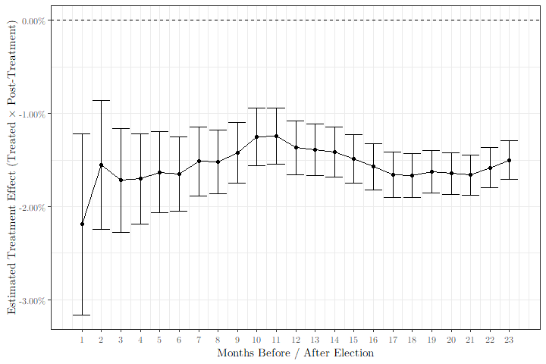

Estimated Treatment Effect for Different Treatment Windows

# Regression Tables for Individual Treatment Years

In the body of this manuscript, we present only the overall treatment effects for the police stops in Hillsborough County, which are effectively averaged across all three years. Here, in Tables 2–4, we present the results for each group of treated and control voters. In Table 2, all treated voters were stopped between the 2012 and 2014 elections, and all controls were stopped between the 2014 and 2016 elections. In Table 3, treated voters were stopped between 2014 and 2016, while controls were stopped between 2016 and 2018. Finally, Table 4 presents the treatment effect for voters stopped between 2016 and 2018, relative to their controls stopped between the 2018 and 2020 elections. In every year, there is a statistically significant, negative treatment effect for non-Black voters. In 2014 and 2016, the effect is significantly smaller for Black individuals, though in 2018 the treatment effect for Black and non-Black voters is statistically indistinguishable.

# Testing Robustness of L2 Racial Estimates

As discussed in the body of this manuscript, our municipality-level racial estimates are constructed by aggregating up from individual-level records provided by L2. Because L2 uses statistical modeling to infer voters’ race—not self-reported information—there is potential room for error in these estimates.

Because there are no precise estimates of the racial demographics of the registered electorate in each city, we compare the estimated Black share of each municipality to the Black share of the citizen voting age population (CVAP) in each municipality. This method is not without drawbacks: if different cities have different racial registration rates, they will not track perfectly. To mitigate some of this discrepancy, we adjust the Black share of the electorate in each municipality by the racial registration gap in that municipality’s state, according to the Current Population Survey’s (CPS) 2018 data. For example, according to the CPS, 27.0% of the citizen population in Alabama was Black in 2018, but just 26.4% of registered voters were Black. We therefore add 0.6% to the estimated Black share of the electorate in each municipality in Alabama, so that it might more closely mirror the Black share of CVAP.

In Table 5 we present the mean absolute error (MAE) of the L2 estimates aggregated up to the municipality level and adjusted according to the CPS, relative to the Census Bureau’s CVAP estimate. Because it seems possible that these errors vary by population size, we present the MAE for each quartile of the set of municipalities as measured by population, as well as the overall MAE.

Table 5 makes clear that the adjusted Black estimates of the electorate mirror the Black share of CVAP very closely: for no group of municipalities does the MAE exceed 3%. This seems to indicate that the L2 racial estimates are quite good when aggregated to the municipal level.

In Table 6, we show that the difference between the adjusted estimate of the Black share of the electorate and the Black share of the CVAP is entirely unrelated to cities’ per-capita fees and fines, after controlling for other characteristics. Given the low MAE and the lack of relationship between the error and the fees and fines, we conclude that the municipal-level racial estimates from the individual-level records are reasonable and unbiased.

# Regression Table for 2018 Cross-Sectional Municipality Model

In Table 7 we present the full results of the econometric used to test the cross-sectional relationship between per-capita fees and fines, and 2018 municipal turnout. The table shows that a doubling of the fees and fines collected per capita is associated with a 0.3 percentage point reduction in overall turnout. That same doubling, however, is associated with a 0.4 percentage point *increase* in the Black turnout. While these point estimates are quite small, it is worth keeping in mind that the range of fees and fines per capita is very wide. The interquartile ranges of fees and fines per capita stretches from $1.96 to $20.63—a more than ten-fold increase.

# Regression Table for Survey Data

Here we present the regression table reported in the national survey data section of the manuscript. In model 1 we test whether personal or proximal contact with a police stop is differentially associated with turnout for Black and non-Black respondents. In this model, *Stopped in Past 12 Months* captures the relationship between police stops and non-Black respondents; *Stopped in Past 12 Months × Black* tests whether this relationship is different for Black respondents.

Models 2, 3, and 4 test whether the relationship is different for other non-white groups. Finally, model 5 tests the relationship between turnout and a historical arrest.

Model 1 in Table 8 shows that Black individuals who had been stopped by the police (or had a family member stopped) in the preceding 12 months were 9 percentage points more likely to vote in 2020, other things equal; they were not related to turnout for non-Black respondents. Police stops are not, however, associated with different turnout effects for other non-white groups. Moreover, as discussed in the body of the paper, historical arrests were uniformly associated with a decrease in turnout of 4 percentage points for Black and non-Black respondents alike.

# References

Meredith, Marc, and Michael Morse. 2014. “Do Voting Rights Notification Laws Increase Ex-Felon Turnout?” *The ANNALS of the American Academy of Political and Social Science* 651 (1): 220–49. <https://doi.org/10.1177/0002716213502931>.