Neighborhoods and Felony Disenfranchisement: The Case of New York City

Kevin Morris

May 21, 2019

# Introduction

Felony disenfranchisement has received much attention over the past few years. This is true in both the academic world (where researchers have dug into the political ramifications in such races as the 2000 presidential election) and in the political world as states such as Florida and Louisiana have gradually moved to dismantle their systems of disenfranchisement. Many researchers, however, have focused on the effects of felony disenfranchisement on individuals, and on racial minorities as a group. They have examined the effect of disenfranchisement on the political participation of individuals, including after they are no longer disenfranchised, and the spillover effects disenfranchisement has on eligible voters of color. Researchers have generally neglected to examine the intersection of spatially concentrated policing and incarceration patterns with the political effects of disenfranchisement. This paper seeks to increase our understanding of the spatial implications of felony disenfranchisement by examining the relationship between disenfranchisement and neighborhood turnout in New York City.

This paper also seeks to complicate the narratives surrounding the end of felony disenfranchisement. Although advocates are correct to push for an end to disenfranchisement, a change to the political system may not be sufficient to reincorporate the voices of formerly incarcerated individuals into the democratic process. In addition to laying out the spatial implications of felony disenfranchisement in New York City, this paper also explores the impact of one policy intended to weaken the disenfranchisement program. Specifically, I investigate the effect of New York Governor Andrew Cuomo’s Executive Order 181 which ended the disenfranchisement of parolees in New York State. The effect of these policies make clear that, while the end of felony disenfranchisement is necessary, it is not enough: Active steps must be taken to reincorporate the formerly disenfranchised.

# Background of Felony Disenfranchisement in the United States

In all but two states (Maine and Vermont), felony disenfranchisement laws ensure that American citizens convicted of felony offenses lose the right to vote for at least some period of time. In some states, such as Oregon and Massachusetts, individuals lose that right only for the period in which they are actively incarcerated. In other states, notably Kentucky and Iowa, felony convictions result in lifelong disenfranchisement unless a returned citizen receives an individual pardon from the state’s governor (Brennan Center for Justice 2018). This variation in laws flows directly from language in the Fourteenth Amendment which allows states to revoke individuals’ voting rights “for participation in rebellion, or other crime.” The definition of “other crime,” left so vague in the Constitution, is now generally used by states to disenfranchize citizens for any felony offense at all. The Supreme Court, in cases such as *Richardson v. Ramirez*, has upheld states’ right to do just that. Collectively, these laws disenfranchise as many as 4.7 million American citizens. Of these, the majority are no longer incarcerated, but are living and working in their communities (Uggen, Larson, and Shannon 2016).[1]

In any discussion of felony disenfranchisement in the United States, it is imperative to acknowledge the central role played by race and white supremacy. As Traci Burch has explained, “If policies restricting the voting rights of offenders disparately affect one racial group or party, it is because such policies were intended to” (Burch 2010). The historical record is undeniable. Previous research has established that the presence of nonwhite potential voters is associated with the implementation of felony disenfranchisement policies and that these policies were often adopted during Jim Crow to reduce the political power of Black Americans (Behrens, Uggen, and Manza 2003). In Florida felony disenfranchisement was added to the state constitution in 1868. Afterwards, a lawmaker boasted that the effort had been made in order to prevent Florida from being “niggerized” (Shofner 1963).

The racial imbalance of felony disenfranchisement laws are not confined to the 19th century. Although the Voting Rights Act of 1965 did much to improve access to the ballot box for minorities, it did nothing to undermine the explicitly racialized system of disenfranchisement. Indeed, as the United States has vastly increased the reach of the carceral system in the post-Civil Rights era, the implications of felony disenfranchisement have only grown. As of 2016, more than 10 percent of Black Americans were disenfranchised in 9 states. In Kentucky, the state with the highest level of disenfranchised Black residents, more than one in four Black adults are barred from casting a ballot. Although Black adults made up just 12.1% of the voting age population in 2016, they accounted for 36.5% of the disenfranchised population (Uggen, Larson, and Shannon 2016).

Recent data Florida make the victims of felony disenfranchisement laws especially clear. Prior to January, 2019, Floridians convicted of felony offenses were permanently disenfranchised unless they were individually pardoned by a clemency board. In November, 2018, voters passed a ballot initiative amending the state constitution to end permanent disenfranchisement. In the first three months after permanent disenfranchisement was ended, 44 percent of formerly incarcerated Floridians who registered to vote were Black — compared with just 13 percent of the statewide electorate (Morris 2019).

# Academic Literature and Felony Disenfranchisement

In the aftermath of the 2000 presidential election, academic interest in the political implications of felony disenfranchisement was stirred thanks to a paper from Christopher Uggen and Jeff Manza (2002). George W. Bush’s margin of victory in Florida in 2000 was famously just 537 votes. In their 2002 paper, Uggen and Manza estimate the likely partisan composition of the disenfranchised population with felony convictions in their past. They estimate that, if this group had been allowed to vote, they would have supported Al Gore by a wide margin. Their enfranchisement, Uggen and Manza argued, would have tipped the presidential contest and resulted in the election of Al Gore. They based their estimates on the voting patterns of eligible individuals who were demographically similar to the disenfranchised population. Though much of the research conducted since their 2002 study has pushed back against some of their key assumptions (namely, that formerly incarcerated individuals turn out at the same rate as those who have not been incarcerated), Uggen and Manza convincingly demonstrated that felony disenfranchisement can have material political consequences. In the years after the Uggen and Manza published their paper, scholars sought to investigate the relationship between felony disenfranchisement and Black and youth turnout (Miles 2004; Hjalmarsson and Lopez 2010). Some of this research compared states and regions with differing disenfranchisement regimes to estimate these effects (Miles 2004; Ochs 2006). Others have used survey data or interviews to construct their estimates (Uggen and Manza 2004; Drucker and Barreras 2005).

In a series of papers in between 2009 and 2011, researchers developed methods for directly estimating the turnout of formerly disenfranchised individuals. Haselswerdt (2009) matched release data and voter registration data from Erie County, NY, to estimate turnout among a small group of formerly incarcerated individuals. Traci Burch (2010, 2011) expanded upon this matching methodology to estimate the voting patterns of formerly disenfranchised individuals in a range of states. She used release data from states’ Departments of Corrections and their registered voter files to identify formerly incarcerated individuals who went on to register to vote. Using the registered voter files, she was also able to estimate the party affiliation of formerly incarcerated individuals (in states with party registration) and their turnout rates. Her methodology has been used to investigate other questions surrounding the voting patterns of formerly incarcerated individuals under different circumstances and to examine the impact of changes in disenfranchisement policy (Meredith and Morse 2013, 2015).

A number of papers have also explored the impact that felony disenfranchisement policies have on turnout among non-disenfranchised residents. King and Erickson (2016), for instance, leverage state-level variation in disenfranchisement laws to estimate the impact that felony disenfranchisement has on turnout among Black Americans. They use data from the 2004 Current Population Survey Voting and Registration Supplement to determine individual-level turnout. They include estimates of the share of Black Americans who are disenfranchised in each state from Manza and Uggen (2006) to explore the impact of these policies on eligible voters. Ultimately, they argue that “African American disenfranchisement plays a unique role in predicting African American voter turnout.” They conclude that disenfranchisement has spillover effects for Black voters: where more Black residents are disenfranchised, elibible Black voters are less likely to cast a ballot. These findings are in line with other research that has explored whether the effects of disenfranchisement extend beyond those whose voting rights are directly suspended (Bowers and Preuhs 2009; Ochs 2006; Walker 2014). As Bowers and Preuhs (2009) sum up: “[I]t is not solely the direct vote of ex-felons that is denied through these laws. [Felony disenfranchisement] impacts the political power of communities that extends beyond felons’ collateral penalty.”

Although scholars have established that felony disenfranchisement decreases turnout among Black voters at the *state* level, relatively little research has been done on how felony disenfranchisement operates at the sub-state level. Though we know that Black voters are generally less likely to cast a ballot when they live in a state with strict disenfranchisement laws, less work has been done exploring the impact these laws might have at the local level. Burch (2013) is an exception to this. In this paper, Burch explores the depressive effect of disenfranchisement laws at the local level in North Carolina by examining census block-group level turnout and involvement with the criminal justice system. Using a standard ordinary least squares regression determined that “at high concentrations, imprisonment and community supervision have an unequivocally demobilizing effect of neighborhoods.” This paper seeks to expand on her work by replicating her findings in New York City; by using a different estimation technique; and by using a different definiton of “lost voters.”

# What This Paper Examines

This paper begins by exploring the effect of felony disenfranchisement on neighborhood turnout in the New York City Mayoral election of 2017. Policing and incarceration patterns have historically targeted communities of color, wreaking havok on the social fabric of these neighborhoods [XX]. It is possible, however, that these effects are even broader than the direct focus on policing has acknowledged. We know that felony disenfranchisement systematically removes voters from certain neighborhoods, but it is not clear whether enough voters are removed relative to the electorate to meaningfully distort neighborhood representation. To the extent that felony disenfranchisement has a depressive effect on *eligible* voters, it is possible that these policies are powerful enough to materially reduce the representatition of certain parts of the city. Although turnout is not a perfect proxy for political representation, there is some evidence that policians are more responsive to groups that turn out at higher rates. Martin and Claibourn (2013), for instance, documents the relationship between voter turnout and the responsiveness of Congressional representatives. “[H]igher citizen participation is rewarded,” they argue, “with enhanced policy responsiveness.” If the neighborhoods most impacted by felony disenfranchisement turn out at lower rates, they may find that their elected representatives are less likely to support their needs. Griffin and Newman (2005) find similar effects in the United States Senate, reporting that “voter preferences predict the aggregate roll-call behavior of Senators while nonvoter preferences do not.”

Although research on the impact of local turnout on city-wide policy is scarce, Anzia (2019) examines the impact of senior turnout on “senior-friendly” policy at the city level. Anzia does not find that senior turnout in general increases the likelihood of senior-friendly policies, but that elected officials *are* responsive to senior turnout when seniors “are a more cohesive, meaningful group.” American cities are highly segregated by race and by class, but less so by age. As such, Anzia’s study does not speak directly to the impact of *neighborhood* turnout rates on city policy. An extension of her paper, however, implies that what she finds might be probitive to the effect of neighborhood turnout rates. Insofar as neighborhoods vote as a bloc, their turnout rates may influence city policy. If felony disenfranchisement has a depressive effect on turnout, it is likely that it is responsible for politicians being less responsive to the particular preferences of voters in neighborhoods where voters are removed — some of the most neglected neighborhoods to begin with.

After examining the effect of felony disenfranchisement on voter turnout at the neighborhood level, I consider the efficacy of a program intended to undo one piece of the felony disenfranchisement apparatus. In April of 2018, Governor Andrew Cuomo signed Executive Order 181 which restored voting rights to New Yorkers on parole.[2] Parole officers were required to provide registration forms the parolees under their supervision and inform them of their voting rights. In theory, such a policy could increase turnout and registration for parolees. To test whether the policy was successful, I compare the turnout rates in the 2018 general election of three groups who finished parole in 2018: those who finished parole immediately before the policy change, those who finished parole immediately after the policy change, and those who finished parole immediately after the election. These three groups allow me to explore whether the re-extension of voting rights while on parole has an impact on turnout (by comparing the first two groups) and whether being under formal supervision while being allowed to vote results in higher turnout than being allowed to vote but being under supervision (by comparing the third group to the first two).

The first part of this project seeks to refine how we think about felony disenfranchisement in the United States. Rather thank think about it purely through the prism of those directly impacted (residents who are actively disenfranchised) or through a prism of race (by examining the impact of disenfranchisement on Black turnout at the state level), I seek to introduce the importance of physical space into the conversation. This will allow us to both better understand the mechanisms through which the depressive effects operate and also to understand more deeply where these effects are concentrated. Of course, understanding the impact of felony disenfranchisement is not enough: we must also test whether our efforts to undo its legacy are effective. The second part of this project seeks to do just that.

## Framing for Turnout Effects

Although understanding whether felony disenfranchisement impacts turnout among different social groups is of great importance, understanding the explicitly spatial dimension of the problem is also an important task. Many political decisions bear on the spatial distribution of resources (XX); funding for parks or schools, for instance, can impact all members of a neighborhood, regardless of their race, income, or criminal justice involvement. As such, even a resident who is not directly affected by felony disenfranchisement policies may lose political power thanks to these policies; if many of my neighbors cannot vote, I am joined by fewer voters in advocating for neighborhood-specific investment and services. This is, of course, tied up closely with race; New York City remains highly racially segregated. Thanks to spatially disparate policing patterns, any depressive effect is therefore likely to be concentrated among Black voters.

Despite dire over-incarceration in some neighborhoods, the number of incarcerated individuals is relatively low compared to the number of voters. In New York, for instance, 46,232 individuals were imprisoned in New York State in early 2019, compared with 11.6 million actively registered voters. Despite the low share of residents who are directly disenfranchised, there is reason to believe the policy impacts more individuals than just those imprisoned. As discussed above, previous research has demonstrated that felony disenfranchisement reduces turnout even among Black voters whose rights are not stripped. This research has found, in particular, that eligible Black voters are less likely to cast a ballot in states where felony disenfranchisement policies are harsher, an effect often referred to as *de facto* disenfranchisement. The existence of such *de facto* disenfranchisement is bolstered by a large body of empirical work on the social nature of voting. Many scholars have established that being in a community where voting is common makes individuals more likely to vote. Children whose parents vote, for instance, are more likely to vote as adults [XX]; XX add more examples here. Literature from urban sociology has established that social networks are largely spatially bounded [XX]. To the extent that felony disenfranchisement policies have depressive effects on turnout in the social and filial networks of the imprisoned and paroled, these effects are likely to be closely concentrated in the neighborhoods where the disenfranchised live.

## Previous Attempts to Re-Incorporate Formerly Disenfranchised Residents

* Super low turnout
* Immediate effects on future participation - Ariel’s paper (White 2019)
* Changes in Notification Laws (M&M)

# Data

## Criminal Justice Data

This paper employs multiple data sets to investigate the extent to which a neighborhood is directly impacted by felony disenfranchisement. The primary data set comes from a freedom of information request filed by the author to obtain individual-level incarceration records for individuals sentenced to incarceration in New York State since 1992. The data includes a host of information, including: first and last name; date of birth; class of offense; incarceration start and end dates; dates of parole; and others. This analysis is limited to individuals incarcerated for felony offenses. Individuals convicted of misdemeanors are not disenfranchised in New York State. These data come from the New York State Department of Corrections and Community Supervision (NYSDOCCS).

The third dataset used to estimate the extent to which a neighborhood is directly impacted by felony disenfranchisement policies in New York State comes from another freedom of information request. The individual-level incarceration data referenced above does not include information about the neighborhood an incarcerated person lived in prior to their conviction. Although the State of New York does not make this information available at the individual level, the author has received prison-admission counts by zip-code for the years XX – XX.

The state does not make a unified database of parolees whose voting rights have been restored available to the public. However, the NYSDOCCS Parolee Lookup website includes a flag indicating whether someone’s voting rights have been restored. By using identification numbers from the parolee data obtained from the state, I constructed a list of the individuals who were on parole and had their rights restored.[3]

## Voter File Data

Most states in the United States are required to maintain files with information on all registered voters. In New York, this information is publicly available from the Board of Elections. It includes information on all registered voters, including: first and last name; date of birth; home address; vote history; and other information. The New York State Voter File also includes information on voters who were previously registered but have since been purged, either because they moved, died, or were incarcerated for a felony offense. The first section of this paper uses a snapshot of the registered voter file from April 30th, 2018. The second section of this paper uses a snapshot from March 3rd, 2019.

## Geocoding

Voters’ home addresses were converted to latitudes and longitudes using a geocoder provided by SmartyStreets. I then used the statistical software R to map these latitudes and longitudes to census block groups, census tracts, and city council districts using shapefiles publicly available from the Census Bureau and the City of New York.

# Effects of Felony Disenfranchisement on Neighborhood Turnout Levels

## Identification of Lost Voters

In this analysis, I offer a slightly different defintion of “lost voter” than much of the literature. Many recent papers have attempted to identify relationships between the number of disenfranchised residents — *potentially* lost voters — and turnout. Here, I explore whether the disenfranchisement of residents with a history of participating in elections is related to neighborhood turnout. In this analysis, “lost voters” are individuals ineligible to cast a ballot on a given election day who have cast a ballot in the previous ten years. To study the effect of felony disenfranchisement on voting at the local level (and its potential implications for the distribution of political power at the local level), I use turnout in the most recent non-special election for city-wide office in New York — the mayoral election which took place on November 7th, 2017. Lost voters, therefore, are all individuals who were incarcerated or on parole on November 7th, 2017, and had cast a ballot between 2007 and 2016.

These individuals are identified by matching NYSDOCCS data to the voter file. I use first, middle, and last names, and dates of birth, to join these two datasets.[4] Figure shows where these lost voters lived before going to prison, with city council districts also included. There were 1,493 such lost voters within New York City as of the 2017 general election, and 3,714 statewide.

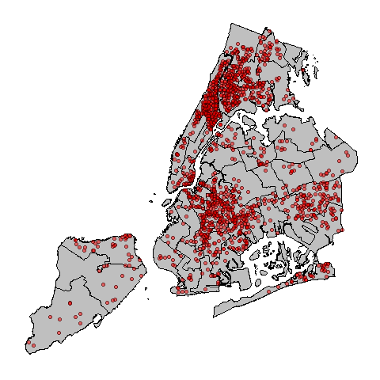

*Figure 1: Lost Voters on Election Day, 2017*

The spatial concentration of lost is readily apparent. In some communities, such as Greenwich Village and Brooklyn Heights, hardly any voters were disqualified from participating in the 2017 elections. In other communities, such as Harlem and Central Brooklyn, large numbers of individuals with a demonstrated history of voting were not allowed to cast a ballot for mayor.

## Testing for Neighborhood Turnout Effects

To test whether neighborhoods with lost voters had systematically lower turnout rates than similar neighborhoods without such disqualifications, I begin by using a matching model. Neighborhoods (defined as census tracts and block groups) are considered treated if they were home to *at least one* lost voter in the 2017 election; they are untreated if no voters were disqualified from the election because of a felony conviction.[5] I use a genetic match to match treated to untreated census tracts and block groups (Sekhon 2011). I match on a series of demographic and political indicators. Estimates of racial characteristics, median income, education, age, population, and share noncitizen[6] come from the Census Bureau. Party affiliation rates come from the geocoded voter file. Registration rate is calculated by dividing the number of registered voters (from the voter file) by the voting age population. I include voteshare won by the winning city council representative in 2017 as a proxy for the competitiveness of the local race.[7] These data come from the New York City Board of Elections. Each treated block group is matched to 30 untreated block groups, and each treated census tract is matched with 10 other tracts. Matching is done with replacement. Tables and present the results of these matches.

### Match Output

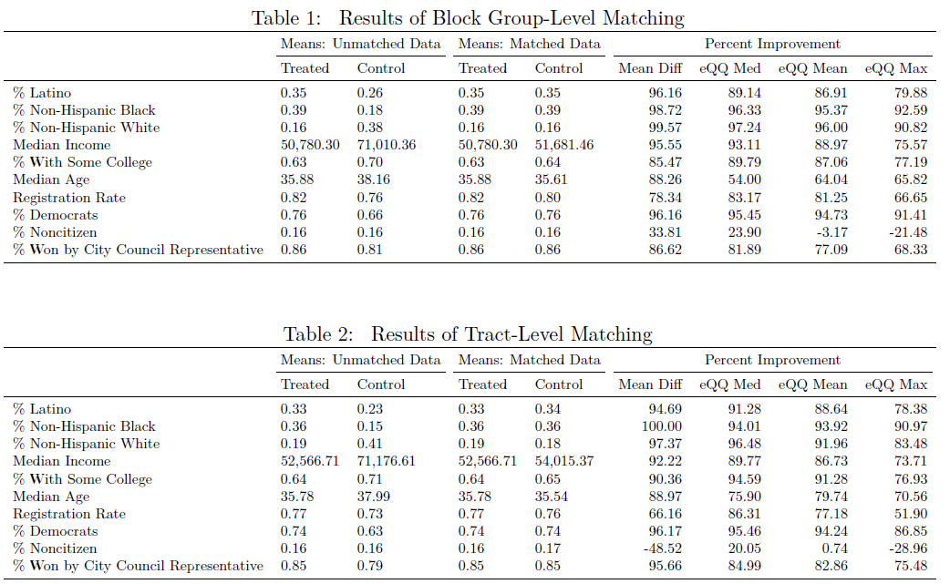

At both the tract and block group level, matching results in an untreated group of neighborhoods that looks substantially like the treatment group. These tables also demonstrate the striking extent to which neighborhoods with lost voters differ from the average neighborhood in New York City. Neighborhoods with lost voters are far less white, have much lower median incomes, and a larger share of voters are registered as Democrats.

After matching neighborhoods, I use a simple regression to test whether turnout in the 2017 mayoral election was different in areas with lost voters. Census tract and block group level turnout rates are calculated using the geocoded voter file. Each voter’s record indicates whether the voter participated in the 2017 general election, which are then aggregated to estimate the number of ballots cast in each neighborhood.[8] The number of ballots cast is divided by the neighborhood’s voting age population as reported by the Census Bureau.

Much of the literature has discussed whether felony disenfranchisement is particularly demobilizing for eligible Black voters. I therefore include models which explore any potential difference in treatment effect in neighborhoods where a higher share of the population is Black. Table presents the results of these regression models. Each neighborhood is weighted by its adult population, and robust standard errors are clustered at the level of the match (Abadie and Spiess 2019).

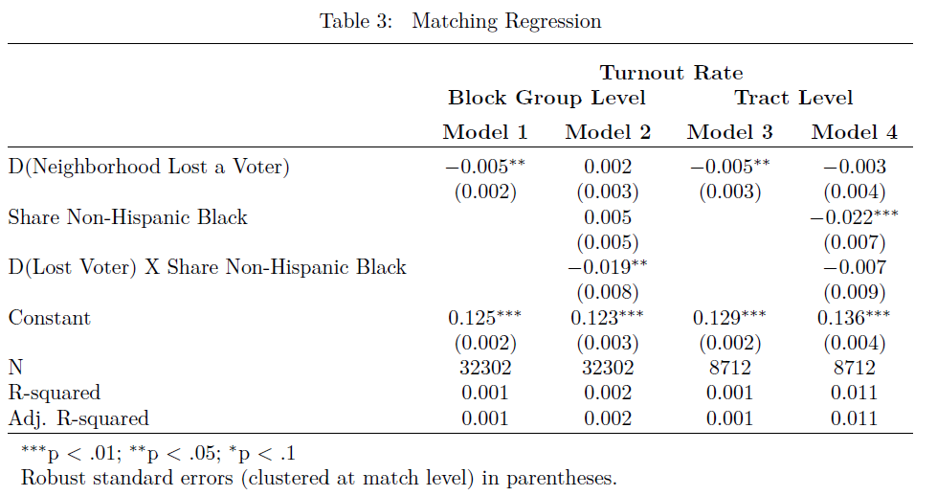

When neighborhoods are measured at the block group level, a lost voter is negatively associated with turnout in the 2017 election. In block groups with lost voters, turnout was on average 0.5 percentage points lower than in comparable block groups without lost voters. This decrease, however, appears to be entirely concentrated within Black neighborhoods. When the dummy identifying neighborhoods with lost voters is interacted with the share of the neighborhood that is Non-Hispanic Black, the basic treatment dummy becomes insignificant. The coefficient on the interaction between treatment and share Black indicates that neighborhoods that are largely Black saw turnout that was as much as 1.9 percentage points lower than similar neighborhoods without lost voters. Considering that the overall turnout rate in block groups with a lost voter was just 11.9 percent, this effect is alarmingly high. For every 100 votes cast in a predominantly Black block group with a lost voter, as many as 15.9 votes went uncast. Although these variables are largely insignificant at the census tract level, this is not particularly surprising. If lost voters have the largest depressive effect on family members and close neighbors, it makes sense that the effect of losing a voter is locally concentrated.

### Testing Intensity Effects

Matching methodologies, of course, only allow us to test the effect of being treated — here, losing any voter for the 2017 election. The model above does not allow for different effects on turnout based on *how many* voters a neighborhood lost. In Table below, I adopt a standard ordinary least squares regression to investigate whether lost voters are associated with lower turnout rates in the 2017 election. This regression uses the same covariates used in the matching procedure described above. Each neighborhood is weighted by its voting age population, and robust standard errors are clustered by city council district.[9]

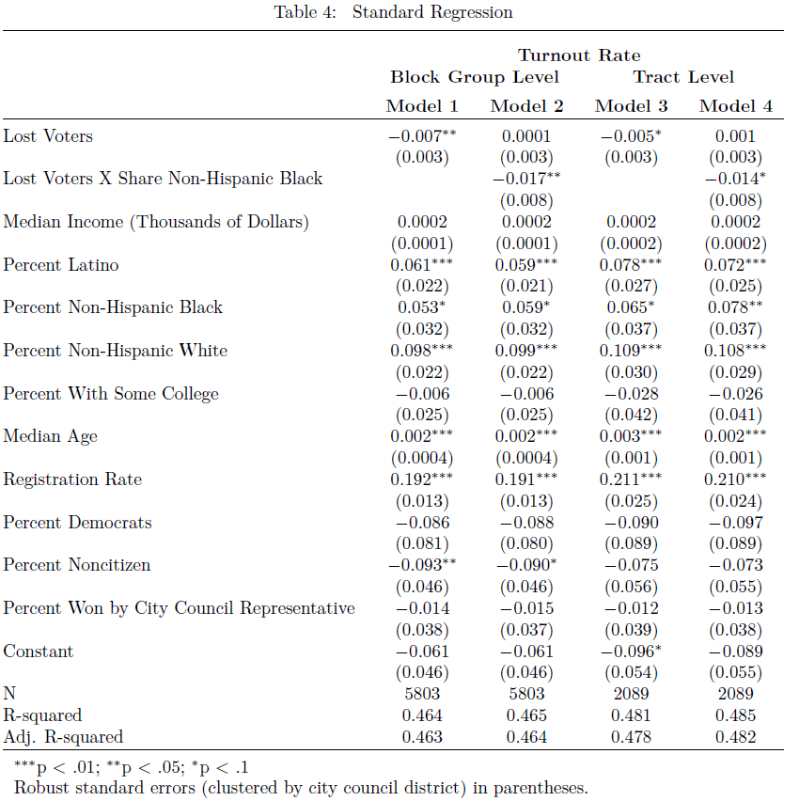

The results presented in Table align very closely with the estimated effect from the matching model. Once again, lost voters are generally associated with lower turnout (each missing voter in a block group reduces that neighborhood’s turnout by about 0.72 percentage points), but Models 2 and 4 again make clear that this effect is concentrated in Black neighborhoods. In neighborhoods where most residents are Black, each lost voter is associated with a turnout decrease of up to 1.7 percentage points.

The block groups where these depressive effects are not randomly distributed througout the city. They are highly spatially concentrated: in Central Brooklyn, Eastern Queens, and Harlem. Figure applies the coefficient on “Lost Voters * Share Black” from Model 2 in Table to the city’s block groups.

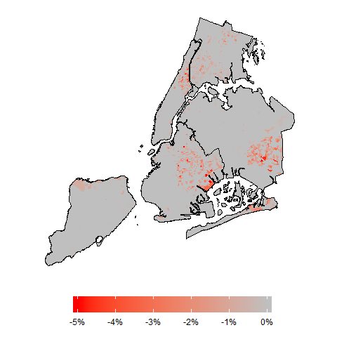

Figure 2: Estimated Depressive Effect of Felony Disenfranchisement

## Discussion

During the 2017 mayoral election, felony disenfranchisement laws were responsible for removing an estimated 1,493 from New York City neighborhoods. The spatial concentration of these lost voters is striking: as Tables and make clear, these voters were removed from neighborhoods with significantly lower incomes than the rest of the city. They were also removed from neighborhoods that were far less white than the average neighborhood. The systematic removal of voters from these neighborhoods is troubling. However, more than 850,000 votes were cast in the general election of 2017. Although felony disenfranchisement rules have enormous implications for the individuals targeted by them, it is unlikely that the removal of such a small number of voters — concentrated though they are — is likely to have large implications on its own.

Felony disenfranchisement, however, reaches beyond the individuals who are incarcerated. Previous literature has established that felony disenfranchisement likely has impacts on Black turnout at the state level. This analysis demonstrates that these demobilizing effects intersect with geographical space to systematically depress the vote in neighborhoods where voters are being sent to prison. These communities are already home to some of the poorest and most marginalized voters in the city; they are home to residents who have the least ability to influence policy through other means such as large campaign contributions. The fact that felony disenfranchisement policies appear to be disincentivizing participation on election day — that these policies are further weakening the ability of these neighborhoods to participate in the democratic process — is cause for alarm.

# References

Abadie, Alberto, and Jann Spiess. 2019. “Robust Post-Matching Inference.”

Anzia, Sarah F. 2019. “When Does a Group of Citizens Influence Policy? Evidence from Senior Citizen Participation in City Politics.” *The Journal of Politics* 81 (1): 1–14. <https://doi.org/10.1086/699916>.

Behrens, Angela, Christopher Uggen, and Jeff Manza. 2003. “Ballot Manipulation and the “Menace of Negro Domination”: Racial Threat and Felon Disenfranchisement in the United States, 18502002.” *American Journal of Sociology* 109 (3): 559–605. <https://doi.org/10.1086/378647>.

Bowers, Melanie, and Robert R. Preuhs. 2009. “Collateral Consequences of a Collateral Penalty: The Negative Effect of Felon Disenfranchisement Laws on the Political Participation of Nonfelons.” *Social Science Quarterly* 90 (3): 722–43. <https://doi.org/10.1111/j.1540-6237.2009.00640.x>.

Brennan Center for Justice. 2018. “Criminal Disenfranchisement Laws Across the United States.” <https://www.brennancenter.org/criminal-disenfranchisement-laws-across-united-states>.

Burch, Traci. 2010. “Did Disfranchisement Laws Help Elect President Bush? New Evidence on the Turnout Rates and Candidate Preferences of Florida’s Ex-Felons.” *Political Behavior* 34 (1): 1–26. <https://doi.org/10.1007/s11109-010-9150-9>.

———. 2011. “Turnout and Party Registration Among Criminal Offenders in the 2008 General Election.” *Law and Society Review* 45 (3): 699–730. <https://doi.org/10.1111/j.1540-5893.2011.00448.x>.

———. 2013. “Effects of Imprisonment and Community Supervision on Neighborhood Political Participation in North Carolina.” Edited by Christopher Wildeman, Jacob S. Hacker, and Vesla M. Weaver. *The ANNALS of the American Academy of Political and Social Science* 651 (1): 184–201. <https://doi.org/10.1177/0002716213503093>.

Drucker, Ernest, and Ricardo Barreras. 2005. “Studies of Voting Behavior and Felony Disenfranchisement Among Individuals in the Criminal Justice System in New York, Connecticut, and Ohio.” Research report. Sentencing Project. <https://www.prisonpolicy.org/scans/sp/fd_studiesvotingbehavior.pdf>.

Griffin, John D., and Brian Newman. 2005. “Are Voters Better Represented?” *The Journal of Politics* 67 (4): 1206–27. <https://doi.org/10.1111/j.1468-2508.2005.00357.x>.

Haselswerdt, Michael V. 2009. “Con Job: An Estimate of Ex-Felon Voter Turnout Using Document-Based Data.” *Social Science Quarterly* 90 (2): 262–73. <https://doi.org/10.1111/j.1540-6237.2009.00616.x>.

Hjalmarsson, R., and M. Lopez. 2010. “The Voting Behavior of Young Disenfranchised Felons: Would They Vote If They Could?” *American Law and Economics Review* 12 (2): 356–93. <https://doi.org/10.1093/aler/ahq004>.

King, Bridgett A., and Laura Erickson. 2016. “Disenfranchising the Enfranchised.” *Journal of Black Studies* 47 (8): 799–821. <https://doi.org/10.1177/0021934716659195>.

Manza, Jeff, and Christopher Uggen. 2006. *Locked Out: Felon Disenfranchisement and American Democracy*. Oxford University Press.

Martin, Paul S., and Michele P. Claibourn. 2013. “Citizen Participation and Congressional Responsiveness: New Evidence That Participation Matters.” *Legislative Studies Quarterly* 38 (1): 59–81. <https://doi.org/10.1111/lsq.12003>.

Meredith, Marc, and Michael Morse. 2013. “Do Voting Rights Notification Laws Increase Ex-Felon Turnout?” Edited by Christopher Wildeman, Jacob S. Hacker, and Vesla M. Weaver. *The ANNALS of the American Academy of Political and Social Science* 651 (1): 220–49. <https://doi.org/10.1177/0002716213502931>.

———. 2015. “The Politics of the Restoration of Ex-Felon Voting Rights: The Case of Iowa.” *Quarterly Journal of Political Science* 10 (1): 41–100. <https://doi.org/10.1561/100.00013026>.

Miles, Thomas J. 2004. “Felon Disenfranchisement and Voter Turnout.” *The Journal of Legal Studies* 33 (1): 85–129. <https://doi.org/10.1086/381290>.

Morris, Kevin. 2019. “Thwarting Amendment 4.” May 9, 2019. <https://www.brennancenter.org/analysis/thwarting-amendment-4>.

Ochs, Holona Leanne. 2006. “"Colorblind" Policy in Black and White: Racial Consequences of Disenfranchisement Policy.” *Policy Studies Journal* 34 (1): 81–93. <https://doi.org/10.1111/j.1541-0072.2006.00146.x>.

Sekhon, Jasjeet S. 2011. “Multivariate and Propensity Score Matching Software with Automated Balance Optimization: The Matching Package for R.” *Journal of Statistical Software* 42 (7). <https://doi.org/10.18637/jss.v042.i07>.

Shofner, Jerrell H. 1963. “The Constitution of 1868.” *The Florida Historical Quarterly* 41 (4): 356–74. <http://www.jstor.org/stable/30139965>.

Uggen, Christopher, Ryan Larson, and Sarah Shannon. 2016. “6 Million Lost Voters: State-Level Estimates of Felony Disenfranchisement, 2016.” Research report. Sentencing Project. <https://www.sentencingproject.org/publications/6-million-lost-voters-state-level-estimates-felony-disenfranchisement-2016/>.

Uggen, Christopher, and Jeff Manza. 2002. “Democratic Contraction? Political Consequences of Felon Disenfranchisement in the United States.” *American Sociological Review* 67 (6): 777. <https://doi.org/10.2307/3088970>.

———. 2004. “Lost Voices: The Civic and Political Views of Disfranchised Felons.” In *Imprisoning America: The Social Effects of Mass Incarceration*, edited by Mary Pattillo, David Weiman, and Bruce Western, 165–204. New York: Russell Sage Foundation.

Walker, Hannah L. 2014. “Extending the Effects of the Carceral State. Proximal Contact, Polit-Ical Participation, and Race.” *Political Research Quarterly* 67 (4): 809–22. <https://doi.org/10.1177/1065912914542522>.

White, Ariel. 2019. “Misdemeanor Disenfranchisement? The Demobilizing Effects of Brief Jail Spells on Potential Voters.” *American Political Science Review* 113 (2): 311–24. <https://doi.org/10.1017/s000305541800093x>.

# Appendix A

Matching across administrative data sets is not a perfect science. Despite having high-quality low-level data from both New York State Department of Corrections and Community Supervision (DOCCS) and the New York State Board of Elections, I cannot be sure that I am correctly identifying formerly incarcerated, registered voters. The results of the analyses in Table give some reason to believe that there are few false negatives. If there were many false negatives (lost voters who are not identified in this analysis), “treated” neighborhoods would be incorrectly categorized as “untreated” neighborhoods. If this were a widespread problem, we would expect to see little difference between treated and control neighborhoods. To the extent that lost voters go unidentified by this analysis, it is likely that the results presented in Tables and are conservative by including treated neighborhoods in the control group. Directly testing for false negatives, however, is difficult. If a voter changes her name before being incarcerated, for instance, our analysis will fail to capture her.

Testing for the presence of false positives is slightly easier. One way to do so is by constructing false records (Meredith and Morse 2013). By slightly changing the birthdates in one set of administrative data, I can estimate how frequently DOCCS records inaccurately match with voter records. To do so, I shift the dates of birth in the DOCCS data by 35 days. I then re-merge the DOCCS records (with “false” birth dates) against the registered voter file.

Table shows the results of these permutations. The first row shows the matches with the raw data. The second row shows the results of adding 35 days to the date of birth in each DOCCS record, and the final row shows the result of subtracting 35 days from these records.

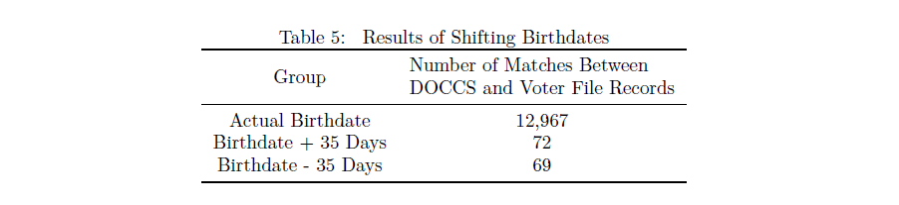Table indicates that there are likely some false positives in our matches. It is not surprising that in a large state like New York, full names and dates of birth fail to uniquely identify individuals. However, the rate of false positives is quite low: this analysis indicates that there is a 0.56%. It is unlikely that such a small incidence of false positives meaningfully impacts this analysis.

# Appendix B

As noted above, the turnout figures reported in the registered voter file do not align with the results reported by the New York City Board of Elections. According to the official results, XX ballots were cast in the 2017 mayoral election. The registered voter file reports that just XX voters cast a ballot. This is not necessarily evidence of poor management by the Board of Elections. Some voters choose not to make their voter registration information publicly available (such as domestic violence survivors and officers of the court).[10] Where more ballots are recorded by the BOE than in the voter file, turnout calculated from the voter file will be artificially lower. If the voter file undercount rate is systematically worse in neighborhoods with lost voters, this would pose a serious challenge to the validity of the results reported in the body of this paper.

To test whether there is a relationship between lost voters and voter file undercount, I examine the undercount rate at the precinct level. The voter file indicates the home precinct of each voter, and the Board of Elections publishes election results at the precinct level. Precincts are assigned the demographics of the block group in which they are situated. Where precincts cross block group lines, the precinct is assigned the characteristics of all block groups in which it is located weighted by the number of voters from each block group. The undercount rate is calculated as the number of votes derived from the voter file divided by the number reported in BOE results. Robust standard errors are clustered at the assembly district level.

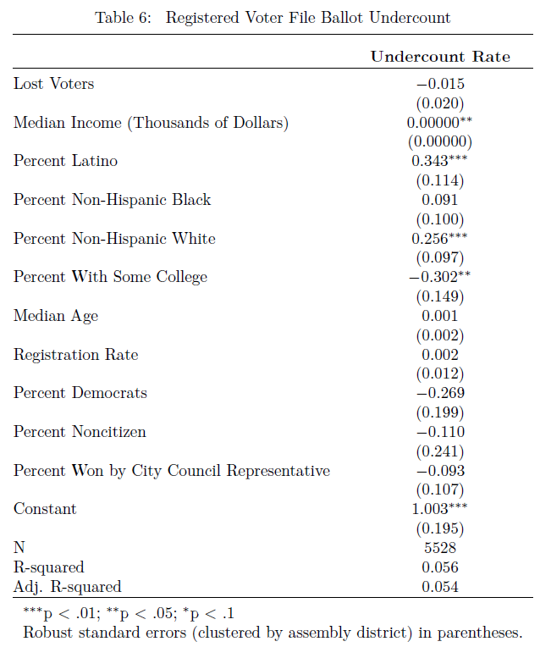

As Table makes clear, there is very little relationship (p = 0.47) between the number of lost voters in a precinct and the ballot undercount rate. Although researchers should be somewhat wary using turnout rates derived from New York State’s registered voter file, there is no evidence that the reporting error impact this analysis.

1. The figures reported in Uggen, Larson, and Shannon (2016) have been adjusted to reflect the impact of Amendment 4 in Florida.
2. Prior to Executive Order 181, residents convicted of felonies in prison and on parole were barred from voting, while individuals sentenced to probation did not have their voting rights revoked. Today, only those in prison for felony offenses are disenfranchised.
3. This list was compiled by using a webscraper written in the Python language.
4. Matching on first and last names and dates of birth can result in false positive matches, especially in large states like New York. Following Meredith and Morse (2013), I discuss the potential impact of these errors in Appendix A.
5. It is worth noting that this definition of lost voter is highly conservative. For instance, some individuals who would have voted may have gone to prison after turning 18 but before their first general election. These “untreated” neighborhoods are likely home to individuals who would have voted if it were not for disenfranchisement policies.
6. The Census Bureau does not make noncitizen estimates available at the block group level. As such, block groups are assigned their census tract’s share noncitizen for matching purposes.
7. Where neighborhoods cross council district lines, this measure is the mean competitiveness faced by each voter in the neighborhood
8. The New York registered voter file does not align exactly with results reported by the city. The voter file indicates that just XX voters cast a ballot in the 2017 mayoral election, but the Board of Elections reports that XX votes were cast. In Appendix B, I demonstrate that there is no relationship between lost voters and underreporting of cast ballots at the precinct level. These reporting anamolies are unlikely to impact this analysis.
9. Where neighborhoods cross city council district lines, they are assigned the district in which most of their voters live for clustering purporses.
10. This is not to say that there is *not* evidence of mismanagement by the BOE. For instance, the author is incorrectly marked as not participating in the 2017 mayoral primary.