A Right Restricted∗
Partisanship, Racial Backlash, and Restrictions to the Ballot Box

Kevin Morris† April 19, 2022

Abstract
TKTKT

∗TKTKT
†Researcher, Brennan Center for Justice (kevin.morris[at]nyu.edu).

Introduction

The past 18 months have been characterized by an unprecedented wave of legislation that voting rights activists argue will make voting more diﬀicult across the country. This wave follows closely on highly-publicized attacks on the validity of the 2020 election. After losing his re-election bid in November, then-president Donald Trump claimed repeatedly that the election had been stolen (Dale 2020), a claim he has continued to maintain and that some 70% of self-identified Republicans believed by early 2022 (Cuthbert and Theodoridis 2022). Many state legislators also justified their support for restrictive legislation in terms similar to Oklahoma State Representative Sean Roberts (sponsor of the restrictive HB 2842 and HB 2847), who told reporters that “[I]t was very clear that the election was stolen from President Trump. We must do everything we can to close those loopholes” (quoted in May 2022). Concerns about election security were not limited to state legislators: 147 Congressional Republicans voted against the certification of the 2020 presidential election, including a supermajority of Republicans in the House (Yourish, Buchanan, and Lu 2021). This raises important questions about the real motivation for the subsequent legislative backlash against voting rights.
This project relies on a comprehensive survey of voting-related bills introduced around the country in 2021 systematically collected by the Brennan Center for Justice to better un- derstand what explains the introduction and passage of restrictive voting legislation.1 Past scholarship exploring the determinants of the passage of restrictive voting legislation has fo- cused exclusively at the state level, providing key insight about the sorts of states most likely
to take such legislative action. This scholarship has largely argued that restrictive voting bills can be explained by racial threat—that is, white legislators are more likely to pass these bills in the face of large and/or growing political power among racial minorities (Behrens, Uggen, and Manza 2003; Bentele and O’Brien 2013; Biggers and Hanmer 2017)—or partisan
1See https://www.brennancenter.org/our-work/research-reports/voting-laws-roundup-december-2021.

control—that is, Republican legislators pass these bills to shore up flagging majorities in electorally competitive states.
This project asks what determines support—as proxied by legislative sponsorship—for these restrictive bills within states. Recent work among sociologists of social threat (Andrews and Seguin 2015) argues that scholars should attend to the interplay between state and local demographic conditions to understand how race shapes white backlash.
The results are unequivocal: it was representatives from the whitest districts in the least- white states that were the most likely to sponsor restrictive legislation. Moreover, even after accounting for partisanship and demographics, the most racially-resentful districts were the most likely to be represented by these lawmakers. Partisanship also plays a role, but not in the way past literature would suggest: sponsorship is not concentrated in contested, competitive districts where lawmakers are seeking an electoral advantage, but rather in the safest Republican districts. In short, the legislative activity related to restrictive voting bills in 2021 seems best explained by racial threat and white backlash.

Methods and Materials

Throughout my analyses, I rely on the Voting Laws Roundup, a project of the Brennan Center for Justice at NYU School of Law. The Brennan Center systematically reviews all laws introduced around the country that relate to voting and the administration of elections in each state. The Brennan Center separates each bill introduced into its constituent provisions, using two coders to designate each provision as “restrictive,” “neutral,” or “expansive.” Each provision is also assigned to a category describing its content (such as “voter ID,” “polling place count,” or “funding for poll workers”). Each bill’s provisions are identified when a bill first includes provisions related to voting, and updated if a bill is passed. In other words, if a bill is introduced with some voting provisions, is subsequently amended to include other voting provisions, but ultimately fails to pass, only the original provisions are included.

Figure 1 shows the categorical breakdown of restrictive provisions introduced and passed, while Figure 2 shows the geographical distribution of these provisions.

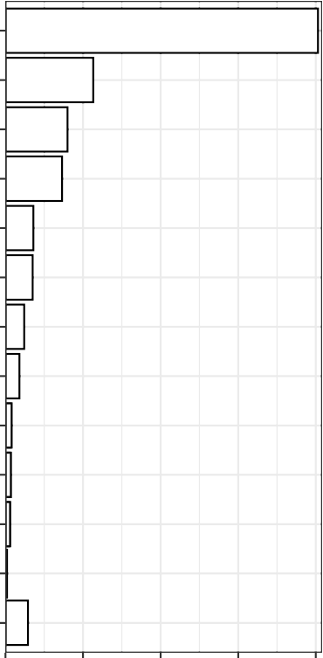
Absentee
Voting
Voter
ID
List Maintenance

Registration

Early Voting
Disability Access
Category
Provisional
Ballots
Administrative Standards Third−Party Registration Organizations
Student Voting
Felony Disenfranchisement

Challengers

Other

Absentee
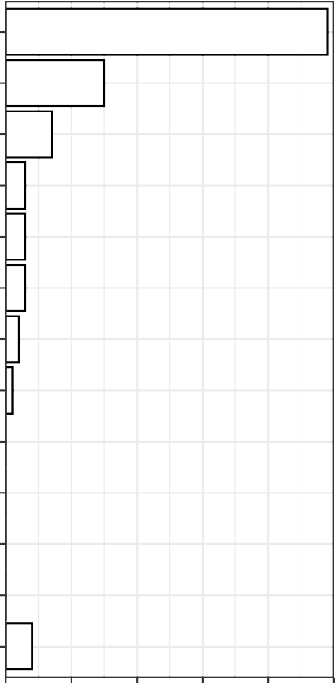
Voting
List Maintenance
Disability Access
Voter
ID
Registration Provisional
Category
Ballots
Early Voting
Student Voting Third−Party Registration Organizations
Felony Disenfranchisement

Challengers

Administrative Standards

Other

0 100 200 300 400
Number of Introduced Provisions
0 10 20 30 40 50
Number of Passed Provisions

Figure 1: Categories of Restrictive Provisions, 2021

Provisions Introduced Provisions Passed
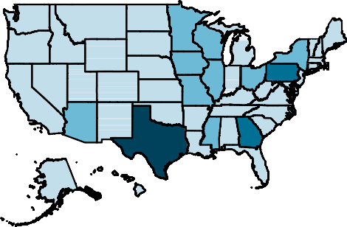
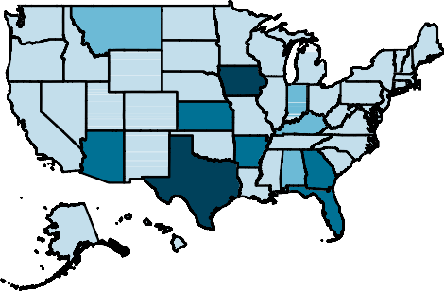



0−15
16−32
33−73
74−203
0−1
2−4
5−7
8−17



Figure 2: Restrictive Provisions, 2021

My independent variable captures whether a given district was represented by a lawmaker

who sponsored a restrictive bill. Sponorship data comes from LegiScan, an organization that tracks state-level bills around the nation. This sponsorship data is merged with the list of bills identified by Brennan Center’s voting laws roundup.
The primary independent variables for the first set of analyses are the white share of the district and the white share of the state. These are included to test whether the influence of the whiteness of a district on the probability that a lawmaker sponsors a restrictive bill is influenced by state-level factors. I also test the relationship between sponsorship and
partisanship at the district level by controlling for the share of the district won by Donald Trump in the 2020 presidential election. Trump’s two-party vote share in each district is calculated by aggregating up from precinct-level results published by the Voting Election and Science Team (2022). I assign each precinct to the upper- and lower-chamber district in which its geographical center is located.2 This coverage is not perfect: in Kentucky and West Virginia, where precinct-level results are not available, I use population-weighted county-level results. Specifically, I assign each Census block the Trump vote share of its home county. District vote share is calculated as the population-weighted mean of Trump vote share in each block in the district. I also account for the partisan control of each state using data from the National Conference of State Legislatures3 Although Nebraska’s unicameral state legislature is formally nonpartisan, they are considered to be under unified Republican control for the purposes of this study.
Of course, administrative and demographic data cannot give us insight into the political disposition of district residents. As such, I also incorporate survey data from the 2020 Cooperative Election Study to test whether districts’ racial resentment scores are associated
with the sponsorship of restrictive bills. The 2020 CES asks white voters how strongly they agree (on a scale of 1 to 5) with two statements related to racial resentment: Irish, Italians, Jewish and many other minorities overcame prejudice and worked their way up. Blacks should
2While this will not perfectly estimate voteshare in chambers where precincts cross district lines, there is
little reason to expect this will systematically distort voteshare estimates.
3See https://www.ncsl.org/documents/elections/Legis_Control_2-2021.pdf.

do the same without any special favors and Generations of slavery and discrimination have created conditions that make it diﬀicult for blacks to work their way out of the lower class. I reverse code agreement with the first statement, such that higher scores for both statements
are associated with higher levels of racial resentment. Respondents’ racial resentment scores are calculated as the mean of their response to these two questions. I retain only the responses of white respondents.
While the CES data do not include respondents’ home legislative districts, the survey makes home ZIP codes available. To calculate district resentment scores, I begin by assigning every Census block in the country the mean resentment score of the ZIP code in which its centroid falls. District resentment scores are then calculated as the population-weighted average racial resentment score of all blocks in the district.
In addition to these measures of voting legislation and policy environment, I incorporate demographic data at the state and legislative-district level from the Census Bureau’s Amer- ican Communities Survey. These estimates are the 5-year numbers ending with 2020. I also incorporate information about how diﬀicult voting was prior to 2021 using the Cost of Voting Index (COVI) (Schraufnagel, Pomante II, and Li 2020).
Based on the literature discussed above, I pose the following hypotheses:

In light of recent sociological work on the geography of racial threat (Andrews and Seguin 2015), H1: I expect that whiter districts in less-white states were the most likely to be represented by legislators that sponsored restrictive voting provisions.
I also test the effect of partisanship and competitiveness along the lines of past scholarship. This past work would predict that H2a: lawmakers from competitive districts controlled by Republicans are the most likely to support restrictive voting legislation. If, however, the sponsorship of such legislation is tied more to racial threat and signalling to an aggrieved base, I predict that H2b: representatives from the most conservative districts were the most likely to sponsor these bills.

Finally, I test the relationship between whites’ racial resentment and lawmaker sponsorship of restrictive bills, hypothesizing that H3: Districts where white voters had higher levels of racial resentment were more likely to be represented by legislators that sponsored restrictive voting provisions.

Results

  - District-Level Legislative Behavior

In Figure 3 I plot the results of an OLS regression testing H1. The regression table can be found in the Supplemental Information (SI), as can robustness checks demonstrating that the results hold when estimating the models using logistic regression. In the first row, I present the results of Models 1 and 4 of Table A1 in the SI, where only racial characteristics are included. The second row plots Models 3 and 6 which include covariates. All other covariates are held at their means.
Figure 3 shows that the relationship between district-level demographics and restrictive vot- ing sponsorship are highly moderated by state-level characteristics, as expected. Namely, representatives from the whitest legislative districts in the most racially diverse states were by far the most likely to sponsor restrictive legislation. There is little relationship between district-level demographics and the probability of sponsoring a restrictive voting bill in the whitest states; it is only in the least-white states that this relationship becomes apparent. Although these relationships are moderated slightly with the inclusion of relevant sociode- mographic and political covariates, the patterns remain clear: representatives from white districts in states with large nonwhite populations—whose (growing) demographic and po- litical power could inspire fear in the more homogeneously-white parts of the state—were disproportionately likely to sponsor bills with provisions making voting more diﬀicult.
Figure 4 also indicates that the sponsorship of restrictive voting laws at the district-level

75%
Lower Chamber
Upper Chamber

50%
No Covariates

25%
Probability Representative Sponsored Restrictive Provision(s)

0%

75%

50%
Covariates

25%

0%

25% 50% 75% 100%25% 50% 75% 100%
White Share of District Population

White Share of State Population
50%
80%

Covariates include Trump 2020 voteshare; median income; median age; share with some college; log(population);
whether the state was competitive in the 2020 election; whether the state has unified Republican control.

Figure 3: Sponsorship and Race

follows substantially different patterns than those established previously looking at state-level factors. As discussed above, past research indicates that electorally-competitive states are the most likely to pass restrictive voting laws in an attempt to maintain control. H2a extended this logic to the district level. The results, however, strongly support H2b, indicating

lawmakers from the most Republican districts were the most likely to sponsor these bills. If these bills were being supported out of genuine fear about fraud distorting the results in close elections, we would have expected to see them supported most by precisely the lawmakers
whose districts were competitive. Instead, representatives from safe districts who could not
reasonably fear electoral loss in a general election from fraud—even if it existed—are the most common sponsors. While partisanship plays a role in these sponsorships, something other than electoral competitiveness drives the Republicans who sponsor these provisions. As discussed above, this is likely racial threat among white Republicans.
I turn to the CES data to more directly test the relationship between resentment and bill sponsorship. After estimating each district’s resentment score, I ask whether this score is associated with the probability that a lawmaker sponsored a bill with at least one restrictive provision. Figure 5 plots the predicted probabilities of sponsorship, both before and after controlling for other covariates (the regression table can be found in the SI). The top panels demonstrate a strong bivariate relationship between racial resentment and sponsorship: dis- tricts where white respondents to the CES were more racially resentful were far more likely to be represented by a lawmaker who sponsored a restrictive bill. This is especially true in the upper chamber.
These relationships are moderated by the inclusion of sociodemographic controls, espe- cially the partisan measures. Although these relationships are smaller, they nevertheless remain substantively quite large and statistically significant. In the lower chamber, the most-resentful districts were more than 50 percent (10 points) more likely to be represented by a lawmaker sponsoring a restrictive bill than the least-resent districts, other things being
equal. In the upper chamber, the probability of being represented by a lawmaker sponsoring a restrictive bill for the most-resentful districts was double that of the least resentful dis- tricts. The explanatory power of racial resentment above-and-beyond what can be explained by racial and partisan measures is striking and provides exceedingly strong evidence for H3.

40%
Lower Chamber
Upper Chamber

20%
No Covariates

0%
Probability Representative Sponsored Restrictive Provision(s)

−20%

40%

20%
Covariates

0%

−20%
0%

25%

50%

75%

100% 0%

25%

50%

75%

100%

Trump 2020 Voteshare
Covariates include district and state white share of population (and interaction); median income; median age;
share with some college; log(population);
whether the state was competitive in the 2020 election; whether the state has unified Republican control.

Figure 4: Sponsorship and Partisanship

Discussion

While legislators claim to pass restrictive voter policies under the guise of improved security, the data unambiguously points to white backlash to perceived racial threat. While discussing

40.0%
Lower Chamber
Upper Chamber

30.0%

20.0%
No Covariates

10.0%
Probability Representative Sponsored Restrictive Provision(s)

0.0%

40.0%

30.0%

20.0%
Covariates

10.0%

0.0%

1 2 3 4 5 1 2 3 4 5
District Racial Resentment Score
Covariates include Biden 2020 voteshare; median income; median age; share with some college; log(population); white share of district; whether the state was competitive in the 2020 election;
whether the state has unified Republican control.

Figure 5: Sponsorship and Racial Resentment

what she calls the “political work of fraud allegations,” Lorraine Minnite argued a decade ago that claims of fraud could be explained by “the existence of marginalized subjects within the political culture whose presence alone stands in as the evidence of the alleged fraud” (Minnite 2010, 87). In other words, the rhetoric of voter fraud draws boundaries around

who does and does not count as a citizen, and whose political participation is inherently suspect.
A similar pattern emerges in this study of regressive voting laws introduced and passed in 2021, following the hard-fought and deeply polarizing 2020 presidential election and subse- quent violent attempt to overturn the results on January 6th, 2021. Although the push to restrict voting access was extremely broad in 2021—more than 1 in 3 Americans lived in a district represented by a legislator who sponsored at least one restrictive provisions—the push was concentrated in states and legislative districts with particular, systematic demo- graphic characteristics.
As anti-democratic forces continue to undermine faith in the United States’ electoral in- frastructure, understanding the source of this backlash is of key importance. This research demonstrates that the backlash is inextricably linked with race: insofar as sponsorship prox- ies a district’s appetite for restrictive voting legislation, these bills found the most fertile soil where white voters are concentrated in racially diverse states. The incorporation of sur- vey data makes the relationships even clearer, showing that racial resentment among white Americans has explanatory power above-and-beyond any partisan effect.
Further, I uncover no evidence that lawmakers from competitive districts were more likely to sponsor restrictive bills. In a year with such widespread restrictive voting legislation, why is support for these measures not concentrated in the districts where shifting the composition of the electorate (or preventing fraud) by a tiny amount might matter? The explanation for this behavior might lie in theories of legislator signalling. As Rocca and Gordon (2010) note, “members of an attentive public pay close attention to legislators’ stances. Representatives know this and use non–roll call forums to signal attentive groups that they are ‘on their side.’ Groups, in turn, reward representatives sympathetic to their causes with campaign contribu- tions” (387). Legislators from less polarized districts, on the other hand, are more likely to take moderate positions, reflecting the influence of a competitive electorate (Kirkland 2014).

Future work should directly interrogate whether legislators who signal support for restrictive voting rights gain campaign such benefits as campaign contributions or increased turnout.

References

Andrews, Kenneth T., and Charles Seguin. 2015. “Group Threat and Policy Change: The Spatial Dynamics of Prohibition Politics, 1890.” American Journal of Sociology 121 (2): 475–510. https://doi.org/10.1086/682134.
Behrens, Angela, Christopher Uggen, and Jeff Manza. 2003. “Ballot Manipulation and the ‘Menace of Negro Domination’: Racial Threat and Felon Disenfranchisement in the
United States, 1850.” American Journal of Sociology 109 (3): 559–605. https://doi.org/
10.1086/378647.

Bentele, Keith G., and Erin E. O’Brien. 2013. “Jim Crow 2.0? Why States Consider and Adopt Restrictive Voter Access Policies.” Perspectives on Politics 11 (4): 1088–1116. https://doi.org/10.1017/S1537592713002843.
Biggers, Daniel R., and Michael J. Hanmer. 2017. “Understanding the Adoption of Voter Identification Laws in the American States.” American Politics Research 45 (4): 560–88. https://doi.org/10.1177/1532673X16687266.
Cuthbert, Lane, and Alexander Theodoridis. 2022. “Analysis | Do Republicans Really Be- lieve Trump Won the 2020 Election? Our Research Suggests That They Do.” Washington Post, January.
Dale, Daniel. 2020. “Fact Checking Trump’s Barrage of Lies over the Weekend.” CNN, November.
Kirkland, Justin H. 2014. “Ideological Heterogeneity and Legislative Polarization in the United States.” Political Research Quarterly 67 (3): 533–46. https://doi.org/10.1177/
1065912914532837.

May, Payton. 2022. “State Lawmakers Debate: Is Election Fraud a Problem in Oklahoma?”
KOKH, March.
Minnite, Lorraine C. 2010. The Myth of Voter Fraud. Ithaca, UNITED STATES: Cornell

University Press.

Rocca, Michael S., and Stacy B. Gordon. 2010. “The Position-taking Value of Bill Sponsor- ship in Congress.” Political Research Quarterly 63 (2): 387–97. https://doi.org/10.1177/ 1065912908330347.
Schraufnagel, Scot, Michael J. Pomante II, and Quan Li. 2020. “Cost of Voting in the American States: 2020.” Election Law Journal: Rules, Politics, and Policy 19 (4): 503–
9. https://doi.org/10.1089/elj.2020.0666.

Voting and Election Science Team. 2022. “2020 Precinct-Level Election Results.” Harvard Dataverse. https://doi.org/10.7910/DVN/K7760H.
Yourish, Karen, Larry Buchanan, and Denise Lu. 2021. “The 147 Republicans Who Voted to Overturn Election Results.” The New York Times, January.

