ICTWEB513 - Q1.17

# Table of contents

# 

**Table of contents** **2**

**Executive summary** **3**

**Target audience** **4**

**Style Guide** **5**

Colour palette 5

Image use 6

Typography 7

**Code Guide** **8**

Language choice 8

Layout of variables, functions, commenting 9

**Mock-ups** **10**

**Web accessibility requirements** **12**

# 

# Executive summary

This is a document organisational process that covers the legislation, within Australia, for the company Travel Tasmania.

# Target audience

This document’s target is anyone who is involved with the website Travel Tasmania.

# Style Guide

## Colour palette

According to the official Tasmanian government website:

<https://www.communications.tas.gov.au/styleguide/colour_palette>

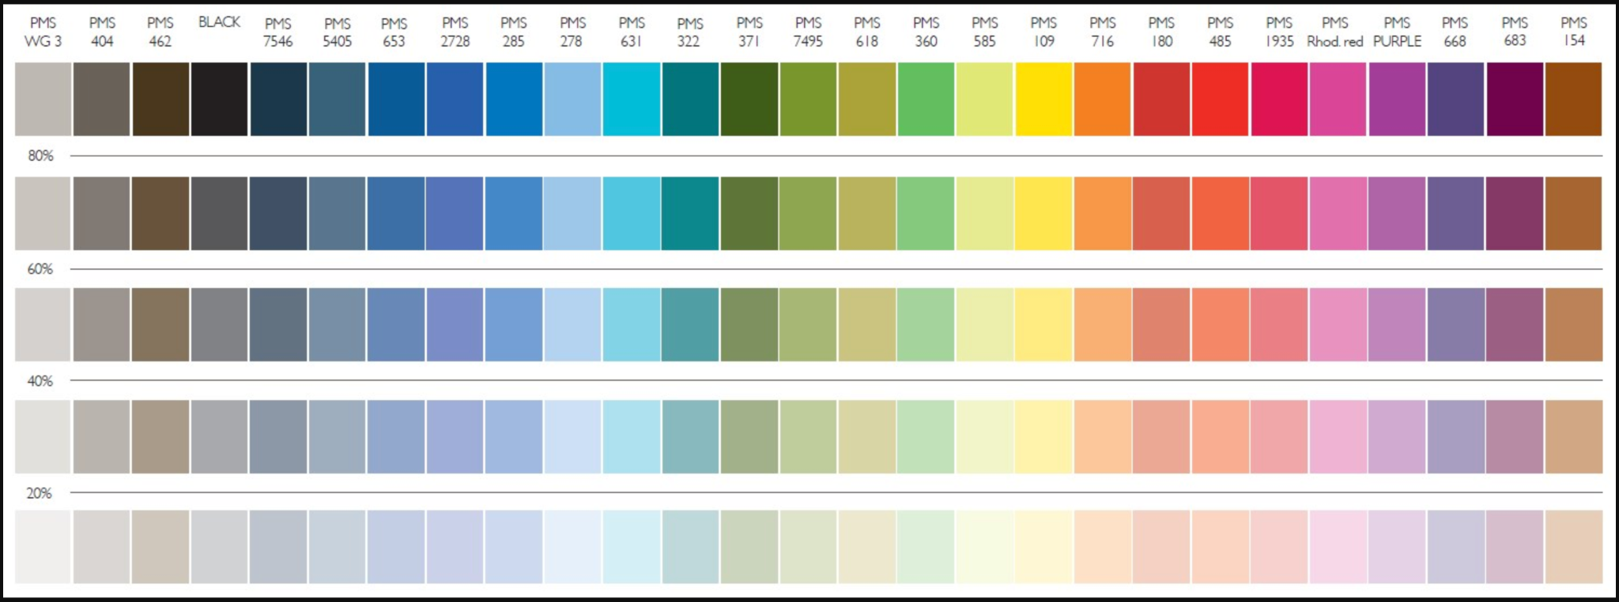

## 

## Image use

According to the official Tasmanian government website:

<https://www.communications.tas.gov.au/channels/images>

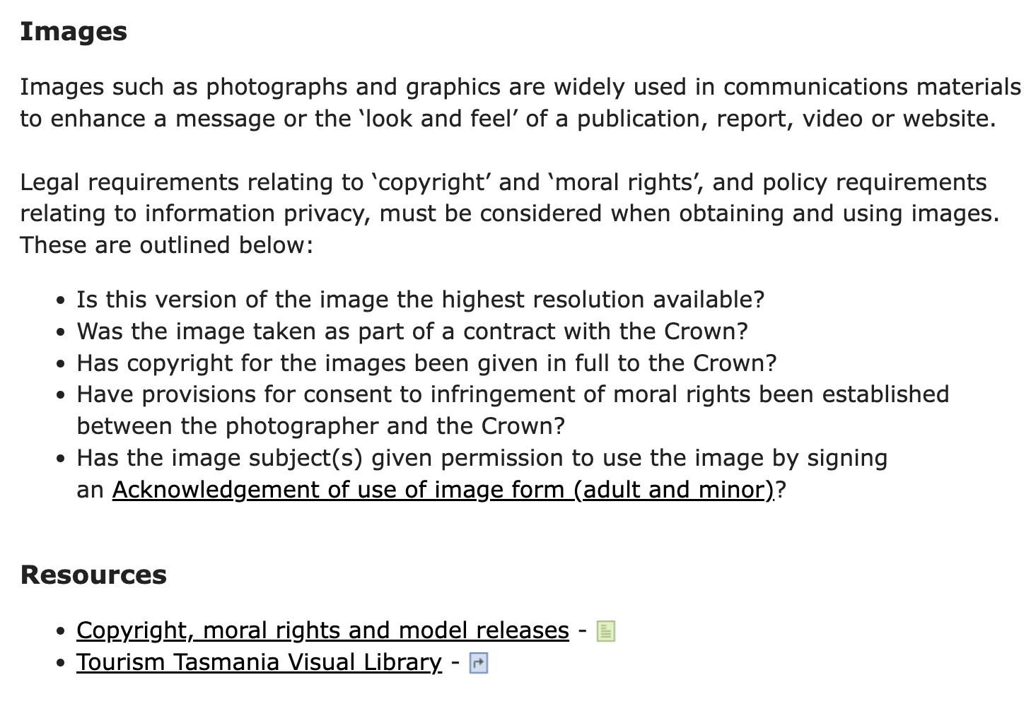

## 

## Typography

According to the official Tasmanian government website:

<https://www.communications.tas.gov.au/styleguide/font/typography>

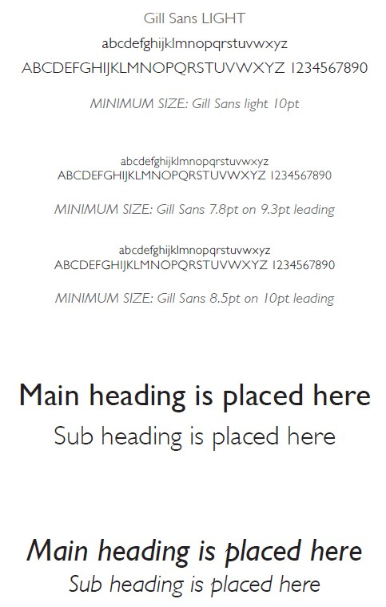

# Code Guide

## Language choice

Due to being largely adopted and the high availability of professionals, HTML, CSS, Javascript, PHP and MySQL are being used.

## 

## Layout of variables, functions, commenting

Follow the official documentations on this:

<https://www.w3.org/standards/webdesign/htmlcss>

[https://html.spec.whatwg.org/](https://html.spec.whatwg.org/multipage/)

<https://www.php.net/manual/en/>

<https://dev.mysql.com/doc/>

## 

# Mock-ups



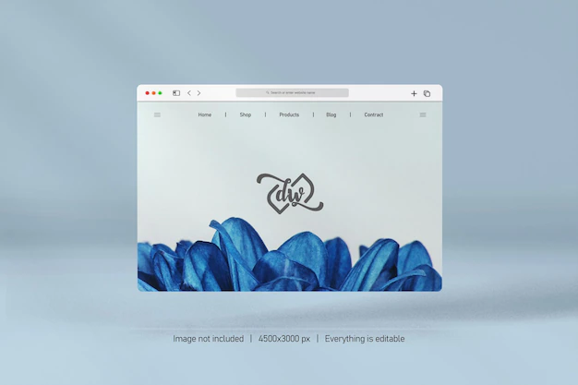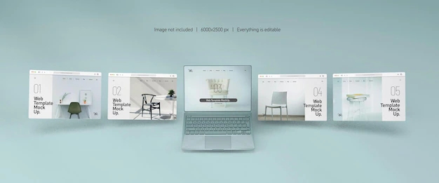

# 

# Web accessibility requirements

I would follow the official guidelines from:

<https://www.w3.org/standards/webdesign/accessibility#case>

<https://www.w3.org/WAI/standards-guidelines/>