ICTWEB513 - Q1.14

# Table of contents

# 

**Table of contents** **2**

**Executive summary** **3**

**Facebook webpage** **4**

Wireframes 4

Branding 6

Colour 6

Light/dark version 8

Database 9

Page layout 11

Page flow 12

# 

# Executive summary

This is a study documentation process of the Facebook website covering design and database aspects.

# Facebook webpage

## Wireframes

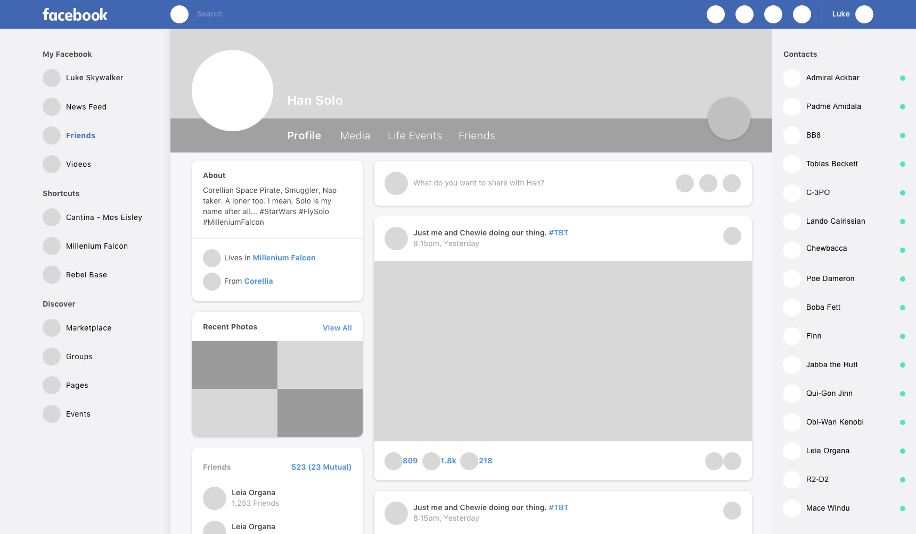

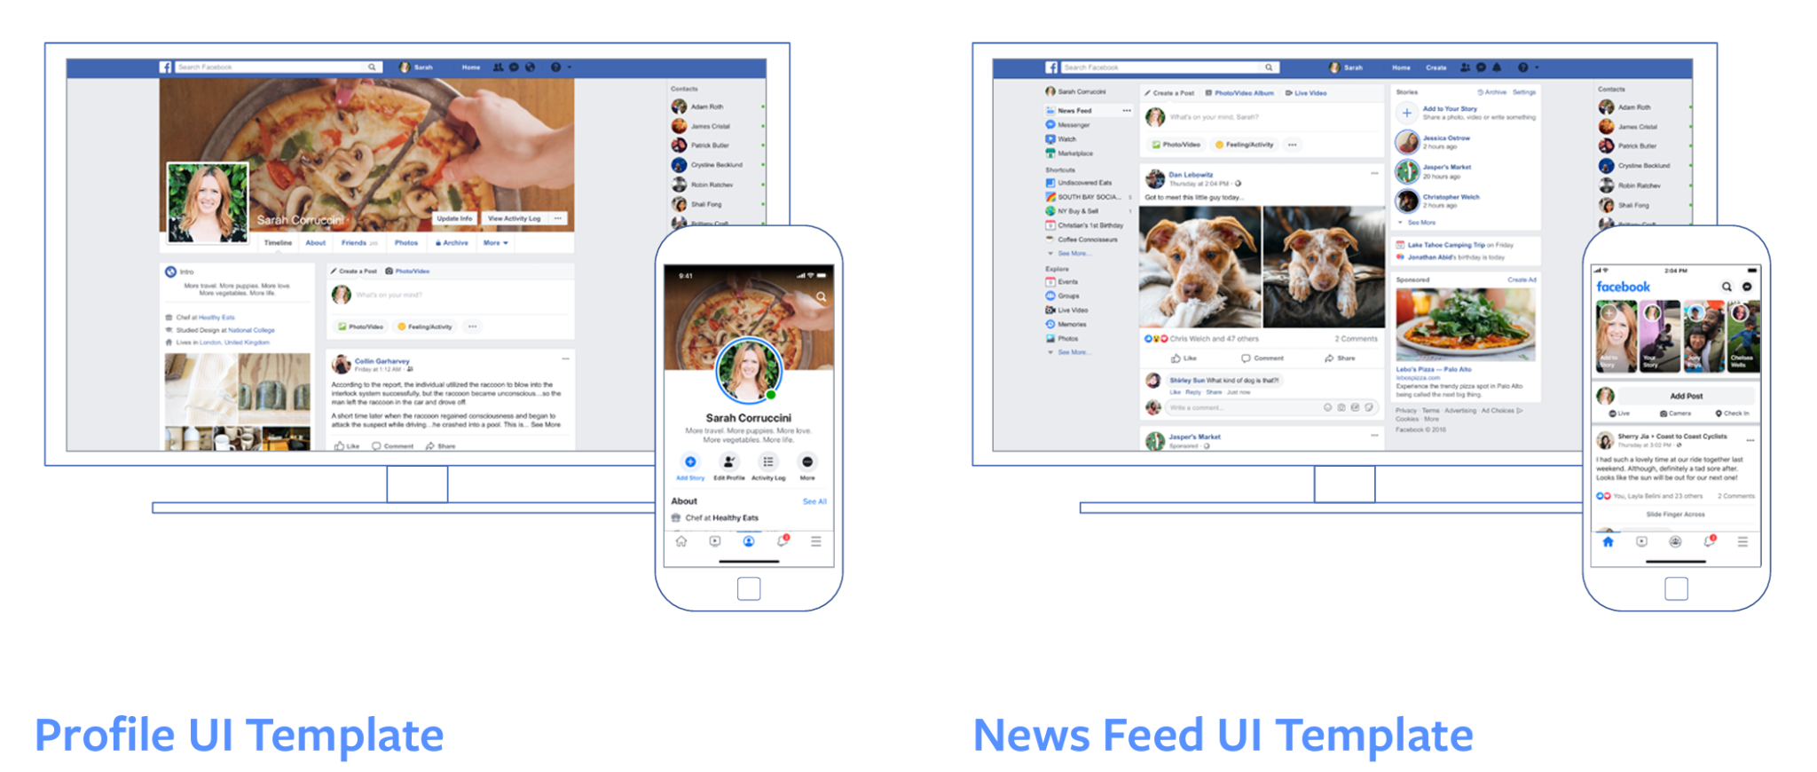

Facebook wireframes aim for responsiveness and have their own version for each device.

## 

## Branding

### Colour





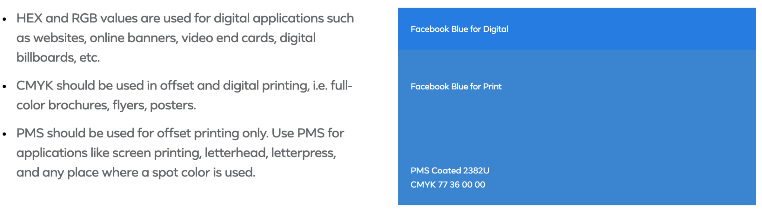

Facebook’s colour palette uses variations of blue to keep a brand identity.

### 

### Light/dark version

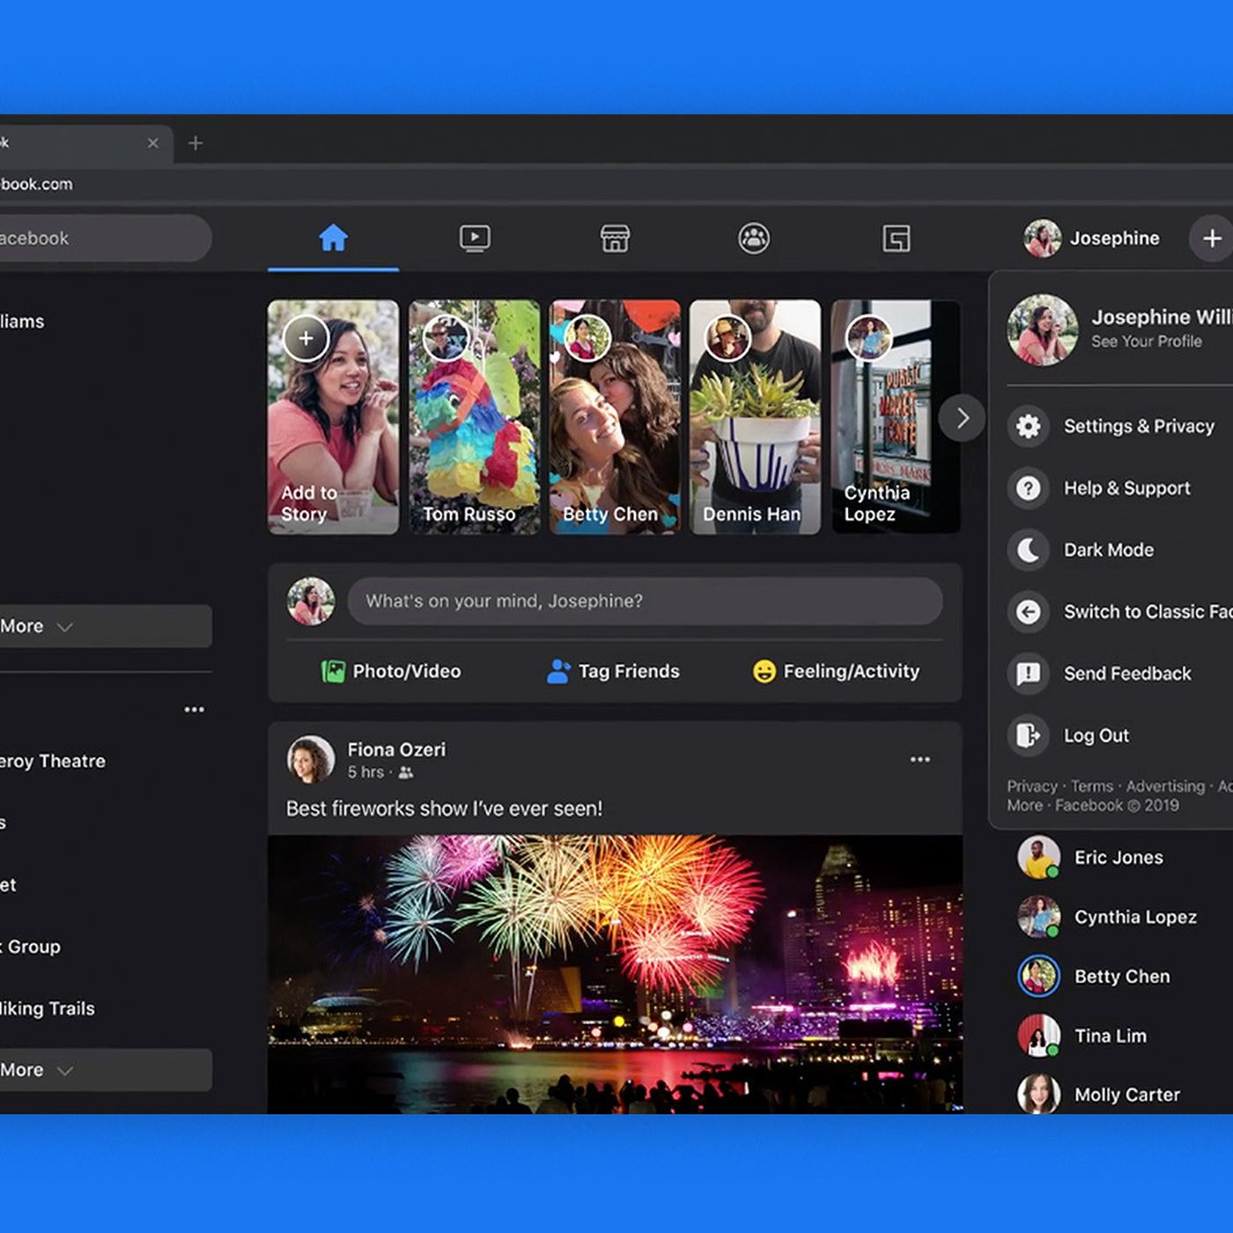

Facebook has light and dark versions but always keeping their blue color in order to keep brand identity.

## 

## Database

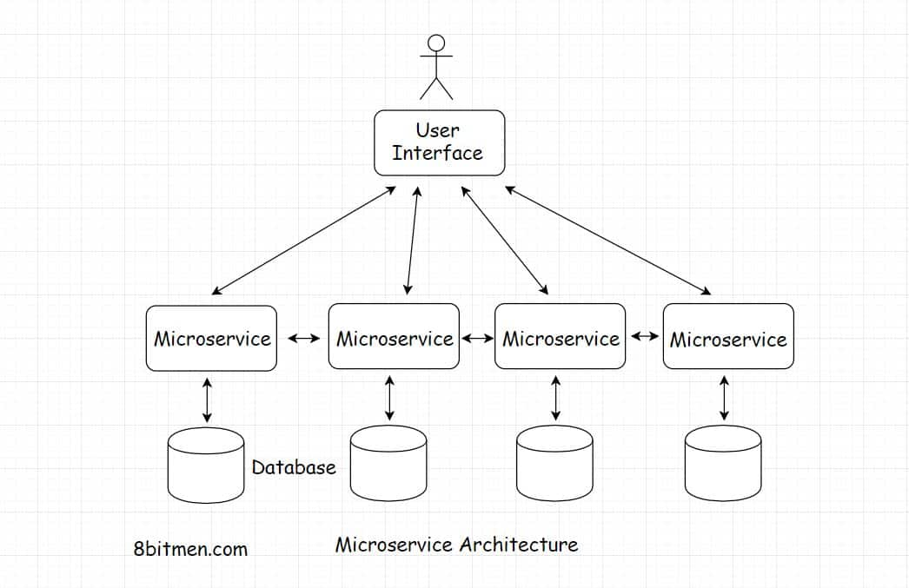

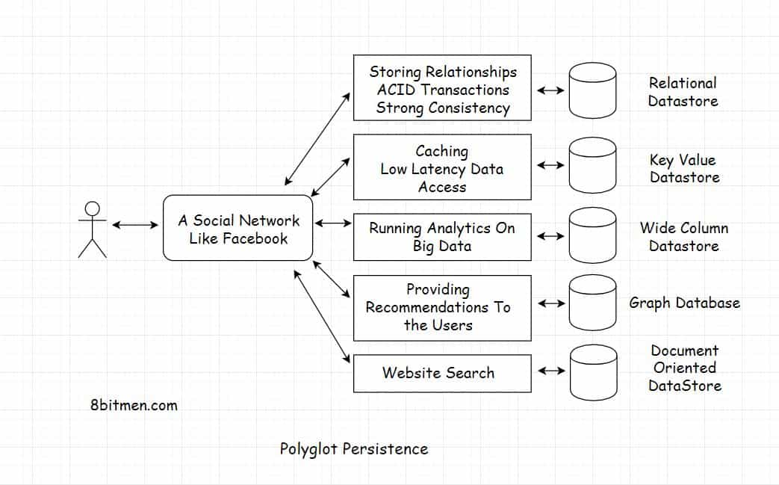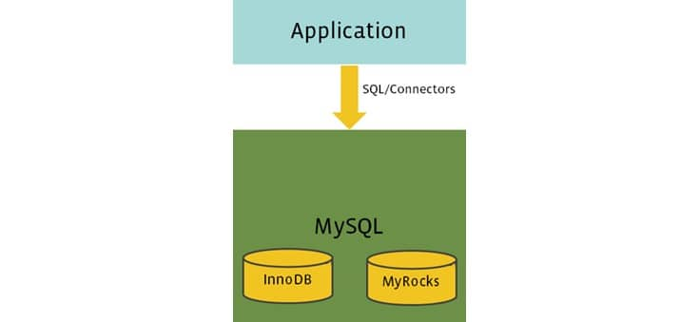

Facebook’s database is based on a polyglot persistence architecture, which means it uses several different loosely coupled components plugged in together like Lego blocks.  
For instance, photo sharing, messenger, social graph, user post, etc. are all different loosely coupled microservices running in conjunction with each other. And every microservice has a separate persistence layer to keep things easy to manage.

Some examples of different databases and it’s variations Facebook uses include:

* MySQL
  + InnoDB
  + MyRocks
* WebScale SQL
* RocksDB
* Memcache
* Apache Hadoop
* Apache Cassandra
* Apache Hive
* Presto DB
* Beringei
* Gorilla
* LogDevice

## 

## Page layout

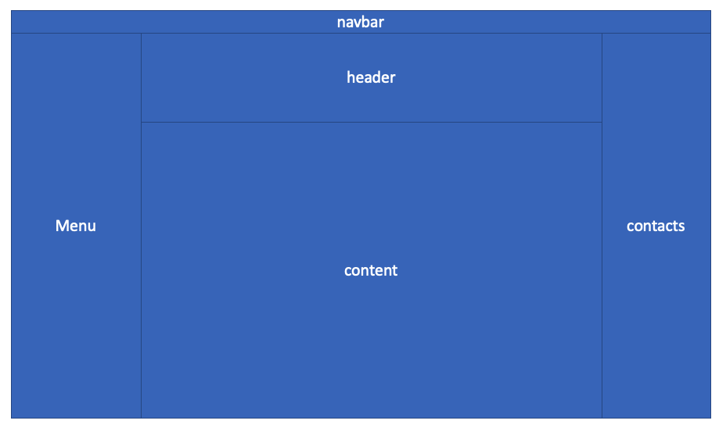

Facebook page layout is well distributed keeping the most important information always accessible and consistent across all the pages.

## 

## Page flow

## 

The page flow is pretty simple as the most important information is kept accessible across all pages.