ICTWEB513 - Q2.3

# Table of contents

# 

**Table of contents** **2**

**Executive summary** **3**

**Screenshots** **4**

Design intent A 4

Design intent B 5

**Feedbacks** **6**

**Conclusions** **7**

# 

# Executive summary

This document will provide a report on A/B testing upon the Lord of the Rings website interface.

# Screenshots

## Design intent A

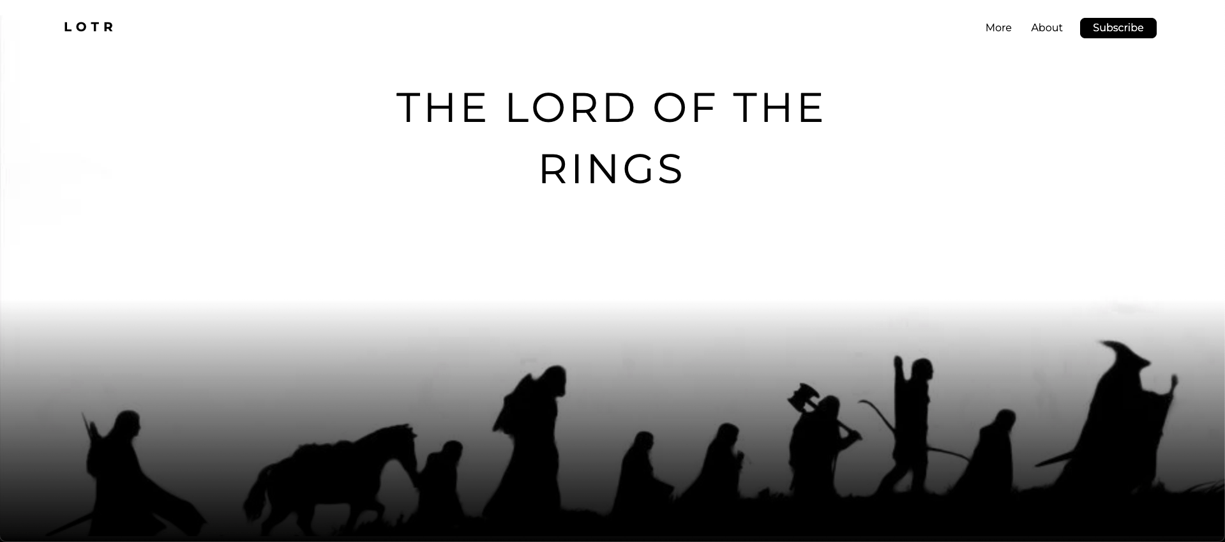

## Design intent B

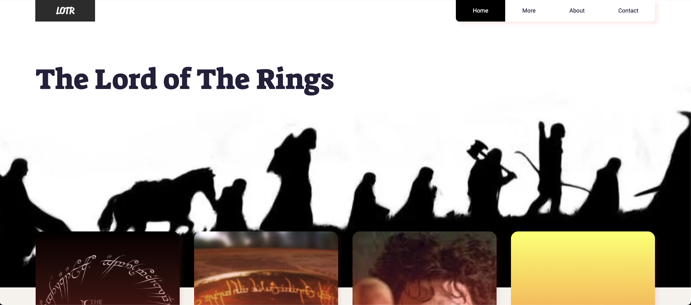

# Feedbacks

1. “I prefer the design intent A because it is cleaner and more pleasing to the eye. The design intent B seems more content-oriented, though.”
2. “The design intent B is a bit fuzzy and the boxes on the below area are too contrasting to the main visual area.”
3. “What a nice view of the protagonists we can see on the design intent A! Well done!”

# Conclusions

From the feedback submitted, I believe design intent A is the best option due to its visual properties being cleaner and more pleasing to the eye. At first sight, people who are searching for cinematographic content generally looks for a more beautiful and fluid experience on websites.

The design intent B is more content-oriented and could be used for a secondary page though, with a few design tweaks.