ICTWEB513 - Q3.2

# Table of contents

# 

**Table of contents** **2**

**Executive summary** **3**

**Page Layouts** **4**

**Mapping ideas** **7**

Mapping ideas for home: 7

Mapping ideas for Equipments: 8

Mapping ideas for About: 9

# 

# Executive summary

This document will provide screenshots showing current ideas on page layout and data flow for navigation and use proposed for the website.

# 

# Page Layouts

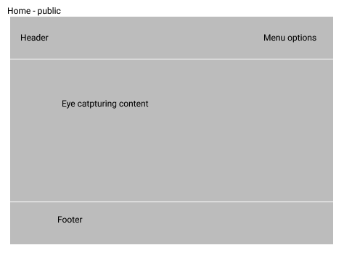

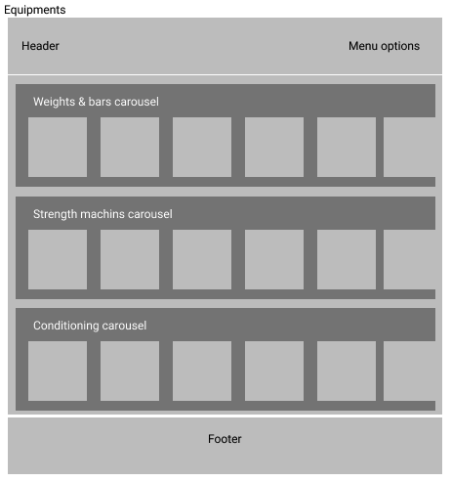

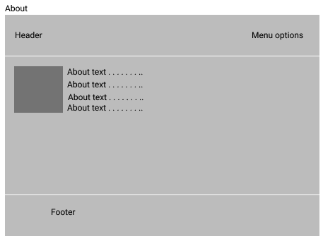

# Mapping ideas

## Mapping ideas for home:

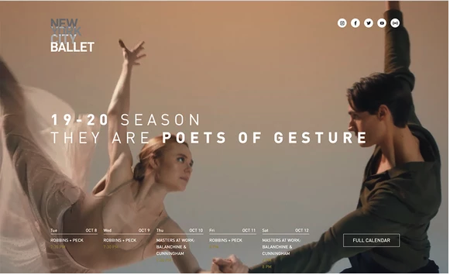

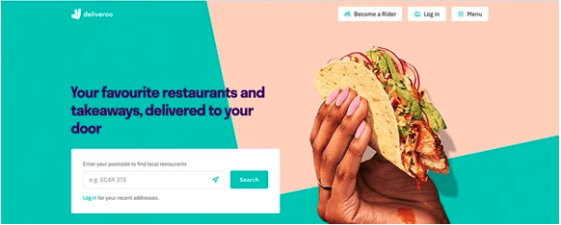



## Mapping ideas for Equipments:

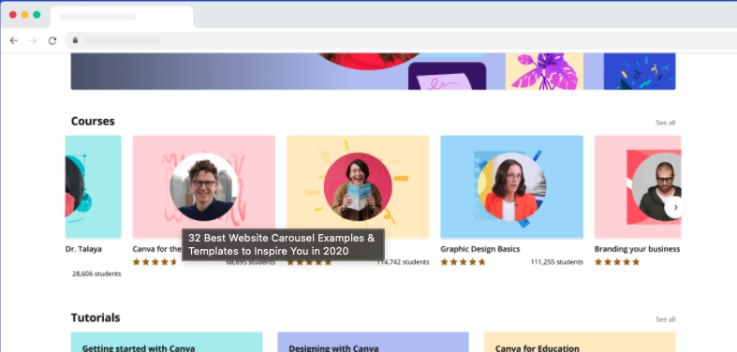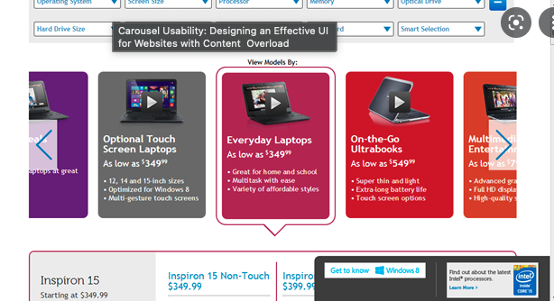

## Mapping ideas for About:

