ICTWEB513 - Q3.5

# Table of contents

# 

**Table of contents** **2**

**Design information** **3**

ERD 3

Example data: 4

# 

# Design information

## ERD

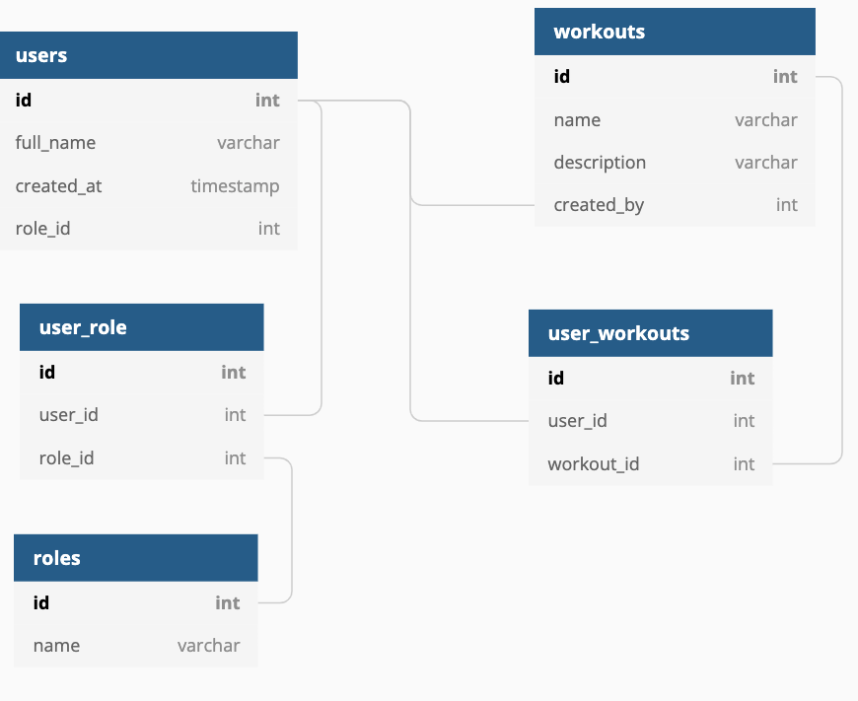

users - the main user data table

User_role - associate users to roles in a many to many relation

Roles - the main roles table

Workouts - the main workout table

User_workouts - associate users to workout and could also be used as bookings by adding a few more info like date of booking for instance.

## Example data:

| **users** |  |  |  |
| --- | --- | --- | --- |
| **id** | **full_name** | **created_at** | **role_id** |
| 1 | user 1 | 1/1/1900 | 1 |
| 2 | user 2 | 1/1/1900 | 2 |
|  |  |  |  |
| **user_role** |  |  |  |
| **id** | **user_id** | **role_id** |  |
| 1 | 1 | 1 |  |
| 2 | 2 | 2 |  |
|  |  |  |  |
| **roles** |  |  |  |
| **id** | **name** |  |  |
| 1 | Staff |  |  |
| 2 | Client |  |  |
|  |  |  |  |
| **workouts** |  |  |  |
| **id** | **name** | **description** | **created_by** |
| 1 | workout 1 | do 20 reps… | 1 |
|  |  |  |  |
| **user_workouts** |  |  |  |
| **id** | **user_id** | **workout_id** |  |
| 1 | 2 | 1 |  |