ICTWEB513 - Q5.3

# Table of contents

# 

**Table of contents** **2**

Summary of tests **3**

Edge 3

Chrome 4

Brave 5

Firefox 6

Safari 7

Mobile devices (Emulation is valid) 8

iPhone 8

Galaxy 20 9

Galaxy Fold 10

Surface Duo 11

iPad 12

Kindle 13

# 

# Summary of tests

The website worked and displayed content on all browsers.

The main issue is regarding the responsiveness and adaptability, which can be solved with css tweaks.

## Edge

## 

## Chrome

## 

## 

## Brave

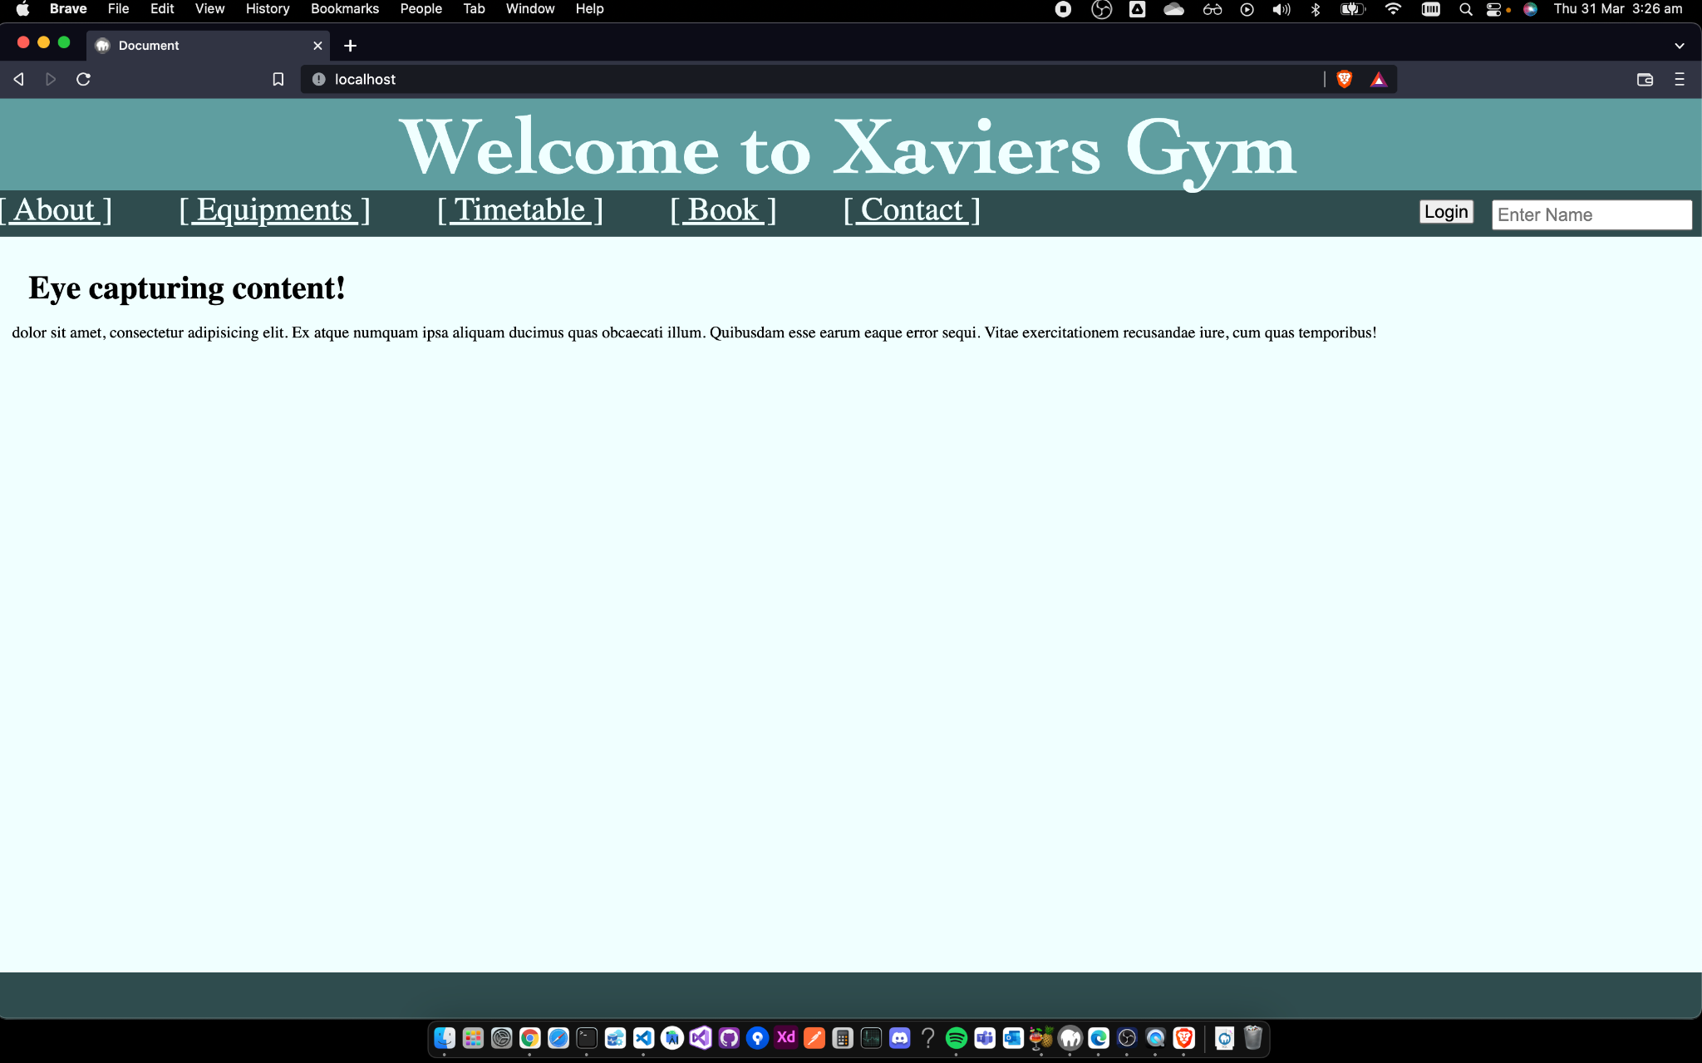

## 

## Firefox

## 

## Safari

## 

## Mobile devices (Emulation is valid)

### iPhone

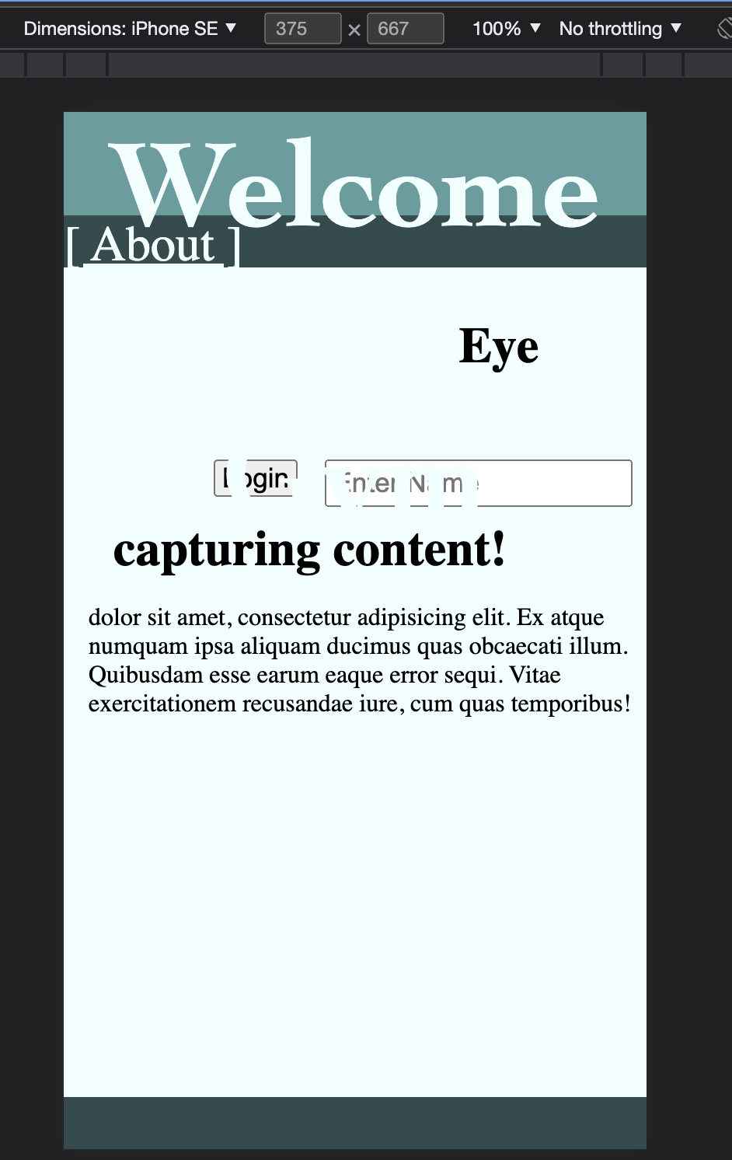

### 

### Galaxy 20



### 

### 

### Galaxy Fold

### 

### Surface Duo



### 

### iPad



### 

### Kindle



# 