ICTWEB513 - Q5.4

# Table of contents

# 

**Table of contents** **2**

Feedbacks **3**

Visual 3

Before: 3

After: 5

Functional 8

Before: 8

After: 9

# 

# Feedbacks

## Visual

1. There are no images on the home page of the website, it’s boring!
2. The visual aspect of the website could receive a bit of love, don’t you think?

### Before:

No images/no visual framework:

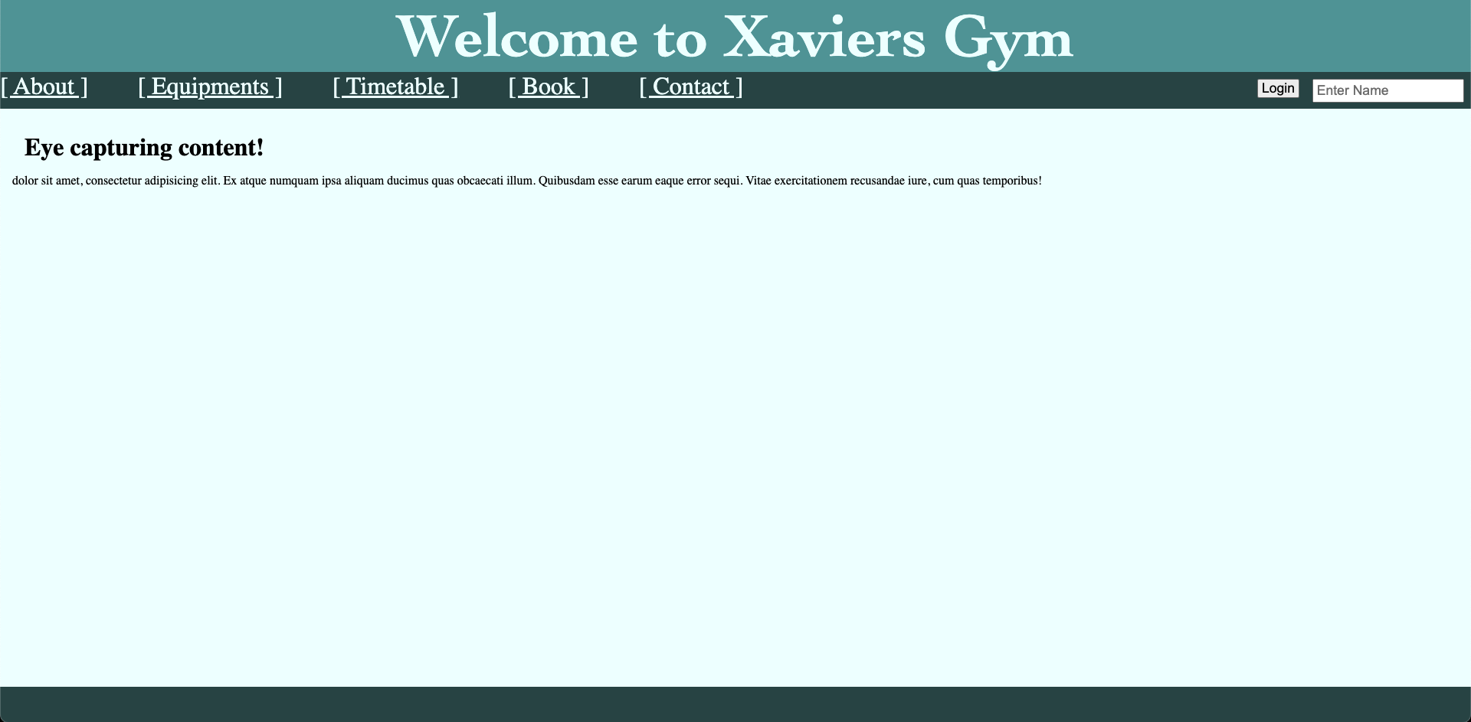

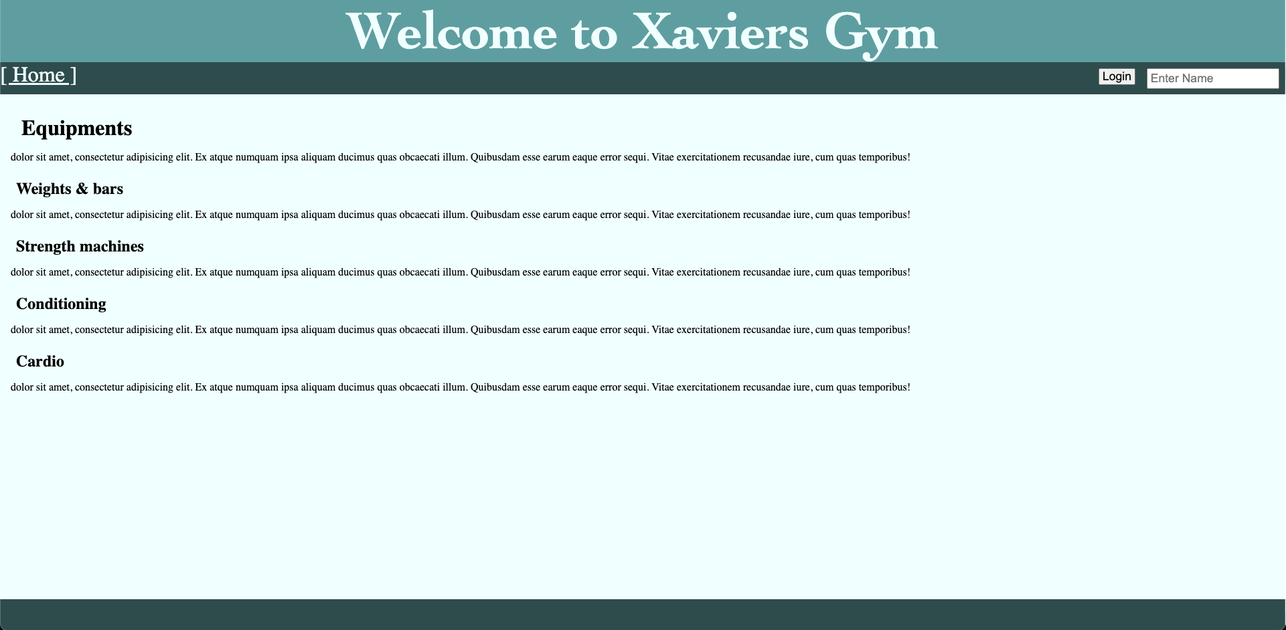

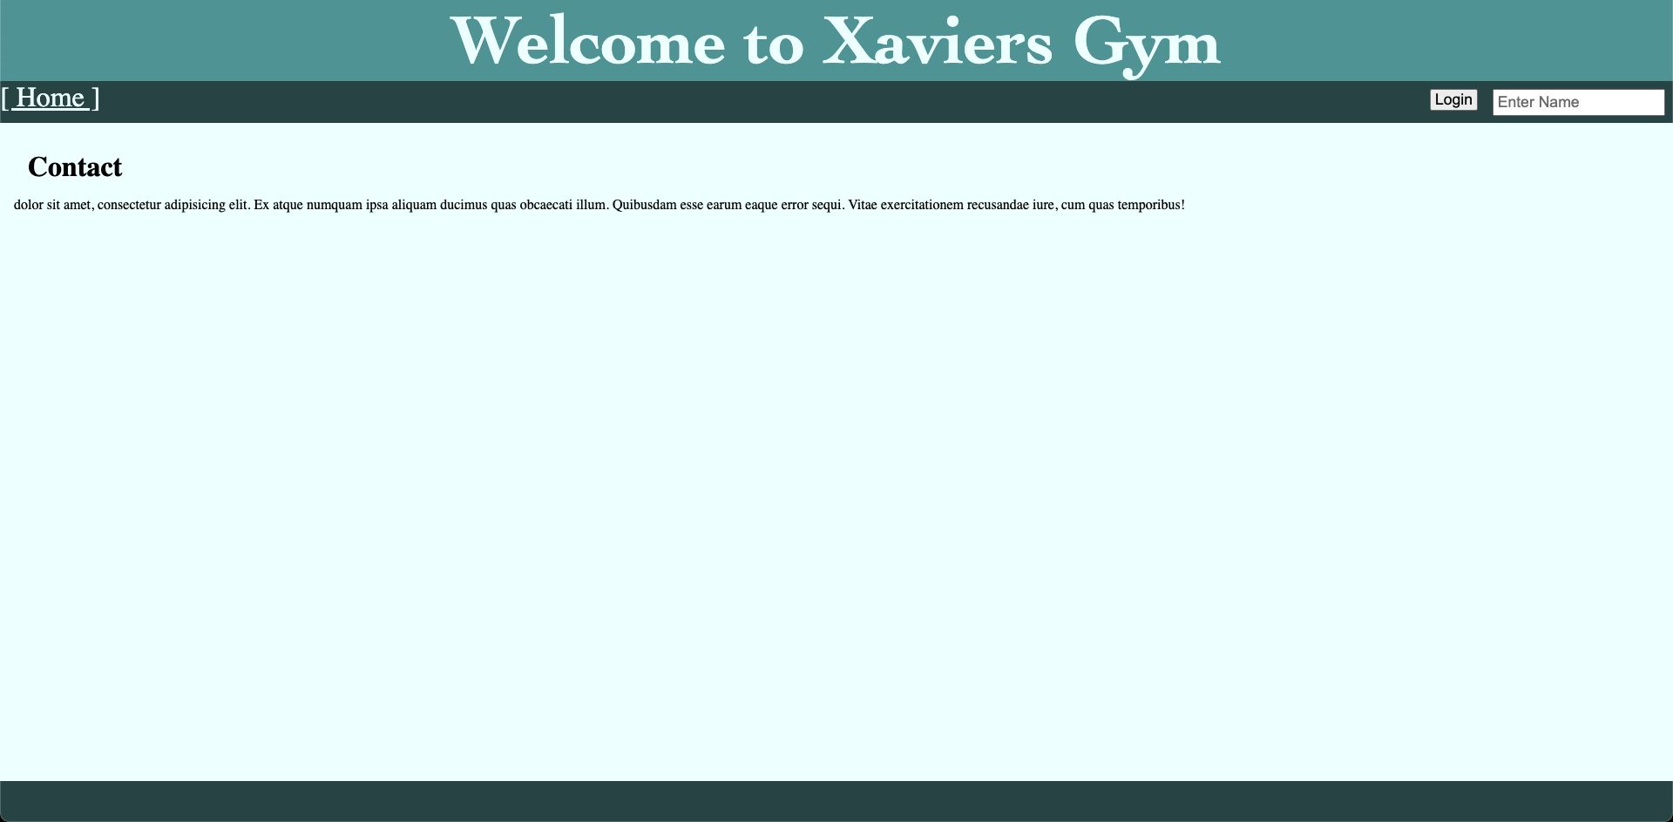

### 

### After:

Included images on index.php, equipments.php, contact.php

Applied bootstrap as framework

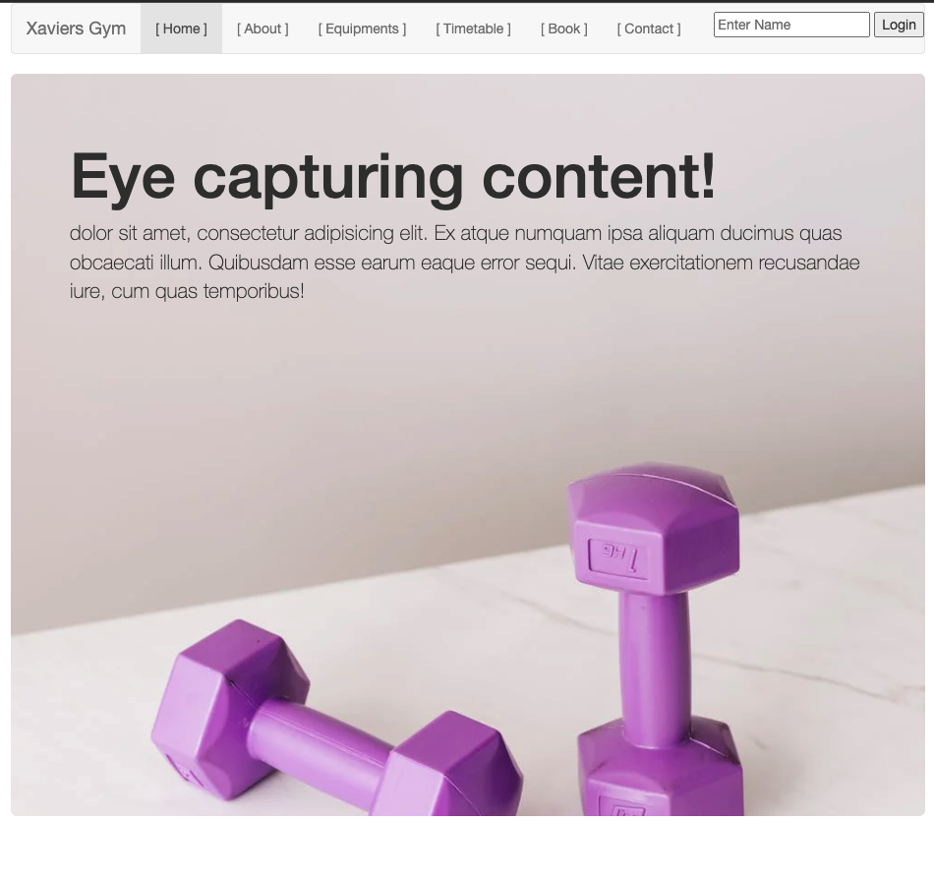

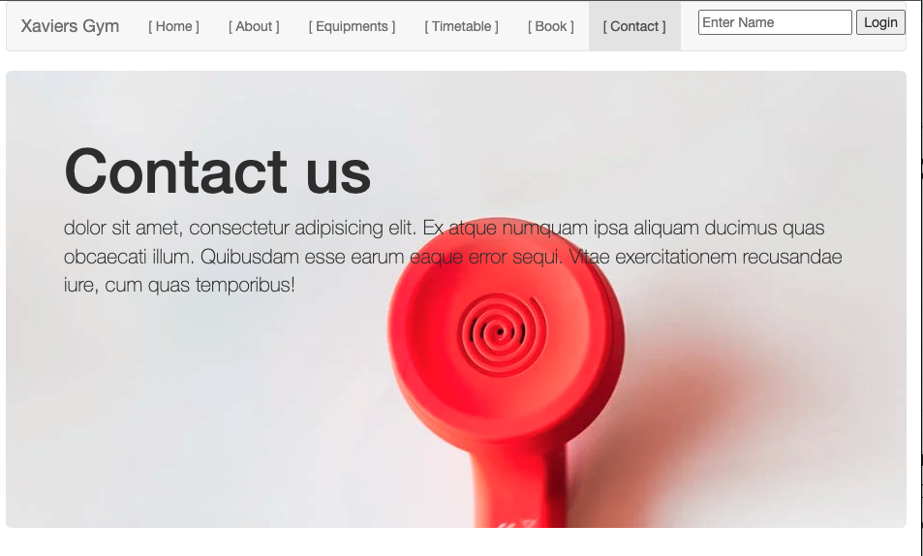

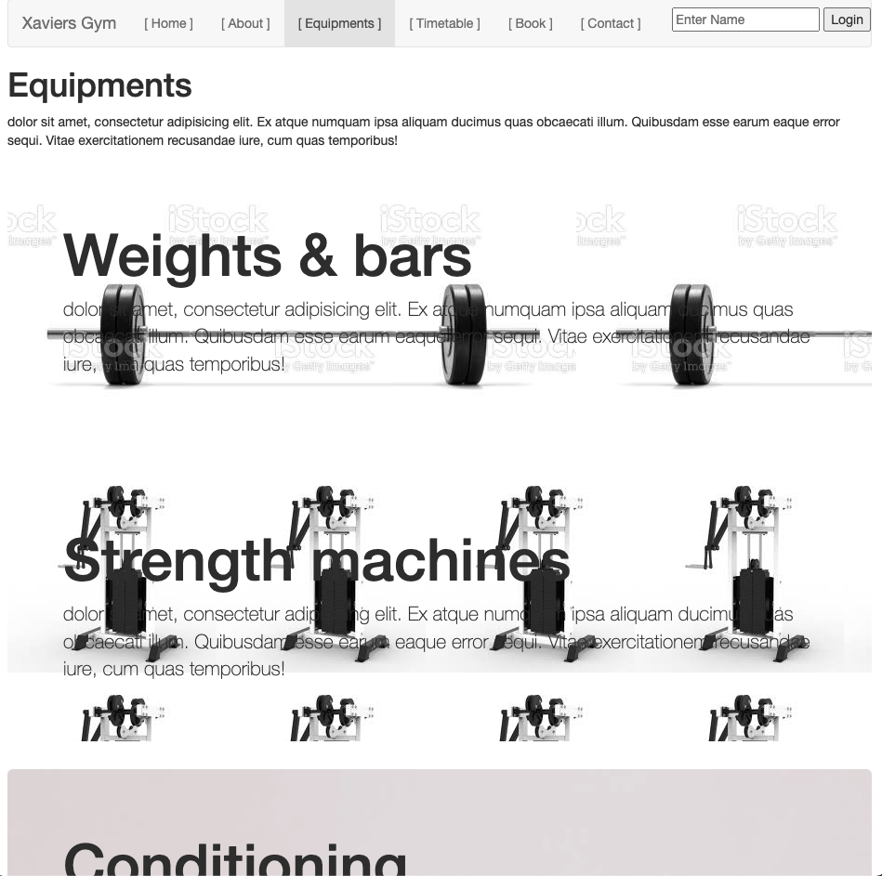

## Functional

* + There’s no option to delete anything!

### Before:

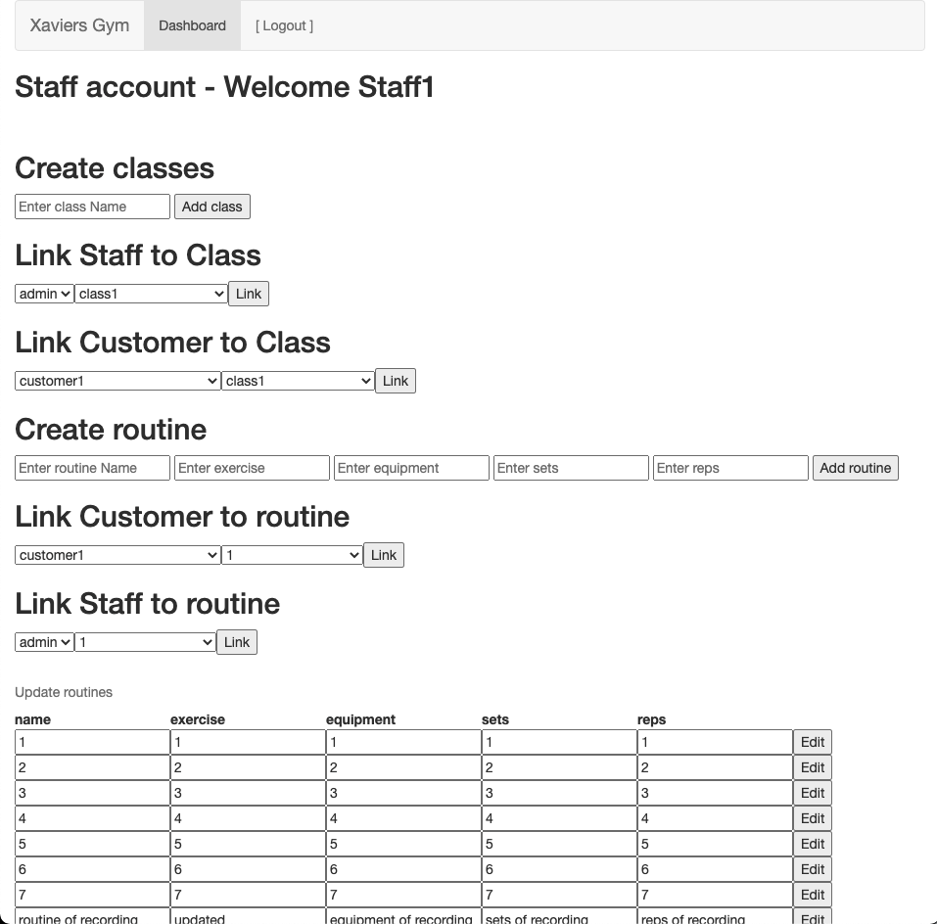

### After:

Implemented delete function for routines:

