ICTWEB513 - Q5.5

Table of contents

Executive summary **4**

**Visual Style Guide** **5**

Colour palette 5

Typography 5

**Client Requirements** **5**

**Requirements checklist** **5**

Eye capturing home page 5

About 5

Equipment section 5

Timetable 5

Various Gym classes 5

Personal training 5

Login for clients 5

Login for staff 5

Contact 5

**Diagrams** **6**

**Page Layouts** **6**

**Mapping ideas** **9**

Mapping ideas for home: 9

Mapping ideas for Equipments: 10

Mapping ideas for About: 11

**Hierarchy tree & Mock-up navigation** **12**

**Potential issues/risks** **13**

**Authentication** **13**

**Authorisation** **13**

**Availability** **13**

**Confidentiality** **13**

**Integrity** **13**

**Technology being used** **14**

**Conclusion** **15**

Final outcome(screenshots) 15

Home 15

About 15

Equipments 16

Timetable 16

Book 17

Contact 17

Staff dashboard 18

Customer dashboard 18

Admin dashboard 19

**Appendices** **20**

ERD 20

Example data: 21

# 

# Executive summary

This document's goal is to present a description of the process of creating, designing and implementing the gym website.

# Visual Style Guide

## Colour palette

The website utilises bootstrap default colour palette that can be found here:

<https://getbootstrap.com/docs/5.0/customize/color/>

## Typography

The website utilises bootstrap default typography that can be found here:

<https://getbootstrap.com/docs/4.0/content/typography/>

# Client Requirements

## Requirements checklist

### Eye capturing home page

### About

### Equipment section

* 1. Weights & bars
  2. Strength machines – Benches, bars, racks
  3. Conditioning- body weight, conditioning
  4. Cardio – Exercise bikes, treadmills, elliptical cross trainers, rowing machines, ski trainers

### Timetable

### Various Gym classes

### Personal training

* 1. Booking sheet for trainers

### Login for clients

* 1. View personalised routines
  2. View scheduled classes

### Login for staff

* 1. Links to clients
  2. Design and create workouts
  3. Link to classes

### Contact

# Diagrams

## Page Layouts

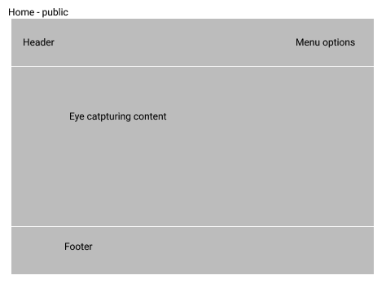

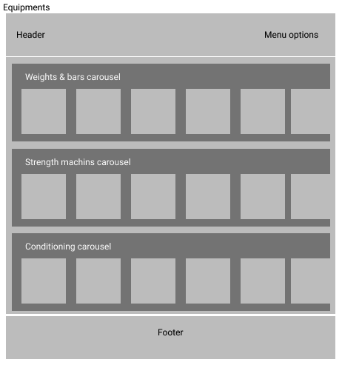

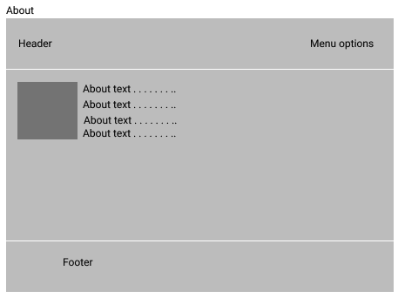

## Mapping ideas

### Mapping ideas for home:

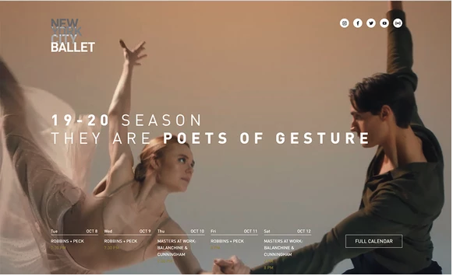

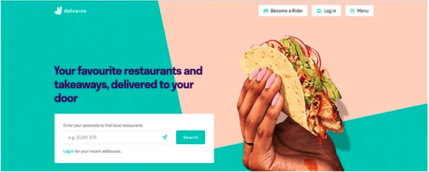

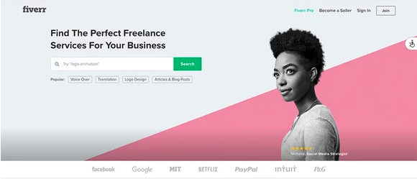

### Mapping ideas for Equipments:

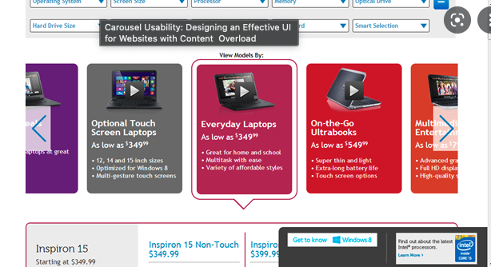

### Mapping ideas for About:

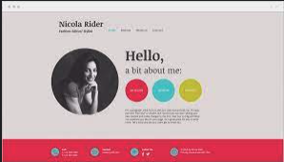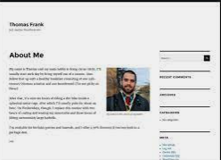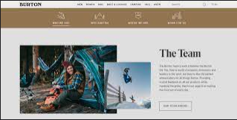

# Hierarchy tree & Mock-up navigation

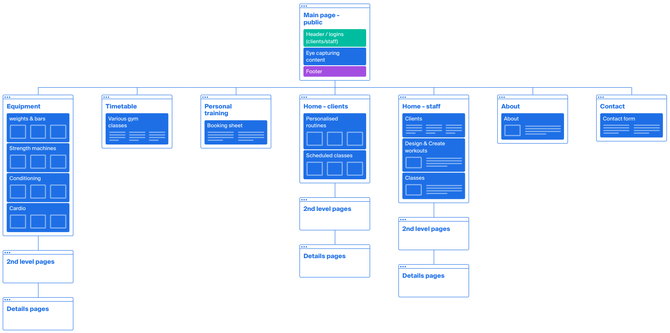

# Potential issues/risks

## Authentication

The website relies only on names being entered; the method used is extremely unsecure. At the very least, we can implement a password system to increase the security of the site.

## Authorisation

After the user is authenticated and logged in, we store the data into the session and only after this, the user can see the private sections or pages of the site. Once the user logs out or the session is cleared, there’s no more access to those areas. We have 3 different authorisation roles: admin, staff, and customer which have different dashboards according to your role.

## Availability

As a local system, it is available until the time the MAMP server is up and running, however,

it is not a concern for now.

Moreover, nowadays, high availability is easily achievable by using cloud computing services to host the system.

## Confidentiality

All the data is stored as plain text/numbers, but there’s no confidential information except for names maybe.

## Integrity

There are no integrity validations, sanitizations and consistency checks. Not even at the database level, we didn’t implement relational integrity, fields types, etc, which could add a bit of consistency to the data.

# Technology being used

The website utilises the most common technologies found on worldwide websites such as HTML, CSS, Javascript, PHP and MySQL.

# Conclusion

## Final outcome(screenshots)

### Home

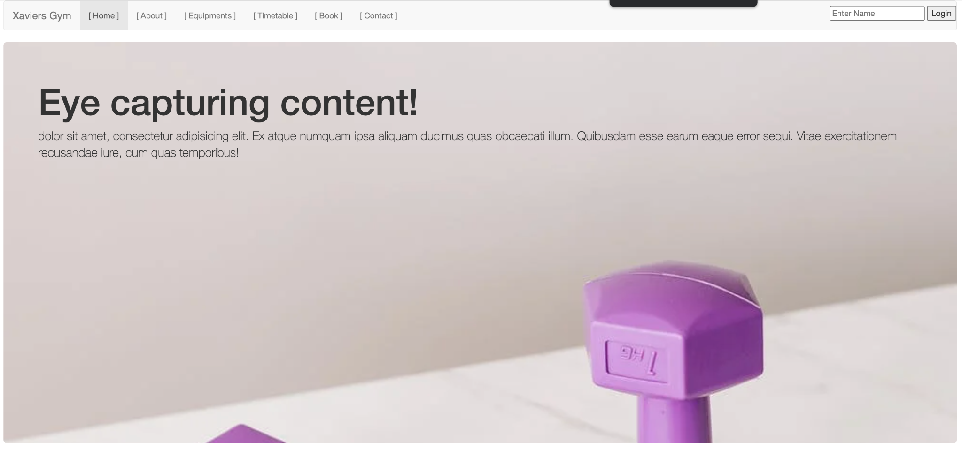

### About

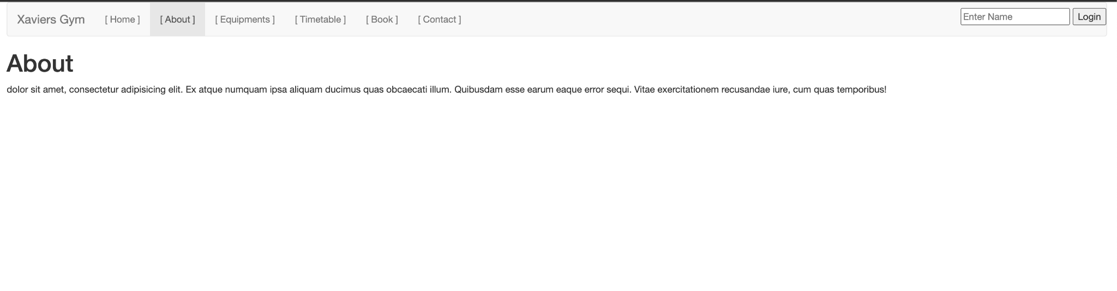

### Equipments

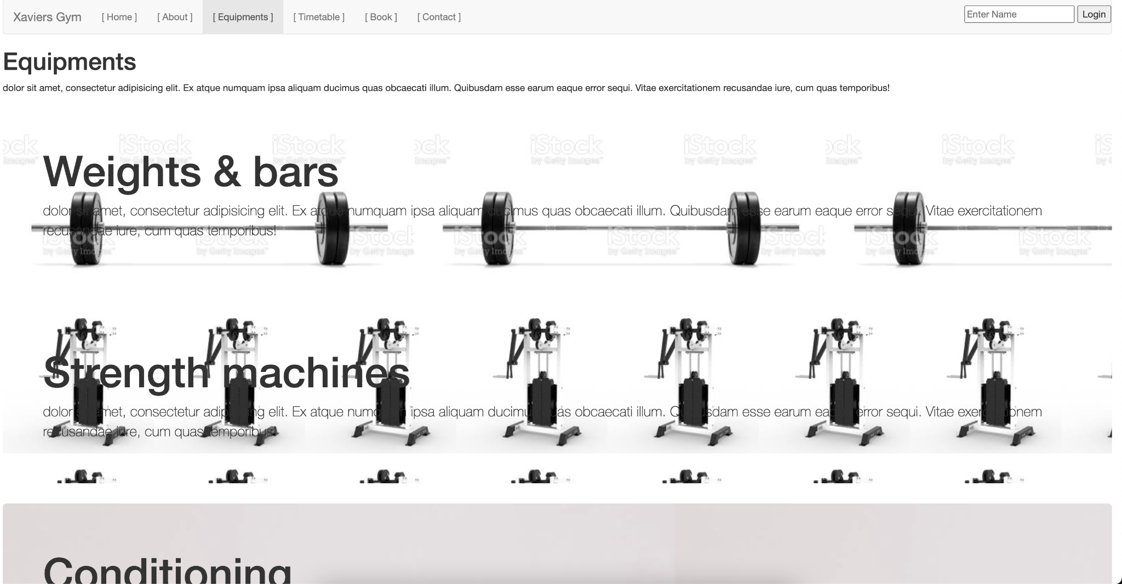

### Timetable

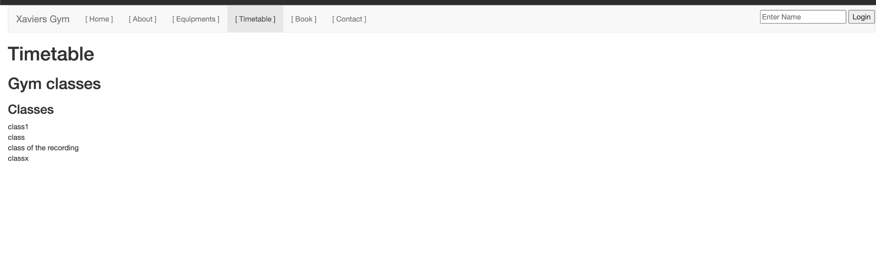

### Book

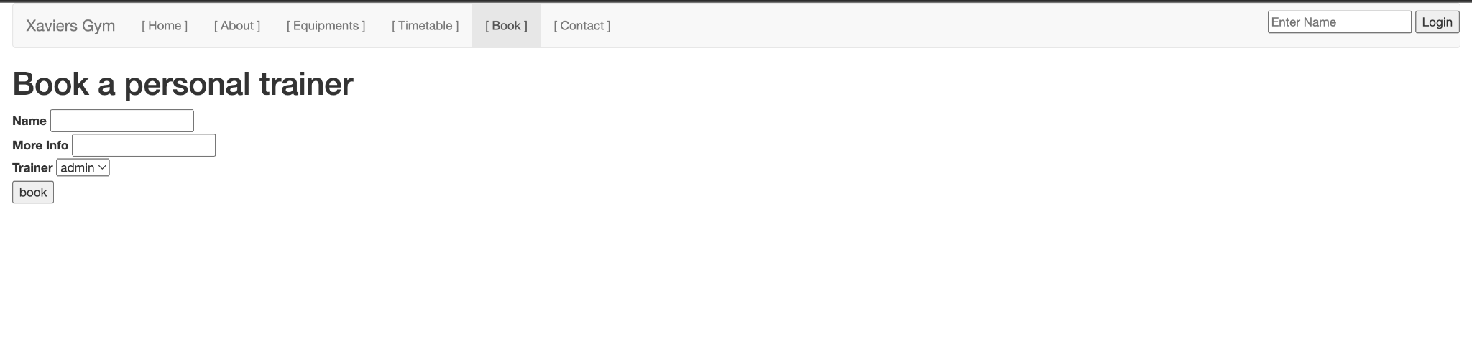

### Contact

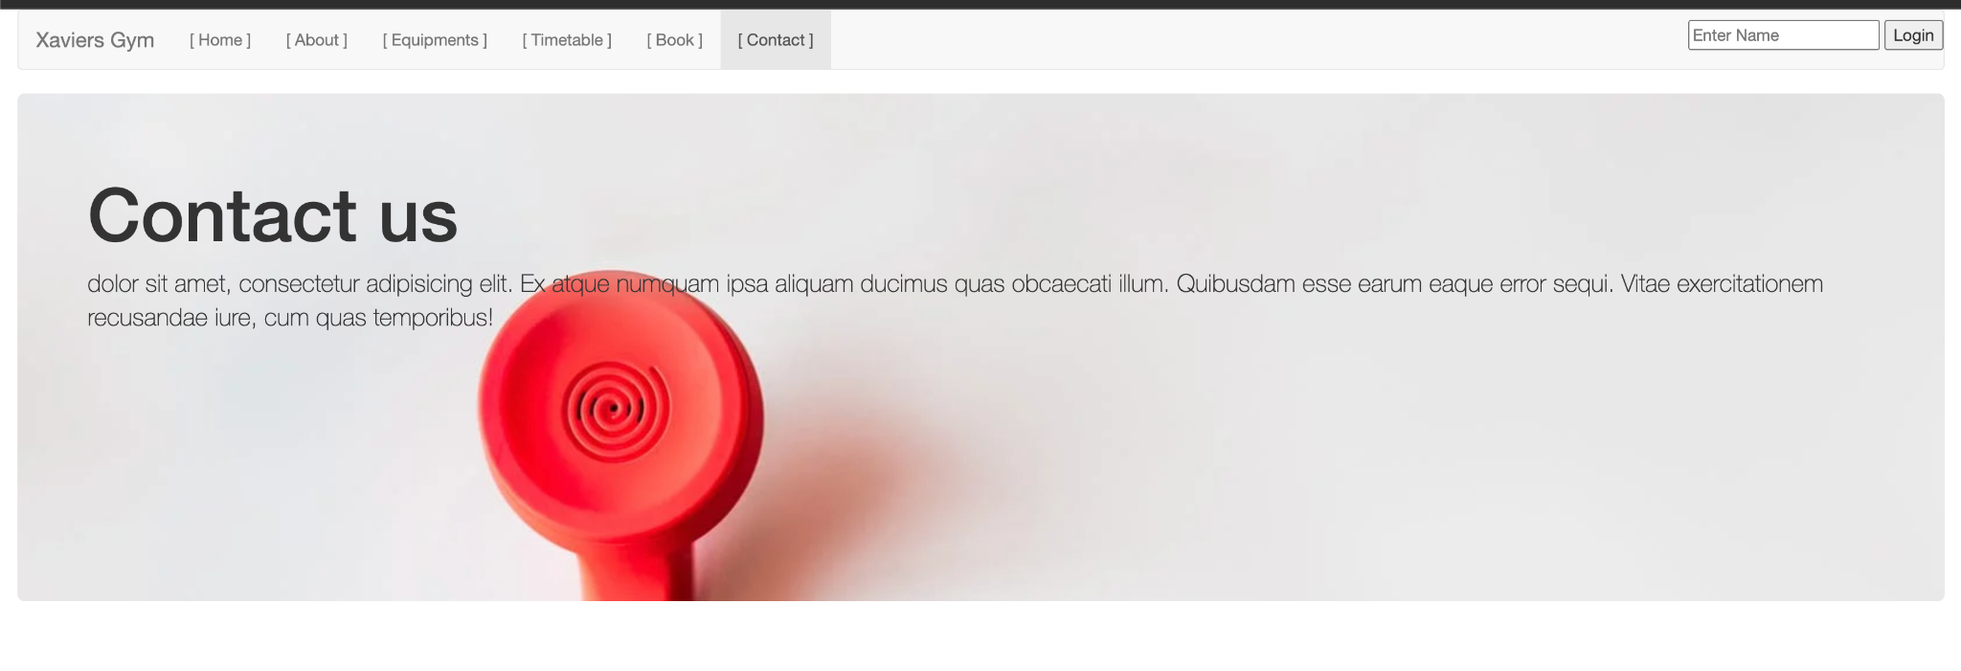

### Staff dashboard

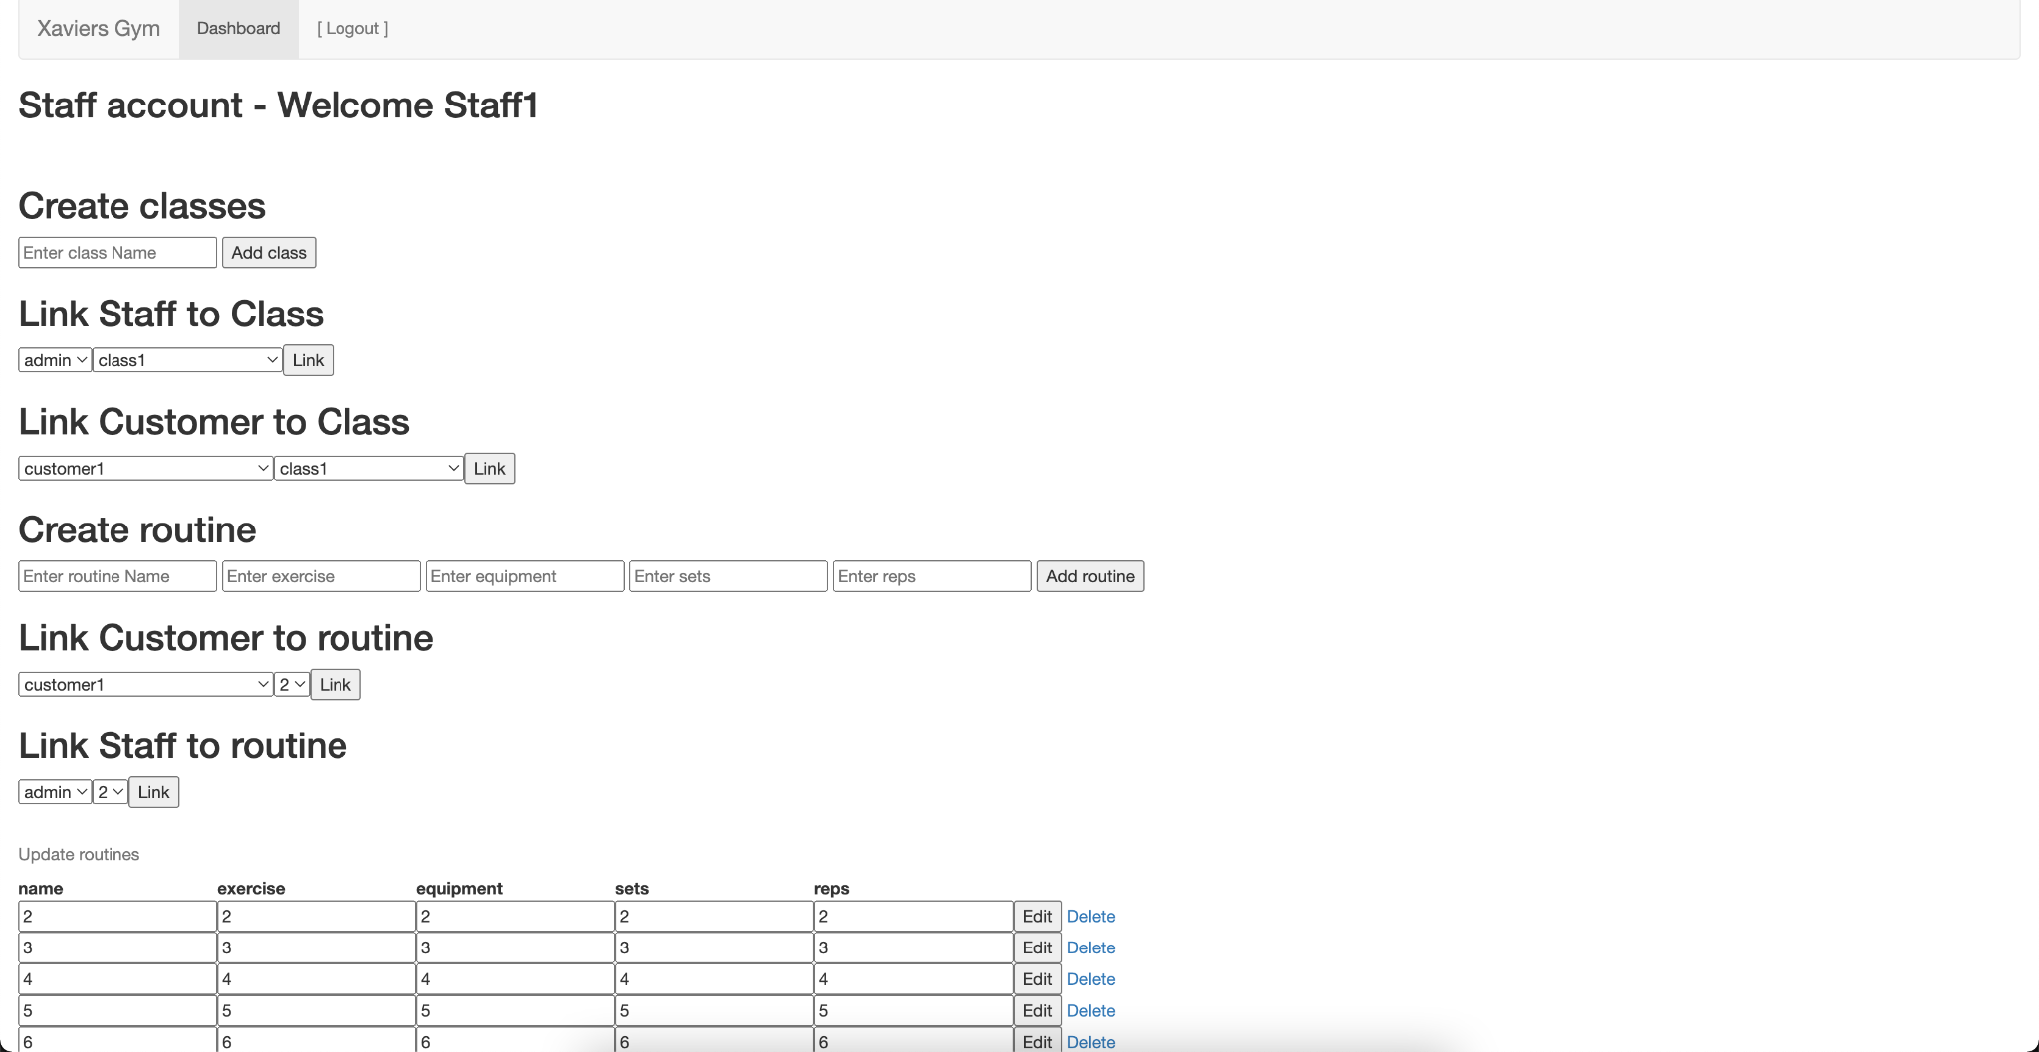

### Customer dashboard

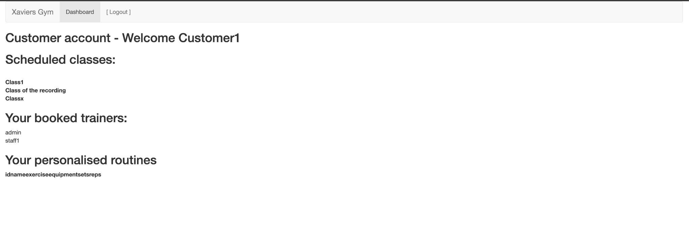

### Admin dashboard

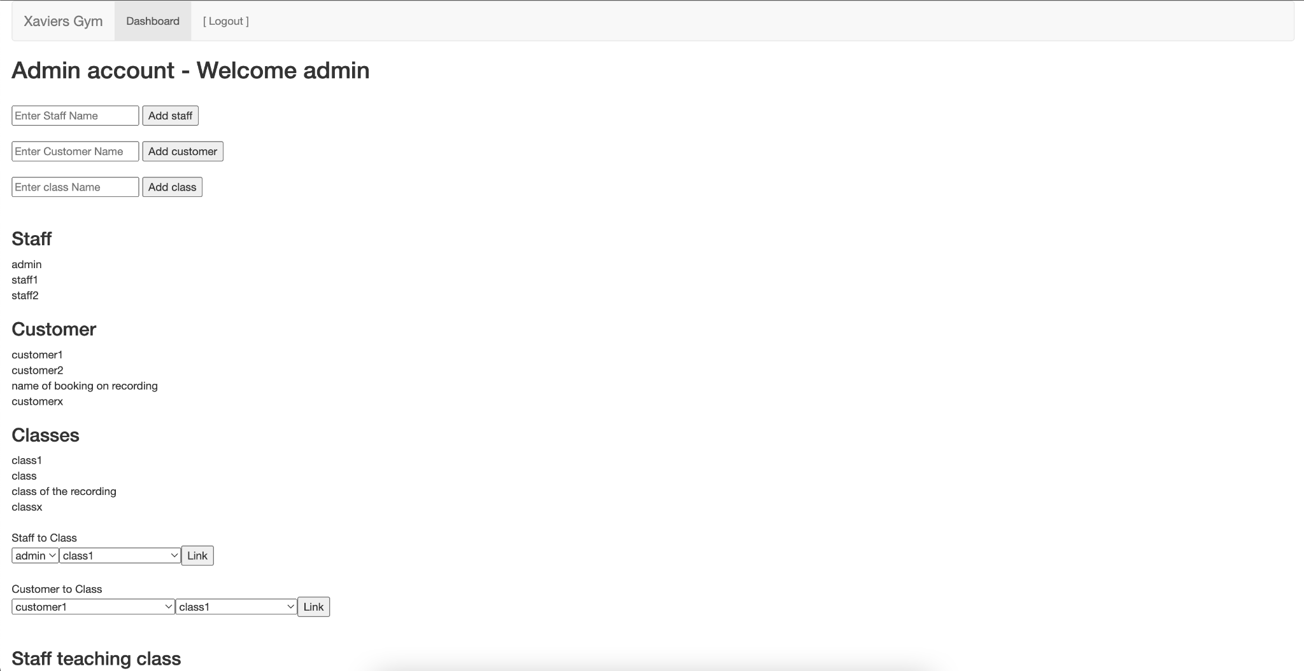

## 

# Appendices

## ERD

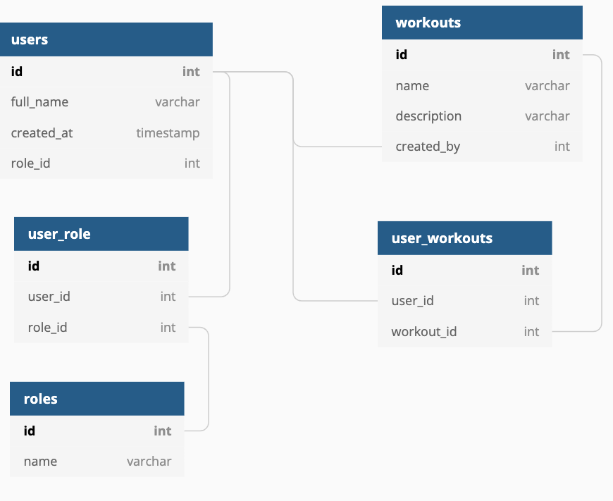

users - the main user data table

User_role - associate users to roles in a many to many relation

Roles - the main roles table

Workouts - the main workout table

User_workouts - associate users to workout and could also be used as bookings by adding a few more info like date of booking for instance.

## Example data:

| **users** |  |  |  |
| --- | --- | --- | --- |
| **id** | **full_name** | **created_at** | **role_id** |
| 1 | user 1 | 1/1/1900 | 1 |
| 2 | user 2 | 1/1/1900 | 2 |
|  |  |  |  |
| **user_role** |  |  |  |
| **id** | **user_id** | **role_id** |  |
| 1 | 1 | 1 |  |
| 2 | 2 | 2 |  |
|  |  |  |  |
| **roles** |  |  |  |
| **id** | **name** |  |  |
| 1 | Staff |  |  |
| 2 | Client |  |  |
|  |  |  |  |
| **workouts** |  |  |  |
| **id** | **name** | **description** | **created_by** |
| 1 | workout 1 | do 20 reps… | 1 |
|  |  |  |  |
| **user_workouts** |  |  |  |
| **id** | **user_id** | **workout_id** |  |
| 1 | 2 | 1 |  |

* lib
  + - app
  + - pages
  + - login
  + - login_page.dart
  + - widgets
  + - domain