## Variable Composition of Microbial Biomass Affects the Accuracy of Microbial Explicit Models Simulation

1Petr Capek*, 1Katherine Todd-Brown, 1Natalie Sadler, 1Nancy Hess, 1Kirsten Hofmockel

*1Pacific Northwest National Laboratory, Environmental Molecular Sciences Laboratory, Richland, WA USA*

* Corresponding author: [petr.capek@pnnl.gov](mailto:petr.capek@pnnl.gov)

Running headline:

Explaining Variable Composition of Microbial Biomass

Key words:

Microbial biomass, Biomass composition, Microbial-Explicit Models, Soil

## Summary

* Microbial-explicit biogeochemical models become rapidly developing area of soil and earth science. At their current state, they are sometimes criticized for ignoring important controlling factors of element cycling such as diffusion rate of organic substrate in structured soil environment, substrate quality or microbial community composition.
* These models depend on the data soil science can provide. There exist inherent methodological limitations associated with quantification of soil microbial biomass, which cannot be measured directly but only indirectly as various proxy parameters converted to biomass using ad-hoc conversion factors.
* Our results show that microbial-explicit models cannot accurately simulate the dynamic of microbial biomass measured as two different proxy parameters - DNA and cellular proteins, in short-term incubation experiment. The reason is the temporal variability of composition of microbial biomass in respect to both proxy parameters.
* When the variable biomass composition is explicitly accounted for in the microbial-explicit model structure, 75 and 30% of variability in temporal dynamic of DNA and cellular proteins can be explained respectively.
* Our results further suggest significant effect of physical structure of the environment on several model parameters.
* We recommend to integrate variable biomass composition into the microbial-explicit models to effectively harmonize experimental, methodological and modelling efforts.

## Introduction

In recent years, abrupt development of soil biogeochemical models has occurred. Abstract models dominated by cohorts of organic carbon ($C_{S}$) pools with inherently different decay rates (e.g. Friedlingstein et al., 2006; Heinemeyer et al., 2010; Lawrence et al., 2011; Parton, Stewart, & Cole, 1988) have become replaced by microbial explicit models (Huang et al., 2018; Schimel & Weintraub, 2003; G. Wang, Post, & Mayes, 2013; W. R. Wieder, Grandy, Kallenbach, & Bonan, 2014; W. R. Wieder, Grandy, Kallenbach, Taylor, & Bonan, 2015; William R. Wieder et al., 2015). On one hand, several studies showed the superior simulation accuracy of microbial explicit models over classical cohort models (Hararuk, Smith, & Luo, 2015; He et al., 2014; Huang et al., 2018; William R. Wieder, Bonan, & Allison, 2013). On the other hand, other studies showed the tendency of these models to unrealistic temporal oscillations of $C_{S}$ and microbial biomass ($C_{MB}$) caused by small perturbations suggesting that the coupled dynamic of $C_{S}$ and $C_{MB}$ (expressed per unit of organic carbon basis) in soil is not completely understood (Li, Wang, Allison, Mayes, & Luo, 2014; Sihi, Gerber, Inglett, & Inglett, 2016; Y. P. Wang et al., 2014).

Microbial-explicit models use the knowledge of general microbiology and apply it to soil system. Unlike the well mixed liquid batch or continuous culture the general microbiology works with, soil system is complex in respect to physical structure, composition of organic substrate and composition of microbial community consuming the substrate. All these factors have been suggested to considerably affect the coupled $C_{S}$ and $C_{MB}$ dynamic in soil (Allison, Chacon, & German, 2014; Allison, Lu, Kent, & Martiny, 2014; Don, Rodenbeck, & Gleixner, 2013; Kaiser, Franklin, Richter, & Dieckmann, 2015; la Cecilia, Riley, & Maggi, 2018; Vogel et al., 2015; Xu et al., 2014) but have not been fully considered in microbial-explicit soil biogeochemical models yet. Physical structure controls the diffusion of $C_{S}$ and extracellular enzymes towards and/or from $C_{MB}$ (Allison, Lu, et al., 2014; Don et al., 2013; M Gharasoo, Centler, Fetzer, & Thullner, 2014; He et al., 2014; Manzoni, Schaeffer, Katul, Porporato, & Schimel, 2014). In mineral soils with low $C_{S}$ and $C_{MB}$ concentrations, the diffusion limits can lead to physical separation of $C_{S}$ and $C_{MB}$ increasing $C_{S}$ turnover time dramatically (Ekschmitt et al., 2008; Schmidt et al., 2011). In contrast to mineral soils, organic substrate composition has been suggested to be a primary control of the turnover time of plant litter and organic material in the top soil horizons (e.g. Berg & McClaugherty, 2014; Currie, 2003; Herman, Moorhead, & Berg, 2008; Schädel et al., 2014). For a long time, it has been considered as the most important factor and therefore all classical cohort models were based on this fact (e.g. Parton et al., 1988). Composition of microbial community is the least established but intensively studied factor regulating $C_{S}$ and $C_{MB}$ dynamic (Gittel et al., 2014; Kaiser et al., 2015; Schnecker et al., 2014). There are few individual-based microbial community models suggesting a great importance of microbial community composition for $C_{S}$ turnover or organic nitrogen mineralization (Allison, 2012; Kaiser et al., 2015). Accounting for all these covariates are supposed to improve the capability of microbial-explicit models to project future development of soil organic carbon stocks. Several manipulation experiments were recently designed and conducted to do so (Chen et al., 2018; Liu et al., 2018; Moyano, Vasilyeva, & Menichetti, 2018; Nunan, Leloup, Ruamps, Pouteau, & Chenu, 2017; Oldfield, Crowther, & Bradford, 2018).

One less obvious difference between the liquid batch/continuous cultures and soil is the feasibility of $C_{MB}$ quantification. In soil, $C_{MB}$ cannot be measured directly and quantitatively. Since microbial cells are impossible to detach from soil particles (Ehlers et al., 2008), the most frequently used high-throughput methods target on specific constituents of $C_{MB}$, typically chloroform labile microbial carbon (i.e. microbial protoplasm), DNA or phospholipid fatty acids (Frostegard & Baath, 1996; Vance, Brookes, & Jenkinson, 1987; Yokoyama et al., 2017), that can be extracted from soil quantitatively. $C_{MB}$ is then calculated using conversion factors (Frostegard & Baath, 1996; Håkan Marstorp, Guan, & Gong, 2000; Vance et al., 1987; Yokoyama et al., 2017). However, the abundance of these constituents in microbial cells varies across different microbial species (H. Christensen, Olsen, & Bakken, 1995; Henrik Christensen, Bakken, & Olsen, 1993; Hanegraaf & Muller, 2001) and changes with changing soil conditions (Dictor, Tessier, & Soulas, 1998; Dilly, 2004; H Marstorp & Witter, 1999; Ross & Täte, 1993; Schimel, Scott, & Killham, 1989; G. P. Sparling, Feltham, Reynolds, West, & Singleton, 1990). For example, Marstrop and Witter (1999) and Dilly (2004) showed that following a substrate addition, the temporal dynamic of DNA, ATP and chloroform labile microbial carbon is significantly different in respect of magnitude and timing of the change. The reciprocal ratios of these cellular constituents vary during the experiment by a factor of four. Yet, most of the studies do not reflect the variability of microbial composition and use one universal conversion factor to calculate $C_{MB}$ implicitely accepting the associated error. Thus, when the composition of microbial cells changes in designated manipulation experiment with time or as a result of experimental treatment, the effect of that treatment on coupled $C_{S}$ and $C_{MB}$ dynamic is confounded by the error associated with quantitative estimation of $C_{MB}$. The only method to avoid such a bias is to explicitely account for the variability of $C_{MB}$ composition in the model. Such a possibility offer a Dynamic Energy Budget theory originally developed by Kooijiman (2009) and successfully used by Hanegraaf and Muller (2001) and Hanegraaf, Stouthamer, & Kooijman (2000) to explain and model macromolecular and elemental composition of several pure microbial cultures along the gradient of organic substrate concentration and growth rate. The fundamental assumption of the theory is an existence of two different pools of $C_{MB}$, reserves ($R$) and Structures ($S$). These pools have different function in the organism and different dynamic. Their proportion changes making $C_{MB}$ composition flexible in respect to $R$ and $S$. The content of these pools can be defined in respect to cell constituents of interest. This allows to make $C_{MB}$ composition flexible in respect to these constituents too (Hanegraaf & Muller, 2001; Hanegraaf et al., 2000). The provided flexibility should be sufficient to explain the variability of single species molecular composition. However, it has to be expected that different microbial species have different molecular composition and that the microbial species abundance can change with changing soil conditions.

The aim of this study is to quantify the effect of physical structure and $C_{S}$ quality on the coupled dynamic of $C_{S}$ and $C_{MB}$ quantified as two different $C_{MB}$ constituents (i.e. Cellular proteins and DNA). To do so, we designed an experiment in which indigenous soil microbial community was incubated with two different substrates (i.e. glucose and cellobiose) and with or without the presence of two types of physical barrier differing in texture (i.e. glass beads and glass wool). We expect that the presence of physical barrier would decrease the rate of $C_{S}$ uptake by microbial community.

## Material and Methods

### Experimental design

Soil microbial culture (see later) was incubated in liquid batch microcosms at 24°C in the dark for five days under six different experimental treatments. These treatments included two different organic substrates as a sole source of organic carbon for microbial culture and three different levels of microcosm structural complexity. The treatments were arranged in full factorial design. The two organic substrates were glucose and cellobiose. The three levels of structural complexity of the system were represented by 30 ml serum bottles with liquid medium (denoted as **"BROTH"** further in the text), with liquid medium and mixture of 2.7, 0.1 and 0.1 mm glass beads (5 g of 2.7 mm Biospec glass beads, 2 g of 1.0 mm Biospec glass beads and 1 g of 0.1 mm Next-Advanced glass beads; denoted as **"GLASS"** further in the text) and with liquid medium and glass wool (0.2 g of Pyrex fiber glass wool cut to ~0.25 cm pieces; denoted as **"WOOL"** further in the text). A total of 12 replicates were prepared for each condition so that four replicates could be harvested at three time points; 24, 48, and 120 hr.

### Indigenous soil microbial culture

Soil collected from a fertilized prairie plot at the Comparison of Biofuel Systems research site at Iowa State University’s South Reynoldson Farm (Boone County, Iowa) was used to prepare a soil derived microbial inoculum for the microcosm time course experiment. Modified M9 Media was used for soil culturing and was prepared by mixing 300 ml of M9 Minimal Media 10X stock solution (59.623 g anhydrous $NaH_{2}PO_{4}$, 29.938 g $KH_{2}PO_{4}$, 4.967 g NaCl, 10.003 g $NH_{4}Cl$, 1.204 g anhydrous $MgSO_{4}$ and 0.140 g $CaCl_{2}⋅2H_{2}0$ in 1 l of ultra pure water), 10 ml of Hutner's Trace Element Solution (10 g $C_{6}H_{9}NO_{6}$, 7.3 g KOH, 14.45 g $MgSO_{4}$, 3.335 g $CaCl_{2}⋅2H_{2}0$, 0.00925 g $(NH_{4})_{6}Mo_{7}O_{24}⋅4H_{2}0$, 0.099 g $FeSO_{4}⋅7H_{2}0$ and 50 mL of Hutner's Stock Salt Solution in 1 l of ultra pure water), 1 ml of Biotin (1 g $l^{-1}$), 1 ml of Thiamin (1 g $l^{-1}$) and ultra pure water to 1 l. Twenty replicates were prepared as follows: one gram of air-dried aggregates (>2 mM) were submerged in 10 mL of sterile modified M9 media and 625 uL of sterile Luria-Bertani (LB) broth (Lennox; Sigma Aldrich) and incubated at 24°C for 7 days. Following 7 days of incubation, the soil cultures were shaken with ~ten 2.7 mm glass beads (Biospec) for ten seconds. The soil cultures were pooled in a sterile glass flask, and particles were allowed to settle for 10 minutes. The liquid phase was further transferred to a new sterile flask and capped with aluminum till microcosm inoculation.

### Microcosm

Microcosms were prepared by adding 3 ml of sterilized modified M9 media enriched with 1 $g l^{-1}$ of organic carbon (cellobiose or glucose) and 1 ml of soil culture inoculum to each of the 72 autoclaved 30 mL serum bottles; 24 empty bottles (BROTH), 24 bottles with a glass wool matrix (WOOL), and 24 bottles with mixed glass beads (GLASS). Accounting for the dilution by the inoculum with assumed organic carbon concentration nearly zero, initial organic carbon concentration of the microcosms was 25 $μ$ mol $(C_{S})$ $l^{-1}$. Samples were covered with air permeable Breath Easier (BE) membranes and kept at 24°C in an Innova 42R incubator except when bottle headspace air was sampled for $CO_{2}$ measurements.

### Respiration rate

Microbial respiration rate was measured at the beginning of the experiment and each following day (six times in total). Approximately two hours before the headspace $CO_{2}$ concentration measurement, BE membranes were removed from the incubation vials and replaced by the ruber septa secured with the alluminium cap. Vials headspace was exchanged for the $CO_{2}$-free air and incubated. Headspace was sampled using 5 ml gas tight syringe. 1.5 ml of well mixed headspace air was sampled and directly injected to Li-Cor 7000 (LI-COR, Inc., Lincoln, Nebraska, USA). $CO_{2}$ concentration was calculated against the calibration standard gas with the $CO_{2}$ concentration 2000 ppm. $CO_{2}$ concentration was corrected for the $CO_{2}$ dissolution in liquid media according to Sparling and West (1990). Respiration rate was calculated as corrected $CO_{2}$ concentration divided by the time between the headspace atmosphere exchange and the measurement.

### Biomass harvest

Immediately after respiration measurement, the whole microcosm culture was transferred to 15 ml conical tubes, and a 2 ml aliquot of phosphate buffer solution (PBS) was dispensed into each bottle. Residual biomass was dislodged from bottle and glass matrix with individually wrapped sterile cell scrapers and transferred to corresponding 15 ml conical tubes. An additional 2 ml aliquot of PBS was dispensed into each bottle, and the biomass recovery step was repeated. Recovered biomass was centrifuged at 4,700 g, 4°C for 10 minutes. Cell pellets were suspended in 500 $μ$ l of PBS and transferred to 1.7 ml locking conical tubes. Samples were stored at -80°C.

### Cell lysis, DNA and protein quantification

To lyse cells, 100 $μ$ g of 100 $μ$ m glass beads (Next-Advanced) were dispensed in each tube and lysed by two consecutive five minutes runs in a bead beater (Next-Advanced) staged in a 4°C cold room. Lysates were centrifuged at 8,000 x g, 4°C for five minutes, and supernatant was transferred to new 1.7 ml conical tubes. DNA from cell lysate was isolated using Qiagen power soil kit following the standard protocol. DNA concentration was measured by Nanodrop meter (***company***). A bicinchronic acid assay (Pierce BCA Protein Assay kit) was used as instructed by manufacturer to determine protein concentration. A SpectraMax Plus 384 Microplate Reader was used to measure absorbance at 562 nm following a 30 minute incubation at 37°C. The DNA and protein concentration was converted to C base concentration ($μ$ mol $(C_{DNA})$ $l^{-1}$ or $μ$ mol $(C_{Protein})$ $l^{-1}$) using the conversion factors 0.45 and 0.51 respectively (Vrede, Dobberfuhl, Kooijman, & Elser, 2004).

### Mathematical description

Three different models (Fig. 1) were used to simulate the changes in respiration rate ($R_{H}$) and microbial biomass ($C_{MB}$) in time. The Monod model (Fig. 1a) represents the microbial part of the microbial-explicit soil biogeochemical model presented by Allison, Wallenstein, & Bradford (2010). The MEND model is its adaptation presented by Wang et al. (2013). The DB model is a simplified adaptation of Dynamic Energy Budget theory derived by Hanegraaf and Muller (2001) for microbial populations. Here we present all models per molar C basis and use the terminology adopted from microbial- explicit biogeochemical models for consistency.

#### Monod model (Fig. 1a)

In this model, organic substrate ($C_{S}$) is consumed by microbial biomass and converted to $C_{MB}$ or respired. Microbial biomass is dying at constant rate returning used organic carbon to $C_{S}$ pool. Mass balance equations for pools $C_{MB}$ and $C_{S}$ are respectively defined by following equations:

[1] $\frac{dC_{MB}}{dt} = uptake × CUE - k_{MB} × C_{MB}$,

[2] $\frac{dC_{S}}{dt} = -uptake + k_{MB} × C_{MB}$.

in which CUE is the carbon use efficiency (defined as an amount of $C_{S}$ converted to biomass over the amount of $C_{S}$ taken up) and $k_{MB}$ is the death rate constant of microbial biomass decay process. Microbial carbon uptake is defined by the equation:

[3] $uptake =\frac{V_{MAX} × C_{S} × C_{MB}}{K_{M} + C_{S}}$,

in which $V_{MAX}$ is maximum velocity constant and $K_{M}$ is affinity constant. Respiration rate is defined as a growth respiration rate ($R_{G}$), which is the constant fraction of uptake:

[4] $R_{H} = R_{G} = uptake × (1 - CUE)$.

#### MEND model (Fig. 1b)

In contrast to Monod model, in this model $R_{H}$ consists of two different processes, growth respiration and maintenance respiration ($R_{M}$). $R_{G}$ and $R_{M}$ are respectively defined by following equations:

[5] $R_{G} = (\frac{1}{CUE} - 1) × \frac{V_{MAX} × C_{S} × C_{MB}}{K_{M} + C_{S}}$,

and

[6] $R_{M} = (\frac{1}{CUE} - 1) × \frac{m_{R} × C_{S} × C_{MB}}{K_{M} + C_{S}}$.

In eq. 6, $m_{R}$ is biomass specific maintenance rate constant. Since $R_{G}$ and $R_{M}$ represent a constant fraction of organic C uptake, the equation defining an uptake rate has to take both fluxes into an account and the eq. 3 is rewritten to:

[7] $uptake = \frac{1}{CUE} × (V_{MAX} + m_{R} )× \frac{C_{S} × C_{MB}}{K_{M} + C_{S}}$.

The overall mass balance equations for pools $C_{MB}$ and $C_{S}$ are respectively defined by the equations:

[8] $\frac{dC_{MB}}{dt} = uptake - (R_{G}+R_{M}) - m_{R} × C_{MB}$,

[9] $\frac{dC_{S}}{dt} = -uptake + m_{R} × C_{MB}$.

The last term of eqs. 8 and 9 indicates that the rate of $C_{MB}$ loss due to decay is controled by $m_{R}$.

#### DB model (Fig. 1c)

In contrast to previous models, microbial biomass consist of two functional parts, reserves ($R$) and structures ($S$). Whereas $S$ is functionally similar to $C_{MB}$, $R$ represents a "buffering zone" of $C_{MB}$. $C_{S}$ is assimilated into reserves by a rate proportional to $C_{S}$ and $S$:

[10] $assimilation =\frac{V_{MAX} × C_{S} × S}{K_{M} + C_{S}}$.

For simplicity, we assume that the $C_{S}$ is assimilated into R with efficiency equal to one. Organic C is released from reserves by a rate proportional to R. The overall mass balance equation for pool R is thus:

[11] $\frac{dR}{dt} = assimilation - f_{0} × R$,

where $f_{0}$ is the constant controlling the rate of release of organic C from reserves. The released organic C is used to maintain structures or to grow (i.e. increase pool $S$). However, maintaining structures have a priority over the growth (@Hanegraaf2001). The growth is realized only when reserves contain enough organic C. When pool $R$ doesn't contain enough organic C to maintain $S$, proportional part of $S$ is lost via respiration. The respective mass balance equations for pools $S$ and $C_{S}$ are defined as:

[12] $\frac{dS}{dt} = max\left\{f_{a} × Y_{S}, 0\right\} + min\left\{f_{a}, 0\right\}$,

and

[13] $\frac{dC_{S}}{dt} = -assimilation$.

In eq. 12, $Y_{S}$ is yield or efficiency of structures production (functionally similar to $CUE$) and $f_{a}$ is the organic C flux available to construct $S$. Depending on the size of the pool $R$ and the amount of organic C needed to maintain $S$. This flux can be positive or negative. If the flux is positive, $S$ increases, while if it is negative, $S$ is lost via respiration (i.e. to cover required maintenance costs). The flux $f_{a}$ is defined by the equation:

[14] $f_{a} = f_{0} × R - m_{R} × S$.

$R_{H}$ consists of two different processes, growth and maintenance respiration:

[15] $R_{H} = R_{G} + R_{M} = max\left\{f_{a} × (1-Y_{S}), 0\right\} + m_{R} × S$.

### Parameters estimation and models evaluation

All three models include parameters, whose value can be adjusted to maximize the correspondence between model simulations and observations. Models were calibrated against the measured respiration rate, cellular protein concentration and/or DNA content. Model parameters were adjusted to minimize the objective function $J$ using the Differential Evolution algorithm (Mullen, Ardia, Gil, Windover, & Cline, 2011). The objective function $J$ was defined for each measured variable (i.e. respiration rate, cellular protein concentration and DNA content) as:

[16] $J = \sum_{i=1}^{n}{(\frac{P_{i} - O_{i}}{μ})^{2}}$,

where $O_{i}$ and $P_{i}$ stand for observation i and its corresponding value predicted by the model, and $μ$ is the mean of all observations. The objective functions calculated for each measured variable were summed up. Uncertainty of parameters estimates were determined by Constrained Markov Chain Monte Carlo simulation on 5000 iterations (Soetaert & Petzoldt, 2010). To evaluate the goodness of correspondence between models simulations and observations, Akaike Information Criterion (AIC) and coefficient of determination ($R^{2}$) were calculated. To evaluate the effect of experimental treatments, model parameters and corresponding goodness of fit were calculated across all treatments or for each substrate (glucose and cellobiose), each level of structural complexity (BROTH, GLASS, WOOL) or each experimental treatment (combination of the substrate and level of structural complexity) separately. The conversion factor between cellular protein concertation or DNA content and $C_{MB}$, $R$ and $S$ was estimated together with model parameters. Monod and MEND model were calibrated against cellular protein concentration and DNA content separately. DB model was calibrated against both measured variables at once (Hanegraaf & Muller, 2001). Cellular proteins were assumed to be part of $R$ and $S$ and DNA was assumed to be part of $S$ only (Hanegraaf & Muller, 2001). To produce Fig. 3, Monod and MEND models were also calibrated against observed respiration rate only.

Models were compared by AIC calculated for each measured variable. Because the total number of estimated parameters dramatically increases when all parameters are estimated for each experimental treatment separately, the model parameters with no variability across treatments were kept fixed to avoid artificial AIC increase. The significance of the difference between goodness of fit of two models were calculated using the equation:

[17] $p = exp(\frac{-ΔAIC}{2})$,

in which $ΔAIC$ is the difference between AIC calculated for two different models and particular variable (i.e. respiration rate, cellular protein concentration and DNA content). All analyses were done in statistical program R (R Development Core Team, 2014).

## Results

### Models comparison

The selected models simulated temporal dynamic of $R_{H}$, $C_{Proteins}$ and $C_{DNA}$ with different adequacy (Tab. 1). The model comparison is complicated by the fact that the goodness of model simulation was different for different variables and furthermore it was significantly affected by the type of $C_{MB}$ constituent used to calibrate the model along with $R_{H}$. In general, $R_{H}$ was simulated by all three models well as seen from $R^{2}$ around 0.9 and higher (Tab. 1). The lowest AIC (i.e. the best correspondence given the number of model parameters) was calculated for $R_{H}$ simulated by Monod model with parameters estimated across all experimental treatments to simulate dynamic of measured $R_{H}$ and $C_{Proteins}$. The goodness of the model fit was significantly better when compared to MEND model with parameters estimated the same way ( $ΔAIC$ = 7.4, p = 0.025) and DB model ( $ΔAIC$ = 7.9, p = 0.019). However, when the Monod model parameters were estimated to simulate dynamic of measured $R_{H}$ and $C_{DNA}$ instead of $C_{Proteins}$ across all experimental treatments, the difference between models in respect to $R_{H}$ goodness of fit diminished (Tab. 1). The temporal dynamic of $C_{Proteins}$ and $C_{DNA}$ was simulated by all models significantly worse than $R_{H}$. The maximum explained variability for $C_{Proteins}$ and $C_{DNA}$ variable was 76% and 30% respectively. DB model simulated the temporal dynamic of $C_{Proteins}$ and $C_{DNA}$ significantly better as compared to Monod and MEND models with one exception. Monod model with parameters estimated for each level of structural complexity separately simulated the $C_{DNA}$ dynamic better than DB model, however, non-significantly at p<0.05 ( $ΔAIC$ = 4.8, p = 0.091).

### Effect of experimental treatments on models simulation accuracy

Experimental treatments affected temporal dynamic of $R_{H}$, $C_{Proteins}$ and $C_{DNA}$ differently. The effect of experimental treatments on $R_{H}$ was small. When parameters of all models were estimated for each experimental treatment separately, $R^{2}$ of $R_{H}$ simulation increased but the corresponding AIC increased disproportionally making the effect of structural complexity and $C_{S}$ quality statistically non-significant. $C_{Proteins}$ and $C_{DNA}$ dynamic, however, was significantly affected by the structural complexity (Fig. 2). When parameters of all three models were estimated for each level of structural complexity separately, AIC calculated for both $C_{MB}$ constituents decreased (Tab. 1). The $R^{2}$ of DB model $C_{Proteins}$ simulation increased to 0.75 when the model parameters were estimated for each experimental treatment separately. However, the required number of parameters was so large that the AIC did not decrease but doubled.

### Effect of $C_{MB}$ constituents on Monod and MEND model parameters

Especially in BROTH and GLASS treatments, the temporal dynamic of $C_{Proteins}$ and $C_{DNA}$ differed (Fig. 2). For this reason, it was not possible to calibrate Monod and MEND model against both constituents simultaneously. Depending on the constituent used to calibrate the model, calibration yielded different set of parameters (Fig. 3). The absolute value of model parameters and the patterns of variability observed across BROTH, GLASS and WOOL treatments were affected. For example, the $m_{R}$ parameter of MEND model decreased in order BROTH > GLASS > WOOL when $C_{Proteins}$ was used to calibrate the model but it did not change when $C_{DNA}$ was used to calibrate the model. In contrast to Monod and MEND, DB model was calibrated against both constituents simultaneously so the calibration yielded one unique set of parameters (Tab. 2).

### Effect of structural complexity on DB model parameters

Structural complexity affected the estimate of all DB parameters except $Y_{S}$. $Y_{S}$ was the only parameter, which was possible to keep constant across structural complexity treatments without decreasing the correspondence between model simulations and observations. $V_{MAX}$ was higher in BROTH treatment compared to GLASS and WOOL treatments (Tab. 2). $K_{M}$ parameter decreased in order BROTH > GLASS > WOOL (Tab. 2). The distribution of $V_{MAX}$ and $K_{M}$ parameters were highly correlated (data not shown). The estimated proteins content of reserves decreased in the same order as $K_{M}$ (Tab. 2) but the distribution of this parameter was not correlated with $V_{MAX}$ and $K_{M}$. The differencess between BROTH, GLASS and WOOL treatments in other parameters were small and the associated uncertainty large. Therefore, no specific pattern can be identified.

## Discussion

### Models comparison

The growth of microbial biomass is regulated by $C_{S}$ concentration and the $C_{S}$ decay rate leading to $CO_{2}$ production (i.e. $R_{H}$) is regulated by the $C_{MB}$ size. This reciprocal relationship is the fundamental part of microbial-explicit biogeochemical models. In pure microbial cultures laboratory studies, $R_{H}$ and $C_{MB}$ are both simulated by a suite of available models that are based on this reciprocal relationship with high accuracy ( $R^{2}$ ~ 0.9; e.g. Bhunia, Basak, Bhattacharya, & Dey, 2012). In laboratory studies conducted with soils, however, $R_{H}$ is always simulated accurately whereas $C_{MB}$ simulation accuracy is much lower (Huang et al., 2018; Salazar, Sulman, & Dukes, 2018; G. S. Wang et al., 2015). The temporal dynamic of $C_{MB}$ is different than the models expect based on observed $R_{H}$. Such an obvious inconsistency between the theory and observations could be explained by the presence of the dormant microbial cells (G. S. Wang et al., 2015), changing microbial community structure (Buchkowski, Bradford, Grandy, Schmitz, & Wieder, 2017; Kaiser et al., 2015), diffusion limits (Mehdi Gharasoo, Centler, Regnier, Harms, & Thullner, 2012; He et al., 2014) or the methodological bias of $C_{MB}$ quantification. In our study, Monod and MEND models were able to explain roughly 90% of variability in $R_{H}$, but almost no variability in $C_{MB}$ measured by two proxy parameters, DNA and cellular proteins. In line with Hanegraaf & Muller (2001) and Hanegraaf et al. (2000), our modelling exercises suggest that the composition of $C_{MB}$ is not constant (Fig. 4) and thus, $C_{MB}$ cannot be ambigously substituted by and measured as specific $C_{MB}$ constituent as it is normally done. When do so, the microbial-explicit models are implicitely required to simulate the $C_{MB}$ dynamic as well as the dynamic of the measrued constituent within the cell (Tab. 1). In contrast, the DB model do it explicitly and therefore, it simulates the $C_{Proteins}$ and $C_{DNA}$ dynamic along with $R_{H}$ with higher accuracy. As shown previously, two abstract $C_{MB}$ pools (i.e. Reserves and Structures) provide a sufficient flexibility to explain the changing composition of $C_{MB}$ in respect to $C_{Proteins}$ and $C_{DNA}$ along the gradient of $C_{S}$ concentration (Fig. 5; Hanegraaf & Muller, 2001; Hanegraaf et al. 2000).

In one case, Monod model outperformed DB model in goodness of simulation of $C_{DNA}$ when AIC metric was used to compare the models. When $R^{2}$ metric was used instead, DB model performed better. The difference here is given by the different number of parameters both models have. The amount of explained variability of $C_{DNA}$ by Monod model was significantly higher as compared to second measured $C_{MB}$ constituent - $C_{Proteins}$. The reason is that unlike $C_{Proteins}$, proportion between $C_{DNA}$ and $C_{MB}$ is relatively stable over time (Fig. 4). Moreover, DNA is present only in S pool (Hanegraaf & Muller, 2001) and as such its concentration is related to $C_{S}$ consumption and maintnance respiration, which dominates the respiratory flux when $C_{S}$ concentration is low. Cellular proteins, on the other hand, make a dominant part of R pool (Tab. 2). R pool controls the growth respiration, which dominates the respiratory flux only during the brief period of time when $C_{S}$ concentration is high. Its proportion to $C_{MB}$ changes in time dramatically (Fig. 4) and as a result, neither Monod nor MEND model were able to simulate $C_{Proteins}$ dynamic accurately (Tab. 1). Thus, different $C_{MB}$ constituents have different dynamic within the cell and different relationship to cellular processes depending on their abundance in R and/or S pool (Fig. 5). According to it, they can fulfill the function of $C_{MB}$ in Monod and MEND model with different efficiency. Important consequence of this fact is that the Monod and MEND model calibration against different $C_{MB}$ constituents, becuase of their different functions, yields different sets of parameters (Fig. 3).

### Effect of $C_{MB}$ constituents on Monod and MEND model parameters

The effect of experimental treatment is usually complex, i.e. more than one model parameter is typically affected (G. S. Wang et al., 2015). Nevertheless, to identify this effect unambiguously is problematic because several combinations of model parameters can give equally good correspondence between simulations and observations (Sierra, Malghani, & Müller, 2015). For that reason, the calibration of microbial-explicit models is advised to be constrained by several variables (Sierra et al., 2015). However, when different $C_{MB}$ constituents are used as a proxy for $C_{MB}$, the unambigeous identification of the effect of experimental treatment on model parameters is problematic too. Our results show that the effect of $C_{MB}$ constituents on model parameters is larger than the effect of experimental treatment itself (Fig. 3) and different conclussions could be reached (Fig. 3). In existing studies, different proxy parameters of $C_{MB}$ are used to calibrate microbial-explicit models. For example, the MEND model was originally calibrated against the $C_{MB}$ measured as a chloroform labile microbial carbon (G. Wang et al., 2013). Its adapted version - MEND_wod, that implements microbial dormancy was, however, was calibrated against $C_{MB}$ measured as DNA (Jagadamma, Mayes, Steinweg, & Schaeffer, 2014; G. S. Wang et al., 2015).

### Effect of experimental treatments on DB models parameters

In contrast to Monod and MEND, DB model calibration yields one unique set of parameters because both $C_{DNA}$ and $C_{Proteins}$ are used to constrain the model calibration. Moreover, DNA represents the variable closely related to S whereas cellular proteins are mainly related to R (Hanegreaf2001). Thus, these two biomass constituents provide robust base for identification of the effects of experimental treatments on DB model parameters.

There was no significant effect of $C_{S}$ quality on DB model parameters. Cellobiose uptake, in contrast to glucose uptake, requires to break cellobiose into two molecules of glucose by $β$-glucosidase enzyme first. Our data suggest that this enzymatic reaction is not the limiting step of the whole process. $β$-glucosidases are presumably located on the cell surface (Burns et al., 2013) and their reaction kinetic is fast (German, Marcelo, Stone, & Allison, 2012). Therefore, no effect of the $C_{S}$ quality or combination of $C_{S}$ quality and structural complexity was found (Tab. 1).

Structural complexity itself, however, affected model parameters significantly. As can be expected, $V_{MAX}$ was higher in BROTH treatments as compared to GLASS and WOOL treatments. It implies that the structural complexity of the environment significantly decrease the difussion of substrate towards microbial cells as previously suggested by Evans, Dieckmann, Franklin, & Kaiser (2016). Nevertheless, $V_{MAX}$ estimated for GLASS and WOOL treatments were the same (Tab. 1) suggesting that the texture or porosity of the structured environment doesn't affect substrate diffusion significantly at least under water saturated conditions. Under lower water content of the porous material, the material porosity is likely to affect diffusion of substrate to microbes significantly (Evans et al., 2016; He et al., 2014; Manzoni et al., 2014).

Our analysis further showed decrease of $K_{M}$ parameter in order BROTH > GLASS > WOOL. We believe that this decrease is consequence of decreasing $V_{MAX}$ parameter whose distribution strongly correlates with the distribution $K_{M}$ parameter (data not shown). The decrease of $K_{M}$ implies increase of microbial affinity to $C_{S}$ in structurally more complex environment. However, opposite trend could be expected. Microbial cells attach to surfaces and create microbial biofilms. As a result, smaller surface of microbial biomass is exposed to liquid phase and thus, affinity of microbial community to $C_{S}$ is expected to decrease, which is in direct contrast to observed pattern.

Surprisingly, the same decrease in order BROTH > GLASS > WOOL was also observed for estimated abundance of cellular proteins in R pool (Tab. 2). In contrast to $K_{M}$ parameter, this estimate was not affected by $V_{MAX}$. In BROTH treatments, R pool was entirely composed of cellular proteins. In GLASS and WOOL treatments, cellular proteins made 59 and 29% of R pool respectively. Without additional analyses, any unambiguous explanation of this pattern cannot be provided. It can be argued that the observed pattern is caused by the difference in microbial community composition that selected during incubation. As reported by Hanegraaf2001, different microbial species have different abundance of cellular proteins in R pool and thus, the change of microbial community composition can affect the estimated abundance of cellular proteins in R pool. However, the microbial community composition did not change with the structural complexity (data not shown). Therefore, we speculate that the observed difference is caused by the attachment of microbial cells and creation of biofilm, which tend to affect physiology and proteins expression of microbial community (e.g. Belas, Simon, Silverman, Costerton, & Davies, 1986; Chua et al., 2014; Mauter, Fait, Elimelech, & Herzberg, 2013; SvensÃ¤ter, Welin, Wilkins, Beighton, & Hamilton, 2001). Estimation of other model parameters was associated with substantial uncertainty and therefore, the effect of structural complexity treatment cannot be identified. Except $Y_{S}$, however, the model parameters couldn't be fixed across treattments without decreasing the correspondence between model simulations and observations. $Y_{S}$ represents the efficiency of biomass production, which largely depends on substrate quality (e.g. Stouthamer, 1973). Since the metabolized substrate is in fact glucose molecule in all treatments, the invariable $Y_{S}$ is reasonable expectation. The estimated value 0.6 corresponds well with the theoretical attainable maximum (Roels, 1980; Sinsabaugh, Manzoni, Moorhead, Richter, & Elser, 2013).

### Residual variability

Even though DB model simulated $C_{Proteins}$ and $C_{DNA}$ with greater accuracy than Monod and MEND model, substantial part of the variability remained unexplained. When DB model parameters were estimated for each experimental treatment separately, the amount of explained variability increased for $C_{Proteins}$ (to 75%) but remained 30% for $C_{DNA}$. The unexplained variability can be associated with methodological issues or DB model assumption:

1. Especially DNA quantification is problematic. UV spectrophotometry can overestimate DNA concentration when UV absorbing compounds such as RNA, proteins, nucleotides etc. are present in the solution (Zipper et al., 2003). An alternative approach offers fluorescence method based on selective reaction of SYBRGreen with DNA, which is calibrated against standard curve of known amounts of Escherichia Coli DNA (Leininger et al., 2006).
2. DNA and proteins are measured as a macromolecular concentration, which have to be converted to organic C. Here we used the conversion factors reported in Vrede et al. (2004) but the C content of DNA and proteins can change among microbial species and through time.
3. DB model assumes invariant composition of R and S pool. If the composition is not invariant (i.e. cellular proteins become more abundant in S pool in time), the model fails to predict $C_{Proteins}$ and $C_{DNA}$ dynamic. For example, we observed unpredicted increase of $C_{Proteins}$ at the end of the incubation in BROTH treatments, which might suggest the change of macromolecular distribution in R and S pools (Fig. 2).

### Variable $C_{MB}$ composition in microbial explicit models

There are unavoidable physical barriers that do not allow to measure $C_{MB}$ in soil quantitatively so all available $C_{MB}$ estimates based on quantification of various $C_{MB}$ constituents are associated with an error of unknown magnitude (Cleveland & Liptzin, 2007). Although $C_{MB}$ represents important variable, which microbial-explicit models needs to constrain possible combinations of parameter values in order to make reasonable projections (Sierra et al., 2015). Our modelling exercise suggest that the discrepancy between models' requirements and the physical limitations of available methods can be efficiently circumvented by defining two pools of $C_{MB}$ allowing to explain variable composition of $C_{MB}$. The microbial-explicit model with two $C_{MB}$ pools can be calibrated against any or all possible constituents of $C_{MB}$ that can be measured quantitatively. Ideally, at least two $C_{MB}$ constituents should be measured at the same time in designated experiments.

## Acknowledgment

The project was supported by the TES program of the U.S. Department of Energy (DOE) Office of Science, Biological and Environmental Research (BER) for partial support at Pacific Northwest National Laboratory (PNNL). PNNL is operated by Battelle for DOE.

## Tables

**Tab. 1:** Goodness of correspondence between the observed respiration rate (RH), DNA concentration (per organic carbon basis, CDNA)and cellular proteins concentration (per organic carbon basis, CProteins) and corresponding simulation of three different models (i.e. Monod, MEND and DB, see Material and Methods for details). Two different metrics of the goodness of correspondence (R2 and Akaike Information Criterion (AIC)) are calculated for each model with parameters estimated across all experimental treatments, for each substrate and structure treatment separately and for all combinations of substrate and structure treatments separately. Monod and MEND models were calibrated against DNA or cellular proteins, whereas DB model was calibrated against both variables simultaneously.

|  |  |  |  |  |  |  |  |  |  |  |  |
| --- | --- | --- | --- | --- | --- | --- | --- | --- | --- | --- | --- |
|  |  |  | Monod | | | MEND | | | DB | | |
|  |  |  | RH | CProteins | CDNA | RH | CProteins | CDNA | RH | CProteins | CDNA |
| All treatments | | *R2* | *0.90* | *0* |  | *0.86* | *0* |  | *0.90* | *0* | *0* |
| *0.86* |  | *0* | *0.86* |  | *0* |
| AIC | 29.9 | 140.0 |  | 37.3 | 246.0 |  | 37.8 | 80.7 | 98.4 |
| 37.4 |  | 325.0 | 37.7 |  | 140.0 |
| Substrate | | *R2* | *0.90* | *0* |  | *0.90* | *0* |  | *0.91* | *0* | *0* |
| *0.88* |  | *0* | *0.87* |  | *0* |
| AIC | 42.0 | 333.0 |  | 42.1 | 121.0 |  | 57.7 | 99.1 | 117.0 |
| 45.7 |  | 163.0 | 48.6 |  | 159.0 |
| Structure | | *R2* | *0.95* | *0* |  | *0.95* | *0* |  | *0.95* | *0.51* | *0.30* |
| *0.94* |  | *0.19* | *0.91* |  | *0* |
| AIC | 45.0 | 123.0 |  | 46.1 | 116.0 |  | 50.9 | 68.7 | 88.8 |
| 40.3 |  | 84.0 | 51.8 |  | 155.0 |
| Substrate ᵡ Structure | | *R2* | *0.96* | *0* |  | *0.96* | *0.06* |  | *0.97* | *0.75* | *0.30* |
| *0.97* |  | *0* | *0.93* |  | *0* |
| AIC | 78.8 | 184.0 |  | 79.2 | 124.0 |  | 102.0 | 110.0 | 143.0 |
| 80.0 |  | 157.0 | 84.4 |  | 166.0 |

**Tab. 2:** DB model parameters (VMAX – maximum velocity constant, KM – affinity constant, f0 – reserves release rate constant, YS – efficiency of structures production, mR – specific maintenance rate constant, RProteins – abundance of proteins in reserves, SProteins – abundance of proteins in structures, SDNA – abundance of DNA in structures) estimated separately for three levels of structural complexity experimental treatment (BROTH, GLASS and WOOL). Best model parameters (plain numbers) estimated by the Differential Evolution Algorithm and standard deviation of posterior parameter distribution (italic numbers) estimated by Constrained Markov Chain Monte Carlo simulation are reported.

|  |  |  |  |  |  |  |  |  |
| --- | --- | --- | --- | --- | --- | --- | --- | --- |
|  | *VMAX* | *KM* | *f0* | *YS* | *mR* | *RProteins* | *SProteins* | *SDNA* |
|  | µmol (CS) ml-1 [µmol(CMB)ml-1]-1 h-1 | µmol ml-1 | µmol (R) h-1 | unitless | nmol (CO2) [µmol(S)]-1 h-1 | % | | |
|  |
| BROTH | 0.5 | 17.7 | 3.2 | 0.6 | 4.8 | 99.8 | 4.4 | 0.6 |
| *0.1* | *3.6* | *2.2* | *0.1* | *2.5* | *27.5* | *1.4* | *0.2* |
| GLASS | 0.3 | 5.0 | 7.5 | 0.6 | 4.2 | 58.8 | 4.1 | 0.3 |
| *0.0* | *2.6* | *3.4* | *0.1* | *2.7* | *26.6* | *2.3* | *0.1* |
| WOOL | 0.3 | 2.5 | 3.1 | 0.6 | 2.9 | 29.4 | 6.3 | 0.5 |
| *0.0* | *1.5* | *2.8* | *0.1* | *2.6* | *21.4* | *2.2* | *0.2* |

## Figures

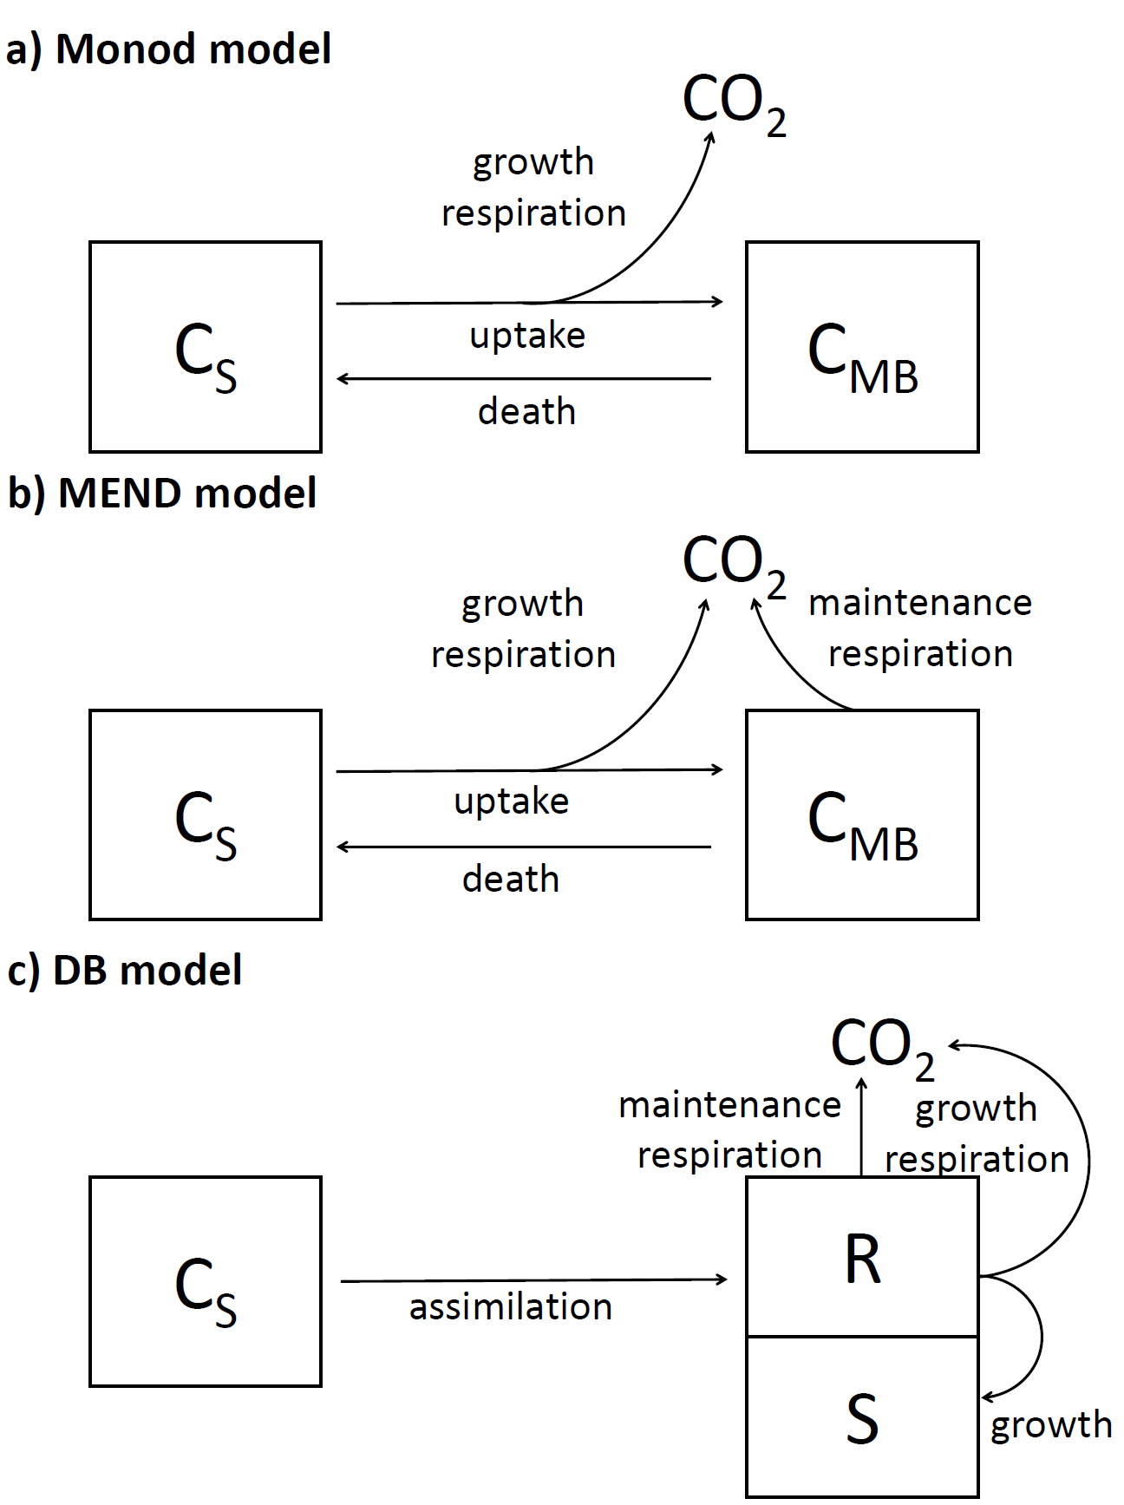

**Fig. 1:** Schematic representation of three models (Monod, MEND and DB) simulating coupled dynamic of organic substrate (CS) and microbial biomass (CMB) on per carbon basis leading to CO2 production. Squares represent pools and arrows represent. DB model defines two pools of microbial biomass, i.e. Reserves (R) and Structures (S).

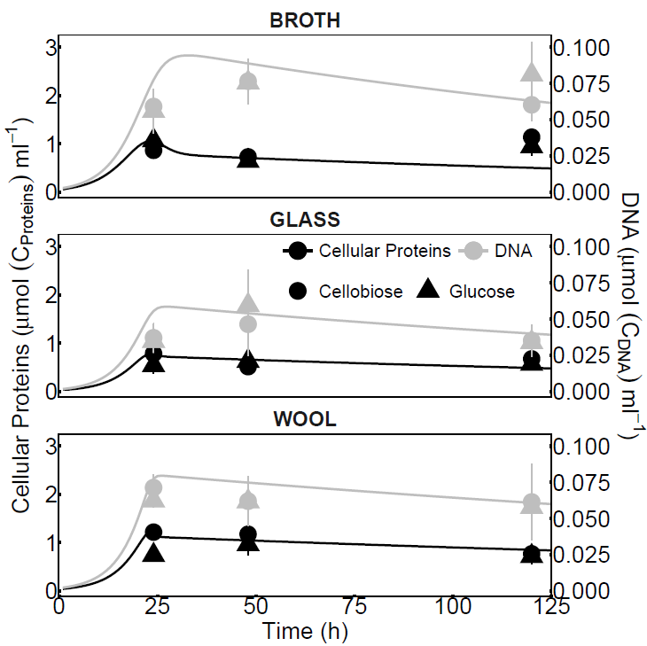

**Fig. 2:** The dynamic of cellular proteins (black symbols) and DNA (grey symbols) in time (mean and corresponding standard deviation are shown). Filled circles and triangles represent measured cellular proteins and DNA concentration in Glucose and Cellobiose treatments respectively. Black and grey lines represent DB model simulation of DNA and cellular proteins temporal dynamic respectively. Data and model simulation is shown for three different levels of structural complexity treatment (BROTH, GLASS and WOOL) separately. Note that the left (cellular proteins) and right (DNA) y-axis have different scales.

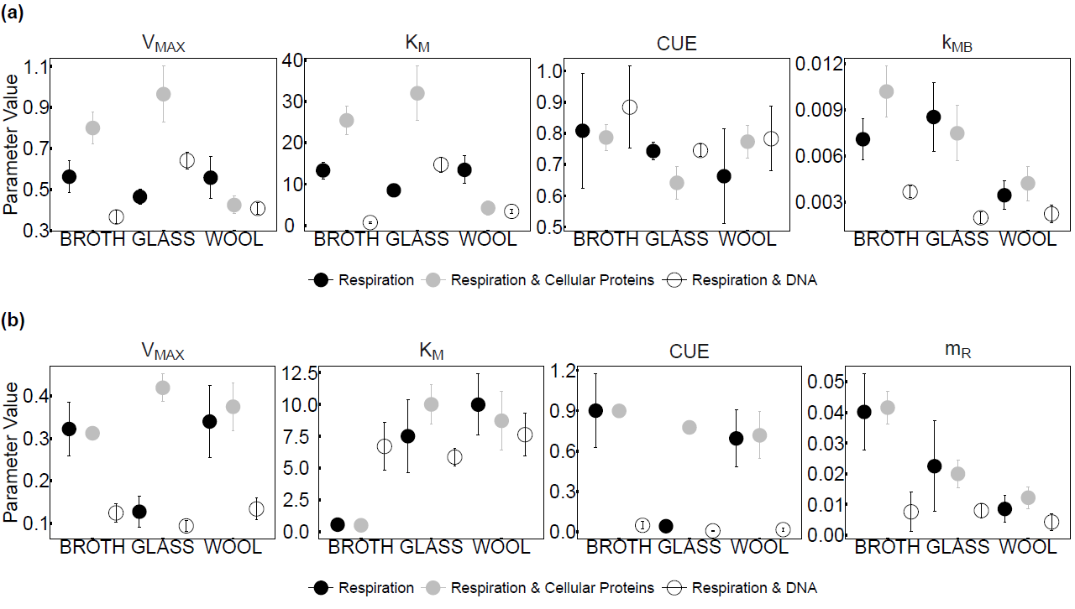

**Fig. 3:** Monod (a) and MEND (b) model parameters (VMAX – maximum velocity constant, KM – affinity constant, CUE – carbon use efficiency, kMB – microbial biomass decay rate constant, mR – specific maintenance rate constant) estimated separately for three different levels of structural complexity treatment (BROTH, GLASS and WOOL). Symbols represent best parameters values estimated by the Differential Evolution Algorithm and error bars represent standard deviation of posterior parameters distribution estimated by Constrained Markov Chain Monte Carlo simulation. Parameters estimation was constrained by either observed respiration rates (black full circles), observed respiration rates and cellular proteins concentration (grey full circles) or observed respiration rates and DNA concentration (empty circles).

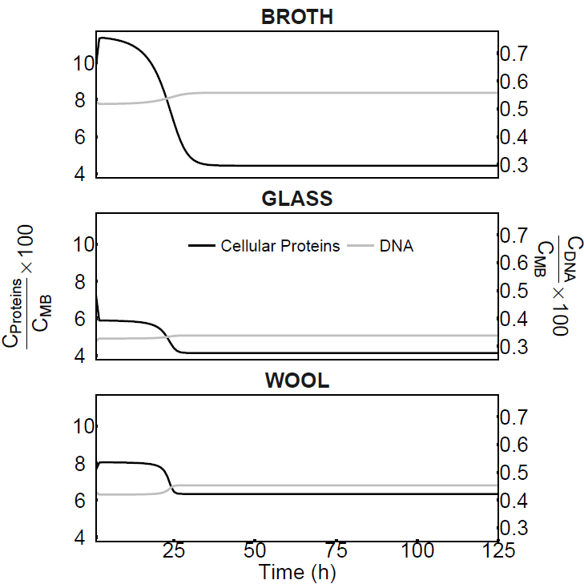

**Fig. 4:** Temporal dynamic of conversion factors between cellular proteins (CProteins) or DNA (CDNA) and microbial biomass (CMB) as predicted by DB model for three different levels of structural complexity treatment (BROTH, GLASS and WOOL). Note that the left (cellular proteins) and right (DNA) y-axis have different scales.

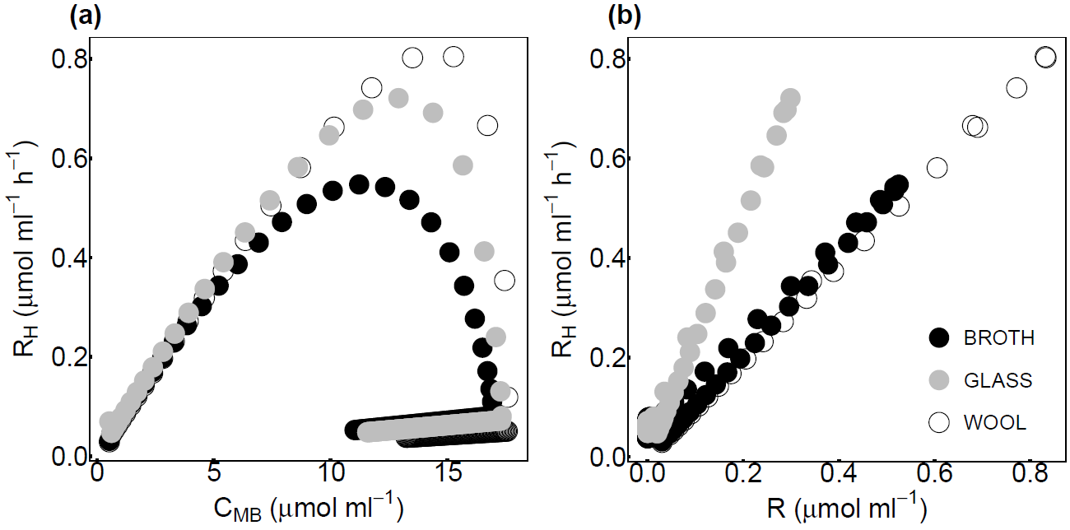

**Fig. 5:** Relationship between respiration rate (RH) and microbial biomass (CMB) or reserves (R) predicted by DB model for three different levels of structural complexity treatment (BROTH, GLASS and WOOL).

## References

Allison, S. D. (2012). A trait-based approach for modelling microbial litter decomposition. *Ecology Letters*, *15*(9), 1058–1070. doi:10.1111/j.1461-0248.2012.01807.x

Allison, S. D., Chacon, S. S., & German, D. P. (2014). Substrate concentration constraints on microbial decomposition. *Soil Biology & Biochemistry*, *79*, 43–49. doi:10.1016/j.soilbio.2014.08.021

Allison, S. D., Lu, L., Kent, A. G., & Martiny, A. C. (2014). Extracellular enzyme production and cheating in Pseudomonas fluorescens depend on diffusion rates. *Frontiers in Microbiology*, *5*. doi:16910.3389/fmicb.2014.00169

Allison, S. D., Wallenstein, M. D., & Bradford, M. A. (2010). Soil-carbon response to warming dependent on microbial physiology. *Nature Geoscience*, *3*(5), 336–340. doi:10.1038/ngeo846

Belas, R., Simon, M., Silverman, M., Costerton, J. W., & Davies, D. G. (1986). Regulation of lateral flagella gene transcription in Vibrio parahaemolyticus. *Journal of Bacteriology*, *167*(1), 210–8. doi:10.1128/jb.184.4.1140-1154.2002

Berg, B., & McClaugherty, C. (2014). *Plant Litter*. *Plant Litter: Decomposition, Humus Formation, Carbon Sequestration*. Berlin, Heidelberg: Springer Berlin Heidelberg. doi:10.1007/978-3-642-38821-7

Bhunia, B., Basak, B., Bhattacharya, P., & Dey, A. (2012). Kinetic studies of alkaline protease from Bacillus licheniformis NCIM-2042. *Journal of Microbiology and Biotechnology*, *22*(12), 1758–66. Retrieved from http://www.ncbi.nlm.nih.gov/pubmed/23221540

Buchkowski, R. W., Bradford, M. A., Grandy, A. S., Schmitz, O. J., & Wieder, W. R. (2017). Applying population and community ecology theory to advance understanding of belowground biogeochemistry. *Ecology Letters*, *20*(2), 231–245. doi:10.1111/ele.12712

Burns, R. G., DeForest, J. L., Marxsen, J., Sinsabaugh, R. L., Stromberger, M. E., Wallenstein, M. D., … Zoppini, A. (2013). Soil enzymes in a changing environment: Current knowledge and future directions. *Soil Biology and Biochemistry*, *58*, 216–234. doi:10.1016/J.SOILBIO.2012.11.009

Chen, H., Yang, Z., Chu, R. K., Tolic, N., Liang, L., Graham, D. E., … Gu, B. (2018). Molecular Insights into Arctic Soil Organic Matter Degradation under Warming. *Environmental Science & Technology*, *52*(8), 4555–4564. doi:10.1021/acs.est.7b05469

Christensen, H., Bakken, L. R., & Olsen, R. A. (1993). Soil bacterial DNA and biovolume profiles measured by flow-cytometry. *FEMS Microbiology Letters*, *102*(3–4), 129–140. doi:10.1016/0378-1097(93)90196-9

Christensen, H., Olsen, R. A., & Bakken, L. R. (1995). Flow cytometric measurements of cell volumes and DNA contents during culture of indigenous soil bacteria. *Microbial Ecology*, *29*(1), 49–62. doi:10.1007/BF00217422

Chua, S. L., Liu, Y., Yam, J. K. H., Chen, Y., Vejborg, R. M., Tan, B. G. C., … Yang, L. (2014). Dispersed cells represent a distinct stage in the transition from bacterial biofilm to planktonic lifestyles. *Nature Communications*, *5*(1), 4462. doi:10.1038/ncomms5462

Cleveland, C. C., & Liptzin, D. (2007). C : N : P stoichiometry in soil: is there a “Redfield ratio” for the microbial biomass? *Biogeochemistry*, *85*(3), 235–252. doi:10.1007/s10533-007-9132-0

Currie, W. S. (2003). Relationships between carbon turnover and bioavailable energy fluxes in two temperate forest soils. *Global Change Biology*, *9*(6), 919–929. doi:10.1046/j.1365-2486.2003.00637.x

Dictor, M.-C., Tessier, L., & Soulas, G. (1998). Reassessement of the Kec coefficient of the fumigation–extraction method in a soil profile. *Soil Biology and Biochemistry*, *30*(2), 119–127. doi:10.1016/S0038-0717(97)00111-9

Dilly, O. (2004). Effects of glucose, cellulose, and humic acids on soil microbial eco-physiology. *Journal of Plant Nutrition and Soil Science*, *167*(3), 261–266. doi:10.1002/jpln.200321041

Don, A., Rodenbeck, C., & Gleixner, G. (2013). Unexpected control of soil carbon turnover by soil carbon concentration. *Environmental Chemistry Letters*, *11*(4), 407–413. doi:10.1007/s10311-013-0433-3

Ehlers, K., Bünemann, E. K., Oberson, A., Frossard, E., Frostegård, Å., Yuejian, M., & Bakken, L. R. (2008). Extraction of soil bacteria from a Ferralsol. *Soil Biology and Biochemistry*, *40*(7), 1940–1946. doi:10.1016/j.soilbio.2008.04.005

Ekschmitt, K., Kandeler, E., Poll, C., Brune, A., Buscot, F., Friedrich, M., … Wolters, V. (2008). Soil-carbon preservation through habitat constraints and biological limitations on decomposer activity. *Journal of Plant Nutrition and Soil Science-Zeitschrift Fur Pflanzenernahrung Und Bodenkunde*, *171*(1), 27–35. doi:10.1002/jpln.200700051

Evans, S., Dieckmann, U., Franklin, O., & Kaiser, C. (2016). Synergistic effects of diffusion and microbial physiology reproduce the Birch effect in a micro-scale model. *Soil Biology and Biochemistry*, *93*, 28–37. doi:10.1016/J.SOILBIO.2015.10.020

Friedlingstein, P., Cox, P., Betts, R., Bopp, L., von Bloh, W., Brovkin, V., … Zeng, N. (2006). Climate–Carbon Cycle Feedback Analysis: Results from the C 4 MIP Model Intercomparison. *Journal of Climate*, *19*(14), 3337–3353. doi:10.1175/JCLI3800.1

Frostegard, A., & Baath, E. (1996). The use of phospholipid fatty acid analysis to estimate bacterial and fungal biomass in soil. *Biology and Fertility of Soils*, *22*(1–2), 59–65. doi:10.1007/BF00384433

German, D. P., Marcelo, K. R. B., Stone, M. M., & Allison, S. D. (2012). The Michaelis-Menten kinetics of soil extracellular enzymes in response to temperature: a cross-latitudinal study. *Global Change Biology*, *18*(4), 1468–1479. doi:10.1111/j.1365-2486.2011.02615.x

Gharasoo, M., Centler, F., Fetzer, I., & Thullner, M. (2014). How the chemotactic characteristics of bacteria can determine their population patterns. *Soil Biology & Biochemistry*, *69*, 346–358. doi:10.1016/j.soilbio.2013.11.019

Gharasoo, M., Centler, F., Regnier, P., Harms, H., & Thullner, M. (2012). A reactive transport modeling approach to simulate biogeochemical processes in pore structures with pore-scale heterogeneities. *Environmental Modelling & Software*, *30*, 102–114. doi:10.1016/J.ENVSOFT.2011.10.010

Gittel, A., Barta, J., Kohoutova, I., Mikutta, R., Owens, S., Gilbert, J., … Urich, T. (2014). Distinct microbial communities associated with buried soils in the Siberian tundra. *Isme Journal*, *8*(4), 841–853. doi:10.1038/ismej.2013.219

Hanegraaf, P. P. F., & Muller, E. B. (2001). The Dynamics of the Macromolecular Composition of Biomass. *Journal of Theoretical Biology*, *212*(2), 237–251. doi:10.1006/jtbi.2001.2369

Hanegraaf, P. P. F., Stouthamer, A. H., & Kooijman, S. A. L. M. (2000). A mathematical model for yeast respiro-fermentative physiology. *Yeast*, *16*(5), 423–437. doi:10.1002/(SICI)1097-0061(20000330)16:5<423::AID-YEA541>3.0.CO;2-I

Hararuk, O., Smith, M. J., & Luo, Y. (2015). Microbial models with data-driven parameters predict stronger soil carbon responses to climate change. *Global Change Biology*, *21*(6), 2439–53. doi:10.1111/gcb.12827

He, Y., Yang, J., Zhuang, Q., McGuire, A. D., Zhu, Q., Liu, Y., & Teskey, R. O. (2014). Uncertainty in the fate of soil organic carbon: A comparison of three conceptually different decomposition models at a larch plantation. *Journal of Geophysical Research: Biogeosciences*, *119*(9), 1892–1905. doi:10.1002/2014JG002701

Heinemeyer, A., Croft, S., Garnett, M. H., Gloor, E., Holden, J., Lomas, M. R., & Ineson, P. (2010). The MILLENNIA peat cohort model: predicting past, present and future soil carbon budgets and fluxes under changing climates in peatlands. *CLIMATE RESEARCH*, *45*(1), 207–226. doi:10.3354/cr00928

Herman, J., Moorhead, D., & Berg, B. (2008). The relationship between rates of lignin and cellulose decay in aboveground forest litter. *Soil Biology & Biochemistry*, *40*(10), 2620–2626. doi:10.1016/j.soilbio.2008.07.003

Huang, Y., Guenet, B., Ciais, P., Janssens, I. A., Soong, J. L., Wang, Y., … Huang, Y. (2018). ORCHIMIC (v1.0), a microbe-mediated model for soil organic matter decomposition. *Geoscientific Model Development*, *11*(6), 2111–2138. doi:10.5194/gmd-11-2111-2018

Jagadamma, S., Mayes, M. A., Steinweg, J. M., & Schaeffer, S. M. (2014). Substrate quality alters the microbial mineralization of added substrate and soil organic carbon. *Biogeosciences*, *11*(17), 4665–4678. doi:10.5194/bg-11-4665-2014

Kaiser, C., Franklin, O., Richter, A., & Dieckmann, U. (2015). Social dynamics within decomposer communities lead to nitrogen retention and organic matter build-up in soils. *Nature Communications*, *6*, 8960. doi:10.1038/ncomms9960

Kooijman, S. A. L. M. (2009). *Dynamic Energy Budget theory for metabolic organisation* (Third). Cambridge, United Kingdom and New York, NY, USA: Cambridge University Press.

la Cecilia, D., Riley, W. J., & Maggi, F. (2018). Biochemical modeling of microbial memory effects and catabolite repression on soil organic carbon compounds. *Soil Biology and Biochemistry*. doi:10.1016/J.SOILBIO.2018.10.003

Lawrence, D. M., Oleson, K. W., Flanner, M. G., Thornton, P. E., Swenson, S. C., Lawrence, P. J., … Slater, A. G. (2011). Parameterization improvements and functional and structural advances in Version 4 of the Community Land Model. *Journal of Advances in Modeling Earth Systems*, *3*(3), M03001. doi:10.1029/2011MS000045

Leininger, S., Urich, T., Schloter, M., Schwark, L., Qi, J., Nicol, G. W., … Schleper, C. (2006). Archaea predominate among ammonia-oxidizing prokaryotes in soils. *Nature*, *442*(7104), 806–809. doi:10.1038/nature04983

Li, J. W., Wang, G. S., Allison, S. D., Mayes, M. A., & Luo, Y. Q. (2014). Soil carbon sensitivity to temperature and carbon use efficiency compared across microbial-ecosystem models of varying complexity. *Biogeochemistry*, *119*(1–3), 67–84. doi:10.1007/s10533-013-9948-8

Liu, Y.-R., Delgado-Baquerizo, M., Wang, J.-T., Hu, H.-W., Yang, Z., & He, J.-Z. (2018). New insights into the role of microbial community composition in driving soil respiration rates. *Soil Biology and Biochemistry*, *118*, 35–41. doi:10.1016/J.SOILBIO.2017.12.003

Manzoni, S., Schaeffer, S. M., Katul, G., Porporato, A., & Schimel, J. P. (2014). A theoretical analysis of microbial eco-physiological and diffusion limitations to carbon cycling in drying soils. *Soil Biology & Biochemistry*, *73*, 69–83. doi:10.1016/j.soilbio.2014.02.008

Marstorp, H., Guan, X., & Gong, P. (2000). Relationship between dsDNA, chloroform labile C and ergosterol in soils of different organic matter contents and pH. *Soil Biology and Biochemistry*, *32*(6), 879–882. doi:10.1016/S0038-0717(99)00210-2

Marstorp, H., & Witter, E. (1999). Extractable dsDNA and product formation as measures of microbial growth in soil upon substrate addition. *Soil Biology and Biochemistry*, *31*(10), 1443–1453. doi:10.1016/S0038-0717(99)00065-6

Mauter, M., Fait, A., Elimelech, M., & Herzberg, M. (2013). Surface Cell Density Effects on Escherichia coli Gene Expression during Cell Attachment. *Environmental Science & Technology*, *47*(12), 6223–6230. doi:10.1021/es3047069

Moyano, F. E., Vasilyeva, N., & Menichetti, L. (2018). Diffusion limitations and Michaelis–Menten kinetics as drivers of combined temperature and moisture effects on carbon fluxes of mineral soils. *Biogeosciences*, *15*(16), 5031–5045. doi:10.5194/bg-15-5031-2018

Mullen, K., Ardia, D., Gil, D., Windover, D., & Cline, J. (2011). “DEoptim”: An R Package for Global Optimization by Differential Evolution. *Journal of Statistical Software*, *40*(6), 1–26.

Nunan, N., Leloup, J., Ruamps, L. S., Pouteau, V., & Chenu, C. (2017). Effects of habitat constraints on soil microbial community function. *Scientific Reports*, *7*(1), 4280. doi:10.1038/s41598-017-04485-z

Oldfield, E. E., Crowther, T. W., & Bradford, M. A. (2018). Substrate identity and amount overwhelm temperature effects on soil carbon formation. *Soil Biology and Biochemistry*, *124*, 218–226. doi:10.1016/J.SOILBIO.2018.06.014

Parton, W. J., Stewart, J. W. B., & Cole, C. V. (1988). Dynamics of C, N, P and S in grassland soils: a model. *Biogeochemistry*, *5*(1), 109–131. doi:10.1007/BF02180320

R Development Core Team. (2014). R: A language and environment for statistical computing. (R. D. C. Team, Ed.), *R Foundation for Statistical Computing, Vienna, Austria. URL Http://Www.R-Project.Org/*. R Foundation for Statistical Computing. doi:10.1007/978-3-540-74686-7

Roels, J. A. (1980). Application of macroscopic principles to microbial metabolism. *Biotechnology and Bioengineering*, *22*(12), 2457–2514. doi:10.1002/bit.260221202

Ross, D. J., & Täte, K. R. (1993). Microbial C and N in litter and soil of a southern beech (Nothofagus) forest: Comparison of measurement procedures. *Soil Biology and Biochemistry*, *25*(4), 467–475. doi:10.1016/0038-0717(93)90072-J

Salazar, A., Sulman, B. N., & Dukes, J. S. (2018). Microbial dormancy promotes microbial biomass and respiration across pulses of drying-wetting stress. *Soil Biology and Biochemistry*, *116*, 237–244. doi:10.1016/J.SOILBIO.2017.10.017

Schädel, C., Schuur, E. A. G., Bracho, R., Elberling, B., Knoblauch, C., Lee, H., … Turetsky, M. R. (2014). Circumpolar assessment of permafrost C quality and its vulnerability over time using long-term incubation data. *Global Change Biology*, *20*(2), 641–652. doi:10.1111/gcb.12417

Schimel, J. P., Scott, W. J., & Killham, K. (1989). Changes in cytoplasmic carbon and nitrogen pools in a soil bacterium and a fungus in response to salt stress. *Applied and Environmental Microbiology*, *55*(6), 1635–7. Retrieved from http://www.ncbi.nlm.nih.gov/pubmed/16347957

Schimel, J. P., & Weintraub, M. N. (2003). The implications of exoenzyme activity on microbial carbon and nitrogen limitation in soil: a theoretical model. *Soil Biology and Biochemistry*, *35*(4), 549–563. doi:10.1016/s0038-0717(03)00015-4

Schmidt, M. W. I., Torn, M. S., Abiven, S., Dittmar, T., Guggenberger, G., Janssens, I. A., … Trumbore, S. E. (2011). Persistence of soil organic matter as an ecosystem property. *Nature*, *478*(7367), 49–56. doi:10.1038/nature10386

Schnecker, J., Wild, B., Hofhansl, F., Alves, R. J. E., Barta, J., Capek, P., … Richter, A. (2014). Effects of Soil Organic Matter Properties and Microbial Community Composition on Enzyme Activities in Cryoturbated Arctic Soils. *Plos One*, *9*(4). doi:e9407610.1371/journal.pone.0094076

Sierra, C. A., Malghani, S., & Müller, M. (2015). Model structure and parameter identification of soil organic matter models. *Soil Biology and Biochemistry*, *90*, 197–203. doi:10.1016/j.soilbio.2015.08.012

Sihi, D., Gerber, S., Inglett, P. W., & Inglett, K. S. (2016). Comparing models of microbial–substrate interactions and their response to warming. *Biogeosciences*, *13*(6), 1733–1752. doi:10.5194/bg-13-1733-2016

Sinsabaugh, R. L., Manzoni, S., Moorhead, D. L., Richter, A., & Elser, J. (2013). Carbon use efficiency of microbial communities: stoichiometry, methodology and modelling. *Ecology Letters*, *16*(7), 930–939. doi:10.1111/ele.12113

Soetaert, K., & Petzoldt, T. (2010). Inverse Modelling, Sensitivity and Monte Carlo Analysis in R Using Package FME. *Journal of Statistical Software*, *33*(3), 1–28.

Sparling, G. P., Feltham, C. W., Reynolds, J., West, A. W., & Singleton, P. (1990). Estimation of soil microbial c by a fumigation-extraction method: use on soils of high organic matter content, and a reassessment of the kec-factor. *Soil Biology and Biochemistry*, *22*(3), 301–307. doi:10.1016/0038-0717(90)90104-8

Sparling, G., & West, A. (1990). A comparison of gas-chromatography and differential respirometer methods to measure soil respiration and to estimate the soil microbial biomass. *Pedobiologia*, *34*(2), 103. Retrieved from https://eurekamag.com/research/001/736/001736146.php

Stouthamer, A. H. (1973). A theoretical study on the amount of ATP required for synthesis of microbial cell material. *Antonie van Leeuwenhoek*, *39*(1), 545–565. doi:10.1007/BF02578899

Svensäter, G., Welin, J., Wilkins, J. C., Beighton, D., & Hamilton, I. R. (2001). Protein expression by planktonic and biofilm cells of Streptococcus mutans. *FEMS Microbiology Letters*, *205*(1), 139–146. doi:10.1111/j.1574-6968.2001.tb10937.x

Vance, E. D., Brookes, P. C., & Jenkinson, D. S. (1987). An extraction method for measuring soil microbial biomass-C. *Soil Biology & Biochemistry*, *19*(6), 703–707. doi:10.1016/0038-0717(87)90052-6

Vogel, L. E., Makowski, D., Garnier, P., Vieublé-Gonod, L., Coquet, Y., Raynaud, X., … Pot, V. (2015). Modeling the effect of soil meso- and macropores topology on the biodegradation of a soluble carbon substrate. *Advances in Water Resources*, *83*, 123–136. doi:10.1016/J.ADVWATRES.2015.05.020

Vrede, T., Dobberfuhl, D. R., Kooijman, S., & Elser, J. J. (2004). Fundamental connections among organism C : N : P stoichiometry, macromolecular composition, and growth. *Ecology*, *85*(5), 1217–1229.

Wang, G., Post, W. M., & Mayes, M. A. (2013). Development of microbial-enzyme-mediated decomposition model parameters through steady-state and dynamic analyses. *Ecological Applications*, *23*(1), 255–272. doi:10.1890/12-0681.1

Wang, G. S., Jagadamma, S., Mayes, M. A., Schadt, C. W., Steinweg, J. M., Gu, L. H., & Post, W. M. (2015). Microbial dormancy improves development and experimental validation of ecosystem model. *Isme Journal*, *9*(1), 226–37. doi:10.1038/ismej.2014.120

Wang, Y. P., Chen, B. C., Wieder, W. R., Leite, M., Medlyn, B. E., Rasmussen, M., … Luo, Y. Q. (2014). Oscillatory behavior of two nonlinear microbial models of soil carbon decomposition. *Biogeosciences*, *11*(7), 1817–1831. doi:10.5194/bg-11-1817-2014

Wieder, W. R., Allison, S. D., Davidson, E. A., Georgiou, K., Hararuk, O., He, Y., … Xu, X. (2015). Explicitly representing soil microbial processes in Earth system models. *Global Biogeochemical Cycles*, *29*(10), 1782–1800. doi:10.1002/2015GB005188

Wieder, W. R., Bonan, G. B., & Allison, S. D. (2013). Global soil carbon projections are improved by modelling microbial processes. *Nature Climate Change*, *3*(10), 909–912. doi:10.1038/nclimate1951

Wieder, W. R., Grandy, A. S., Kallenbach, C. M., & Bonan, G. B. (2014). Integrating microbial physiology and physio-chemical principles in soils with the MIcrobial-MIneral Carbon Stabilization (MIMICS) model. *Biogeosciences*, *11*(14), 3899–3917. doi:10.5194/bg-11-3899-2014

Wieder, W. R., Grandy, A. S., Kallenbach, C. M., Taylor, P. G., & Bonan, G. B. (2015). Representing life in the Earth system with soil microbial functional traits in the MIMICS model. *Geoscientific Model Development*, *8*(6), 1789–1808. doi:10.5194/gmd-8-1789-2015

Xu, X. F., Schimel, J. P., Thornton, P. E., Song, X., Yuan, F. M., & Goswami, S. (2014). Substrate and environmental controls on microbial assimilation of soil organic carbon: a framework for Earth system models. *Ecology Letters*, *17*(5), 547–555. doi:10.1111/ele.12254

Yokoyama, S., Yuri, K., Nomi, T., Komine, M., Nakamura, S., Hattori, H., & Rai, H. (2017). The high correlation between DNA and chloroform-labile N in various types of soil. *Applied Soil Ecology*, *117*–*118*, 1–9. doi:10.1016/J.APSOIL.2017.04.002

Zipper, H., Buta, C., Lämmle, K., Brunner, H., Bernhagen, J., & Vitzthum, F. (2003). Mechanisms underlying the impact of humic acids on DNA quantification by SYBR Green I and consequences for the analysis of soils and aquatic sediments. *Nucleic Acids Research*, *31*(7), e39. Retrieved from http://www.ncbi.nlm.nih.gov/pubmed/12655027