Problem 1:
Euro to USD
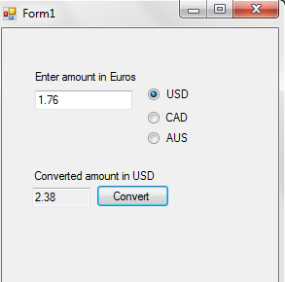
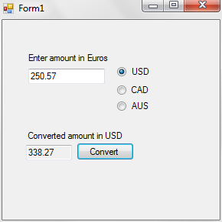
Euro to CAD
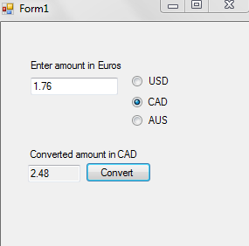
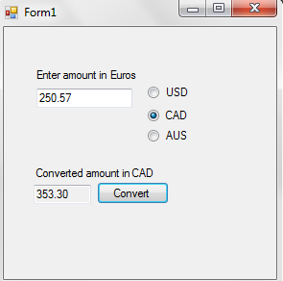

Euro to AUS
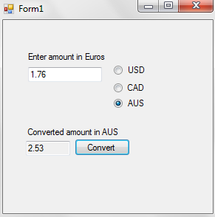
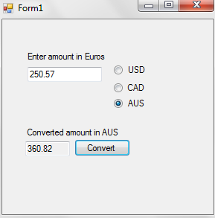
Code:
using System;
using System.Collections.Generic;
using System.ComponentModel;
using System.Data;
using System.Drawing;
using System.Linq;
using System.Text;
using System.Windows.Forms;

namespace designPatterns2
{
public partial class Form1 : Form
{
Char currency = 'U';
decimal value, value2;
public Form1()
{
InitializeComponent();
}

private void radioButton1_CheckedChanged(object sender, EventArgs e)
{
currency = 'U';
//label3.Text = "USD";
}

private void radioButton2_CheckedChanged(object sender, EventArgs e)
{
currency = 'C';
//label3.Text = "CAD";
}

private void radioButton3_CheckedChanged(object sender, EventArgs e)
{
currency = 'A';
//label3.Text = "AUS";
}

private void button1_Click(object sender, EventArgs e)
{
moneyHandler usd = new USD(currency);
moneyHandler cad = new CAD(currency);
moneyHandler aus = new AUS(currency);

value = Convert.ToDecimal(textBox1.Text);
usd.setSuccessor(cad);
cad.setSuccessor(aus);

value2 = usd.handleRequest(value);
value2 = Math.Round(value2, 2);
textBox2.Text = value2.ToString();
if (currency == 'U')
{
label3.Text = "USD";
}
else if (currency == 'C')
{
label3.Text = "CAD";
}
else if (currency == 'A')
{
label3.Text = "AUS";
}
}

}

// handler for money
public abstract class moneyHandler
{
public moneyHandler successor;
public decimal convertedValue;
public void setSuccessor( moneyHandler money )
{
this.successor = money;
}

public abstract decimal handleRequest(decimal money);
}
//class for when converting to USD
class USD : moneyHandler
{
char currencyType;
public USD( char currency)
{
currencyType = currency;
}
override public decimal handleRequest(decimal money)
{
if (currencyType == 'U' )
{
return money * 1.35m;
}
else if (successor != null)
{
return successor.handleRequest(money);
}
else
{
return money;
}
}
}
//class for when converting to CAD
class CAD : moneyHandler
{
char currencyType;
public CAD( char currency)
{
currencyType = currency;
}
override public decimal handleRequest(decimal money)
{
if (currencyType == 'C')
{
return convertedValue = money * 1.41m;
}
else if (successor != null)
{
return successor.handleRequest(money);
}
else
{
return money;
}
}
}
//class for converting to AUS
class AUS : moneyHandler
{
char currencyType;
public AUS( char currency)
{
currencyType = currency;
}
override public decimal handleRequest(decimal money)
{
if (currencyType == 'A')
{
return convertedValue = money * 1.44m;
}
else if (successor != null)
{
return successor.handleRequest(money);
}
else
{
return money;
}
}
}
}

Problem 2
Euro to USD
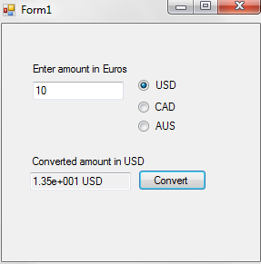
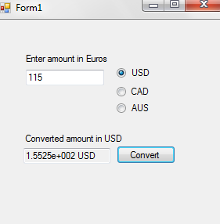
Euro to CAD
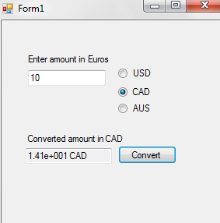
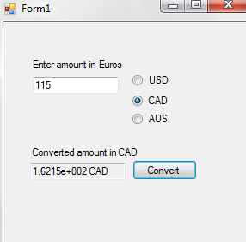
Euro to AUS
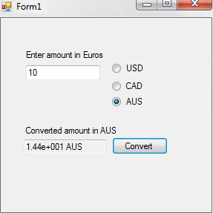
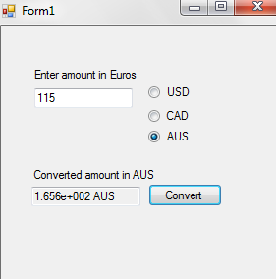
Code:
using System;
using System.Collections.Generic;
using System.ComponentModel;
using System.Data;
using System.Drawing;
using System.Linq;
using System.Text;
using System.Windows.Forms;
//this is a test about the files work
namespace designPatterns2
{
public partial class Form1 : Form
{
Char currency = 'U';
double value, value2;
String m;
public Form1()
{
InitializeComponent();
}

private void radioButton1_CheckedChanged(object sender, EventArgs e)
{
currency = 'U';
//label3.Text = "USD";
}

private void radioButton2_CheckedChanged(object sender, EventArgs e)
{
currency = 'C';
//label3.Text = "CAD";
}

private void radioButton3_CheckedChanged(object sender, EventArgs e)
{
currency = 'A';
//label3.Text = "AUS";
}

private void button1_Click(object sender, EventArgs e)
{
moneyHandler usd = new USD(currency);
moneyHandler cad = new CAD(currency);
moneyHandler aus = new AUS(currency);

value = Convert.ToDouble(textBox1.Text);
usd.setSuccessor(cad);
cad.setSuccessor(aus);
value2 = usd.handleRequest(value);
m = value2.ToString();
Money money = new convertedMoney(m);
money = new roundedMoney(money);
money = new scientificMoney(money);
money = new currencyMoney(currency, money);
textBox2.Text = money.modifyMoney();
if (currency == 'U')
{
label3.Text = "USD";
}
else if (currency == 'C')
{
label3.Text = "CAD";
}
else if (currency == 'A')
{
label3.Text = "AUS";
}

int length = textBox2.Text.IndexOf("e");
int length2 = length--;
while (textBox2.Text[length] == '0')
{
length--;
}
length++;
textBox2.Text = textBox2.Text.Remove(length, length2 - length);
}

private void Form1_Load(object sender, EventArgs e)
{

}

}

public abstract class moneyHandler
{
public moneyHandler successor;
public double convertedValue;
public void setSuccessor( moneyHandler money )
{
this.successor = money;
}

public abstract double handleRequest(double money);
}

class USD : moneyHandler
{
char currencyType;
public USD( char currency)
{
currencyType = currency;
}
override public double handleRequest(double money)
{
if (currencyType == 'U' )
{
return money * 1.35;
}
else if (successor != null)
{
return successor.handleRequest(money);
}
else
{
return money;
}
}
}

class CAD : moneyHandler
{
char currencyType;
public CAD( char currency)
{
currencyType = currency;
}
override public double handleRequest(double money)
{
if (currencyType == 'C')
{
return convertedValue = money * 1.41;
}
else if (successor != null)
{
return successor.handleRequest(money);
}
else
{
return money;
}
}
}

class AUS : moneyHandler
{
char currencyType;
public AUS( char currency)
{
currencyType = currency;
}
override public double handleRequest(double money)
{
if (currencyType == 'A')
{
return convertedValue = money * 1.44;
}
else if (successor != null)
{
return successor.handleRequest(money);
}
else
{
return money;
}
}
}

//Everything below this is used for the decorator classes
//Money is the component and is the "base" item we start with
public abstract class Money
{
public String moneyDescr;
public abstract String modifyMoney();
//{
// return moneyDescr;
//}
}
//My value decorator. Makes it abstract for the decorators to override
public abstract class moneyDecorator : Money
{
public override abstract String modifyMoney();
}
//Decorator that rounds my number
public class roundedMoney : moneyDecorator
{
Money money;
public roundedMoney(Money money)
{
this.money = money;
}
override public String modifyMoney()
{
moneyDescr = money.modifyMoney();
Decimal d = Convert.ToDecimal(moneyDescr);
d = Math.Round(d, 2);
moneyDescr = d.ToString();
return moneyDescr;
}
}
//decorator that converts my standard number into scientific notation
public class scientificMoney : moneyDecorator
{
Money money;
public scientificMoney(Money money)
{
this.money = money;
}
override public String modifyMoney()
{
moneyDescr = money.modifyMoney();
decimal d = Convert.ToDecimal(moneyDescr);
moneyDescr = d.ToString("e");
return moneyDescr;
}
}
//this is the decorator that dictates currency type
public class currencyMoney : moneyDecorator
{
Char currency;
Money money;
public currencyMoney(Char c, Money m)
{
this.currency = c;
this.money = m;
}
override public String modifyMoney()
{ //I call money's modifyMoney to get to the original object and return my value all the way back to the outermost wrapper
moneyDescr = money.modifyMoney();
if (currency == 'U')
{
moneyDescr = moneyDescr + " USD";
}
else if (currency == 'C')
{
moneyDescr = moneyDescr + " CAD";
}
else if (currency == 'A')
{
moneyDescr = moneyDescr + " AUS";
}
return moneyDescr;
}
}
//concrete decorator that starts as just an unknown currency
public class convertedMoney : Money
{
public convertedMoney( String m )
{
moneyDescr = m;
}

public override String modifyMoney()
{
return moneyDescr;
}
}
}

Class diagrams
Problem 1:
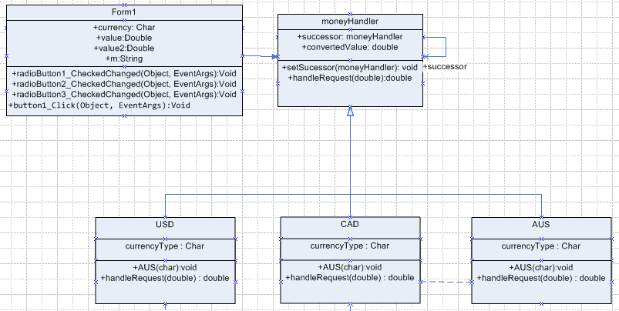

Problem 2
