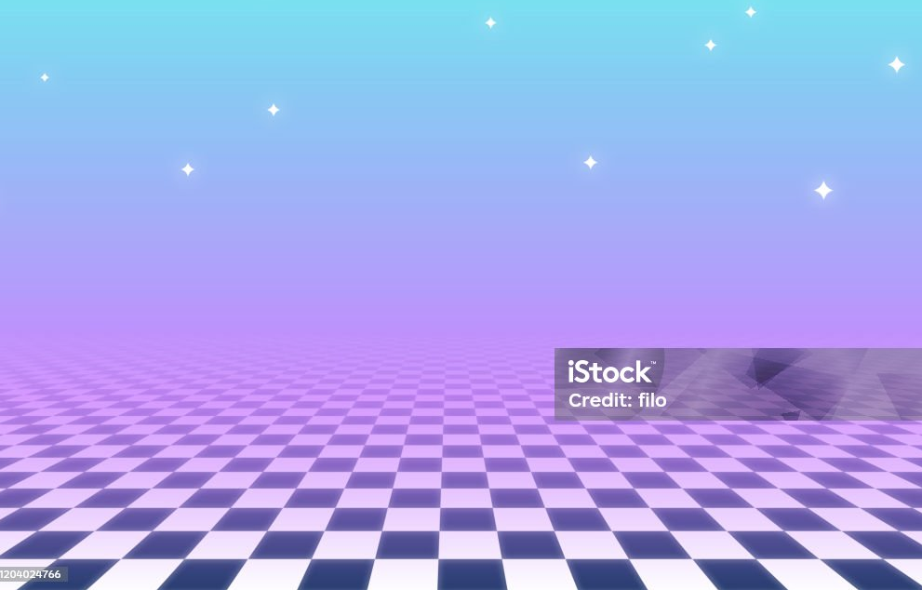
Especially like the checkerboard pattern and purple fog on this one
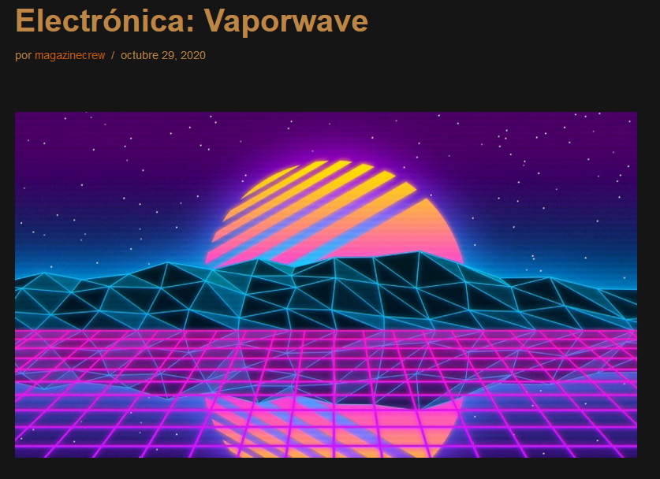
https://undergroundlab.es/2020/10/vaporwave/

Hardest hitting is the middle part with glowing lines and triangles. The square patter below is also nice. Horizontal scan lines are a nice touch.
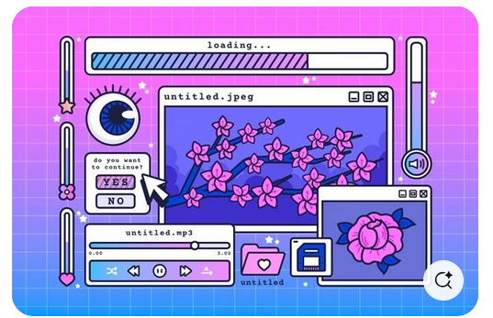
https://es.pinterest.com/pin/726346246158374805/

Thick black edges do a lot of work here. Also putting a teal/pink gradient into places is really nice.

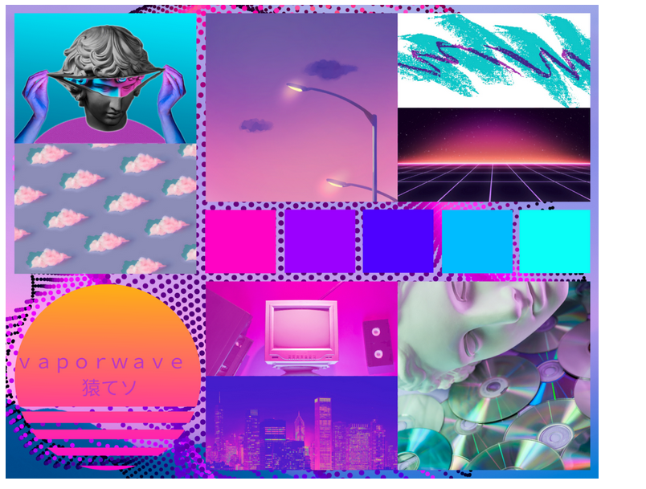

https://www.nativ3.io/blog/vaporwave-aesthetic

Old tech including CRT monitors, cassettes and CDs works well.

https://www.nativ3.io/blog/vaporwave-aesthetic

Vaporwave Aesthetic Design Motifs and Themes
- 80s and 90s nostalgia, particularly older technology (cassettes, CDs, Gameboy Advance, CRT TVs) and retro, 8-bit pixel graphics
- Liminal spaces, like abandoned shopping malls, school hallways after dark, or cities devoid of humans
- Effortless irony; looking down on those who “try too hard” to be ironic
- Japanese typographical characters
- Lo-fi photography and “glitchy” overlays
- Marble busts
- Hypersaturated palm trees and sunsets
- Neon lights
- Older animes, like Sailor Moon and Akira
- Simplified computer windows, often displaying cynical quotes
- Windows95
- Rejection of consumerism is expressed by placing branded objects (often drink cans or tech companies) in strange places where they don’t belong
- Geometric lines and grids
- Romanticizing pessimism, sadness, and addiction by making it look more visually appealing through the use of Vaporwave aesthetic colors and visuals
- Disconnection from others and the world at large; visualizing spaces devoid of human contact
- Creating a sonic ambiance that sounds pleasant but is strange or slightly “off” with careful listening
- Sarcasm and patronizing speech, particularly towards those who want to dissect or elevate Vaporwave in an effort to present it as something deeper than it actually is
- Favoring aesthetic over meaning, feeling, or thought

Smithsonian statues:
Bust of George Washington
https://www.si.edu/object/3d/george-washington:ff28cb3a-ad00-43b3-a928-fa61ab0a288f
Life Cast of Left Forearm and Hand
https://www.si.edu/object/3d/life-cast-left-forearm-and-hand-fragment-study-greek-slave:7f2659ba-2953-47a5-9358-921da9b0ce16
Model of the Greek Slave
https://www.si.edu/object/3d/model-greek-slave:8edffe56-c358-4c3a-a61f-019f615ccef0
Another head of George Washington
https://www.si.edu/object/3d/george-washington:d8c63fde-4ebc-11ea-b77f-2e728ce88125
Figure of a Dancer
https://www.si.edu/object/3d/figure-dancer:88de08dd-b8ab-470a-b987-ed6fe35def04

Smithsonian sea stuff:
Acropora (Rhabdocyathus) murrayensis
https://www.si.edu/object/3d/acropora-rhabdocyathus-murrayensis:13ea6bd0-d481-4a38-af3f-d526f80c08ac
Siderastrea glynni
https://www.si.edu/object/3d/siderastrea-glynni:ea3db9bf-aefe-4e27-8384-f637fc3296c8
Coeloseris mayeri
https://www.si.edu/object/3d/coeloseris-mayeri:a8b1aece-9bd5-4f7a-abd3-b3b34238ab3c
Prionastraea spectabilis
https://www.si.edu/object/3d/prionastraea-spectabilis:d5bea90f-8442-4f59-815e-88c63671c7c9
Astraea (Fissicella) favistella: Detail View
https://www.si.edu/object/3d/astraea-fissicella-favistella-detail-view:39444ca1-a8ca-47d4-926d-eb0c0e2dba63

Smithsonian other stuff:
Ewer
https://www.si.edu/object/3d/ewer:349e8fa2-9461-4e33-bae9-5e9cdd3e72bb
Palm tree:
https://www.si.edu/object/pritchardia-lowreyana-rock-ex-becc:nmnhbotany_10293240
Palm picture kinda cool
https://www.si.edu/object/blossom-chandelier-plant:saam_1994.91.88
funky palm hat
https://www.si.edu/object/high-crown-fabric-hat-multicolored-palm-tree-print:nmaahc_2007.3.531

Random Vaporwave assets:
Track named "Prismatic Shopping Network"
https://prismaticaudio.itch.io/shopping-music

