# Instruction for the exercise (2h00)

To complete this exercise, you must reproduce the picture bellow:

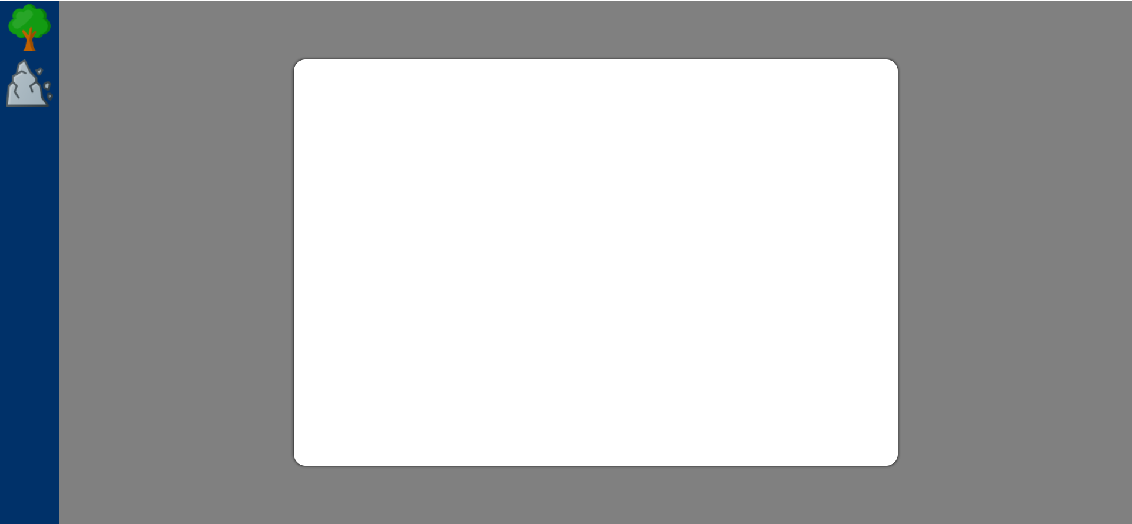

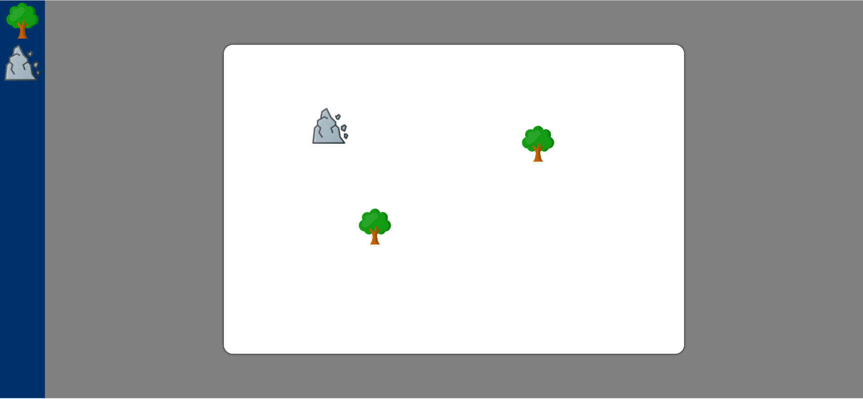

We have a container on the left part of the screen (100px). In this container, you have 2 icons that you can find in this folder. In the middle of the screen we have a container called “iPad screen” (1024X690) that must be white at the beginning.

First, if the display screen is too small to contain the iPad screen, you must recalculate the size of the ipad screen like bellow (care must be taken to keep the ratio):

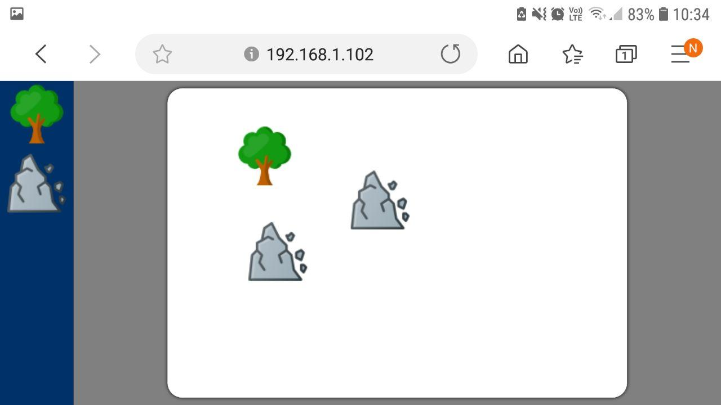

Then we must be able to drag an icon from the left container to the ipad screen, then drop it. As an example, you can watch the video in this folder.

The following specifications are required:

* Can be done with a mouse
* Can be done with a touch action
* Create a ghost picture when you are dragging
* If the customer drops the icon out of the ipad screen the icon must not be dropped

You must write your code with HTML5, CSS3 and JS. You can use external library like JQuery, Bootstrap, etc.

# Backend exercise (30min)

You must write a code in C# that allows the creation of shapes (triangle, square, pentagon, …).

Each shape must define how many points are needed to be drawn.

A point is defined by a X and a Y.

A function draw must write inside the console “I draw a *<NameOfTheShape>* with points *<ListOfPoints>*”

The list of points must be displayed as below x1,y1; x2,y2;…

Think in terms of reusability and maintainability.