App Being Review: crushthedoges__________________________________________________________________________

Overall Comments:

Took me a while to figure out what to do. README says “Pressing the button to the FAR LEFT”, but there are no buttons on the left. Tapping the dog head on the far right seemed to start a game. The head left of that crashed the app, so I assume that’s the reset.

Maybe have some kind of usage hints, like arrows that indicate you should drag the dog head somewhere and release?

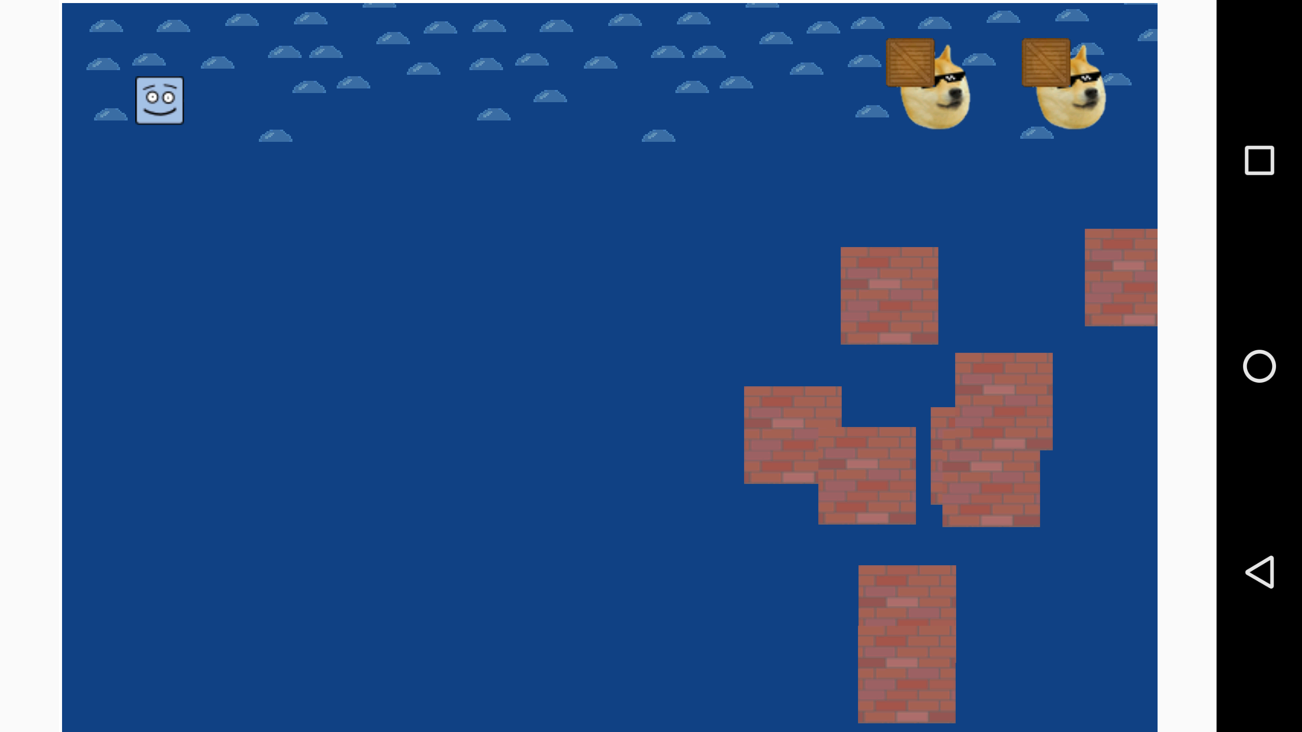

Could you draw the game fullscreen? there’s big white areas on each side that dont seem to do anything.

Response to Dev. Teams Wishes:

Usage Problems/Concerns:

The dog head button turned into a moving part of the game once I clicked it, which was confusing. Maybe just have a start button?

Bugs Found & How To Reproduce:

Suggestions: