Django web application development tutorial

Django web application development tutorial 1

The goal of this tutorial 3

Introduction to Django 4

Django is a high-level Python Web framework... 4

...that encourages rapid development... 5

...and clean, pragmatic design. 5

Django philosophy 5

Other frameworks 6

How to learn Django 7

Preparing the development environment 7

Step 1: Install the python 7

Step 2 django development environment 7

Step 3: Using django-admin to build the a project 8

Build the first app: basic request & response 10

Setup the database 11

Add "apps" package directory in "webapp" 12

Defining views 13

Define the urls  14

Build the model 16

Django Admin 16

Define our own views 20

Define the index view 20

Define the show view 21

Define the delete view 23

Models, Views and Templates 23

The MVC design pattern: 24

User input url address to request something 26

Forms 26

Define the “create” method 26

Define “update” method 31

Static and media files 33

Image and other static files 33

CSS file 33

User authentication 33

Creating the login page 33

Enabling logout functionality 33

User registration 33

Message 34

Ajax 34

Bootstrap 34

脚手架 34

EC2 34

# The goal of this tutorial

Recently, I developed a django web app named "[iBookmark](http://www.ibookmark.me/) (http://www.ibookmark.me)", which can help users to manage their bookmark online, just like google and delicious bookmark. Users can import and export their bookmarks from browsers and google, delicious.

This simple but useful web app screen shot as below.

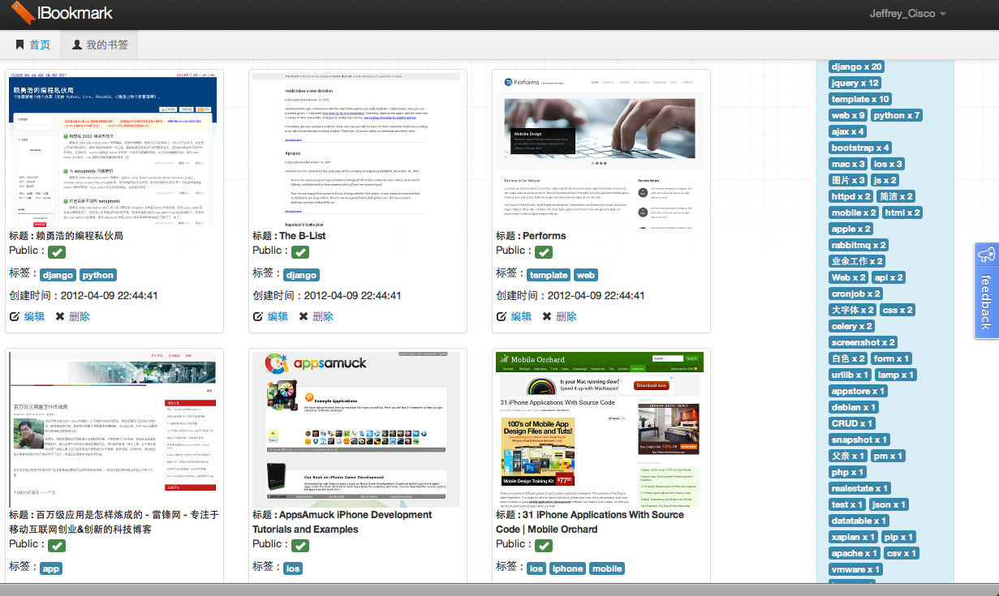

Diagram The snapshot of the http://ibookmark.me

I developed this web app for 1-2 weeks with my spare time. I used many skills as following:

1. Python
2. Django
3. Many django third part apps: django-tagging, pinax, django-oauth, etc.
4. Restful web api with django-piston
5. Ajax
6. jQuery
7. Twitter bootstrap front framework
8. Amazon ec2 server and apache httpd for deployment
9. My own scaffold django_blank_project
10. mysql
11. gitlite

I learned those skills of development and deployment from django document, books and google. I decide to record all skills in several blog posts and make them as a tutorial. The tutorial goal is how to use these skills to build a popular web app. I'll use the "iBookmark" as the example for this tutorial.

# Introduction to Django

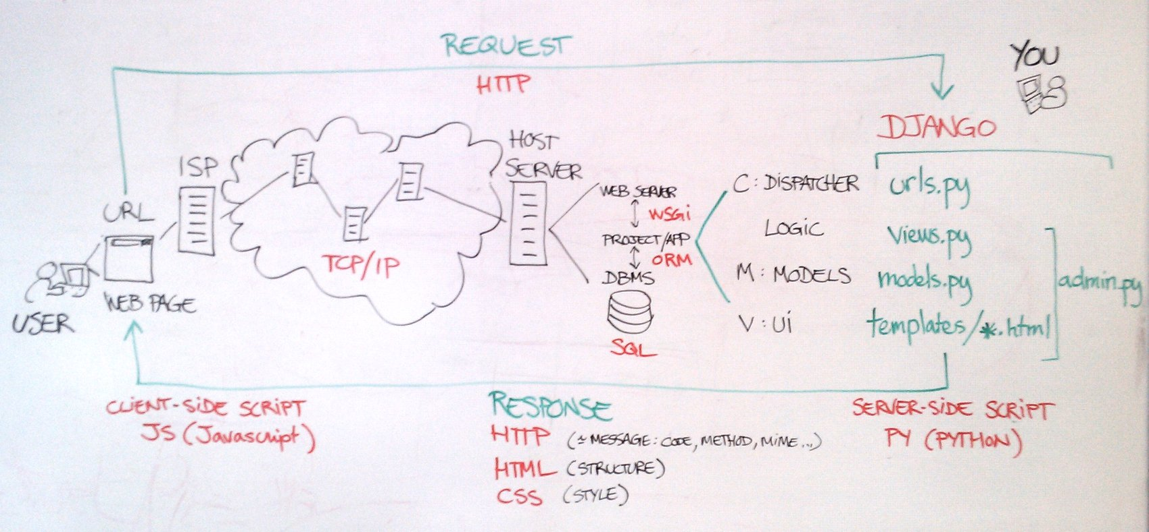

Diagram The django architecture

Django is a high-level Python Web framework that encourages rapid development and clean, pragmatic design.

### Django is a high-level Python Web framework...

A Web framework is software that abstracts common problems of Web development and provides shortcuts for frequent programming tasks.

A good web framework finds the “pain points” of web developers and smoothes them over — but never gets in the way! It should let you work at a much higher level of abstraction, so you don’t need to worry about details of HTTP, SQL, or whatever. Again, it shouldn’t get in your way if you need to “step down” a level.

Python itself is another key “feature” of Django. It’s a beautiful, concise, powerful, high-level language with an amazing community; many things are easier in Django simply because of the tools you can build on top of.

Django also makes a point of not changing anything about how Python works; if you learn Django, you’re also learning Python. This helps down the road.

### ...that encourages rapid development...

Regardless of how many powerful features it has, a Web framework is worthless if it doesn't save you time. Django's philosophy is to do all it can to facilitate hyper-fast development. With Django, you build Web sites in a matter of hours, not days; weeks, not years.

This comes directly out of real-world problems. We’re programmers, yes, but we work at a news organization. When a big story breaks, we don’t have the luxury of a long development cycle. Every convenience in Django is there because it makes you more productive.

### ...and clean, pragmatic design.

Django strictly maintains a clean design throughout its own code and makes it easy to follow best Web-development practices in the applications you create.

The philosophy here is to make it easy to do things the "right" way.

### Django philosophy

https://docs.djangoproject.com/en/1.4/misc/design-philosophies/

#### Loose coupling

A fundamental goal of Django’s stack is [loose coupling and tight cohesion](http://c2.com/cgi/wiki?CouplingAndCohesion). The various layers of the framework shouldn’t “know” about each other unless absolutely necessary.

For example, the template system knows nothing about Web requests, the database layer knows nothing about data display and the view system doesn’t care which template system a programmer uses.

Although Django comes with a full stack for convenience, the pieces of the stack are independent of another wherever possible.

#### Less code

Django apps should use as little code as possible; they should lack boilerplate. Django should take full advantage of Python’s dynamic capabilities, such as introspection.

#### Quick development

The point of a Web framework in the 21st century is to make the tedious aspects of Web development fast. Django should allow for incredibly quick Web development.

#### Don’t repeat yourself (DRY)

Every distinct concept and/or piece of data should live in one, and only one, place. Redundancy is bad. Normalization is good.

The framework, within reason, should deduce as much as possible from as little as possible.

See also

The [discussion of DRY on the Portland Pattern Repository](http://c2.com/cgi/wiki?DontRepeatYourself)

#### Explicit is better than implicit

This is a core Python principle listed in [PEP 20](http://www.python.org/dev/peps/pep-0020), and it means Django shouldn’t do too much “magic.” Magic shouldn’t happen unless there’s a really good reason for it. Magic is worth using only if it creates a huge convenience unattainable in other ways, and it isn’t implemented in a way that confuses developers who are trying to learn how to use the feature.

#### Consistency

The framework should be consistent at all levels. Consistency applies to everything from low-level (the Python coding style used) to high-level (the “experience” of using Django).

### Other frameworks

Non python-based frameworks : Java (not quick, not dirty), PHP (quick, dirty), ASP(quick, not dirty, but close), Ruby (quick, but magic)

Python-based frameworks : Django, bottle, Toronto, web.py

Django : quick, not dirty; full-stack; popular in job markets

### How to learn Django

1 : Learn Python

2 : Learn Django concepts and conventions

3 : Google and Document

# Preparing the development environment

From this chapter, we'll begin our trip to develop a real but tiny web app using Django.

Frist, we should prepare the development environment.

### Step 1: Install the python and PIP

Since the django only support the python 2.x, so we should install the python 2.x.

Download the latest python 2.x to install. After install please check the result as following:

|  |
| --- |
| *$ python*  *Python 2.7.1 (r271:86832, Jul 31 2011, 19:30:53)*  *[GCC 4.2.1 (Based on Apple Inc. build 5658) (LLVM build 2335.15.00)] on darwin*  *Type "help", "copyright", "credits" or "license" for more information.*  *>>> print "hello world"*  *hello world*  *>>> exit()* |

To install PIP:

<http://www.pip-installer.org/en/latest/installing.html>

**What's pip?**

pip is a tool for installing and managing Python packages, such as those found in the [Python Package Index](http://pypi.python.org/pypi). It's a replacement for [easy_install](http://peak.telecommunity.com/DevCenter/EasyInstall).

We'll put all dependent third python libraries into a txt file, such as requirement.txt.

*#All dependences here#*

*django*

*# If you need a special version #*

*# django==1.4#*

Then we can install all required packages using:

*pip install -r webapp/requirement.txt*

### Step 2 django development environment

|  |
| --- |
| *$ pip install django*  Downloading/unpacking django  Downloading Django-1.4.tar.gz (7.6Mb): 7.6Mb downloaded  Running setup.py egg_info for package django    Installing collected packages: django  Running setup.py install for django  changing mode of build/scripts-2.7/django-admin.py from 644 to 755    changing mode of /Users/jeffrey/Dev/django_tutorial/env/bin/django-admin.py to 755  Successfully installed django  Cleaning up... |

To check the version of Django:

|  |
| --- |
| *>>> import django*  *>>> django.get_version()*  *'1.4'* |

### Step 3: Using django-admin to build the a project

Django provides a tool to do django development tasks, such as build a project, add an app, sync db, etc. We'll introduce the tool later, now we need use it to build a project.

|  |
| --- |
| *$ django-admin.py startproject webapp*  *$ cd webapp/*  *$ python manage.py runserver*  *Validating models...*  *0 errors found*  *Django version 1.3.1, using settings 'webapp.settings'*  *Development server is running at http://127.0.0.1:8000/*  *Quit the server with CONTROL-C.* |

It worked!

**Choose an IDE**

Here are some IDEs which you can choice:

Text editor

Eclipse + pyDev

PyCharm

I suggest user can choice PyCharm, I like this IDE.

<http://www.jetbrains.com/pycharm/>

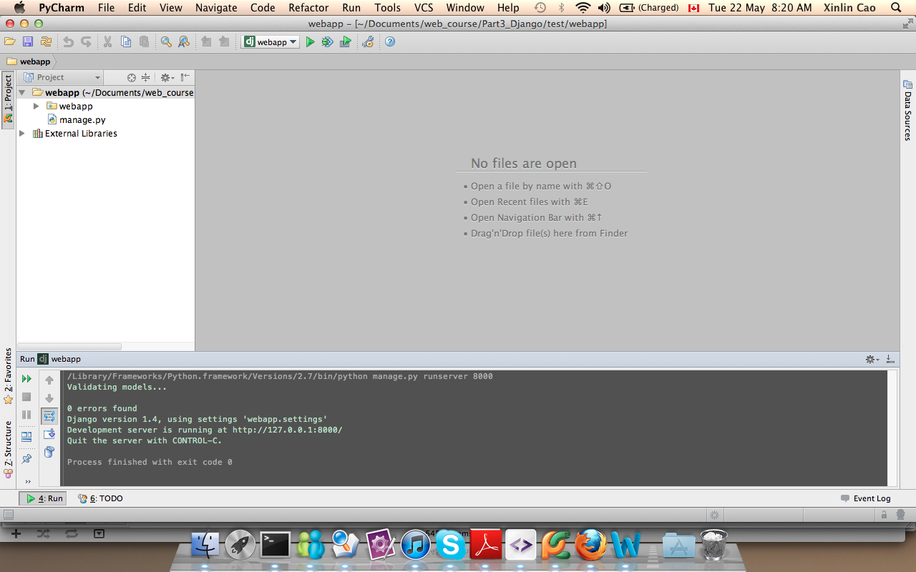

Remember the latest web app?

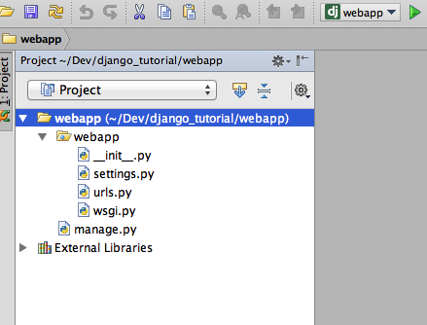

These files are:

* The outer webapp/ directory is just a container for your project. Its name doesn't matter to Django; you can rename it to anything you like.
* manage.py: A command-line utility that lets you interact with this Django project in various ways. You can read all the details about manage.py in [django-admin.py and manage.py](https://docs.djangoproject.com/en/1.4/ref/django-admin/).
* The inner webapp/ directory is the actual Python package for your project. Its name is the Python package name you'll need to use to import anything inside it (e.g. import webapp.settings).
* webapp/__init__.py: An empty file that tells Python that this directory should be considered a Python package. (Read [more about packages](http://docs.python.org/tutorial/modules.html#packages) in the official Python docs if you're a Python beginner.)
* webapp/settings.py: Settings/configuration for this Django project. [Django settings](https://docs.djangoproject.com/en/1.4/topics/settings/) will tell you all about how settings work.
* webapp/urls.py: The URL declarations for this Django project; a "table of contents" of your Django-powered site. You can read more about URLs in [URL dispatcher](https://docs.djangoproject.com/en/1.4/topics/http/urls/).
* webapp/wsgi.py: An entry-point for WSGI-compatible webservers to serve your project. See [How to deploy with WSGI](https://docs.djangoproject.com/en/1.4/howto/deployment/wsgi/) for more details.Prepare development

What is WSGI?

WSGI is the Web Server Gateway Interface. It is a specification for web servers and application servers to communicate with web applications (though it can also be used for more than that). It is a Python standard, described in detail in [PEP 333](http://www.python.org/dev/peps/pep-0333).

For more, see [Learn about WSGI](http://wsgi.readthedocs.org/en/latest/learn.html).

# Build the first app: basic request & response

In the last chapter, we have built a web app, and run it worked! But it's only for demo and no practical purpose. Now we need go on to build our real application base on it.

## Setup the database

In settings.py, we should define the database：

|  |
| --- |
| **import** os.path  PROJECT_ROOT = os.path.abspath(os.path.dirname(__file__))  DATABASES = {  'default': {  'ENGINE': 'django.db.backends.sqlite3',  'NAME': os.path.join(PROJECT_ROOT, 'dev.db'),  'USER': '', # Not used with sqlite3.  'PASSWORD': '', # Not used with sqlite3.  'HOST': '', # Set to empty string for localhost. Not used with sqlite3.  'PORT': '', # Set to empty string for default. Not used with sqlite3.  }  } |

And need to run "python manage.py syncdb" in webapp directory.

|  |
| --- |
| *$python manage.py syncdb*  *Creating tables ...*  *Creating table auth_permission*  *Creating table auth_group_permissions*  *Creating table auth_group*  *Creating table auth_user_user_permissions*  *Creating table auth_user_groups*  *Creating table auth_user*  *Creating table auth_message*  *Creating table django_content_type*  *Creating table django_session*  *Creating table django_site*  *You just installed Django's auth system, which means you don't have any superusers defined.*  *Would you like to create one now? (yes/no): yes*  *Username (Leave blank to use 'jeffrey'): admin*  *E-mail address: admin@admin.com*  *Password:*  *Password (again):*  *Superuser created successfully.*  *Installing custom SQL ...*  *Installing indexes ...*  *No fixtures found.* |

Note: If you encounter any errors about encoding, you can try “**export LC_ALL="en_US.UTF-8"**”(<https://code.djangoproject.com/ticket/16017>)

Use sqlitemanager to debug and manage the database.

## Add "apps" package directory in "webapp"

We used the "apps" directory as the application root path.

Please note: apps is a python package directory, it include a file named "__init__.py", please do not forget it.

In "apps" package, we create the first app:

|  |
| --- |
| *$ cd webapp/webapp*  *$ mkdir apps*  *$ cd apps*  *$ touch __init__.py*  *$ python ../../manage.py startapp bookmark*  *$ cd bookmark*  *total 24*  *drwxr-xr-x 6 jeffrey staff 204 4 16 20:26 .*  *drwxr-xr-x 4 jeffrey staff 136 4 16 20:26 ..*  *-rw-r--r-- 1 jeffrey staff 0 4 16 20:26 __init__.py*  *-rw-r--r-- 1 jeffrey staff 57 4 16 20:26 models.py*  *-rw-r--r-- 1 jeffrey staff 383 4 16 20:26 tests.py*  *-rw-r--r-- 1 jeffrey staff 26 4 16 20:26 views.py* |

You can see in webapp/webapp/apps/bookmarks/ package, there are 4 python files.

* models.py: defined the models. A model is the single, definitive source of data about your data. It contains the essential fields and behaviors of the data you're storing. Django follows the [DRY Principle](https://docs.djangoproject.com/en/1.3/misc/design-philosophies/#dry). The goal is to define your data model in one place and automatically derive things from it.
* views.py: defined the views. A view is a “type” of Web page in your Django application that generally serves a specific function and has a specific template.

settings.py：

|  |
| --- |
| import sys  sys.path.insert(0, os.path.join(PROJECT_ROOT))  sys.path.insert(0, os.path.join(PROJECT_ROOT, "apps"))  INSTALLED_APPS = (  'django.contrib.auth',  'django.contrib.contenttypes',  'django.contrib.sessions',  'django.contrib.sites',  'django.contrib.messages',  'django.contrib.staticfiles',  # Uncomment the next line to enable the admin:  # 'django.contrib.admin',  # Uncomment the next line to enable admin documentation:  # 'django.contrib.admindocs',  'bookmark',  ) |

## Defining views

A view function, or view for short, is simply a Python function that takes a Web request and returns a Web response. This response can be the HTML contents of a Web page, or a redirect, or a 404 error, or an XML document, or an image . . . or anything, really. The view itself contains whatever arbitrary logic is necessary to return that response. This code can live anywhere you want, as long as it’s on your Python path. There’s no other requirement–no “magic,” so to speak. For the sake of putting the code somewhere, the convention is to put views in a file called views.py, placed in your project or application directory.

Imaging for the bookmark objects, the owner can create/update/delete/view a bookmark, and list bookmarks.

So we need add some method in views, for every method can correspond a option of the owner.

Now we add the views.py

|  |
| --- |
| **from** django.http **import** HttpResponse  **def** index(request):  **return** HttpResponse("index")  **def** create(request):  **return** HttpResponse("create")  **def** update(request):  **return** HttpResponse("update")  **def** delete(request):  **return** HttpResponse("delete")  **def** show(request):  **return** HttpResponse("show") |

## Define the urls

After defining the views.py, we need to define the urls.py. A urls.py is a url mapping to views method.

Put the urls.py in the bookmark directory.

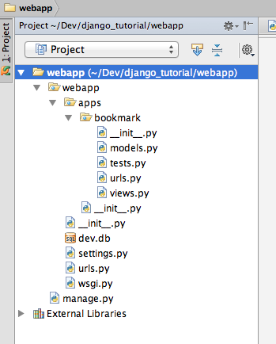

|  |
| --- |
| **from** django.conf.urls.defaults **import** patterns, url  urlpatterns = patterns('',  url(r'^/index/$', 'bookmark.views.index’, name='bookmark_list'),  url(r'^/create/$', 'bookmark.views.create', name='bookmark_create'),  url(r'^/update/$', 'bookmark.views.update', name='bookmark_update'),  url(r'^/delete/$', 'bookmark.views.delete', name='bookmark_delete'),  url(r'^/show/$', 'bookmark.views.show', name='bookmark_show'),  ) |

Find the urls.py in webapp/webapp directory, add the url mapping to bookmark.urls：

|  |
| --- |
| from django.conf.urls import patterns, include, url  urlpatterns = patterns('',  url(r'^bookmark', include('bookmark.urls')),  ) |

Now we run the app by using "python manage.py runserver". And input the url for "http://localhost:8000/bookmark/index", you will find the page show the text "index".

**Why two URLs?**

Loose coupling

**Summary**

In this part, we did a real app named "bookmark" and setup the Directory file structure.

User input the url, django will use the urls.py to mapping the method

Views.py defined the methods which get the user request and return response

Need make sure your app added in "INSTALLED_APPS" in settings.py

## Build the model

|  |
| --- |
| from django.contrib.auth.models import User  from django.db import models  class Bookmark(models.Model):  url = models.URLField()  title = models.CharField(blank=True, max_length=100, help_text='Limit of 100 characters')  public = models.BooleanField(verbose_name='Public this bookmark', blank=True, default=True)  create_time = models.DateTimeField(auto_now_add=True)  last_modified_time = models.DateTimeField(auto_now=True)  def __unicode__(self):  return self.url |

Try syncdb check the database again. (Delete the database file and refresh again)

|  |
| --- |
| *$python manage.py syncdb* |

# Django Admin

One of the most powerful parts of Django is the automatic admin interface. It reads metadata in your model to provide a powerful and production-ready interface that content producers can immediately use to start adding content to the site. In this document, we discuss how to activate, use and customize Django’s admin interface.

There are seven steps in activating the Django admin site:

* Add 'django.contrib.admin' to your [INSTALLED_APPS](https://docs.djangoproject.com/en/1.4/ref/settings/#std:setting-INSTALLED_APPS) setting.
* The admin has four dependencies - [django.contrib.auth](https://docs.djangoproject.com/en/1.4/topics/auth/#module-django.contrib.auth), [django.contrib.contenttypes](https://docs.djangoproject.com/en/1.4/ref/contrib/contenttypes/#module-django.contrib.contenttypes), [django.contrib.messages](https://docs.djangoproject.com/en/1.4/ref/contrib/messages/#module-django.contrib.messages) and [django.contrib.sessions](https://docs.djangoproject.com/en/1.4/topics/http/sessions/#module-django.contrib.sessions). If these applications are not in your [INSTALLED_APPS](https://docs.djangoproject.com/en/1.4/ref/settings/#std:setting-INSTALLED_APPS) list, add them.
* Add django.contrib.messages.context_processors.messages to [TEMPLATE_CONTEXT_PROCESSORS](https://docs.djangoproject.com/en/1.4/ref/settings/#std:setting-TEMPLATE_CONTEXT_PROCESSORS) and [MessageMiddleware](https://docs.djangoproject.com/en/1.4/ref/middleware/#django.contrib.messages.middleware.MessageMiddleware) to [MIDDLEWARE_CLASSES](https://docs.djangoproject.com/en/1.4/ref/settings/#std:setting-MIDDLEWARE_CLASSES). (These are both active by default, so you only need to do this if you’ve manually tweaked the settings.)
* Determine which of your application’s models should be editable in the admin interface.
* For each of those models, optionally create a ModelAdmin class that encapsulates the customized admin functionality and options for that particular model.
* Instantiate an AdminSite and tell it about each of your models and ModelAdmin classes.
* Hook the AdminSite instance into your URLconf.

After you’ve taken these steps, you’ll be able to use your Django admin site by visiting the URL you hooked it into (/admin/, by default). Without writing a line of code, you can have a powerful web admin page.

1. Add django.contrib.admin into your installed apps list in settings.py

|  |
| --- |
| INSTALLED_APPS = (  'django.contrib.auth',  'django.contrib.contenttypes',  'django.contrib.sessions',  'django.contrib.sites',  'django.contrib.messages',  'django.contrib.staticfiles',  # Uncomment the next line to enable the admin:  'django.contrib.admin',  # Uncomment the next line to enable admin documentation:  # 'django.contrib.admindocs',  'bookmark',  ) |

1. Add admin in urls.py

|  |
| --- |
| from django.conf.urls import patterns, include, url  # Uncomment the next two lines to enable the admin:  from django.contrib import admin  admin.autodiscover()  urlpatterns = patterns('',  url(r'^bookmark', include('bookmark.urls')),  url(r'^admin/', include(admin.site.urls)),  ) |

1. Add an admin.py (webapp/webapp/apps/bookmark/admin.py)

|  |
| --- |
| from django.contrib import admin  from models import Bookmark  class BookmarkAdmin(admin.ModelAdmin):  pass  admin.site.register(Bookmark, BookmarkAdmin) |

Now check the url <http://localhost:8000/admin/> you will see

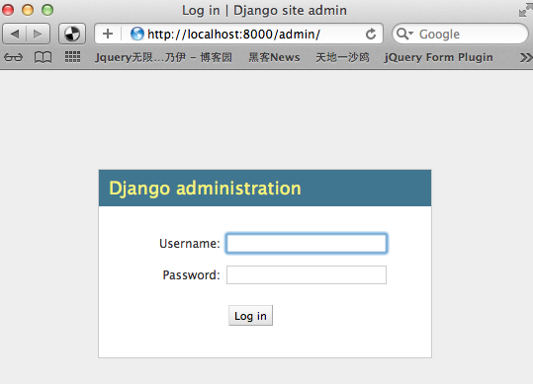

Input the admin user and password(remember we syncdb first time and let me input the user name and password?)

1. After login, you can see django have build-in a power admin page let you CRUD data.

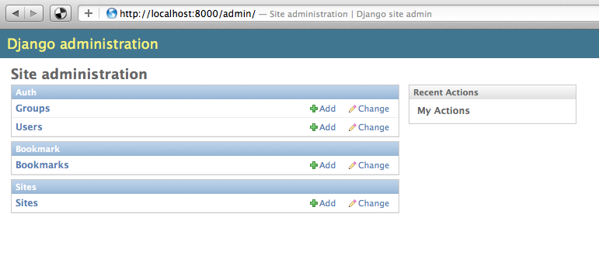

And you can see the Bookmarks link, let’s see what operations we can do?

We can add/edit/delete/batch delete/search bookmarks!

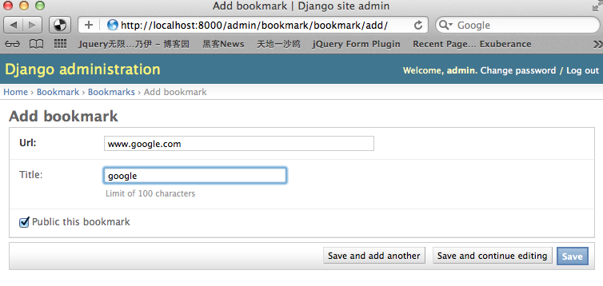

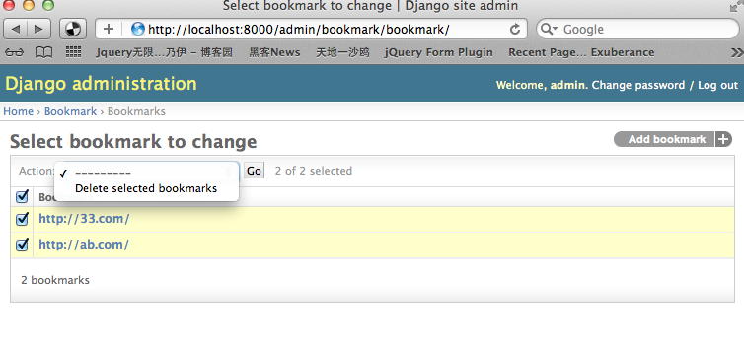

# Define our own views

## Define the index view

In the apps/bookmark/views.py, let’s define a new method which can show all bookmarks data from db to page.

The steps are:

Get a bookmarks list from db

Render the bookmarks list to page(template)

That’s all, now we code:

|  |
| --- |
| **from** django.http **import** HttpResponse  **from** django.shortcuts **import** render_to_response  **from** models **import** Bookmark  **def** index(request):  bookmarks = Bookmark.objects.all()  **return** render_to_response('index.html',  {  'bookmarks': bookmarks,  }) |

bookmarks = Bookmark.objects.all() can get the all bookmarks list from db, there is no need to write any sql, but it actually worked as you do in other language:

Create db connection

Write a sql and execute the sql then get a result set

Get the list from the result set

return render_to_response('index.html', {…}) just tell us django will render the bookmarks list to the template “index.html”, so we can use this “bookmarks” in the template page directly.

Let’s look the “index.html” (in bookmarks/ templates directory)

|  |
| --- |
| <**html**>  <**head**>  <**title**>Bookmark list</**title**>  </**head**>  <**body**>  {% for bookmark in bookmarks %}  {{ bookmark }}  {% empty %}  No data.  {% endfor %}  </**body**>  </**html**> |

In the “index.html” we can see the django template markup language:

{% %} can execute some logic code, such as if, for,etc.

{{ }} can display some variable to page.

In this example, we use {% for %} {% empty %} {% endfor %} markup language, you can get the meaning from the literal meaning. It’s means “loop the bookmarks list and print every bookmark, if the bookmarks is empty, just tell user no data.” Simple? Yes, but powerful!

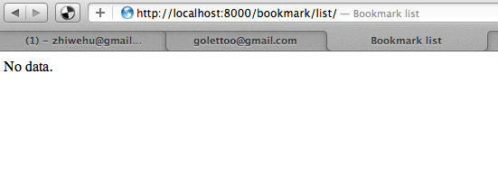

## Define the show view

For the show method, we just need to do are:

Get a bookmark which user want to show

Render the bookmark to page

Let’s look how to implement in code:

|  |
| --- |
| …  **from** django.http **import** HttpResponse, Http404  …  **def** show(request, bookmark_id):  **try**:  bookmark = Bookmark.objects.get(id=bookmark_id)  **except** Bookmark.DoesNotExist:  **raise** Http404  **return** render_to_response('show.html',  {  'bookmark': bookmark,  }) |

bookmark = Bookmark.objects.get(id=bookmark_id), **This line can get a bookmark object from db by bookmark_id, and the question is, where get the bookmark_id?**

Define the show template (show.html):

|  |
| --- |
| <html>  <head>  <title>Show Bookmark</title>  </head>  <body>  {{ bookmark }}  </body>  </html> |

Please look the urls.py, and see how we define the “show” method url mapping:

|  |
| --- |
| url(r'^/show/(?P<bookmark_id>\d+)/$', 'bookmark.views.show', name='bookmark_show'), |

You can see, we have defined a url which can get the bookmark_id from url input, for example, if the user input the url like this: <http://localhost:8000/bookmark/show/1/>, it tell the django urls.py to mapping this url to “bookmark.views.show” method, and pass the “bookmark_id” parameter to this method.

Using try…except… to protect if the user input a non-exists data, if the user input an id which not exists in db, it’ll raise a HTTP404 error.

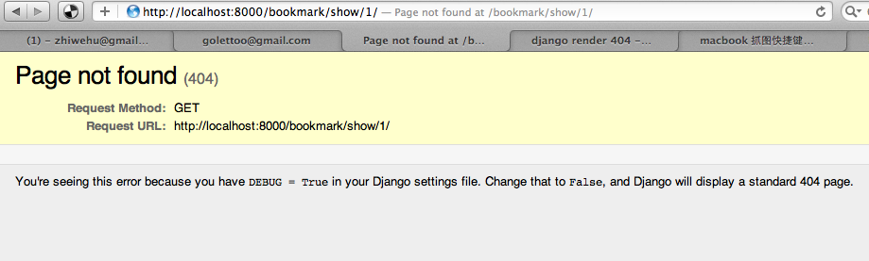

## Define the delete view

Just like the “show” method, the delete method need a parameter let django to know which data need to delete, and also, if the data does not exists, it’ll raise a HTTP404 error.

We can change the url of this method to:

|  |
| --- |
| url(r'^/delete/(?P<bookmark_id>\d+)/$', 'bookmark.views.delete', name='bookmark_delete'), |

|  |
| --- |
| def delete(request, bookmark_id):  try:  bookmark = Bookmark.objects.get(id=bookmark_id)  bookmark.delete()  except Bookmark.DoesNotExist:  raise Http404  return index(request) |

bookmark.delete() method will delete this data in db.

After delete, we just call return index(request) method, so we can go to the index page again.

# Models, Views and Templates

Web application is base on request-response mode.

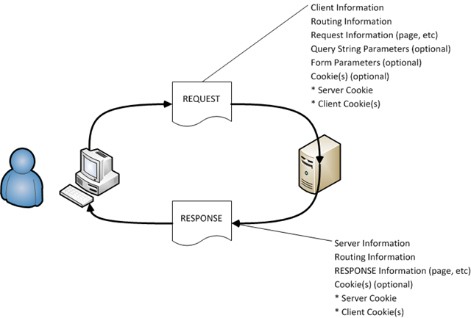

## The MVC design pattern:

Model–View–Controller (MVC) is a [design pattern](http://en.wikipedia.org/wiki/Design_pattern) for computer [user interfaces](http://en.wikipedia.org/wiki/User_interface) that divides an application into three areas of responsibility:

the Model: the [domain objects](http://en.wikipedia.org/wiki/Domain_objects) or [data structures](http://en.wikipedia.org/wiki/Data_structures) that represent the application's state.

the View, which observes the state and generates output to the users.

the Controller, which translates user input into operations on the model.

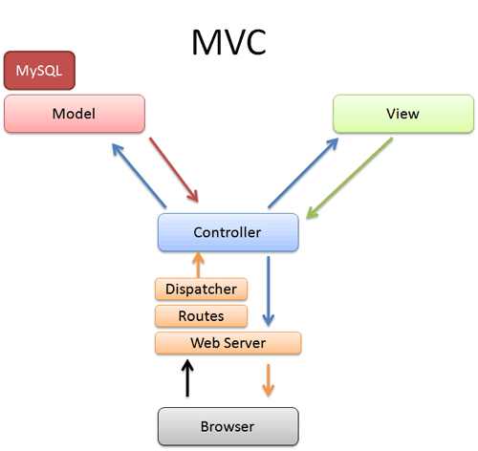

In django, MVC=MVT

Controller = django Views

View = django templates

In Django, the Python method called when a URL is requested is called a view, and the page loaded and rendered by the view is called a template. Because of this, the Django team refers to Django as an MVT (model-view-template) framework. TurboGears, on the other hand, calls its methods controllers and their rendered templates views so that they can fit squarely into the MVC acronym. The difference is largely semantic, as they accomplish the same things.

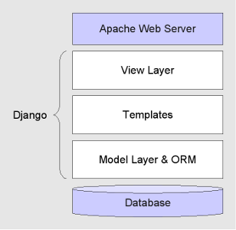

## User input url address to request something

The urls.py will mapping the url to python method which defined in views.py

views.py methods will filter users’ request, get parameters from the request.GET or request.POST, then do some query from db, get the models from models.py

views.py will use the templates to show the data to user, django will render the data (include models data) to template page.(html)

# Forms

Form is used to get input form the user. In Django, Form framework is easy. We can ask Django to generate form semi-automatically. We will use Form to create and modify data.

## Define the “create” method

Let’s make a create method, first let user input a form, and submit the form, the method can handle the data which post in a form, then validate the data first

If validate pass, save it to db.

First, define a forms.py in bookmark directory, we used to write all forms in this file:

|  |
| --- |
| **from** django **import** forms  **from** models **import** Bookmark  **class** BookmarkForm(forms.ModelForm):  **class** Meta:  model = Bookmark  fields = ('url','title','public') |

The BookmarkForm is a subclass of django.forms.ModelForm, this from need can bind a model automatically. Simple? Powerful! But if you need customize the form, maybe you need to use the django.forms.Form, it’ll not bind the model, you should bind the data in the form to a model by yourself.

Model=Bookmark in “class Meta” tell us the form bind the model Bookmark

fields tell us which fields in the Bookmark model need to show in the form.

Let’s look the create method in views.py

For first time user input the create url, it’ll create an empty form and render it to the “create.html” template.

If the user submit the form with the “post” method, the method will check it and handle the data in the form

form.is_valid() method will check if the data are all ok for this form. It can defined some valid method in the “BookmarkForm”, we left it empty, but since the “BookmarkForm” is bind with the model “Bookmark”, so for example, the Bookmark.url is not allow null or empty, so if the user didn’t input the url field in the form, it’ll get an error, we’ll look later.

bookmark = form.save() can save the data just use the form.save() since the form is bind to the model, if the form doesn’t bind the model, it need you write the method by self. For example:

*url=form.cleaned_data[‘url’]*

*title=form.cleaned_data[‘title’]*

*public= form.cleaned_data[‘public’]*

*bookmark = Bookmark(url=url, title=title, public=public)*

*bookmark.save()*

Now we need to define the “create.html”, this html need render an empty form in the page.

|  |
| --- |
| <**html**>  <**head**>  <**title**>Create a bookmark</**title**>  </**head**>  <**body**>  <**form** action="." method="post">  {% csrf_token %}  {{ form.as_p }}  <**input** type="submit" />  <**input** type="reset" />  </**form**>  </**body**>  </**html**> |

We defined a <form>, which action=”.”, it’s mean the action is same with the current page, just like action=”/bookmark/create/”, the mehod is “post”

{% csrf_token %} is django build-in plugin which provide easy-to-use protection against “Cross site request forgeries”. For the detail, please check here: <https://docs.djangoproject.com/en/dev/ref/contrib/csrf/>

{{ form.as_p }} is a quick way to display the form with <p></p>

Then, let’s define the view function for “create”:

|  |
| --- |
| from django.template.context import RequestContext  from forms import *  from django.http import *  from django.core.urlresolvers import reverse  def create(request):  if request.method == 'POST': # If the form has been submitted...  form = BookmarkForm(request.POST) # A form bound to the POST data  if form.is_valid(): # All validation rules pass  bookmark = form.save()  return HttpResponseRedirect(reverse('bookmark_list')) # Redirect after POST  else:  form = BookmarkForm() # An unbound form  return render_to_response('create.html',  RequestContext(request, {  'form': form,  })) |

That’s ok, let me check the result:

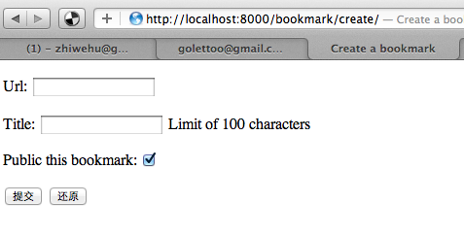

You can see the page display a from with labels, and input text, for the “public” field of Bookmark model, since this field is a Boolean type, it can use a checkbox to display it automatically! You just use the {{ form.as_p }}, and the django form template tag “as_p” will do it. Easy?

Then, let us chick the “input” button without input any data, and you will see:

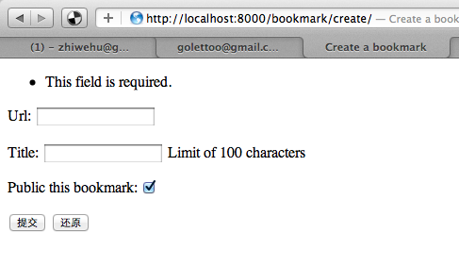

Yeah! Django checked the url field is not allow empty, so, if you forget to input this field, django will valid the data, and return errors.

Now, we input something, for the url input, we just input some text but not a valid url, and you can see:

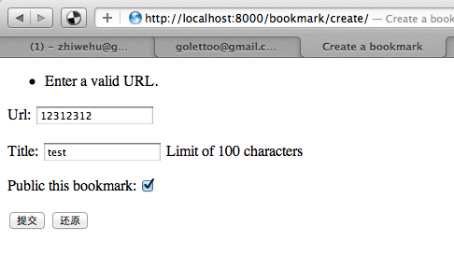

It cannot pass the form.is_valid() method again, and this time, the error is “Enter a valid URL”, cool? Without write 1 code to validate the form data, but django help you to do it!

At the end, let us input some valid data.

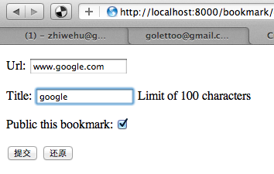

After submit, it’ll redirect to “index” page

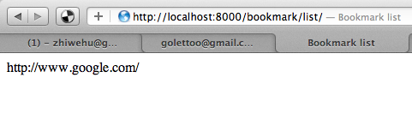

Tips:

We used the return HttpResponseRedirect(reverse('bookmark_list')) # Redirect after POST, it call a reverse method, this method will get the url by name, please check the urls.py, we defined the url like:

url(r'^/index/$', 'bookmark.views.index, name='bookmark_index'),

Define a url name can make django reuse it by name, even you changed the url.

## Define “update” method

Ok, now the latest method is how we update an exist bookmark?

Let’s define the template for “update” (update.html):

|  |
| --- |
| <html>  <head>  <title>Update a bookmark</title>  </head>  <body>  <form action="." method="post">  {% csrf_token %}  {{ form.as_p }}  <input type="submit" />  <input type="reset" />  </form>  </body>  </html> |

Get the bookmark by bookmark_id parameter

Render the bookmark form with the bookmark data

User can update the bookmark data in the form and then submit

If the data in form valid, it’ll update the bookmark and save it to db

Define the url:

|  |
| --- |
| url(r'^/update/(?P<bookmark_id>\d+)/$', 'bookmark.views.update', name='bookmark_update'), |

Let’s see how the views.py looks:

|  |
| --- |
| **def** update(request, bookmark_id):  **try**:  bookmark = Bookmark.objects.get(id=bookmark_id)  **except** Bookmark.DoesNotExist:  **raise** Http404  **if** request.method == 'POST': # If the form has been submitted...  form = BookmarkForm(request.POST, instance=bookmark)  **if** form.is_valid(): # All validation rules pass  bookmark = form.save()  **return** HttpResponseRedirect(reverse('bookmark_list')) # Redirect after POST  **else**:  form = BookmarkForm(instance=bookmark)  **return** render_to_response('update.html',  RequestContext(request, {  'form': form,  })) |

form = BookmarkForm(request.POST, instance=bookmark), the instance is the bookmark which has been exist in db.

Now you can see, the code is very similar with the “create” mehod, even the html template. A Django philosophy is “do not repeat yourself”, so we’ll consider use a common method can handle “create” and “updata” in later chapter.

Summary:

This chapter just implement the very basic concepts for django how to hander request and response data(render data to template). We defined a model, a view which have some methods, some templates to display render data. The urls.py mapping the url and method with some regular expression. And we used the django ModelForm in help us handle user input data in a form.

# Static and media files

## Image and other static files

To configure the static files(javascripts, images and css), we need to define some configuration in settings.py

|  |
| --- |
| # Absolute path to the directory static files should be collected to.  # Don't put anything in this directory yourself; store your static files  # in apps' "static/" subdirectories and in STATICFILES_DIRS.  # Example: "/home/media/media.lawrence.com/static/"  STATIC_ROOT = os.path.join(PROJECT_ROOT, 'site_media', 'static')  # URL prefix for static files.  # Example: "<http://media.lawrence.com/static/>"  STATIC_URL = '/site_media/static/'  # Additional locations of static files  STATICFILES_DIRS = (  os.path.join(PROJECT_ROOT, 'static'),  )  # List of finder classes that know how to find static files in  # various locations.  STATICFILES_FINDERS = (  'django.contrib.staticfiles.finders.FileSystemFinder',  'django.contrib.staticfiles.finders.AppDirectoriesFinder',  ) |

Now we need to create the “static”directory in webapp directory.

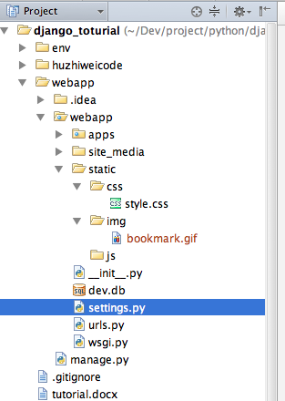

You can see in static directory we defined 3 sub-directoies:

img: store the images for the webapp

css: store the css files

js: store the javascript files

And we need to use these static files in our template html files. For example:

|  |
| --- |
| {% extends "base.html" %}  {% load static %}  {% block main_content %}  <h1>Bookmarks</h1>  <ul>  {% for bookmark in bookmarks %}  <li>{{ bookmark }}</li>  {% endfor %}  </ul>  <img src="{% static 'img/bookmark.gif' %}">  {% endblock %} |

You can see we should add {% load static %} tag to let template know you want to use static, and use {% static 'img/bookmark.gif' %} to load static files.

And let’s see the result in browser.

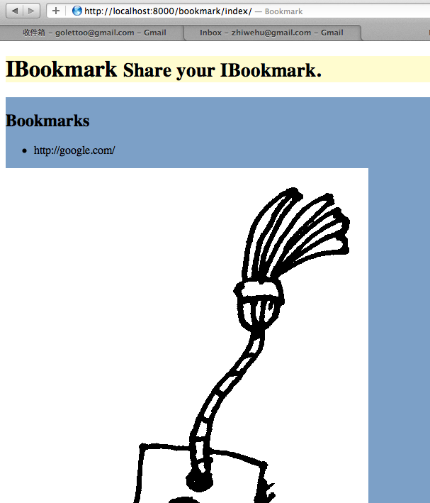

It works!

But please notice we just using “debug=True” mode in our webapp development now, if we set the “debug=False” in production mode, and let we check the result:

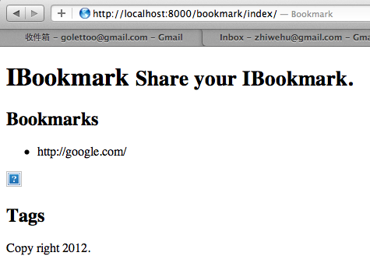

Why?

Since the django will automaticall call a view to serve static files in dev mode(debug=True), the view is:

**django.contrib.staticfiles.views.serve(*request*, *path*)**

from django.conf import settings

**if** settings**.**DEBUG:

urlpatterns **+=** patterns('django.contrib.staticfiles.views',

url(r'^static/(?P<path>.*)$', 'serve'),

)

So if we set the mode to production, it can not works. In production, we’ll use such as httpd web service to handle the static files request. We need to use django admin tool to collect our static files to /site-media/static/

|  |
| --- |
| $ source env/bin/activate  (env)$ cd webapp/  (env)$ python manage.py collectstatic  You have requested to collect static files at the destination  location as specified in your settings.  This will overwrite existing files!  Are you sure you want to do this?  Type 'yes' to continue, or 'no' to cancel: yes  Copying '/Users/jeffrey/Dev/project/python/django_toturial/webapp/webapp/static/css/style.css'  ……  Copying '/Users/jeffrey/Dev/project/python/django_toturial/env/lib/python2.7/site-packages/django/contrib/admin/static/admin/js/admin/RelatedObjectLookups.js'  74 static files copied. |

## CSS file

Let’s write a css file.

|  |
| --- |
| header {  background-color: #fffccf;  }  section {  background-color: #7CA0C7;  width: 80%;  float: left;  }  aside {  background-color: #c9dbed;  width: 20%;  float: left;  }  footer {  background-color: #f6f6f6;  clear: both;  } |

And update the base.html

|  |
| --- |
| <!DOCTYPE HTML>  {% load static %}  <html>  <head>  <link href="{% static 'css/style.css' %}" rel="stylesheet">  <title>Bookmark</title>  </head>  <body>  <header>  <h1>  IBookmark  <small>Share your IBookmark.</small>  </h1>  </header>  <section>  {% block main_content %}{% endblock %}  </section>  <aside>  <h1>  Tags  </h1>  </aside>  <footer>  Copy right 2012.  </footer>  </body>  </html> |

And update index.html to extends this base.html and check the result.

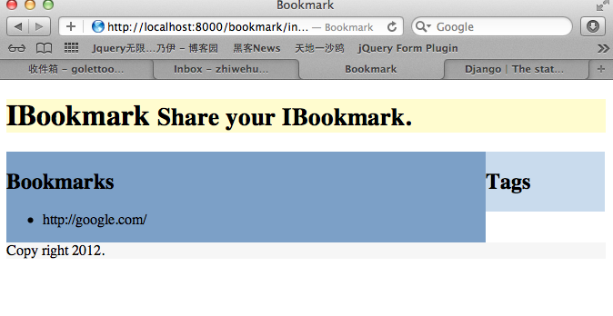

# User authentication

User registration and account management are universal features found in every web application. Users need to identify themselves to the application before they can post and share content with other users. User accounts are also required for activities such as online discussions and friend networks.

The Django authentication system is available in the django.contrib.auth package. It is installed by default as part of Django and projects created with the django-admin.py utility have it enabled by default.

## Creating the login page

Todo

## Enabling logout functionality

Todo

## User registration

Todo

# Message

Todo

# Ajax

Todo

# Bootstrap template

Twitter boostrap is a frontend framework which help use to build web app.

Simple and flexible HTML, CSS, and Javascript for popular user interface components and interactions.

In this chapter, I’ll introduce how to integrate with twitter bootstrap in our webapp.

1. First, we need to download the bootstrap lib from <http://twitter.github.com/bootstrap/> ,now the version is 2.0.4
2. Open the bootstrap.zip, we can found the architecture is same with our static directory.

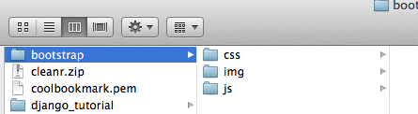

1. Copy the bootstrap directory to our static directory.

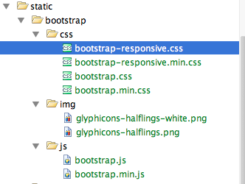

1. Using bootstrap in our base.html template

|  |
| --- |
| <!DOCTYPE HTML>  {% load static %}  {% load i18n %}  <html>  <head>  <link href="{% static 'bootstrap/css/bootstrap.min.css' %}" rel="stylesheet">  <link href="{% static 'bootstrap/css/bootstrap-responsive.min.css' %}" rel="stylesheet">  <title>Bookmark</title>  </head>  <body>  <header>  <div class="navbar">  <div class="navbar-inner">  <div class="container">  <a class="brand" href="{% url bookmark_list %}">{% trans "IBookmark" %}</a>  <ul class="nav">  <li><a href="{% url bookmark_list %}">{% trans "Bookmarks" %}</a></li>  <li><a href="{% url bookmark_create %}">{% trans "Add bookmark" %}</a></li>  </ul>  </div>  </div>  </div>  </header>  <div class="container">  <section>  <div class="page-header">  <h1>Bookmarks  <small>Share your bookmarks!</small>  </h1>  </div>  <div class="row">  <div class="span8">{% block main_content %}{% endblock %}</div>  <div class="span4">Tags</div>  </div>  </section>  <hr />  <footer class="footer">  <p>Copyright 2012</p>  </footer>  </div>  <!-- Le javascript  ================================================== -->  <!-- Placed at the end of the document so the pages load faster -->  <script src="{% static 'bootstrap/js/bootstrap.min.js' %}"></script>  </body>  </html> |

1. And update our index.html

|  |
| --- |
| {% extends "base.html" %}  {% load static %}  {% load i18n %}  {% block main_content %}  <table class="table table-bordered table-striped">  <thead>  <td>{% trans "Title" %}</td>  <td>{% trans "Edit" %}</td>  <td>{% trans "Delete" %}</td>  </thead>  <tbody>  {% for bookmark in bookmarks %}  <tr>  <td><i class="icon-bookmark"></i> <a href="{{ bookmark.url }}">{{ bookmark.title }}</a></td>  <td><i class="icon-edit"></i> <a href="{% url bookmark_update bookmark.id %}">{% trans "Edit" %}</a></td>  <td><i class="icon-remove"></i> <a href="{% url bookmark_delete bookmark.id %}">{% trans "Delete" %}</a></td>  </tr>  {% empty %}  <tr>  <td colspan="3">{% trans "No data" %}</td>  </tr>  {% endfor %}  </tbody>  </table>  {% endblock %} |

And now let’s see the result.

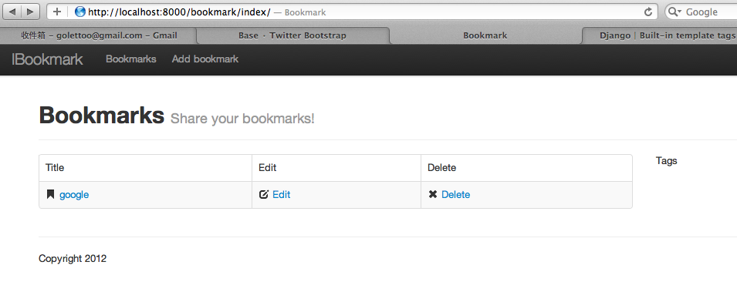

Cool now?

And update others html templates also to extend the base.html

# Scaffold

todo

# EC2 (apache, MySQL)

In this chapter, we’ll deploy our webapp on amazon ec2 host, with apache httpd web server, and use the mysql database.

-- Login ec2

$ ssh -i your_ec2.pem ec2-user@your_ec2_ip_or_hostname

-- Update ec2

$ sudo yum update -y

$ sudo yum install gcc python-devel -y

-- Install git

$ sudo yum install git -y

-- Check out code from git server

$ cd /home/ec2-user

$ git clone git://github.com/zhiweihu/django_toturial.git

-- Install apache httpd and mod_wsgi, mod_ssl

$ sudo yum install httpd mod_wsgi mod_ssl -y

-- Config httpd server

$ sudo vi /etc/httpd/conf.d/wsgi.conf

[Add the below content to the end of the file]

#----------Begin----------#

LoadModule wsgi_module modules/mod_wsgi.so

WSGISocketPrefix run/wsgi

WSGIDaemonProcess django_toturial python-path=/home/ec2-user/django_toturial /env/lib64/python2.6/site-packages

WSGIProcessGroup django_toturial

#-----------End-----------#

$ sudo vi /etc/httpd/conf/httpd.conf

[Change "User apache" to "User ec2-user"]

[Add the below content to the end of the file]

#----------Begin----------#

WSGIScriptAlias / /home/ec2-user/ES_V2/webapp/wsgi.py

Alias /site_media/ /home/ec2-user/ES_V2/webapp/site_media/

#-----------End-----------#

-- Install mysql and create user/password

$ sudo yum install mysql mysql-server mysql-devel -y

$ sudo service mysqld start

$ sudo mysqladmin -u root password Your_password

$ mysql -u root -p

[Input the password, then we use the mysql console]

mysql> CREATE DATABASE tutorial_db;

Query OK, 1 row affected (0.00 sec)

mysql> GRANT ALL PRIVILEGES ON tutorial_db.* TO "youruser"@"localhost" IDENTIFIED BY "password";

Query OK, 0 rows affected (0.00 sec)

mysql> FLUSH PRIVILEGES;

Query OK, 0 rows affected (0.00 sec)

mysql> EXIT

Bye

-- Install virtualenv for python

$ sudo easy_install virtualenv

-- Use virtualenv to install django

$ cd /home/ec2-user/django_tutorial

$ virtualenv env

$ source env/bin/activate

[Now we use the virtualenv to do something, do not print the (env)$ on your console]

(env)$ pip install -r webapp/requirement.txt

-- Settings for production

[Edit "settings_local.py" to save the db settings for production]

DATABASES = {

'default': {

'ENGINE': 'django.db.backends.mysql',

'NAME': 'tutorial_db',

'USER': 'youruser',

'PASSWORD': 'password',

'HOST': '',

'PORT': '',

}

}

-- Sync db and collect static files

(env)$ python manage.py syncdb

(env)$ python manage.py collectstatic

-- Restart the apache http server

$ sudo /etc/init.d/httpd restart

# Todo

注意：修改注意同步修改代码和教程

1. 完成静态文件，bootstrap模板，ec2配置等必要章节
2. Show view方法，弄复杂点，最好能显示bookmark的属性

第二次迭代：

1. 修改model，增加foreginkey的使用演示
2. 简单介绍如何用命令行和控制台调试model，包括如何get objects等等
3. 再介绍show和delete的时候，index。Html模板里面演示如何插入链接来调用show和delete
4. 增加message，ajax，scaffold等章节