**Transaction code – J1IS**

Click on create

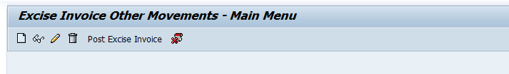

As shown as below screen🡪 Enter below mandatory details and enter.

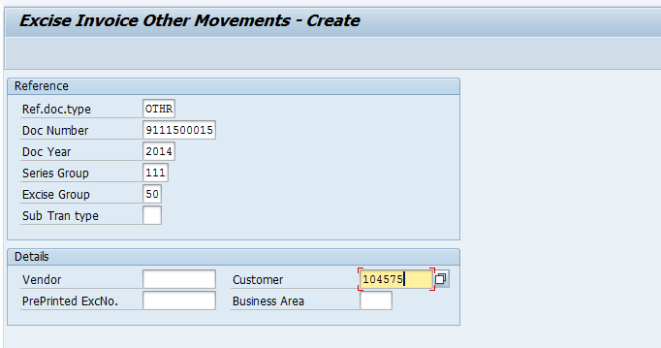

Click on Insert tab

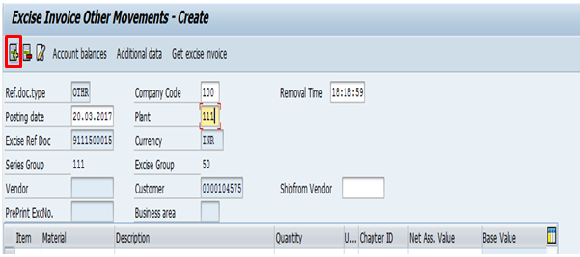

As shown as below screenshot🡪 Enter manually 🡪Material –Material description – Qty –UOM—Chapter ID and Net value…

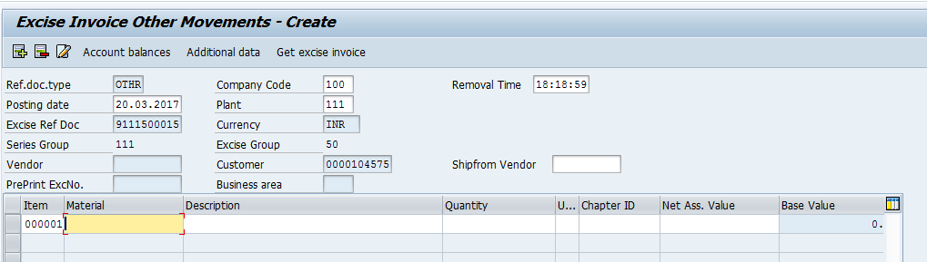

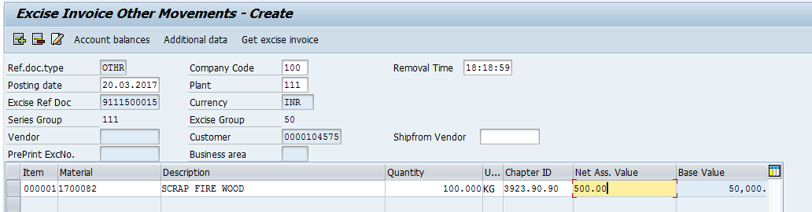

Enter BED %

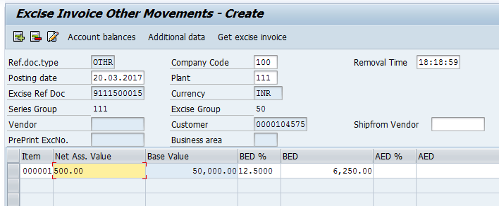

Scroll right side and enter ECS and E Cess.

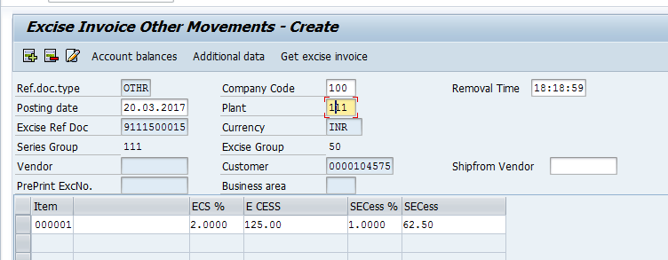

Then enter and check the excise value and SAVE.

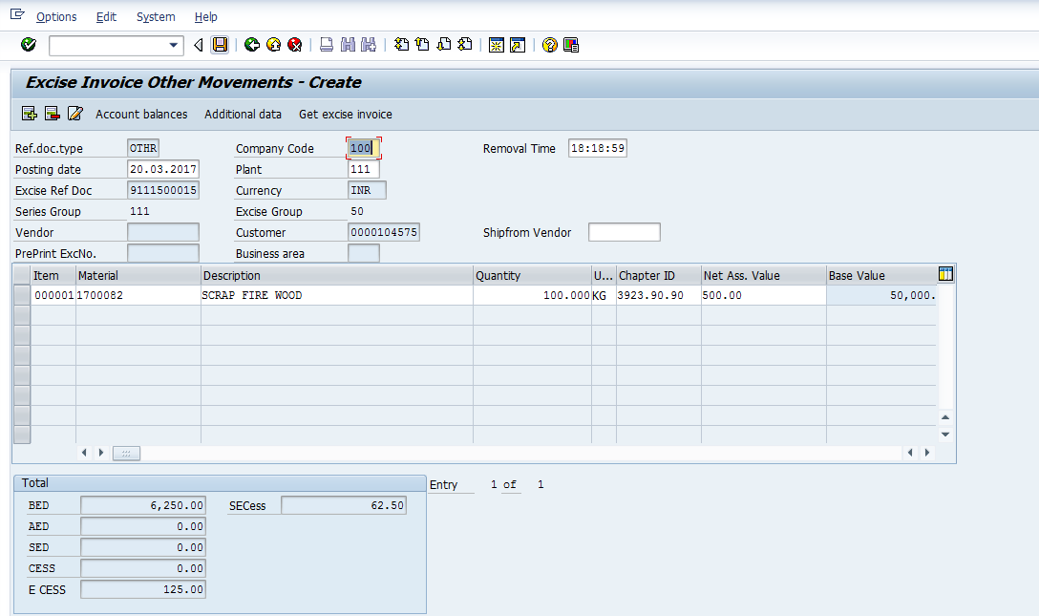

You will get the document no.

