**CIVIL FOUNDATION RELIABILITY**-

**PUMP FOUNDATIONS**. –

We have study reliability of rotary and static equipment foundation at Taloja Unit. We are taken the mechanical reports/ help regarding s find the equipment health and their performance to compare health of civil foundation.

Some Major pump foundations are found damaged so that they can causes regular breakdown.

Foundation details as follows-

|  |  |  |  |  |  |  |  |  |  |
| --- | --- | --- | --- | --- | --- | --- | --- | --- | --- |
| **Tag No** | **Model** | **Sr.no.** | **location** | **Q (m3/hr)** | **H (m)** | **RPM** | **Power (KWH)** | **Size** | **Problems observed** |
| 01G4 A | 2K 6x4-13 A | 20495 | FAP | 154.44 | 68 | 2900 | 55 | 2.2x1.2x0.05 | Damaged grouting / refractory of foundation |
| 01G4 B | 2K 6x4-13 A | 20496 | FAP | 154.44 | 68 | 2900 | 55 | 2.2x1.2x0.05 | Damaged grouting / refractory of foundation |
| 01G1 A | CPK EYM 125-200 | 352444 | FAP | 140 | 13 | 1465 | 55 | 2.2x1.2x0.05 | Damaged grouting / refractory of foundation |
| 01G1 B | CPK EYM 125-250 | 352437 | FAP | 140 | 13 | 1465 | 55 | 2.2x1.2x0.05 | Damaged grouting / refractory of foundation |
| P-308 A | CPK-C-125-315 | 550541 | DFA | 170 | 30 | 1450 | 18.5 | 2.3x1.3x0.03 | Vibration on final grouting portion of foundation |
| P-308 B | CPK-C-125-315 | 550542 | DFA | 170 | 30 | 1450 | 18.5 | 2.3x1.3x0.03 | Vibration on final grouting portion of foundation |

**P-01G1A and P-01G1B –** **–** FAP PROCESS PUMP

**OBSERVATION –**

* Acid proof refractory was removed during regular maintenance of mechanical work.
* Oil, grease and process materials are continuously poured in to foundation through damaged tiles.
* We found some cracks on final grouting of foundation.
* Detoration of grouting is found due to the leakages.
* Vibrations are found slightly more than the normal foundation vibration.

**CONCLUSION –**

Grouting of pump will replace by epoxy grouting for increase the life and resist the earlier causes of failure.

**Estimation and Costing –**

Estimating cost for fairmate epoxy grouting for the each pump is 0.60 Lac

**Duration of work –**

For rectifying the same total 3 days required for each pump with all respect.

**P-01G1A and P-01G1B –** FAP PROCESS PUMP

**OBSERVATION –**

* Acid proof refractory was removed during regular maintenance of mechanical work.
* Oil, grease and process materials are continuously poured in to foundation through damaged tiles.
* We found some cracks on final grouting of foundation.
* Detoration of grouting is found due to leakages.

**CONCLUSION –**

Grouting of pump will replace by epoxy grouting for increase the life and resist the earlier causes of failure.

**Estimation and Costing –**

Estimating cost for fairmate epoxy grouting for the each pump is 0.60 Lac

**Duration of work –**

For rectifying the same total 4 days required for each pump with all respect.

**P-308A and P-308B –** DFA PUMP

**OBSERVATION –**

* Damaged existing grouting of pump
* Oil, grease and process materials are continuously poured in to foundation through damaged tiles.
* We found some cracks on final grouting of foundation.
* Detonation of grouting is found due to leakages of steam, hot water etc.
* Current pump frame is big but only four foundation bolt are fixed on concrete. Due to this in the middle of foundation is vibrating very severely.
* Final grouting gap is very less. It is near about average 20 to 30 mm thick.

**CONCLUSION –**

Grouting of pump will replace by epoxy grouting for increase the life and resist the earlier causes of failure.

**Estimation and Costing –**

Estimating cost for fairmate epoxy grouting for the each pump is **0.60 Lac**

**Costing for 6 Nos Pump Foundation grouting-**

|  |  |  |  |  |  |  |  |  |  |
| --- | --- | --- | --- | --- | --- | --- | --- | --- | --- |
| **Tag No** | **Model** | **Sr.no.** | **location** | **Q (m3/hr)** | **H (m)** | **RPM** | **Power (KWH)** | **Size** | **Costing Rs.** |
| 01G4 A | 2K 6x4-13 A | 20495 | FAP | 154.44 | 68 | 2900 | 55 | 2.2x1.2x0.05 | 60000 |
| 01G4 B | 2K 6x4-13 A | 20496 | FAP | 154.44 | 68 | 2900 | 55 | 2.2x1.2x0.05 | 60000 |
| 01G1 A | CPK EYM 125-200 | 352444 | FAP | 140 | 13 | 1465 | 55 | 2.2x1.2x0.05 | 60000 |
| 01G1 B | CPK EYM 125-250 | 352437 | FAP | 140 | 13 | 1465 | 55 | 2.2x1.2x0.05 | 60000 |
| P-308 A | CPK-C-125-315 | 550541 | DFA | 170 | 30 | 1450 | 18.5 | 2.3x1.3x0.03 | 60000 |
| P-308 B | CPK-C-125-315 | 550542 | DFA | 170 | 30 | 1450 | 18.5 | 2.3x1.3x0.03 | 60000 |

Total Costing- **3.60 Lac**

**PLANT STRUCTURAL RELIBILITY-**

We have maintaining the painting records of plant structure at Taloja location.

As per records and physical look out we observed some critical are which is affected the existing structure. They are badly corroded.

Detail of structure as follows.

**STRUCTURAL PLATFORM AND PIPERACK BEHIND THE DFA PLANT** –

**OBSERVATION –**

1. Existing structure of pipe rack is corroded due to continue spillages of steam condensate, water, oil and fatty acid.
2. These structures are open to atmosphere. No roof over the structure to protect weather.
3. Some structure was painted before 5 years and some part of structure was painted before 10 years.

**CONCLUSION -**

1. We have identified these area and to avoid the further corrosion need to painted anticorrosive protection treatments,
2. THE TREAMENT INVOLVED-

* Surface cleaning by wire brush, mechanical tools etc.
* Applying of 100 microns thick one coat of Berger protectomastic..
* Applying one coat of MIO( 100 MICRONS)
* Two coat of Berger epoxy paints of appropriate Colours( 2 x35-40 Microns)

**Costing –**Affected area is approximate 1200 SQM @ Rs350 including scaffolding etc. Hence estimated cost of painting structure **is 4.2 lac**

**PLANT EQUIPMENT RELIBILITY.CORROSION CONTROL-**

As per records and physical look out we observed some critical are which is affected the existing structure. They are badly corroded.

Detail of structure as follows.

1. **UNDERGROUND WEIGHTBRIDGE–**

**OBSERVATION –**

1. WB bed platform are corroded due to underground mud stick on portion during rainy season
2. These structures are open to atmosphere. No roof over the structure to protect weather.
3. Existing structure was last painted before 10 years.

**CONCLUSION -**

1. We have identified these area and to avoid the further corrosion need to heat and weather resistant paint
2. THE TREAMENT INVOLVED-

* Surface cleaning by wire brush, mechanical tools etc.
* Applying of 100 microns thick one coat of protectomastic primer
* Applying two coat of tar coal paint of total 200 microns thick.

1. **HRSG ECONOMISER CHIMNEY AT CPP –**

**OBSERVATION –**

1. Existing Chimneys are corroded due to continuous working on heats.
2. These structures are open to atmosphere. No roof over the structure to protect weather.
3. Chimney was painted before 5 years.

**CONCLUSION -**

1. We have identified these area and to avoid the further corrosion need to heat and weather resistant paint
2. THE TREAMENT INVOLVED-

* Surface cleaning by wire brush, mechanical tools etc.
* Applying of 250 microns thick three coat of HR 250 paint...
* Applying one coat of protectomastic (100 Microns and MIO( 100 MICRONS) on railing and working platform and Two coat of Berger epoxy paints of appropriate Colours( 2 x35-40 Microns)

**Costing –**

Estimated cost of painting for each chimney is **2.00 lac**

1. **HYDROGEN STACK AT LINDE–**

**OBSERVATION –**

1. Existing Chimneys are corroded due to continuous working on 250 Degree.
2. These structures are open to atmosphere. No roof over the structure to protect weather.
3. Chimney was painted before 5 years.

**CONCLUSION -**

1. We have identified these area and to avoid the further corrosion need to heat and weather resistant paint
2. THE TREAMENT INVOLVED-

* Surface cleaning by wire brush, mechanical tools etc.
* Applying of 250 microns thick two coat of HR 250 paint...

**costing –**

Estimated cost of painting for each chimney is **0.5 lac**

1. **THERMIC FLUID STORAGE TANK**–

**OBSERVATION –**

1. Existing structure of tank is corroded due to earlier not painted.
2. These structures are open to atmosphere. No roof over the structure to protect weather.

**CONCLUSION -**

1. We have identified these area and to avoid the further corrosion need to painted anticorrosive protection treatments,
2. THE TREAMENT INVOLVED-

* Surface cleaning by wire brush, mechanical tools etc.
* Applying of 100 microns thick one coat of Berger protectomastic..
* Applying one coat of MIO( 100 MICRONS)
* Two coat of Berger epoxy paints of appropriate Colours( 2 x35-40 Microns)

**Costing –**

Affected area is approximate 1200 SQM @ Rs350 including scaffolding etc. Hence estimated cost of painting structure is **0.50 lac**

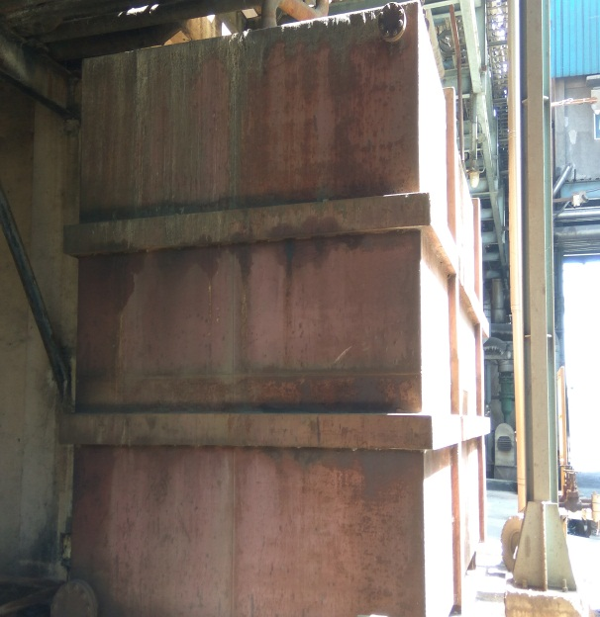 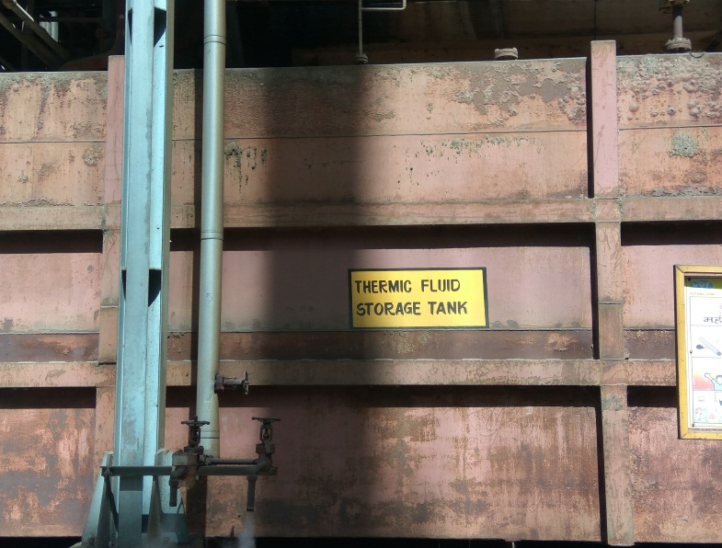

**OVERALL COSTING-**

|  |  |  |
| --- | --- | --- |
| **Sr.No** | **Descriptions** | **Amount Rs.** |
| **1** | **STRUCTURAL PLATFORM AND PIPERACK BEHIND THE DFA PLANT** | **420000/-** |
| **2** | **HRSG ECONOMISER CHIMNEY AT CPP** | **200000/-** |
| **3** | **UNDERGROUND WEIGH BRIDGE -1** | **50000/** |
| **3** | **HYDROGEN STACK AT LINDE** | **75000/-** |
| **4** | **THERMIC FLUID STORAGE TANK** | **50000/-** |

**TOTAL COST- 7.95 LAC**

**FAP BOILER CHIMNEY – 1 NOS**.DONE ON 10TH MARCH 2017.

**OBSERVATION –**

1. Existing Chimneys are corroded due to continuous working on heats.
2. These structures are open to atmosphere. No roof over the structure to protect weather.
3. Chimney was painted before 10 years.

**CONCLUSION -**

1. We have identified these area and to avoid the further corrosion need to heat and weather resistant paint
2. THE TREAMENT INVOLVED-

* Surface cleaning by wire brush, mechanical tools etc.
* Applying of 250 microns thick three coat of HR 400 paint...
* Applying one coat of protectomastic (100 Microns and MIO( 100 MICRONS) on railing and working platform and Two coat of Berger epoxy paints of appropriate Colours( 2 x35-40 Microns)

**Costing –**

Estimated cost of painting for each chimney is **3.0 lac.**

