1. Go to Transaction code – XD03 or FD03 or VD03 – Display Customer Masters

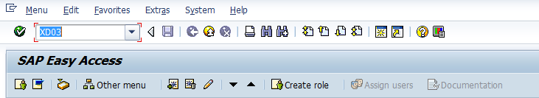

1. Fill up the Mandatory details for e.g. customer code & sales area details 🡪 then enter

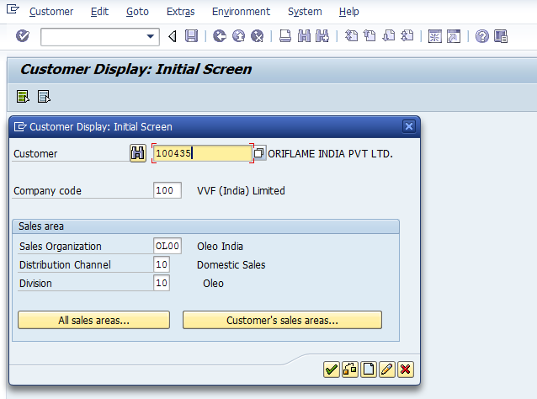

1. After enter as shown as below screen🡪 Customer master have 3 Part – General data / Company code data / Sales area Data 🡪 go to General data.

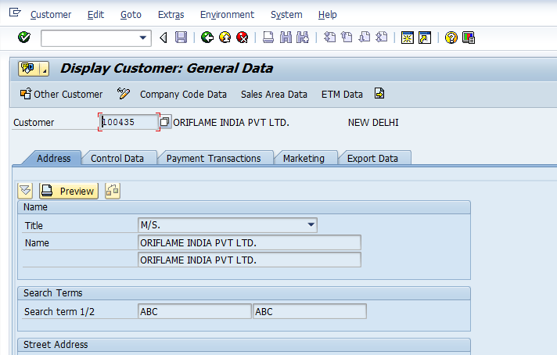

1. Click on symbol of **“Services for Object” OR** go to menu path 🡪 System🡪 **“Services for Object”**

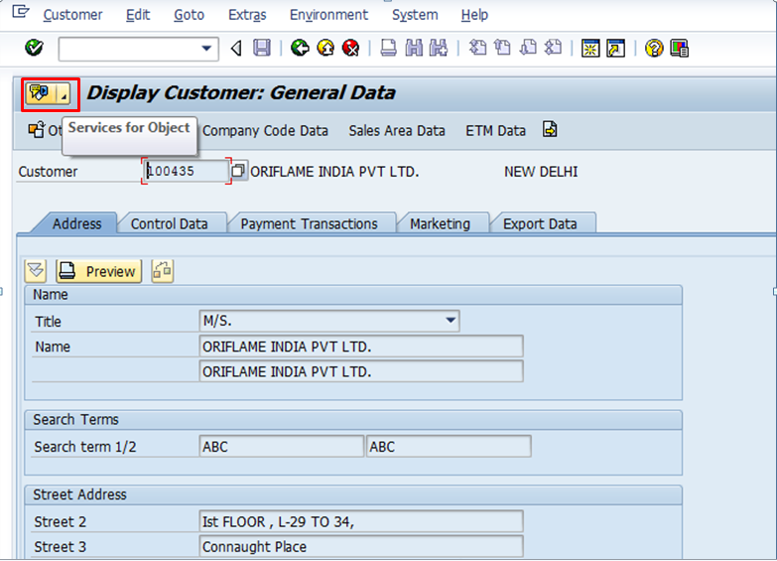

Go to menu path 🡪 System🡪 **“Services for Object”**

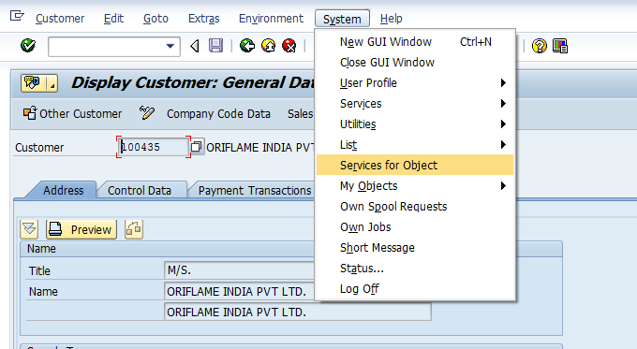

1. Go to Create 🡪Create the Attachment and attached the documents.

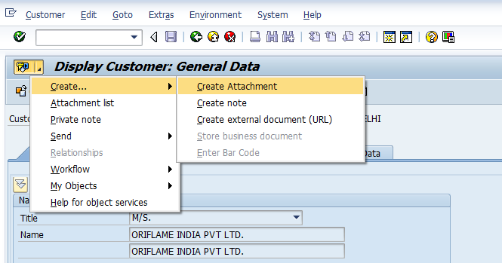

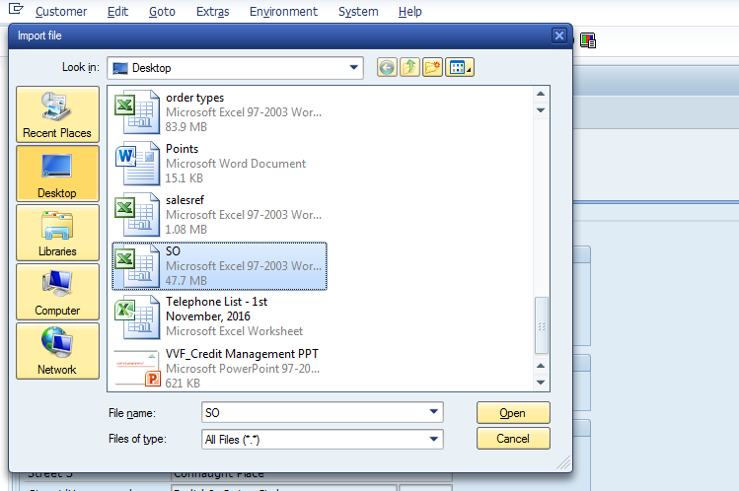

1. Go to the attachment List and check your attached document in customer master

