**KHRONE MAGNETIC FT(ETP)**

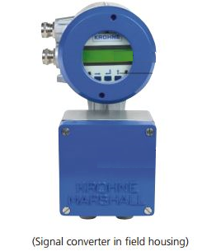

Horizontal Key Enter Key Up key

1. Press Horizontal key for code 1 at initial point

Password is

This will not allow access F50. This will allow accessing only F10, F20, and F30.

1. Press Enter Key for code 2 at initial point
2. Password is
3. Now F10 will display on screen,

Press Horizontal keys to insert F10 function, Again press horizontal key

* F111 ( Full scale)
* F112 (Time Constant)
* F113(Low Freq. Cut )
* Press  enter key for exit till F10

1. Press  UP key for Function F20 then press horizontal key to insert F20.
2. Press  up key to insert F120

* F121 (Flow Unit)
* F122 ( Bar graph NO)
* F123 (Tot. Unit M3)
* F124 ( + total display)
* F125 ( - Total display)
* F126 ( Sum total display NO)
* F127 ( Velo. Unit m/sec)
* F128 ( Error message YES)
* F129 ( Cycle display YES)

1. Press  enter key for exit till F10 after then again press enter  up key 2 times to for F30 then press  key to insert F320

* F302 ( User data)
* F321 ( Tot. reset)
* F322 ( Tot. ON)
* F323 (Entry code YES)
* F324 ( Zero set )
* F325 ( Empty Pipe NO)

1. Press  enter key for exit till F10 after then again press enter  up key 3 times to for F50( Service) then press  key to insert F510 then press  up key

* F511 (Version 3.2) press  enter key
* F512 (Set Confi.) press  up key up to all data
* Now press  enter key up to F10 then again press  enter key it will ask change the data then with the help of up key select Yes or No.
* Wait for few second changes data updated

1. Press  enter key for exit till F10 after then again press enter key it will ask change the data then with the help of up key select Yes or No.