|  |
| --- |
| VVF (india) limited |
| BITUMEN PROJECT |
| Preliminary Report |
|  |
| **Oleochemicals Division** |
| **2/17/2017** |

|  |
| --- |
| [Type the abstract of the document here. The abstract is typically a short summary of the contents of the document. Type the abstract of the document here. The abstract is typically a short summary of the contents of the document.] |

Contents

1. Introduction 2

2. Properties 2

2.1. Engineering Properties of Bitumen 3

2.2. Production Process 3

3. Packaging & Transportation 5

3.1.1. Bulk Bitumen 5

3.1.2. Drummed Bitumen 5

3.1.3. Others 6

4. Types of Bitumen 7

4.1. Paving Grade Bitumen (Viscosity Grade) 7

4.1.1. Advantages of Bituminous Roads 8

4.2. Bitumen Emulsion (BE) 9

4.3. Rubber modification 10

4.3.1. Crumb Rubber Modified Bitumen (CRMB) 11

4.4. Cutback 11

5. Market 13

5.1. Global Scenario 13

5.2. Domestic Scenario 14

Annexure 1: Bitumen Prices 17

Annexure 2: Bitumen Prices Graphs 19

# Introduction

Petroleum bitumen is known by different names throughout the world. For example the term “bitumen” is typically used in Europe and is synonymous with the term “asphalt”, or “asphalt binder” used in North America. Outside North America, the term “asphalt” is used to describe mixtures of bitumen with mineral materials. In this document the term bitumen will be used to represent all bitumen and products manufactured.

It is last residue of Crude Oil treated to produce Bitumen. It is defined as a viscous liquid, or a solid consisting essentially of hydrocarbons and their derivatives, which is soluble in carbon disulphate.

**Composition**

* It is depends on origin of Crude Oil and refining process
* It is extremely complex. Astronomically large number of molecules with different chemical structures. Not feasible to attempt a complete analysis of bitumen

*Elemental composition provide little information of the types of molecular structure present*

|  |  |
| --- | --- |
| Element | Composition |
| Carbon | 80.2-84.3% |
| Hydrogen | 9.8-10.8% |
| Sulphur | 0.9%-6.6% |
| Oxygen | 0.4%-1.0% |
| Nitrogen | 0.2-1.2% |

Source:  *Asphalt Institute and Eurobitume*’s report The Bitumen Industry Global Perspective, 2015

# Properties

# Engineering Properties of Bitumen

* A visco-elastic material: Deformation under stress a function of temperature and loading time.
* At high temperature and loading it behaves as viscous liquid, whereas at very low temperature or low loading it behaves as elastic solids
* In the intermediates range of temperatures / pressures, more typical of the conditions in road service, bitumen has visco-elastic behavior.

# Production Process

Bitumen is primarily obtained by vacuum distillation of crude oil or blends of crude oil. It comprises the non-distillable fraction, often technically referred to as (vacuum) residue. In its simplest form bitumen manufacturing separates the lighter, low boiling point fractions from crude oil resulting in product with high boiling point, high molecular weight with very low volatility. Properties and quality of bitumen depend mainly on the crude oil(s) used in its manufacture. It is produced to grade specification either directly by refining or by blending. Bitumen can be further processed to alter its physical properties in order meet certain specifications.

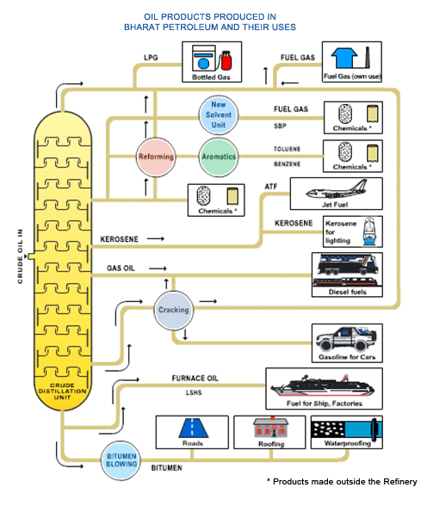

**Source: Bharat Petroleum Corporation Limited, India.**

**Produced by fractional distillation of Crude Oil**

* Crude Oil heated to 300-350 0C in distillation column. Lighter fractions separated at different column heights. Bottom product called Long Residue
* Long Residue heated upto 450 0C in vacuum distillation column. Bottom Residue (short residue) used for manufacturing Bitumen
* Hot air is blown through short residue or blended with superior quality bottom products to achieve desired consistency / penetration.

# Packaging & Transportation

# Bulk Bitumen

Bulk Bitumen is available for road transportation. It is carried in 22 MT or 2o MT tankers/ vessels.

# Drummed Bitumen

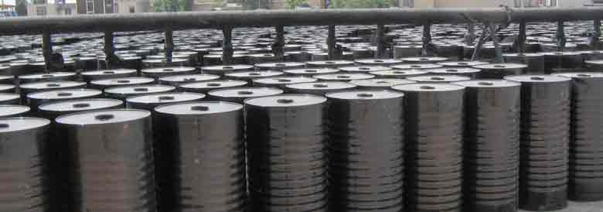

**Drum Specification and capacity of various sizes**

|  |  |  |  |
| --- | --- | --- | --- |
| Description | 150 KG | 180 KG | 200 KG |
| Plate Thickness (Body) | 0.6±0.02 MM | 0.6±0.02 MM | 0.8±0.02 MM |
| Plate Thickness (Top & Bottom) | 0.6±0.02 MM | 0.6±0.02 MM | 0.8±0.02 MM |
| Height | 86±2 CM | 98±2 CM | 98±2 CM |
| Diameter | 50 CM | 50 CM | 55 CM |
| Lid Hole Position | Center | | |
| Lid Hole Diameter | 10±1 CM | 10±1 CM | 10±1 CM |
| Net Filling Capacity | 147±3 KG | 182±3 KG | 200±3 KG |
| Gross Weight | 154±3 KG | 192±3 KG | 215±3 KG |
| Drum Tare Weight | 7.0±0.1 KG | 9.5±0.1 KG | 16.0±0.2 KG |
| Color | Glossy Black | | |
| Loading in 20ft Container – With Pallet | | | |
| Number of Drums | 80 | 80 | 80 |
| Net Weight of Bitumen | ≈ 12.00 MT | ≈ 14.40 MT | ≈ 16.00 MT |
| Loading in 20ft Container – Without Pallet | | | |
| Number of Drums | 110 | 110 | 96 |
| Net Weight of Bitumen | ≈ 16.50 MT | ≈ 19.80 MT | ≈ 19.20 MT |
| * Drums supplied will be of good workmanship and are sufficiently leak-proof when filled with hot bitumen. DIN 1623 ST12 new cold rolled a grade steel | | | |

# *Source: Nuroil Trading FZE*

# Others

Innovative packaging types like polybags although are available, are not preferred in India due to the hot climate which results to melting of the bags.

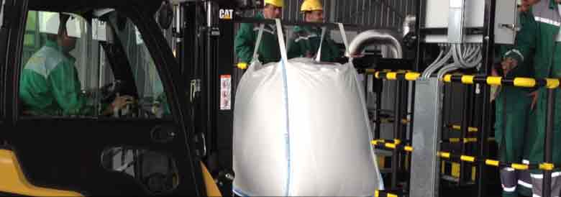

**Polybag Specification and capacity of various sizes**

|  |  |  |  |
| --- | --- | --- | --- |
| Capacity | 40 Kg | 300 Kg | 1 Ton |
| Filling quantity for Bitumen (net) | 40 kg | 300 kg | 1,000 Kg |
| Materials | | | |
| Outer bag | - | PP Fabric | PP Fabric |
| Inner Liner | Polyethylene | Polyethylene | Polyethylene |
| Melting peak inner bag (liner) | 125°C /257°F | 137°C / 279°F | 137°C / 279°F |
| Storage under roof | 6-12 Months | 6-12 Months | 6-12 Months |
| Multiuse of outer bag | No | No | No |
| Loading in 20Ft Container | | |  |
| Number of Bags | TBD | 80 | 20 |
| Quantity of Bitumen - Net Weight | ≈  20.00 MT | ≈  24.00 MT | ≈  20.00 MT |

# *Source: Nuroil Trading FZE*

Note:

* *Handling of bitumen in India is still done mostly by using traditional methods, which includes heating of bitumen drums in open on-site, no usage of decanters, etc. The GoI has issued norms and regulations to curb these problems and facilitate the eco-friendly application methods of bitumen.*

# Types of Bitumen

* Conventional Bitumen
  + Paving Grade Bitumen
  + Industrial Grade Bitumen
* Bitumen Emulsions
* Modified Bitumen
  + Crumb Rubber Modified Bitumen (CRMB)
  + Natural Rubber Modified Bitumen (NRMB)
  + Polymer Modified Bitumen : Triene – Butadiene – Styrene (PMB-SBS)
* Liquid Bitumen (Cutback)
* Others

Diagrammatic representation



*Source: Asphalt Institute and Eurobitume*

# Paving Grade Bitumen (Viscosity Grade)

* Bitumen is a thermoplastic material and its stiffness is dependent on temperature. The temperature-vs-stiffness relationship of bitumen is dependent on the source of crude oil and the method of refining.
* The Bureau of Indian Standards (BIS) introduced paving grade bitumen specifications (IS: 73-1950) for the first time in the year 1950 and classified it on penetration. The specifications were revised in the years 1962 and 1992. To improve the quality of Bitumen, BIS revised IS-73-1992 specifications based on Viscosity (Viscosity at 60oC) in July 2006. As per these specifications, there are four grades VG-10, VG-20, VG-30 & VG-40. A few qualification tests like specific gravity, water content, ductility, loss on heating & Farass breaking point were removed from IS: 73-1992 specifications as these tests do not have any relationship either with the quality or performance of the product.
* Indian Oil commenced marketing of Bitumen as per Viscosity Grade specifications conforming to IS: 73-1992 from all its refineries from Aug 2009. Therefore, the Penetration grades have been replaced by Viscosity grade Bitumen. According to viscosity (degree of fluidity) grading, higher the grade, stiffer the Bitumen. Tests are conducted at 60o C and 135o C, which represent the temperature of road surface during summer (hot climate, similar to northern parts of India) and mixing temperature respectively. The penetration at 25o C, which is annual average pavement temperature, is also retained.
* Different Grades of Bitumen
* VG-10 BITUMEN: VG-10 is widely used in spraying applications such as surface-dressing and paving in very cold climate in lieu of old 80/100 Penetration grade. It is also used to manufacture Bitumen Emulsion and Modified Bitumen products.
* VG-20 BITUMEN: VG-20 is used for paving in cold climate & high altitude regions
* VG-30 BITUMEN: VG-30 is primarily used to construct extra heavy duty Bitumen pavements that need to endure substantial traffic loads. It can be used in lieu of 60/70 Penetration grade.
* VG-40 BITUMEN: VG-40 is used in highly stressed areas such as intersections, near toll booths and truck parking lots in lieu of old 30/40 Penetration grade. Due to its higher viscosity, stiffer Bitumen mixes can be produced to improve resistance to shoving and other problems associated with higher temperature and heavy traffic loads.

# Advantages of Bituminous Roads

* Initial Saving : Fast Construction + Low Cost

**Selection of Grade of Bitumen**

* Choice of Bitumen is based on
* Climatic Conditions – Maximum & Minimum temp. & rainfall
* Intensity of Traffic – Number of vehicles per day and axle load of vehicles.
* Ageless – Rehabilitation is inexpensive
* Stage Construction – in ribbons, not in slabs
* Safe : High Skid resistance + Good Visibility
* Better riding quality less wear and tear of vehicle, low noise while cruising
* Can be fully recycled

# Bitumen Emulsion (BE)

An emulsion is a dispersion of one immiscible liquid in another, stabilised by an emulsifier. In a typical bitumen emulsion the bitumen is dispersed in water and the emulsion is stabilised with a surface active agent (surfactant) which is tailored to the intended use of the emulsion. The dispersed droplets may have a net electrical charge which can be positive, negative, or uncharged depending upon the surfactant employed. The binder can be either bitumen, a cutback, or modified bitumen.

**Bitumen Emulsion**

**(Free Flowing Dark Brown Liquid)**

**Bitumen**

**(Dispersed Phase)**

**Emulsifier / Additives**

**Water**

**(Continuous phase)**

*Source: Asphalt Institute and Eurobitume*

**Process**

* Emulsification bitumen milled into fine particles & held in molecular spaces of water
* Use of correct emulsifier / chemicals facilitate proper emulsification

**Significance**

* Economy
* All weather application (ideal for monsoon applications)
* Worker friendly
* Environment friendly
* Efficiency

**Types**

* Rapid Setting
* Medium Setting
* Slow Setting

**Applications**

* Pot hole repairs
* Tack coat
* Prime coat
* Surface dressing
* Premix / liquid seal coat
* 20 mm premix carpet
* Fog spray/fog seal/slury seal

# Rubber modification

Polymer modification is widely used with polymers added to bitumen for many reasons. Natural and

synthetic polymers have been used since the early 20th century to improve bitumen properties. Since the mid-1960s many polymers have been used in bitumen to enhance its properties:

* Natural Polymers (e.g. Lignin)
* Thermoplastics/plastomers (e.g. polypropylene, polyethylene, ethylene vinyl acetate)
* Elastomers (e.g. natural rubber, synthetic rubber, polybutadiene, butyl rubber)
* Thermoplastic Elastomers (e.g. styrenic block copolymers, polyolefin blends, thermoplastic polyurethane)
* Ground Tyre Rubber (e.g. reclaimed scrap tires)

Polymer additives generally range from 1 %m to typical levels of 3 %m, to as much as 7 %m of the total binder for some applications. Of those listed above, thermoplastic elastomers account for largest use of polymers in bitumen modification. These products typically stiffen bitumen at high temperatures and make bitumen less brittle at low temperatures with their rubber characteristics giving bitumen the best blend of properties to address desired performance characteristics depending on end use.

Ground tyre rubber (crumb rubber), which has been used regionally for approximately 30 years, can range from as little as 5 %m to as much as 20 %m of the total binder, depending on the properties being targeted. Within the past five years efforts to eliminate stockpiles of discarded tyres have resulted in more widespread use of crumb rubber in bituminous blends.

**Modifiers under use**

**Polymers**

**Rubbers**

**Plastics**

**Thermoplastic**

**EVA**

**Natural Rubber**

**Crumb Rubber**

**Plain**

**Chemically Treated**

**Synthetic Elastomers SBS, SBR etc.**

# Crumb Rubber Modified Bitumen (CRMB)

It is Conventional Bitumen with treated Crumb Rubber Additive at high temperature which results in –Lower susceptibility to temperature variation –Higher resistance to deformation at high temperature –Better Age Resistance Properties –Higher Fatigue Life of Mixes –Better Adhesion Properties

**Significance**

* Be compatible with Bitumen.
* Blend with Bitumen properly & thoroughly.
* Improve temperature resistance of Bitumen.
* Resist degradation of bituminous mix.
* Be capable of being processed by conventional mixing plants and laying machinery. Produce coating viscosity at application temp.
* Maintain premium properties during storage, application and in service.
* Be cost-effective considering life cycle cost.

# Cutback

These are products whose viscosity has been reduced or “cutback” by the addition of a volatile cut-back solvent, such as petroleum naphtha, white spirit (Stoddard solvent), kerosene, or gas oil.

Fluxed bitumen (see glossary for a definition) generally uses a relatively non-volatile solvent oil which softens the bitumen without increasing the volatility of the bitumen.

# Market

# Global Scenario

According to *Asphalt Institute and Eurobitume*

* During 2015, global production of bitumen is approximately 87 Million tonnes per year. The chart below shows estimated bitumen use and application by sector. There are more than 250 known applications of bitumen, with the majority of bitumen being used in paving and roofing applications:
* 85% of all the bitumen is estimated to be used as the binder in various kinds of asphalt pavements: pavements for roads, airports, parking lots.
* About 10% of the bitumen is estimated to be used for roofing: shingles, hot applied built up roofing, cold applied roll on roofing.
* The remaining part (approximately 5% of the total), is used for a variety of applications each small in volume: e.g. sound deadening, water pipe coating, bitumen paints, waterproofing and sealing materials. This sector is referred to as “Other applications”.

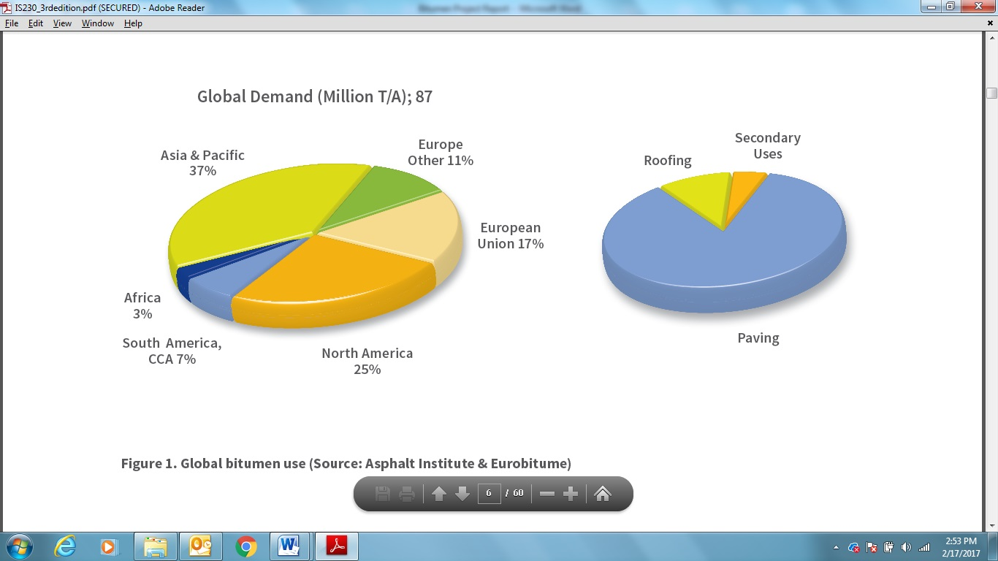

According to a research report released by Transparency Market Research,

* The global bitumen market will expand at a CAGR of 3.90% from 2014 to 2020. The market was valued at USD 71.44 bn in 2013. It is expected to reach USD 93.38 bn by the end of 2020.
* It is primarily driven by the growing rate of use in construction of roadways around the world. There is a rapid increase in the rate of creation of roadways and other related activities, creating a high demand for the global bitumen market. Polymer modified bitumen, a type of bitumen, is highly preferred due to the advantages it provides, such as high porosity, high skid resistance, and low noise. All three properties are the most sought-after ones in the global roadways industry, giving PMB an advantage over other materials
* More than 80% of the global bitumen market, from the perspective of applications, was dominated by road construction in 2013. Other applications of bitumen arise in automotive, adhesives, paints and enamels, and the roofing industries. From a geographical point of view, the global bitumen market was led by North America in 2013. North America took up over 30% of the global bitumen market in 2013, a market share attributed to expansion of state infrastructure. However, the fastest growth rate in the global bitumen market for its given forecast period will be held by the Asia Pacific region owing to rapid rate of industrialization.
* The key players of the global bitumen market are Villas Austria GmbH, Valero Energy Corporation, Shell Bitumen, Petroleos Mexicanos, Nynas AB, NuStar Energy, JX Nippon Oil & Energy Corporation, Marathon Oil Company, Indian Oil Corporation, ExxonMobil, China Petroleum and Chemical Corporation ChevronTexaco Corporation, British Petroleum, Bouygues S.A., and Bau Holding Vermögensverwaltung AG. The global bitumen market is highly competitive and fragmented due to the presence of a large number of regional players.

# Domestic Scenario

High consumption of bitumen is attributed to the major repair/ road widening projects being undertaken across the country.

(All Figures in KT)

|  |  |  |  |
| --- | --- | --- | --- |
| **Description / Type** | **2002-03** | **2004-05** | **2014-15** |
| Paving Grade | 2,605 | 3,025 | 4,000 |
| Bitumen Emulsions | 90 | 120 | 200 |
| Crumb Rubber Modified Bitumen  (CRMB) | 65 | 250 | 475 |
| Natural Rubber Modified Bitumen  (NRMB) | 10 | 25 | 50 |
| Polymer Modified Bitumen –  (Triene – Butadiene – Styrene)  (PMB-SBS) | 30 | 80 | 100 |
| Liquid Bitumen  (Cutback) | 3 | 5 | 10 |
| Others (including bitumen formed due to addition of zinc, copper, etc) | 6 | 12 | 20 |
| **TOTAL** | **2,809** | **3,517** | **4,855** |

***Source: Industry Performance Review Report of PPAC: December, 2015***

The entire Indian bitumen market comprises four types of stakeholders:

* Refiners,
* Traders,
* Importers, and
* End-users.

The market price of bitumen is majorly impacted by the import prices and India’s largest state-owned refinery IOCL.

**Major Players**

* IOCL
* HPCL
* Shell Bitumen has a modified Bitumen and emulsion production plant that produce a range of special application bituminous products.
* Road Star Bitumen India Pvt. Ltd. is one of the most prominent manufacturer and supplier of Cationic Bitumen Emulsion, Polymer Modified Bitumen, Crumb Rubber Modified Bitumen and other value-added bitumen products for the incipient as well as the established markets.
* HINCOL is a 50:50 Joint Venture between two global giants and strives to promote the ideals of both its parent organisations. They are pioneering role in the evolution of Bitumen Emulsions and Modified Bitumen as technologically superior alternatives for specific applications in the road construction industry in India.

Few other major Indian players are as under-

* Art Infra Solutions Pvt. Ltd.
* B G H Exim Pvt. Ltd.
* Bitchem Asphalt Technologies Ltd.
* Hemi Petro Products Ltd.
* Kochi Refineries Ltd.
* Modern Road Makers Pvt. Ltd.
* Ojas Technochem Products Ltd.
* Stanpacks (India) Ltd.
* Tinna Rubber & Infrastructure Ltd.

In India presently Bitumen is supplied by the following companies from their respective refinery location and also from depots across the country:

* HPCL-Mumbai, Vishakapatnam
* BPCL- Mumbai, Kochi
* IOC- Koyali, Mathura, Panipat, Haldia, Chennai, Barauni.
* MRPL- Mangalore
* Essar- Jamnagar

Apart from above Imported Bulk Bitumen is being supplied from

* Karwar
* Kakinada
* Mundra
* Haldia

# Annexure 1: Bitumen Prices

|  |  | **Viscosity Grade : Ex-Koyali, Gujarat (Rs./MT)** | | | | | |  | **Emulsion : Ex-Chennai (Rs./MT)** | | | | | |  | **CRMB : Ex-Chennai (Rs./MT)** | | | |
| --- | --- | --- | --- | --- | --- | --- | --- | --- | --- | --- | --- | --- | --- | --- | --- | --- | --- | --- | --- |
| **IOCL products** |  | **VG-10** | **VG-30** | **VG-40** | **VG-10** | **VG-30** | **VG-40** |  | **Rapid** | **SS2** | **SS1** | **Rapid** | **SS2** | **SS1** |  | **55** | **60** | **55** | **60** |
| **Applicable from** |  | **Bulk** | | | **Packed** | | |  | **Bulk** | | | **Packed** | | |  | **Bulk** | | **Packed** | |
| 1-Jan-15 |  | 36,760 | 37,560 |  | 39,760 | 40,560 |  |  |  |  |  |  |  |  |  | 38,760 | 38,830 |  |  |
| 15-Jan-15 |  |  |  |  |  |  |  |  |  |  |  |  |  |  |  |  |  |  |  |
| 1-Feb-15 |  | 32,760 | 33,560 |  | 35,760 | 36,560 |  |  |  |  |  |  |  |  |  | 35,160 | 35,310 |  |  |
| 15-Feb-15 |  | 29,390 | 30,190 |  | 32,390 | 33,190 |  |  |  |  |  |  |  |  |  | 32,130 | 32,340 |  |  |
| 1-Mar-15 |  | 29,390 | 30,190 |  | 32,390 | 33,190 |  |  |  |  |  |  |  |  |  | 32,130 | 32,340 |  |  |
| 15-Mar-15 |  | 29,060 | 29,860 |  | 32,060 | 32,860 |  |  |  |  |  |  |  |  |  | 31,830 | 32,050 |  |  |
| 1-Apr-15 |  | 29,360 | 30,160 |  | 32,360 | 33,160 |  |  |  |  |  |  |  |  |  | 32,100 | 32,320 |  |  |
| 15-Apr-15 |  | 29,870 | 30,670 |  | 32,870 | 33,670 |  |  |  |  |  |  |  |  |  | 32,560 | 32,770 |  |  |
| 1-May-15 |  | 30,630 | 31,430 |  | 33,630 | 34,430 |  |  |  |  |  |  |  |  |  | 34,210 | 34,380 |  |  |
| 15-May-15 |  | 31,170 | 31,970 |  | 34,170 | 34,970 |  |  |  |  |  |  |  |  |  | 33,730 | 33,910 |  |  |
| 1-Jun-15 |  | 31,170 | 31,970 |  | 34,170 | 34,970 |  |  |  |  |  |  |  |  |  | 33,730 | 33,910 |  |  |
| 15-Jun-15 |  | 31,540 | 32,340 |  | 34,540 | 35,340 |  |  |  |  |  |  |  |  |  | 34,060 | 34,240 |  |  |
| 1-Jul-15 |  | 31,710 | 32,510 |  | 34,710 | 35,510 |  |  |  |  |  |  |  |  |  | 34,210 | 34,380 |  |  |
| 15-Jul-15 |  | 31,490 | 32,290 |  | 34,490 | 35,290 |  |  | 25,590 | 26,920 |  | 29,440 | 30,770 |  |  | 34,020 | 34,190 |  |  |
| 1-Aug-15 |  | 31,490 | 32,290 |  | 34,710 | 35,510 |  |  | 24,980 | 26,320 |  | 28,830 | 30,170 |  |  | 33,200 | 33,390 |  |  |
| 15-Aug-15 |  | 29,860 | 30,660 | 31,820 | 32,860 | 33,660 |  |  | 24,450 | 25,700 |  | 28,300 | 29,550 |  |  | 32,550 | 32,760 |  |  |
| 1-Sep-15 |  | 30,200 | 31,000 | 32,200 | 33,200 | 34,000 |  |  | 24,620 | 25,780 |  | 28,470 | 29,630 |  |  | 32,850 | 33,060 |  |  |
| 15-Sep-15 |  | 26,680 | 27,480 | 28,280 | 30,480 | 31,280 |  |  | 22,260 | 23,460 |  | 26,110 | 27,310 |  |  | 30,410 | 30,660 |  |  |
| 1-Oct-15 |  | 26,200 | 27,000 | 27,720 | 30,000 | 30,800 |  |  | 21,960 | 23,210 |  | 25,810 | 27,060 |  |  | 29,970 | 30,240 |  |  |
| 15-Oct-15 |  | 26,963 | 27,763 | 28,433 | 30,863 | 31,663 |  |  | 22,823 | 24,083 |  | 27,313 | 27,313 |  |  | 30,053 | 30,333 |  |  |
| 1-Nov-15 |  | 26,843 | 27,643 | 28,393 | 30,743 | 31,543 |  |  | 22,743 | 24,003 |  | 27,233 | 28,483 |  |  | 29,943 | 30,233 |  |  |
| 15-Nov-15 |  |  |  |  |  |  |  |  |  |  |  |  |  |  |  |  |  |  |  |
| 1-Dec-15 |  | 26,583 | 27,383 | 28,093 | 30,483 | 31,283 |  |  | 22,563 | 23,813 |  | 27,053 | 28,293 |  |  | 29,703 | 30,003 |  |  |
| 15-Dec-15 |  | 25,323 | 26,123 | 26,643 | 29,223 | 30,023 |  |  | 21,723 | 22,983 |  | 26,203 | 27,463 |  |  | 28,573 | 28,893 |  |  |
| 1-Jan-16 |  | 24,573 | 25,373 | 25,773 | 28,473 | 29,273 | 29,573 |  | 21,163 | 22,333 |  | 25,653 | 26,813 |  |  | 27,903 | 28,233 |  |  |
| 15-Jan-16 |  | 22,433 | 23,233 | 23,433 | 26,333 | 27,133 |  |  | 19,723 | 20,923 |  | 24,213 | 25,403 |  |  | 25,973 | 26,353 |  |  |
| 1-Feb-16 |  | 22,103 | 22,903 | 23,103 | 26,003 | 26,803 | 27,203 |  | 19,443 | 20,523 |  | 23,923 | 25,003 |  |  | 25,673 | 26,063 |  |  |
| 15-Feb-16 |  | 20,773 | 21,573 | 21,873 | 24,673 | 25,473 |  |  | 18,543 | 19,653 |  | 23,033 | 24,123 |  |  | 24,483 | 24,893 |  |  |
| 1-Mar-16 |  | 21,513 | 22,313 | 22,613 | 25,413 | 26,213 | 26,713 |  | 19,063 | 20,203 |  | 23,553 | 24,673 |  |  | 25,143 | 25,543 |  |  |
| 10-Mar-16 |  | 21,046 | 21,846 | 22,146 | 24,946 | 25,746 | 26,246 |  | 18,596 | 19,736 |  | 23,086 | 24,206 |  |  | 24,676 | 25,076 |  |  |
| 15-Mar-16 |  | 22,246 | 23,046 | 23,346 | 26,146 | 26,946 |  |  | 19,406 | 20,526 |  | 23,886 | 24,996 |  |  | 25,756 | 26,126 |  |  |
| 1-Apr-16 |  | 23,546 | 24,346 | 24,646 | 27,446 | 28,246 |  |  | 20,306 | 21,476 |  | 24,796 | 25,956 |  |  | 26,926 | 27,276 |  |  |
| 15-Apr-16 |  | 23,866 | 24,666 | 24,646 | 27,766 | 28,566 |  |  | 20,516 | 21,686 |  | 25,006 | 26,166 |  |  | 27,216 | 27,556 |  |  |
| 1-May-16 |  | 23,846 | 24,646 | 24,946 | 27,746 | 28,546 |  |  | 20,516 | 21,696 |  | 25,006 | 26,176 |  |  | 27,196 | 27,536 |  |  |
| 15-May-16 |  | 23,846 | 24,646 | 24,946 | 27,746 | 28,546 |  |  | 20,516 | 21,696 |  | 25,006 | 26,176 |  |  | 27,196 | 27,536 |  |  |
| 1-Jun-16 |  | 23,556 | 24,356 | 24,656 | 27,456 | 28,256 |  |  | 20,366 | 21,616 |  | 24,856 | 26,096 |  |  | 26,936 | 27,286 |  |  |
| 15-Jun-16 |  | 23,046 | 23,846 | 24,146 | 26,946 | 27,746 |  |  | 20,016 | 21,286 |  | 24,506 | 25,756 |  |  | 26,626 | 27,016 |  |  |
| 1-Jul-16 |  | 23,246 | 24,046 | 24,346 | 27,146 | 27,946 |  |  | 20,186 | 21,486 |  | 24,666 | 25,966 |  |  | 26,806 | 27,186 |  |  |
| 15-Jul-16 |  | 22,716 | 23,516 | 23,816 | 26,616 | 27,416 |  |  | 19,826 | 21,136 |  | 24,306 | 25,616 |  |  | 26,326 | 26,726 |  |  |
| 1-Aug-16 |  | 22,346 | 23,146 | 23,446 | 26,246 | 27,046 |  |  | 19,556 | 20,866 |  | 24,046 | 25,346 |  |  | 25,996 | 26,396 |  |  |
| 15-Aug-16 |  | 22,576 | 23,376 | 23,676 | 26,476 | 27,276 |  |  | 19,706 | 21,026 |  | 24,196 | 25,496 |  |  | 26,206 | 26,596 |  |  |
| 1-Sep-16 |  | 22,726 | 23,526 | 23,826 | 26,626 | 27,426 |  |  | 19,796 | 21,066 | 30,206 | 24,276 | 25,546 | 34,546 |  | 26,336 | 26,736 |  |  |
| 15-Sep-16 |  | 22,846 | 23,646 | 23,946 | 26,746 | 27,546 |  |  | 19,876 | 21,146 | 30,266 | 24,356 | 25,626 | 34,606 |  | 26,446 | 26,836 |  |  |
| 1-Oct-16 |  | 22,846 | 23,646 | 23,946 | 26,746 | 27,546 |  |  | 19,876 | 21,136 | 30,266 | 24,356 | 25,616 | 34,606 |  | 26,456 | 26,846 |  |  |
| 15-Oct-16 |  | 22,996 | 23,796 | 24,096 | 26,896 | 27,696 |  |  | 19,986 | 21,286 | 30,906 | 24,476 | 25,756 | 35,246 |  | 26,586 | 26,966 |  |  |
| 1-Nov-16 |  | 23,606 | 24,406 | 24,706 | 27,506 | 28,306 |  |  | 20,436 | 21,786 | 32,696 | 24,916 | 26,266 | 37,026 |  | 27,136 | 27,506 |  |  |
| 15-Nov-16 |  | 26,926 | 27,726 | 28,156 | 30,826 | 31,626 |  |  | 22,666 | 23,976 | 34,296 | 27,146 | 28,456 | 38,636 |  | 30,116 | 30,426 |  |  |
| 1-Dec-16 |  | 25,316 | 26,116 | 26,416 | 28,416 | 29,216 |  |  | 21,566 | 22,856 | 32,746 | 25,516 | 26,806 | 36,696 |  | 28,666 | 29,016 |  |  |
| 15-Dec-16 |  | 24,476 | 25,276 | 25,576 | 27,576 | 28,376 |  |  | 20,996 | 22,306 | 32,336 | 24,946 | 26,256 | 36,286 |  | 27,916 | 28,276 |  |  |
| 1-Jan-17 |  | 25,386 | 26,186 | 26,486 | 28,486 | 29,286 |  |  | 21,646 | 23,026 | 34,516 | 25,596 | 26,976 | 38,466 |  | 28,736 | 29,076 |  |  |
| 15-Jan-17 |  | 26,766 | 27,566 | 27,966 | 29,866 | 30,666 |  |  | 22,576 | 23,936 | 35,186 | 26,526 | 27,886 | 39,136 |  | 29,976 | 30,286 |  |  |

# Annexure 2: Bitumen Prices Graphs