**Export process flow for VVFL sales organization**

1. Create Export Sales Contract (Transaction Code – VA41)
2. Sales Order Creation – (Transaction Code – VA01)
3. Create Billing Document– (Transaction Code – VF01)
4. Check Export Accounting Entry
5. Check Output Type – ZTRS

**NOTE:**

1. **Before processing the contract Customer master and Material master should be extended to Export Sales area i.e.VVFL/20/40**
2. **Maintain Invoicing Export Exchange Rate.**
3. **Create Export Contract**

Transaction Code –VA41 🡪 Select Contract type (ZSEX) and Sales area (VVFL/20/40) as shown as below screen shot.

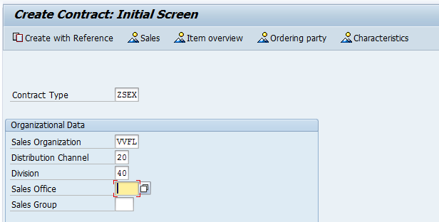

Enter Customer code, PO Number, Valid from & Valid To date, Material and Quantity

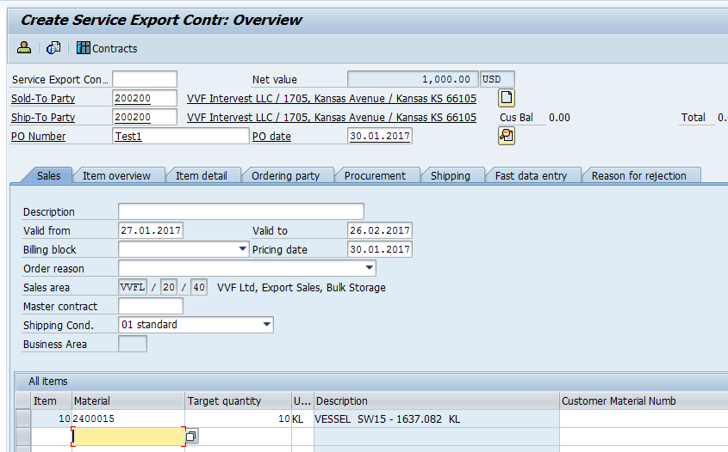

Enter Pricing and check Taxes.

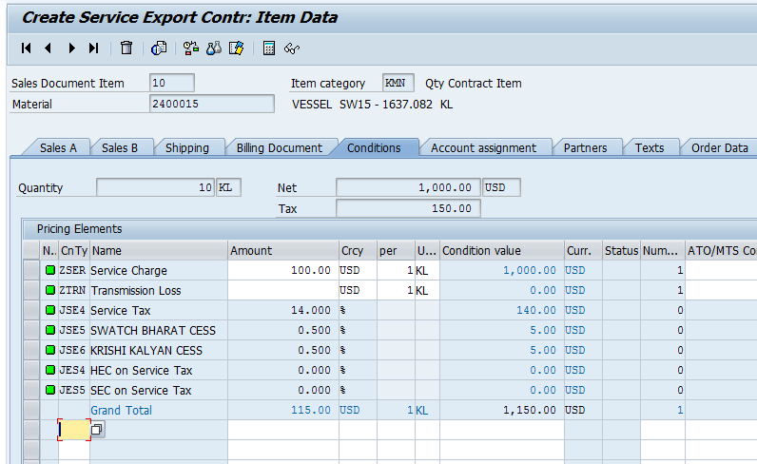

Save the contract 🡪 you will get the contract Number.

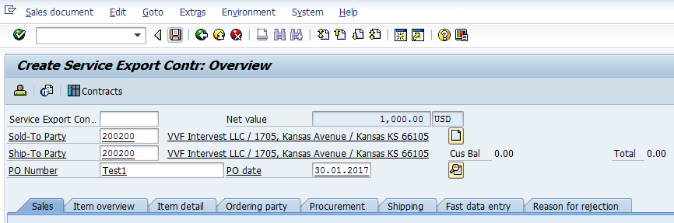



1. **Create Export Sales Order with reference to Export Contract.**

Transaction Code –VA01 🡪 Select Order Type (ZJSE) and Sales area (VVFL/20/40) as shown as below screen shot🡪 then enter.

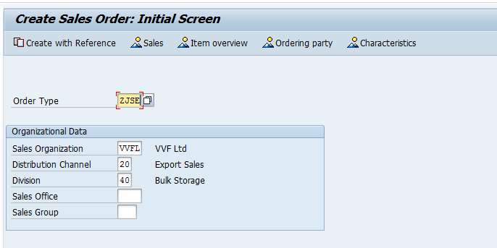

Enter the contract number and click on Copy.

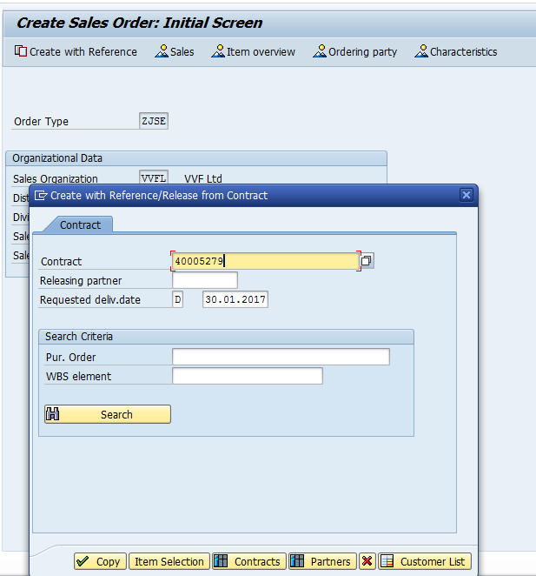

All details will be copied from contract🡪 check the all details.

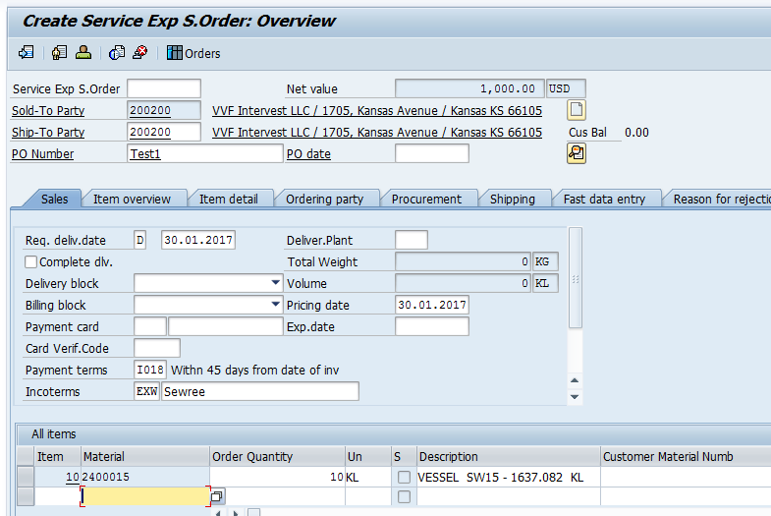

Check the Pricing and SAVE the Sales Order

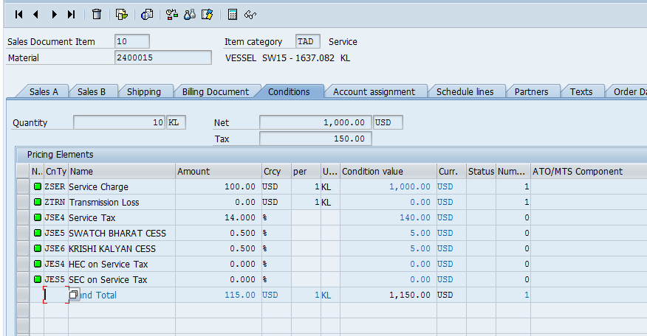

You will get the Sales Order Number



1. **Create Export Billing Document with reference to Export Sales Order.**

Transaction Code –VF01 🡪 Enter Export Sales Order as shown as below screen shot🡪 then enter.

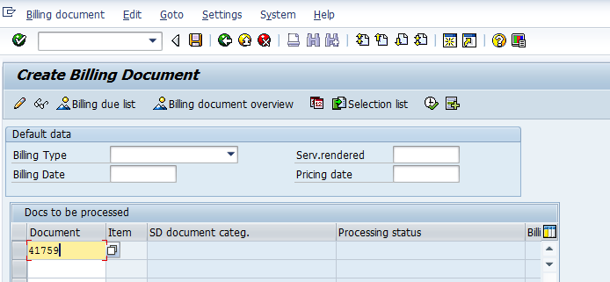

As shown as below Invoice screen🡪 check the billing quantity.

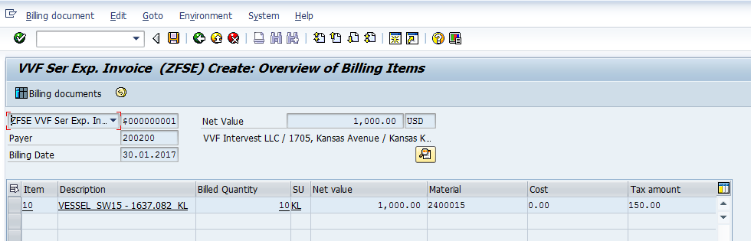

Go to condition check the Pricing🡪 and SAVE the Billing Document.

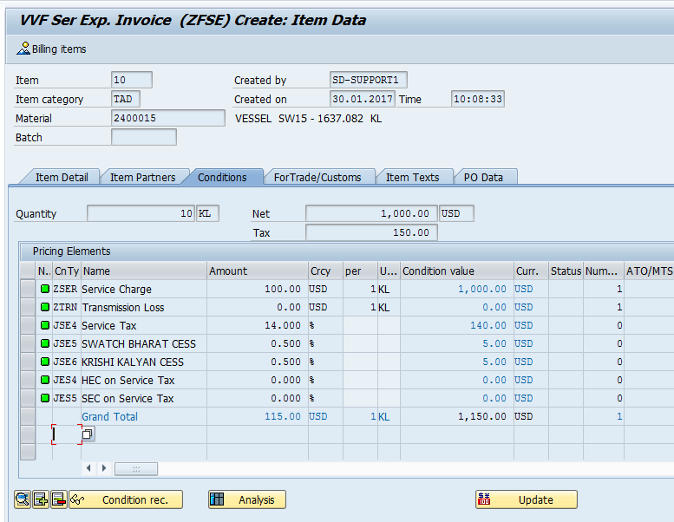

You will get the Billing Document number.



1. **Check Accounting Entry of Export Invoice.**

Transaction Code –VF03 🡪 Enter Export Invoice as shown as below screen shot🡪 then click on Accounting Tab.

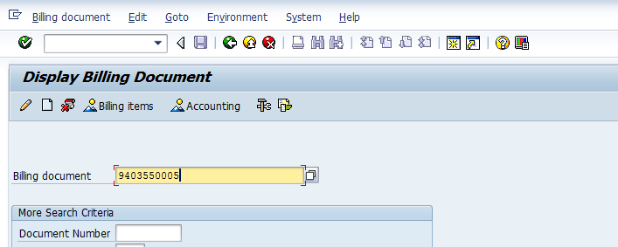

You will get the Accounting document number 🡪Double click on Accounting Number and check the Accounting Posting Entries.

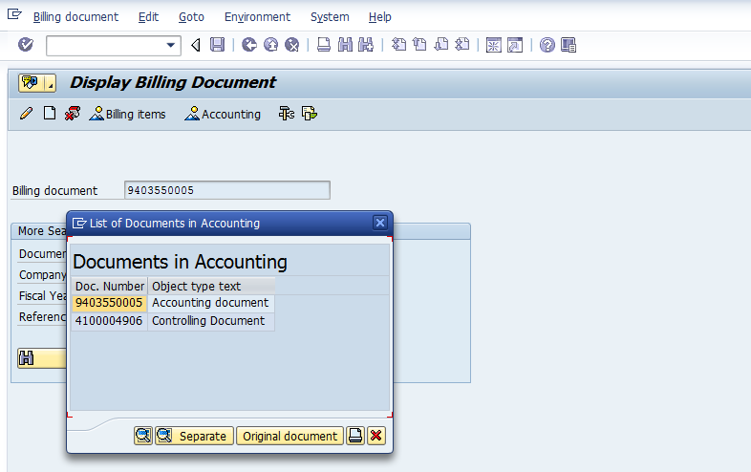

Accounting Entry.

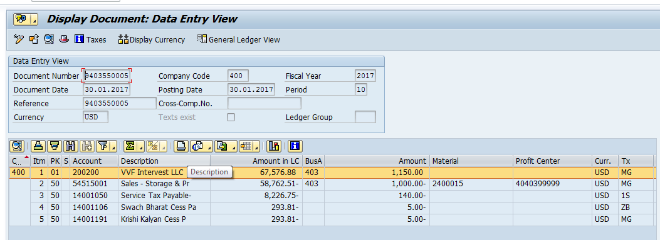

1. **Check Output Type -ZTRS.**

Transaction Code –VF02 🡪 Enter Export Invoice as shown as below screen shot

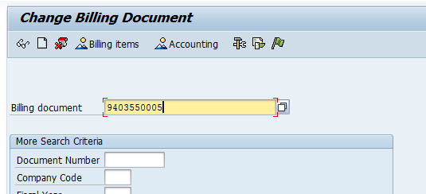

Then go to 🡪Header 🡪 Output 🡪 Assign the Output type and check output print preview.

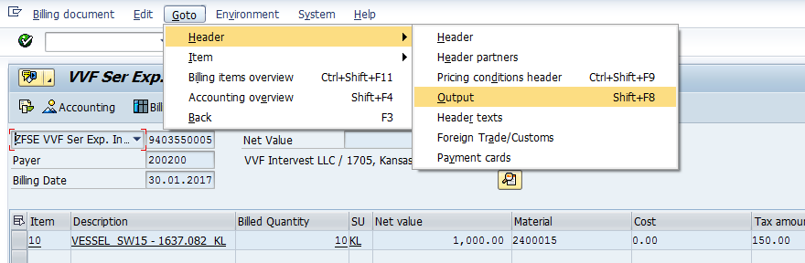

Select Output Type ZTRS.

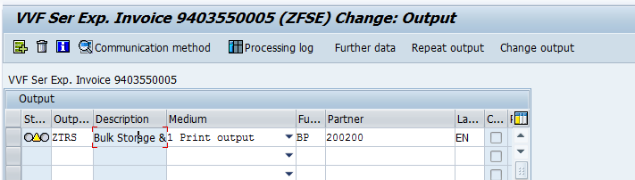

Go to Transaction code VF03 and check the Output print preview.

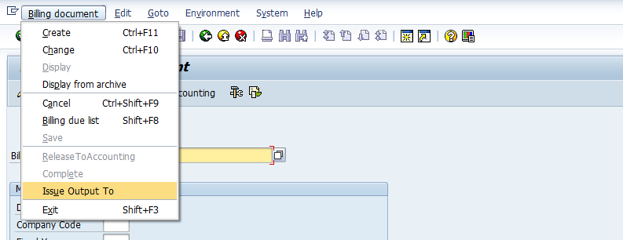

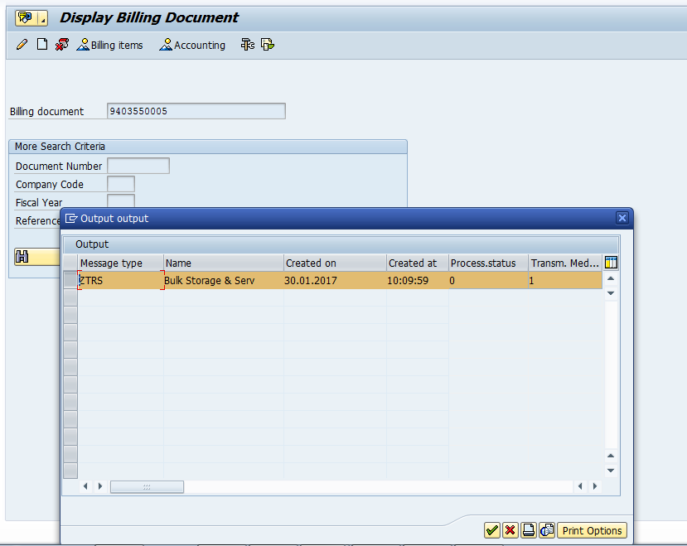

Print Preview.

