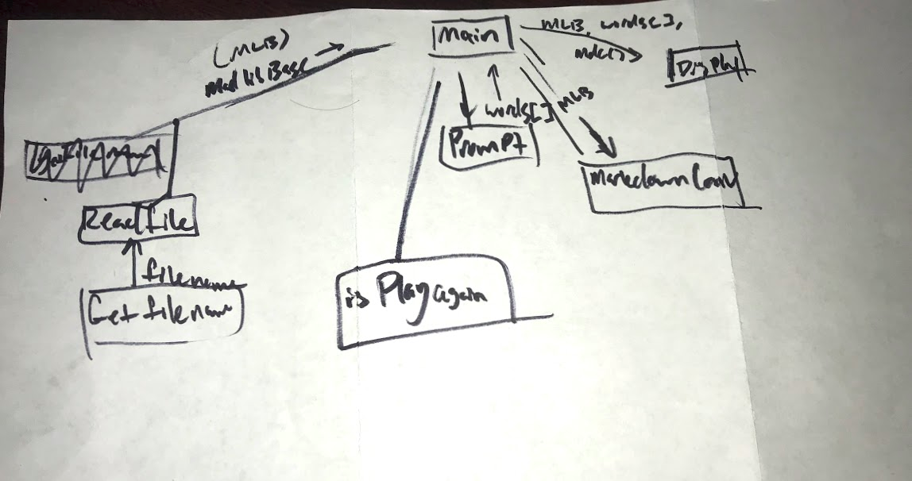

Psuedocode:

char readFile{

//fin open
OPEN story.txt

IF error fin
THEN DISPLAY error
RETURN 0

//figure out average
story.txt = char story[256]

numOfWords = 0

WHILE numOfWords < 256 && fin reads ok
THEN askQuestions(MLB[numOfWords]
THEN numofWords++

}

askQuestions(MLB)
{
CREATE poionters in text
IF <trigger character>
THEN place pointer

IF :NOUN
THEN \tNOUN

ELSE IF <the rest of trigger chars>
THEN < their respective responces>

PUT the text pack at the pointer
}

}

