**Learn Unity Beginner/Intermediate 2023 (FREE COMPLETE Course - Unity Tutorial) By YouTube Channel - “Code Monkey”**

**Unity Template used:** 3D (URP) Core

**Naming Rules:**

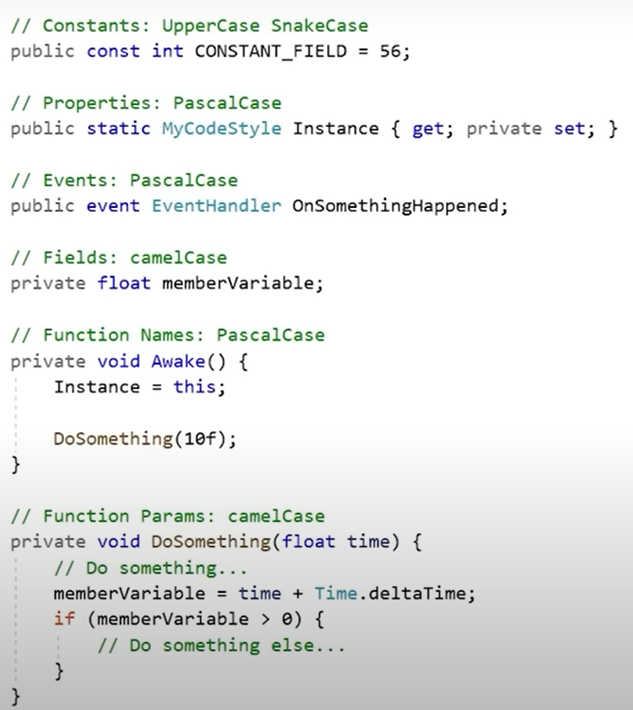

Downloaded assets from <https://unitycodemonkey.com/kitchenchaoscourse.php>

Post processing: <https://www.youtube.com/watch?v=bkPe1hxOmbI&feature=youtu.be>

Char Rotation: transform.forward = Slerp(transform.forward, moveDir, Time.deltaTime * rotateSpeed)

Downloaded OnScreen Controls for mobile game input: [Onscreen controls (8 styles) | OpenGameArt.org](https://opengameart.org/content/onscreen-controls-8-styles)  
Mobile Input System reference video: [(60) Mobile input/touch control for your Unity game - YouTube](https://www.youtube.com/watch?v=NqrJHj9xlqY)

Collision Detection: Raycast / CapsuleCast