24 Hours report

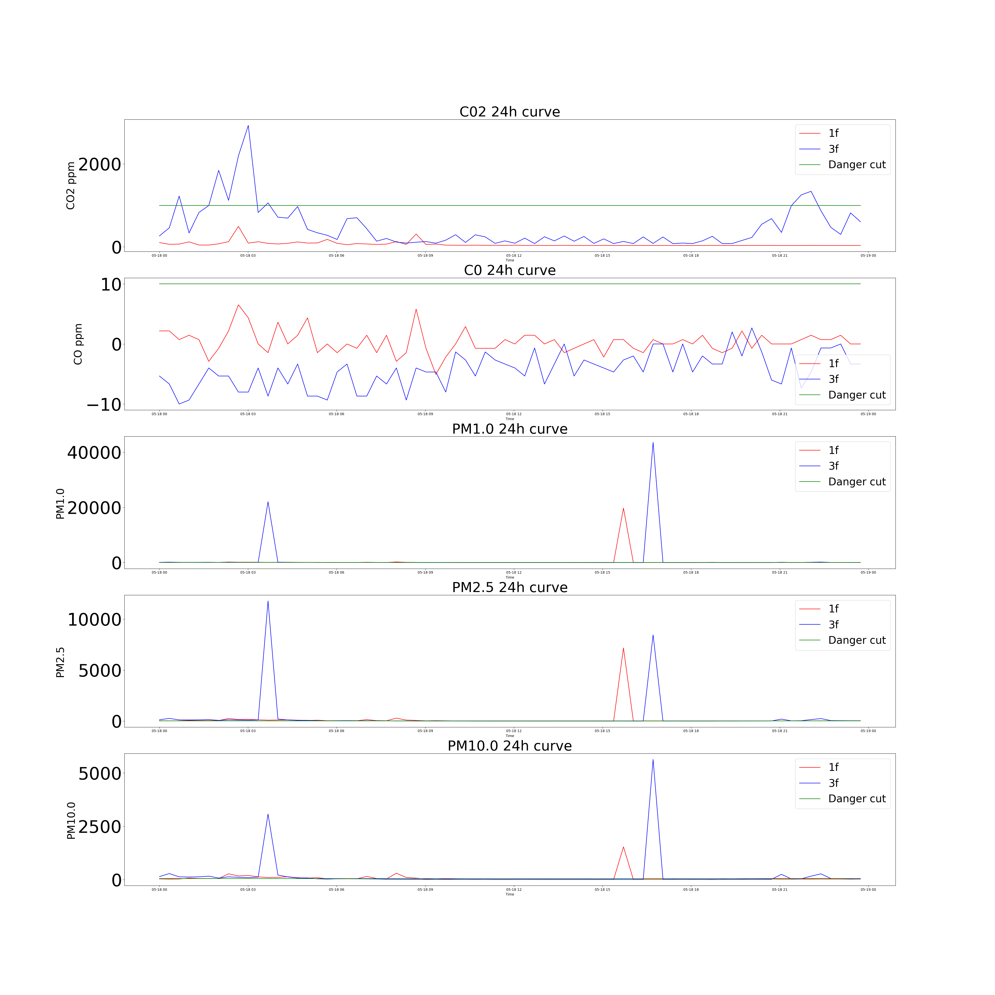

평균 표

|  |  |  |  |  |  |
| --- | --- | --- | --- | --- | --- |
|  | **CO2** | **C0** | **PM 1.0** | **PM 2.5** | **P, 10,0** |
| **1 층** | **61.07** | **61.07** | **357.34** | **333.97** | **322.04** |
| **2 층** | **538.84** | **538.84** | **334.12** | **320.48** | **349.82** |