Weak prompts:
a) Explain regression
b) Help me understand SQL
c) Create a dataset
For each:
a) Write the improved prompt
b) Include a screenshot of the AI response
c) Briefly explain why your revised prompt is stronger

- Explain regression in simple terms, including what it is, why it’s used, and a real-world example.
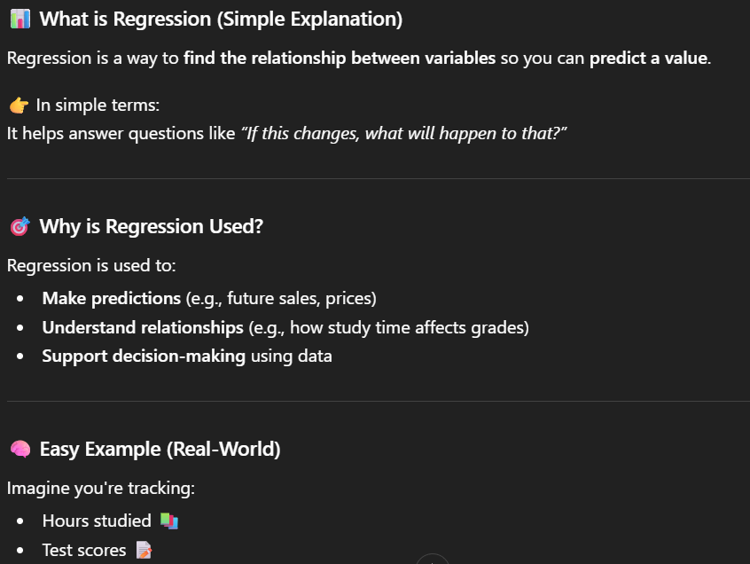
This revised prompt is stronger because it gives a better direction instead of being vague. It added specific information that the user wants to know.
- Explain SQL in a way a beginner can understand, including key concepts, common commands, and include follow-up questions to check my knowledge.
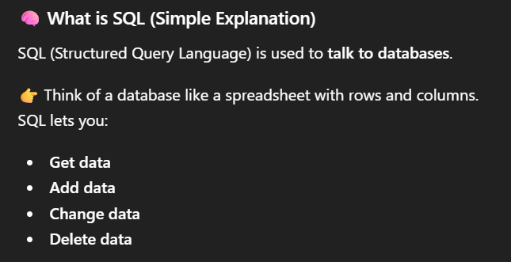
This improved prompt gives more context to the input, giving it a specific area to cover. It targets a clear audience and is designed for beginners.
- Create a dataset with 10 rows showing Customer Name, Age, Purchase Amount, and City. Format it as a table
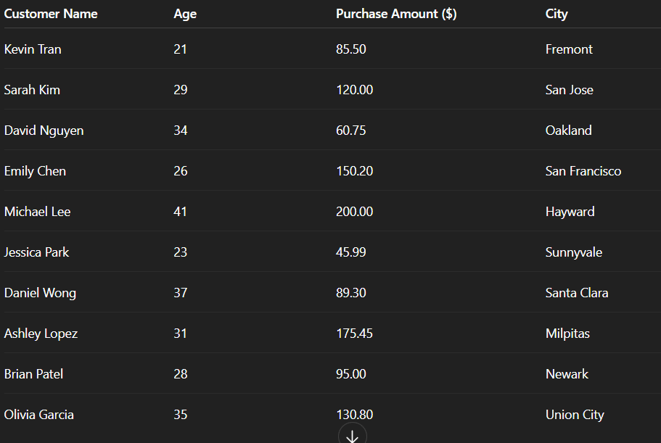
“Create a dataset” is too vague and doesn’t tell what kind of data is needed. With the new one, it defines the columns, gives specific rows, and requests a specific format.

