Jennifer Shin

Jocelyne Zarco

Jasmine Kwong

Kevin Tran

Matthew Lebouvier

CS180: Nearby+ Design Document

UI Design

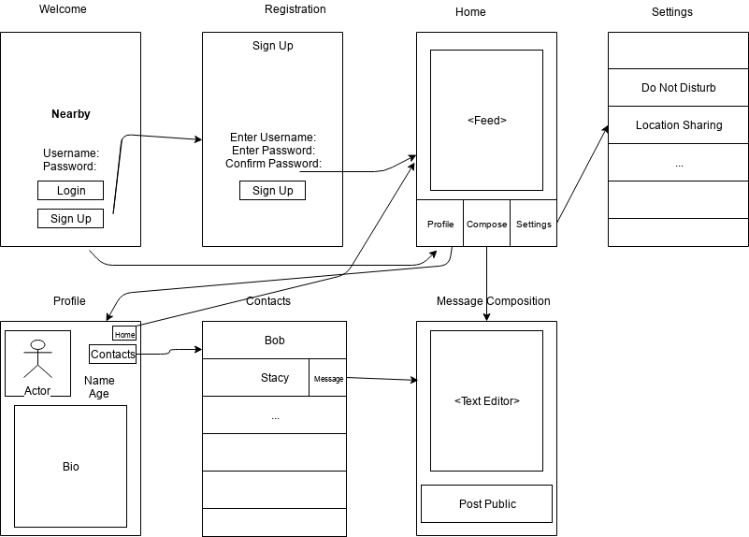

Architectural Design

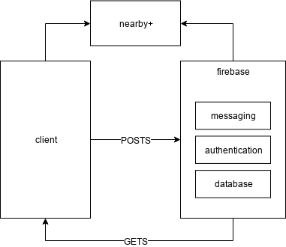

UML

