# Lab 5: *Query in a single table database: Application*

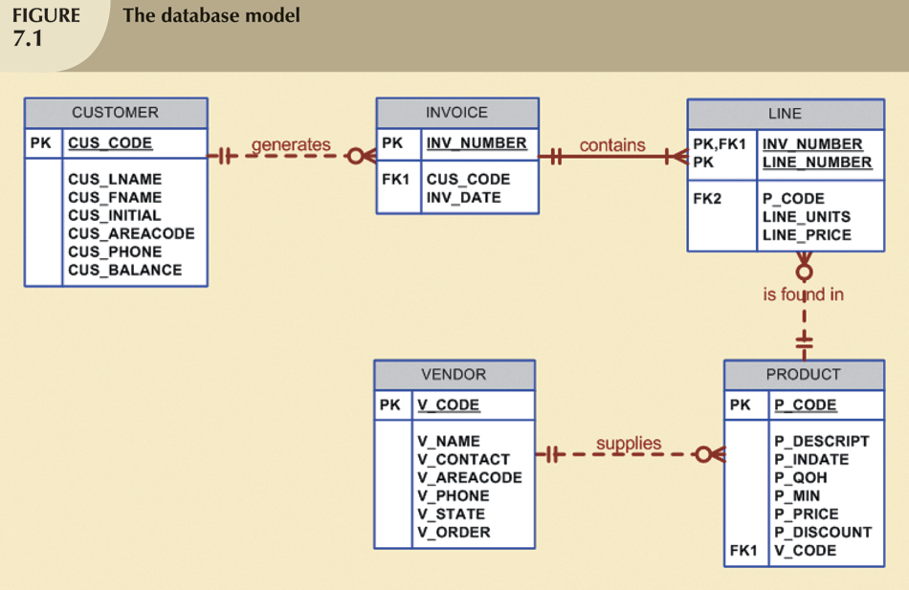

1. **Data Preparation**

Run the following SQL all at once.

|  |
| --- |
| /* SQLINTRODBINIT.SQL */  /* Script file for MYSQL DBMS */  /* This script file creates the following tables: */  /* VENDOR, PRODUCT, CUSTOMER, INVOICE, LINE */  /* DEPARTMENT, EMPLOYEE */  /* and loads the default data rows */  /* CREATOR: HOON S. CHA */  DROP TABLE IF EXISTS LINE;  DROP TABLE IF EXISTS INVOICE;  DROP TABLE IF EXISTS CUSTOMER;  DROP TABLE IF EXISTS PRODUCT;  DROP TABLE IF EXISTS VENDOR;  CREATE TABLE VENDOR (  V_CODE INTEGER,  V_NAME VARCHAR(35) NOT NULL,  V_CONTACT VARCHAR(15) NOT NULL,  V_AREACODE CHAR(3) NOT NULL,  V_PHONE CHAR(8) NOT NULL,  V_STATE CHAR(2) NOT NULL,  V_ORDER CHAR(1) NOT NULL,  PRIMARY KEY (V_CODE));  CREATE TABLE PRODUCT (  P_CODE VARCHAR(10),  P_DESCRIPT VARCHAR(35) NOT NULL,  P_INDATE DATE NOT NULL,  P_QOH INTEGER NOT NULL,  P_MIN INTEGER NOT NULL,  P_PRICE DECIMAL(8,2) NOT NULL,  P_DISCOUNT DECIMAL(5,2) NOT NULL,  V_CODE INTEGER ,  PRIMARY KEY (P_CODE),  CONSTRAINT PRODUCT_V_CODE_FK  FOREIGN KEY (V_CODE) REFERENCES VENDOR(V_CODE));  CREATE TABLE CUSTOMER (  CUS_CODE INTEGER PRIMARY KEY,  CUS_LNAME VARCHAR(15) NOT NULL,  CUS_FNAME VARCHAR(15) NOT NULL,  CUS_INITIAL CHAR(1),  CUS_AREACODE CHAR(3) DEFAULT '615' NOT NULL CHECK(CUS_AREACODE IN ('615','713','931')),  CUS_PHONE CHAR(8) NOT NULL,  CUS_BALANCE DECIMAL(9,2) DEFAULT 0.00);  CREATE TABLE INVOICE (  INV_NUMBER INTEGER PRIMARY KEY,  CUS_CODE INTEGER NOT NULL,  INV_DATE DATE NOT NULL,  CONSTRAINT INVOICE_CUS_CODE_FK  FOREIGN KEY (CUS_CODE) REFERENCES CUSTOMER(CUS_CODE));  CREATE TABLE LINE(  INV_NUMBER INTEGER,  LINE_NUMBER INTEGER,  P_CODE VARCHAR(10) NOT NULL,  LINE_UNITS DECIMAL(9,2) DEFAULT 0.00 NOT NULL,  LINE_PRICE DECIMAL(9,2) DEFAULT 0.00 NOT NULL,  PRIMARY KEY(INV_NUMBER, LINE_NUMBER),  CONSTRAINT LINE_INV_NUMBER_FK FOREIGN KEY (INV_NUMBER) REFERENCES INVOICE(INV_NUMBER) ON DELETE CASCADE,  CONSTRAINT LINE_P_CODE_FK FOREIGN KEY (P_CODE) REFERENCES PRODUCT(P_CODE),  CONSTRAINT LINE_UI1 UNIQUE(INV_NUMBER, P_CODE));  /* Loading data rows */  /* VENODR rows */  INSERT INTO VENDOR VALUES(21225,'Bryson, Inc.' ,'Smithson','615','223-3234','TN','Y');  INSERT INTO VENDOR VALUES(21226,'SuperLoo, Inc.' ,'Flushing','904','215-8995','FL','N');  INSERT INTO VENDOR VALUES(21231,'D\&E Supply' ,'Singh' ,'615','228-3245','TN','Y');  INSERT INTO VENDOR VALUES(21344,'Gomez Bros.' ,'Ortega' ,'615','889-2546','KY','N');  INSERT INTO VENDOR VALUES(22567,'Dome Supply' ,'Smith' ,'901','678-1419','GA','N');  INSERT INTO VENDOR VALUES(23119,'Randsets Ltd.' ,'Anderson','901','678-3998','GA','Y');  INSERT INTO VENDOR VALUES(24004,'Brackman Bros.' ,'Browning','615','228-1410','TN','N');  INSERT INTO VENDOR VALUES(24288,'ORDVA, Inc.' ,'Hakford' ,'615','898-1234','TN','Y');  INSERT INTO VENDOR VALUES(25443,'B\&K, Inc.' ,'Smith' ,'904','227-0093','FL','N');  INSERT INTO VENDOR VALUES(25501,'Damal Supplies' ,'Smythe' ,'615','890-3529','TN','N');  INSERT INTO VENDOR VALUES(25595,'Rubicon Systems' ,'Orton' ,'904','456-0092','FL','Y');  /* PRODUCT rows */  INSERT INTO PRODUCT VALUES('11QER/31','Power painter, 15 psi., 3-nozzle','2022-11-03',8,5,109.99,0,25595);  INSERT INTO PRODUCT VALUES('13-Q2/P2','7.25-in. pwr. saw blade','2022-12-13',32,15,14.99,0.05,21344);  INSERT INTO PRODUCT VALUES('14-Q1/L3','9.00-in. pwr. saw blade', '2022-11-13',18,12,17.49,0,21344);  INSERT INTO PRODUCT VALUES('1546-QQ2','Hrd. cloth, 1/4-in., 2x50','2023-01-15',15,8,39.95,0,23119);  INSERT INTO PRODUCT VALUES('1558-QW1','Hrd. cloth, 1/2-in., 3x50','2023-01-15',23,5,43.99,0,23119);  INSERT INTO PRODUCT VALUES('2232/QTY','B&D jigsaw, 12-in. blade','2022-12-30',8,5,109.92,0.05,24288);  INSERT INTO PRODUCT VALUES('2232/QWE','B&D jigsaw, 8-in. blade','2022-12-24',6,5,99.87,0.05,24288);  INSERT INTO PRODUCT VALUES('2238/QPD','B&D cordless drill, 1/2-in.','2023-01-20',12,5,38.95,0.05,25595);  INSERT INTO PRODUCT VALUES('23109-HB','Claw hammer','2023-01-20',23,10,5.95,0.1,21225);  INSERT INTO PRODUCT VALUES('23114-AA','Sledge hammer, 12 lb.','2023-01-02',8,5,14.40,0.05,NULL);  INSERT INTO PRODUCT VALUES('54778-2T','Rat-tail file, 1/8-in. fine','2022-12-15',43,20,4.99,0,21344);  INSERT INTO PRODUCT VALUES('89-WRE-Q','Hicut chain saw, 16 in.','2023-02-07',11,5,256.99,0.05,24288);  INSERT INTO PRODUCT VALUES('PVC23DRT','PVC pipe, 3.5-in., 8-ft','2023-02-20',188,75,5.87,0,NULL);  INSERT INTO PRODUCT VALUES('SM-18277','1.25-in. metal screw, 25','2023-03-01',172,75,6.99,0,21225);  INSERT INTO PRODUCT VALUES('SW-23116','2.5-in. wd. screw, 50','2023-02-24',237,100,8.45,0,21231);  INSERT INTO PRODUCT VALUES('WR3/TT3','Steel matting, 4''x8''x1/6", .5" mesh','2023-01-17',18,5,119.95,0.1,25595);  /* CUSTOMER rows */  INSERT INTO CUSTOMER VALUES(10010,'Ramas' ,'Alfred','A' ,'615','844-2573',0);  INSERT INTO CUSTOMER VALUES(10011,'Dunne' ,'Leona' ,'K' ,'713','894-1238',0);  INSERT INTO CUSTOMER VALUES(10012,'Smith' ,'Kathy' ,'W' ,'615','894-2285',345.86);  INSERT INTO CUSTOMER VALUES(10013,'Olowski' ,'Paul' ,'F' ,'615','894-2180',536.75);  INSERT INTO CUSTOMER VALUES(10014,'Orlando' ,'Myron' ,NULL,'615','222-1672',0);  INSERT INTO CUSTOMER VALUES(10015,'O''Brian','Amy' ,'B' ,'713','442-3381',0);  INSERT INTO CUSTOMER VALUES(10016,'Brown' ,'James' ,'G' ,'615','297-1228',221.19);  INSERT INTO CUSTOMER VALUES(10017,'Williams','George',NULL,'615','290-2556',768.93);  INSERT INTO CUSTOMER VALUES(10018,'Farriss' ,'Anne' ,'G' ,'713','382-7185',216.55);  INSERT INTO CUSTOMER VALUES(10019,'Smith' ,'Olette','K' ,'615','297-3809',0);  /* INVOICE rows */  INSERT INTO INVOICE VALUES(1001,10014,'2023-01-16');  INSERT INTO INVOICE VALUES(1002,10011,'2023-01-16');  INSERT INTO INVOICE VALUES(1003,10012,'2023-01-16');  INSERT INTO INVOICE VALUES(1004,10011,'2023-01-17');  INSERT INTO INVOICE VALUES(1005,10018,'2023-01-17');  INSERT INTO INVOICE VALUES(1006,10014,'2023-01-17');  INSERT INTO INVOICE VALUES(1007,10015,'2023-01-17');  INSERT INTO INVOICE VALUES(1008,10011,'2023-01-17');  /* LINE rows */  INSERT INTO LINE VALUES(1001,1,'13-Q2/P2',1,14.99);  INSERT INTO LINE VALUES(1001,2,'23109-HB',1,9.95);  INSERT INTO LINE VALUES(1002,1,'54778-2T',2,4.99);  INSERT INTO LINE VALUES(1003,1,'2238/QPD',1,38.95);  INSERT INTO LINE VALUES(1003,2,'1546-QQ2',1,39.95);  INSERT INTO LINE VALUES(1003,3,'13-Q2/P2',5,14.99);  INSERT INTO LINE VALUES(1004,1,'54778-2T',3,4.99);  INSERT INTO LINE VALUES(1004,2,'23109-HB',2,9.95);  INSERT INTO LINE VALUES(1005,1,'PVC23DRT',12,5.87);  INSERT INTO LINE VALUES(1006,1,'SM-18277',3,6.99);  INSERT INTO LINE VALUES(1006,2,'2232/QTY',1,109.92);  INSERT INTO LINE VALUES(1006,3,'23109-HB',1,9.95);  INSERT INTO LINE VALUES(1006,4,'89-WRE-Q',1,256.99);  INSERT INTO LINE VALUES(1007,1,'13-Q2/P2',2,14.99);  INSERT INTO LINE VALUES(1007,2,'54778-2T',1,4.99);  INSERT INTO LINE VALUES(1008,1,'PVC23DRT',5,5.87);  INSERT INTO LINE VALUES(1008,2,'WR3/TT3',3,119.95);  INSERT INTO LINE VALUES(1008,3,'23109-HB',1,9.95); |

Sample of “Screen capture” that will be used to answer to your questions:

|  |
| --- |
| *Report the description, in-date, and price of products with a vendor code of 21344.* |
| *Note: You must include the first line (server name, database name, etc.)* |

2. Practice Queries

(1) Comparison Operation: =

|  |
| --- |
| *Report the description, in-date, and price of products with a vendor code of 21344.* |
| **Screen capture** |

(2) Comparison Operation: <>

|  |
| --- |
| *Report the description, in-date, and price of products provided by any vendor whose vendor code is NOT 21344.* |
|  |

(3) Comparison Operation: Number

|  |
| --- |
| *Report the description, quantity on hand, minimum quantity, and price of the products whose prices are less than or equal to $10.* |
|  |

(4) Comparison Operation: String

|  |
| --- |
| *Report the description, quantity on hand, minimum quantity, and price of the products whose product codes are alphabetically less than 1558-QW1.* |
|  |

(5) Comparison Operation: Date

|  |
| --- |
| *Report the description, quantity on hand, minimum quantity, price, and in-date of the products in which stock dates occur on or after January 20, 2023.* |
|  |

(6) AND/OR

|  |
| --- |
| *Report the description, in-date, price, and vendor code of the products where*   * The in-date is after January 15, 2023 and the price is less than $50. * Or the vendor code is 24288 |
|  |

(7) IN/NOT IN

|  |
| --- |
| *Report the description, in-date, and price of products with a vendor code of 21344 or 24288.* |
|  |

(8) Pattern Matching: LIKE/NOT LIKE

|  |
| --- |
| *Report the all the vendors whose last names for contacts start with Smith.* |
|  |

(9) Pattern Matching: LIKE/NOT LIKE

|  |
| --- |
| *Report the all the vendors whose last names for contacts does NOT start with Smith.* |
|  |

(10) Ordering a Listing: ORDER BY [ASC|DESC]

|  |
| --- |
| *Report the description, quantity on hand, price of the products in descending order by price.* |
|  |

(11) Derived data

|  |
| --- |
| *Report the description, quantity on hand, price, and the total value of each of the products currently held in inventory.* |
|  |

(12) Distinct Data

|  |
| --- |
| *Report the distinct vendor codes in the PRODUCT table.* |
|  |

(13) Aggregate function: COUNT

|  |
| --- |
| *Find out how many different vendors are in the product table.* |
|  |

(14) Aggregate function: MAX/MIN

|  |
| --- |
| *What is the highest price in the PRODUCT table?* |
|  |

(15) Subqueries

|  |
| --- |
| *What is the highest price in the PRODUCT table? Report the product code, description, and price of that product.* |
|  |

(16) Subqueries with IN/NOT IN

|  |
| --- |
| *List the vendor code and name of only those vendors who provide products (i.e., whose vendor codes are in the PRODUCT table).* |
|  |

**Save it as “Lab 5_your last name). Then, upload this to MyClasses (under Lab5)**