Отчет по тестированию новостоного бота:

- Mind map
https://miro.com/app/board/uXjVNbPoa60=/?share_link_id=401322140833

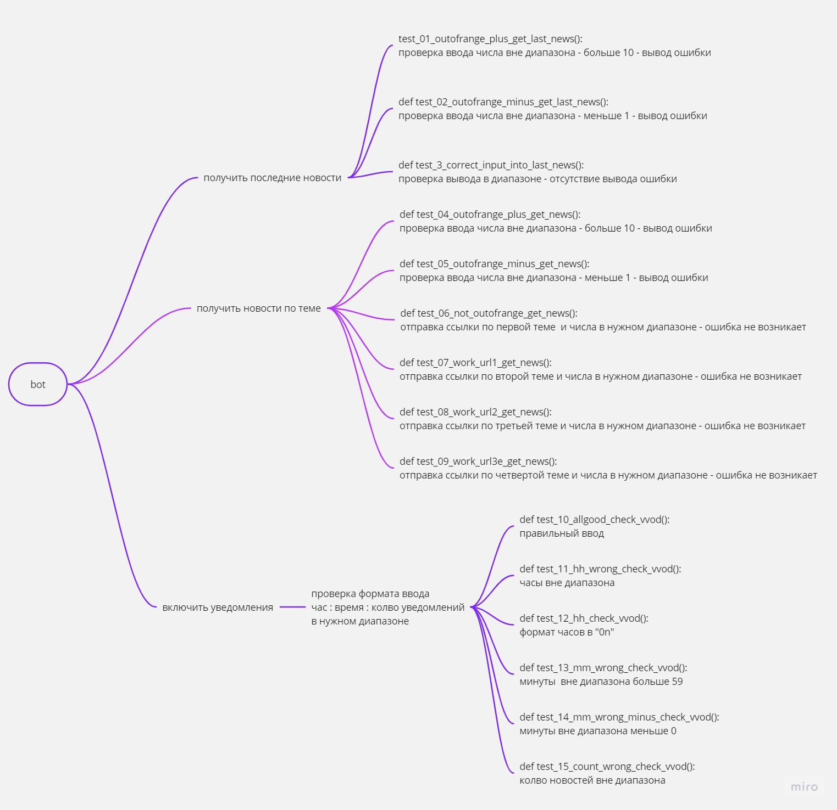

- Результаты тестов

============================= test session starts =============================
collecting ... collected 15 items

test.py::test_01_outofrange_plus_get_last_news PASSED [ 6%]
test.py::test_02_outofrange_minus_get_last_news PASSED [ 13%]
test.py::test_03_correct_input_into_last_news PASSED [ 20%]
test.py::test_04_outofrange_plus_get_news PASSED [ 26%]
test.py::test_05_outofrange_minus_get_news PASSED [ 33%]
test.py::test_06_not_outofrange_get_news PASSED [ 40%]
test.py::test_07_work_url1_get_news PASSED [ 46%]
test.py::test_08_work_url2_get_news PASSED [ 53%]
test.py::test_09_work_url3e_get_news PASSED [ 60%]
test.py::test_10_allgood_check_vvod PASSED [ 66%]
test.py::test_11_hh_wrong_check_vvod PASSED [ 73%]
test.py::test_12_hh_check_vvod PASSED [ 80%]
test.py::test_13_mm_wrong_check_vvod PASSED [ 86%]
test.py::test_14_mm_wrong_minus_check_vvod PASSED [ 93%]
test.py::test_15_count_wrong_check_vvod PASSED [100%]

============================= 15 passed in 5.40s ============================
Вывод: Ошибок не обнаружено

