file system management

1. List out 5 files in your system which consuming most of the disk space.

Use combination of commands - find, du, grep, sort, head etc

Top 5 largest files from the current directory

[root@ip-172-31-39-210 riteshkt]# du -h | sort -nr | head -n5

316K ./100-Java-programs

168K ./linux-content/Shell-Script

140K ./linux/filesystem

140K ./linux

132K ./linux/filesystem/.git

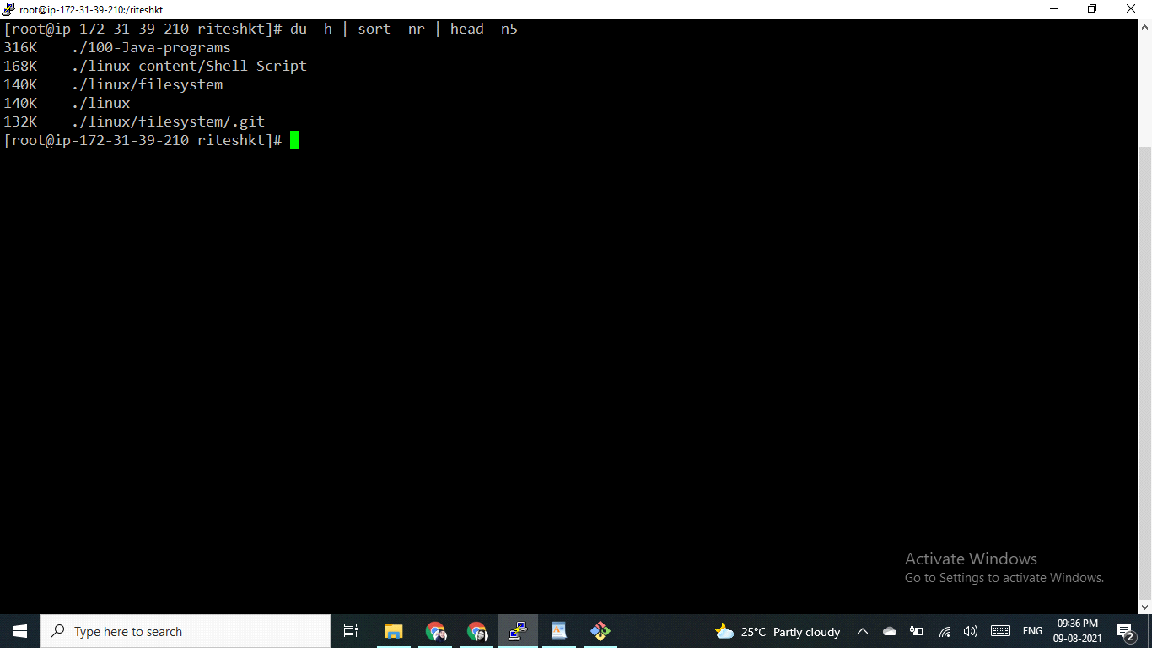

Top 5 largest directories from the current directory

[root@ip-172-31-39-210 riteshkt]# du -sh \* | sort -nr | head -n5

316K 100-Java-programs

140K linux

28M linux-content

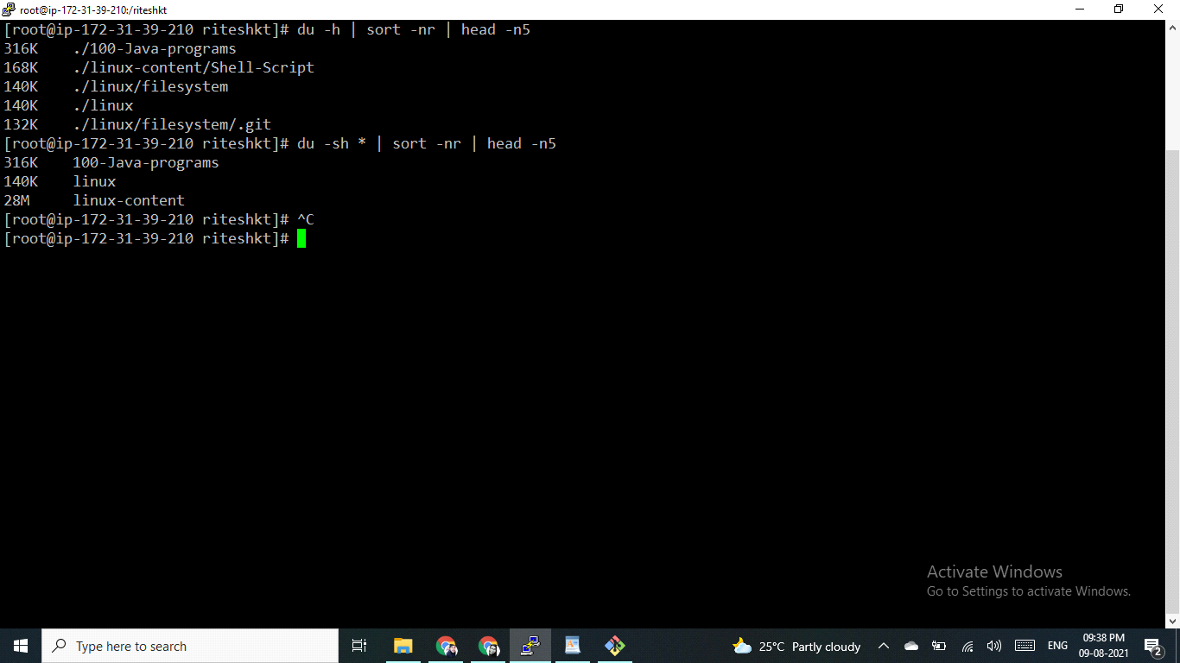

1. Create one common folder in such way that anyone can create files inside that independently and should not be able to delete other users files from that common folder.

You need to explore advance filesystem permission, special permissions

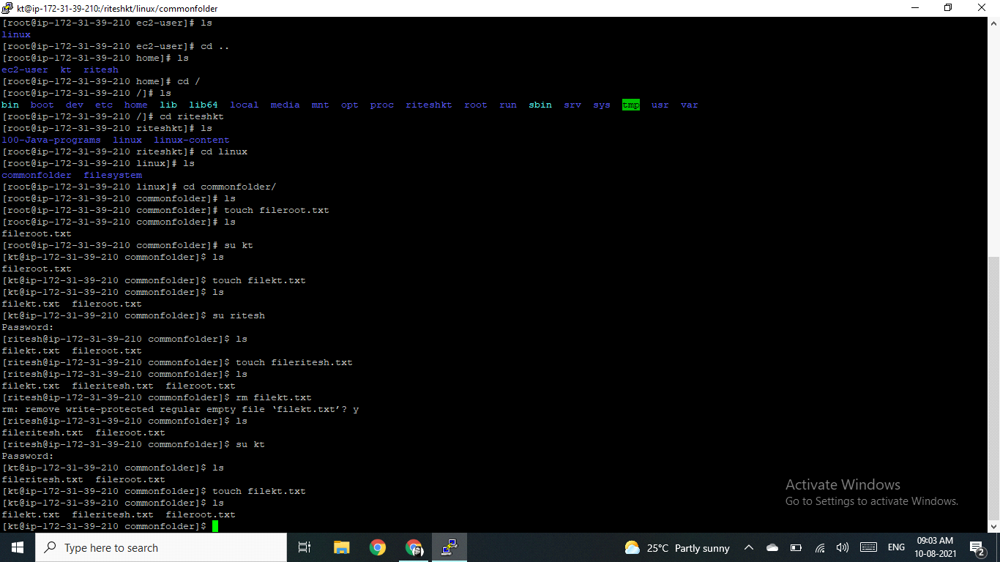

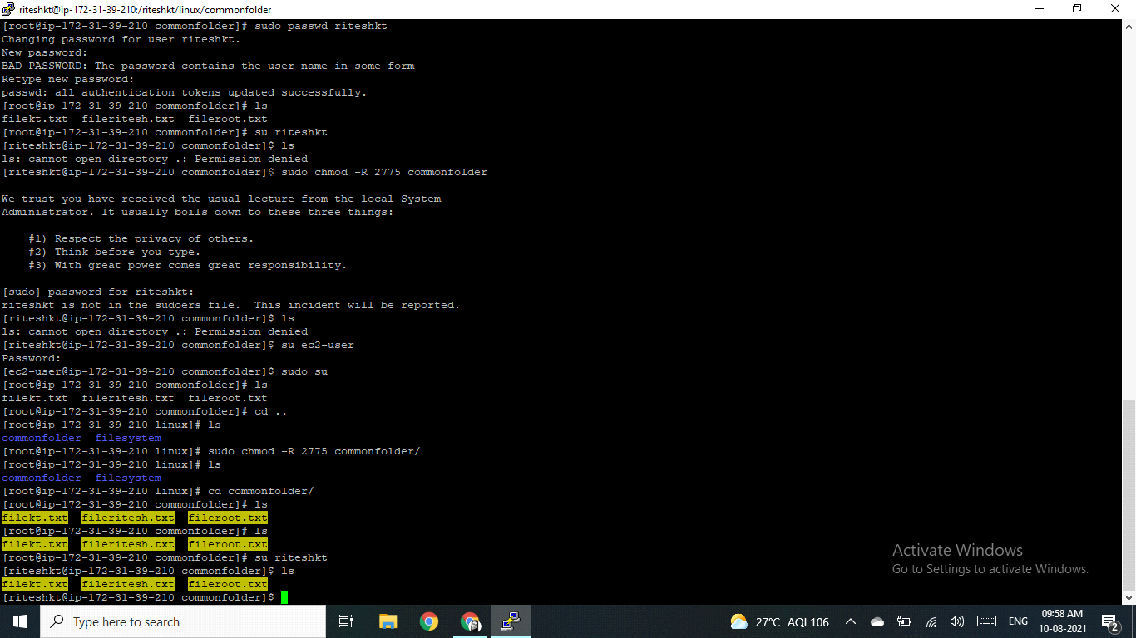

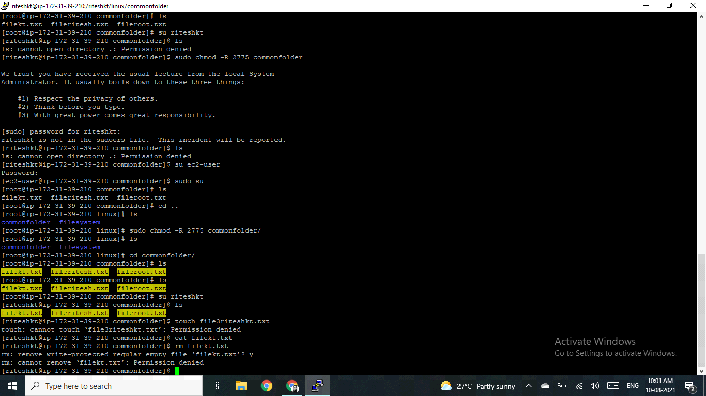

3) Create user name "shubham" and add that user in the group "adm"

Created user = shubham

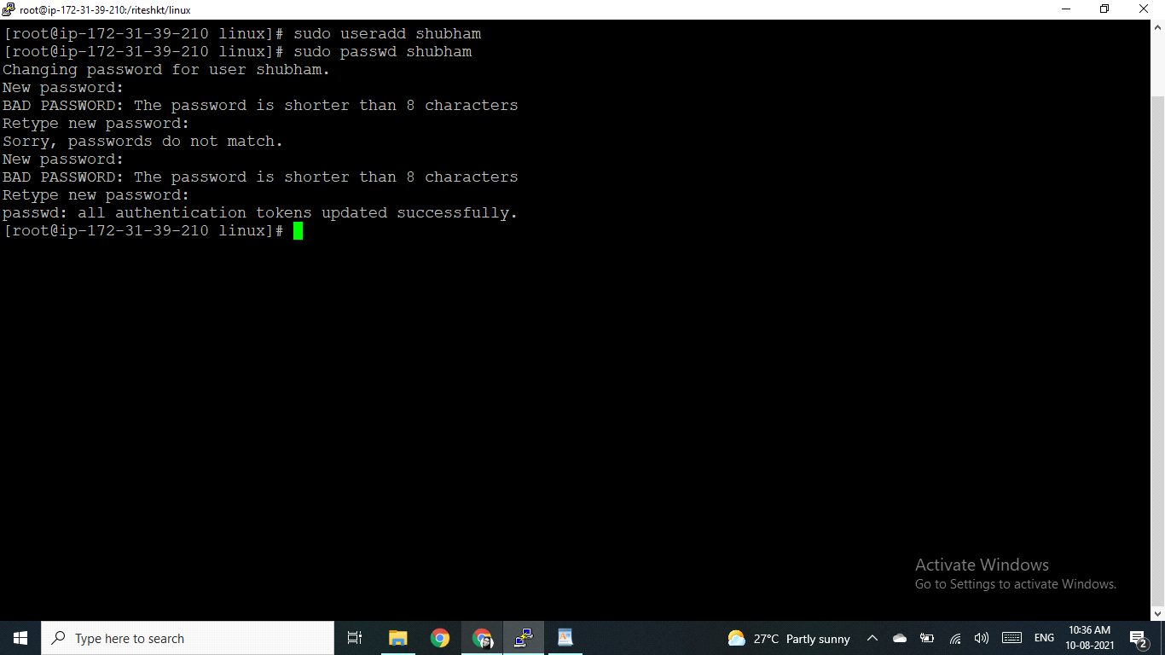

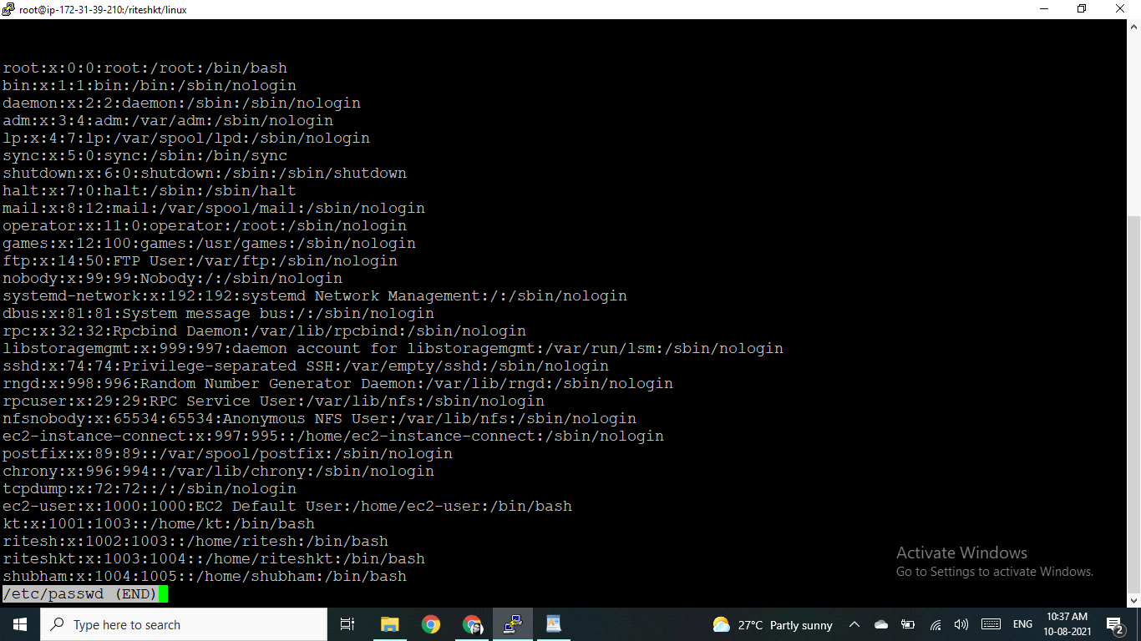

created group = admin

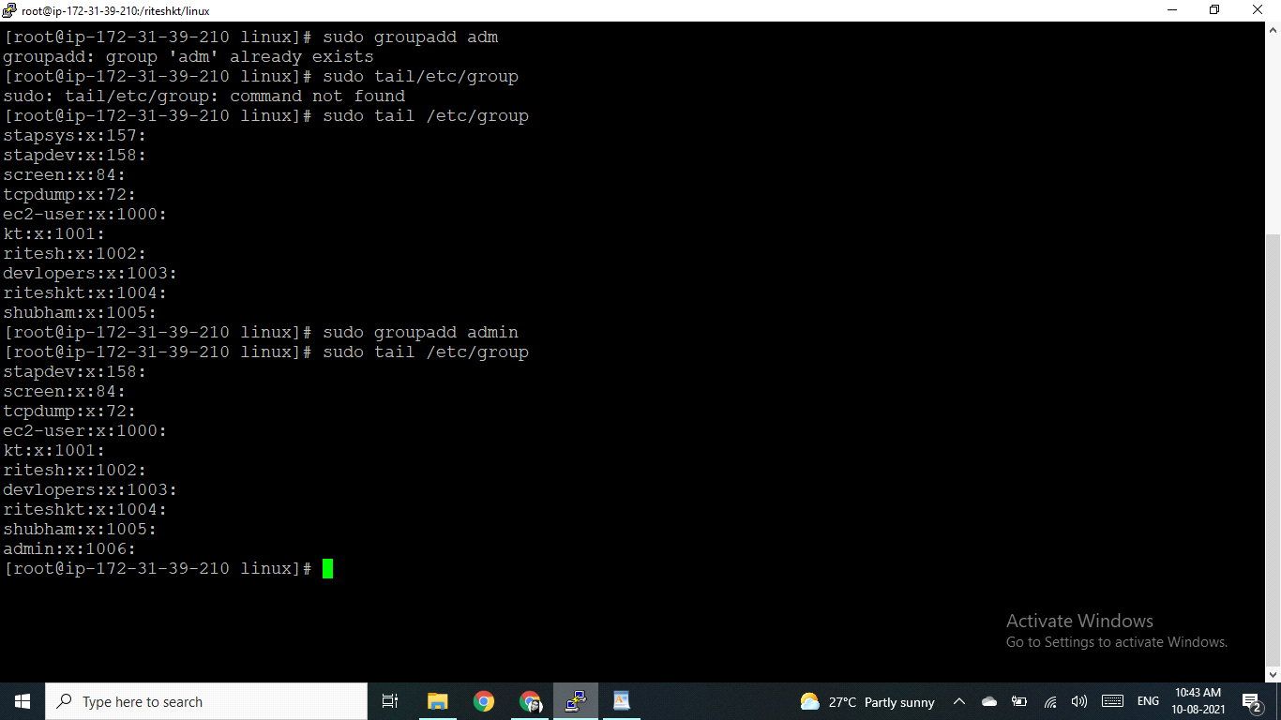

a) Create folder /data , change owner and group as "root:adm

created folder :: data

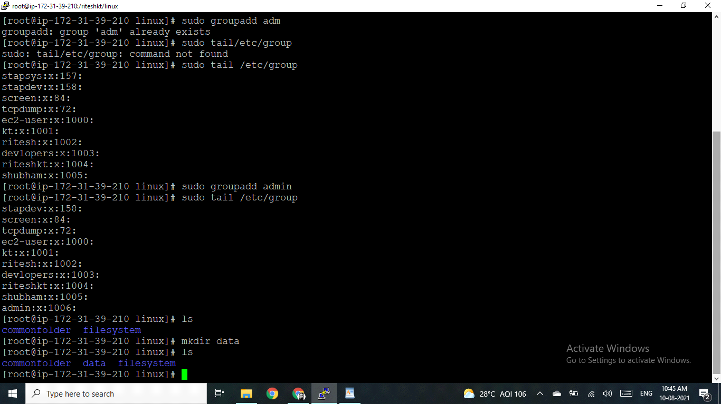

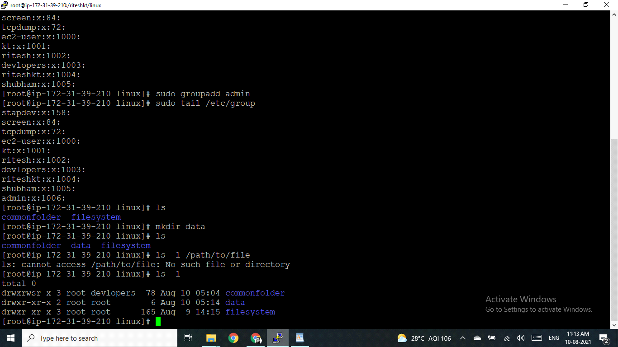

change owner and group as "root:adm

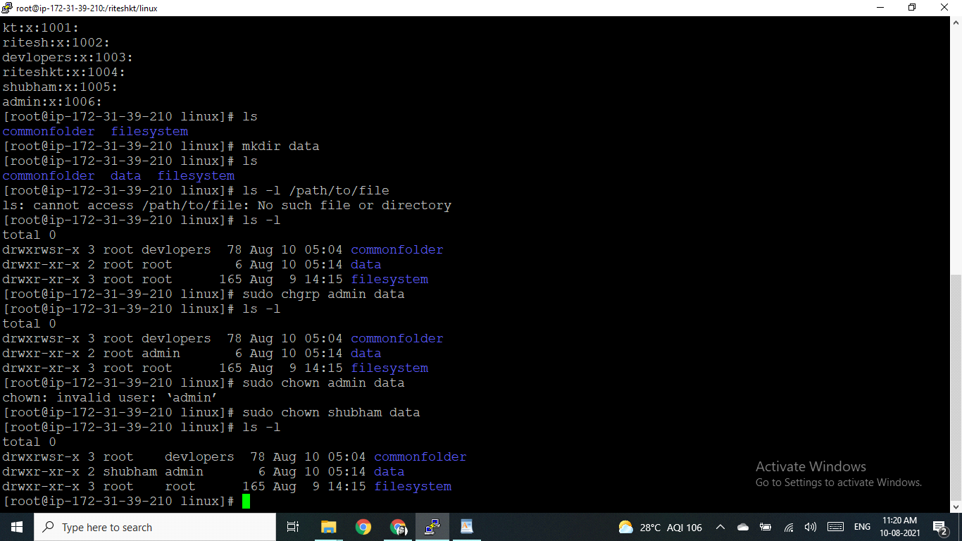

b) Change /data permission such a way that user can able to write data in this folder and ownership of files or folder which you creates in this folder should be same as parent folder i.e /data folder permission (root:adm)

Explore advanced filesystem permission, special permission

