**IT3160E INTRODUCTION TO ARTIFICIAL INTELLIGENCE**

**CAPSTONE PROJECT**

**Class: 131117**

**Lecturer: Than Quang Khoat**

1. **GROUP INFO**

|  |  |  |
| --- | --- | --- |
| **Name** | **Student ID** | **Email** |
| Nguyen Khanh Trung | 20205133 | trung.nk205133@sis.hust.edu.vn |
| Nguyen Phuong Quang | 20205191 | [quang.np205191@sis.hust.edu.vn](mailto:quang.np205191@sis.hust.edu.vn) |
| Hoang Van Phuong | 20200478 | [phuong.hv200478@sis.hust.edu.vn](mailto:phuong.hv200478@sis.hust.edu.vn) |
| Bui Van Thanh | 20200585 | [thanh.bv200585@sis.hust.edu.vn](mailto:thanh.bv200585@sis.hust.edu.vn) |

1. **PROBLEM DESCRIPTION**

Problem: Route Planning

*Overview*

We’re a writing a program to find the shortest route between two Vietnamese cities (e.g. Hanoi and Hai Phong). The intelligent vehicle can only travel between 2 adjacent cities, and the objective is to minimize the number of kms between two cities. We’ll generate ourselves a map of the northern side of Vietnam using <https://www.distantias.com/distance-calculator-vietnam.html>

*Input*

The cities list and distance list between cities will then be read from an excel file having the following format:

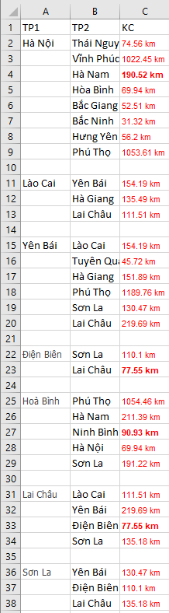

The starting city and ending city will be fixed randomly.

*Output*

The program will have several outputs:

* Time complexity (number of nodes expanded in order to solve the route planning problem)
* Space complexity (number of nodes kept in memory)
* The path used to solve the route planning problem (solution) if there was a solution
* The cumulated number of km of the solution (if any)

*Algorithms*

We’re planning to use Breadth first search, Greedy best first search and A* search algorithm with the heuristic function h(n) = the estimated straight-line distance (flying distance) from n to the goal city.

There’ll also be deep analysis and comparison between the three algorithms and visualization for the solution.

*Applications*

Optimized Travelling, Delivery and many more.