**Title:**  Intelligent Surveillance System for Anomaly Detection Using Machine Learning

**Objectives:**

The objective of this project is to develop an intelligent surveillance system that utilizes machine learning algorithms to detect anomalies in real-time. The system should be able to analyze video footage from surveillance cameras and identify unusual patterns, behaviors or objects that could indicate potential threats, seizure attacks, hand symbols, fight/violence and safety hazards. By leveraging machine learning techniques, the system should be able to learn from past data and improve its accuracy over time, while minimizing false alarms. The ultimate goal is to create a robust and reliable system that can enhance the effectiveness of existing surveillance systems, and contribute to improving safety and security in various settings, such as airports, schools, colleges, hospitals, public spaces, and critical infrastructure facilities.

The development of an intelligent surveillance system that uses machine learning algorithms is becoming increasingly important in today's world. With the rising need for security and safety measures, there is a growing demand for systems that can detect and prevent potential threats in real-time. Traditional surveillance systems can be limited in their ability to detect anomalies, as they often rely on human operators to manually analyze footage and identify unusual patterns. This can be time-consuming and prone to errors, especially in large and complex environments.

By contrast, an intelligent surveillance system that leverages machine learning can offer several advantages. First, it can analyze video footage in real-time and identify any anomaly easily, allowing for a faster response to any safety or security incidents. Second, it can learn from past data and improve its accuracy over time, making it more effective at detecting anomalies and reducing false alarms. Finally, it can operate autonomously, reducing the need for human intervention and freeing up personnel to focus on other critical tasks.

**Required Details:**

* Architecture
  1. Video Input: The system should take in a video stream from surveillance cameras.
  2. Pre-processing: The video input should be pre-processed to remove any noise, distortion, and to normalize the video for further analysis.
  3. Object Detection: YOLO (You Only Look Once) is a deep learning-based object detection model that can detect multiple objects in real-time. It can be used to detect and track people, vehicles, and other objects of interest. YOLO can be used to provide a high-level overview of the video feed by detecting objects and their positions.
  4. Feature Extraction: To extract relevant features from the pre-processed video input, this system could use a combination of deep learning techniques such as Convolutional Neural Networks (CNNs) and Recurrent Neural Networks (RNNs). The CNNs could be used to extract spatial features from individual frames of the video, while the RNNs could be used to capture temporal features across multiple frames.
  5. Anomaly Detection Model: To detect anomalies in the extracted features, this system could use a combination of deep learning models such as ResNet, SRU, and RCNN, which can extract relevant features from the video input and improve accuracy. Additionally, reinforcement learning techniques could be used to adapt the system to changing environments and improve its performance over time. This combination of models could help this system detect potential threats and anomalies with higher accuracy and reduce false positives.
  6. Alert Generation: When an anomaly is detected, an alert should be generated and sent to the security team for further action. The alert can be generated using a combination of YOLO, CNNs, and ANNs.
  7. User Interface: The system should have a user interface that allows security personnel to monitor the video feed and view alerts generated by the system.

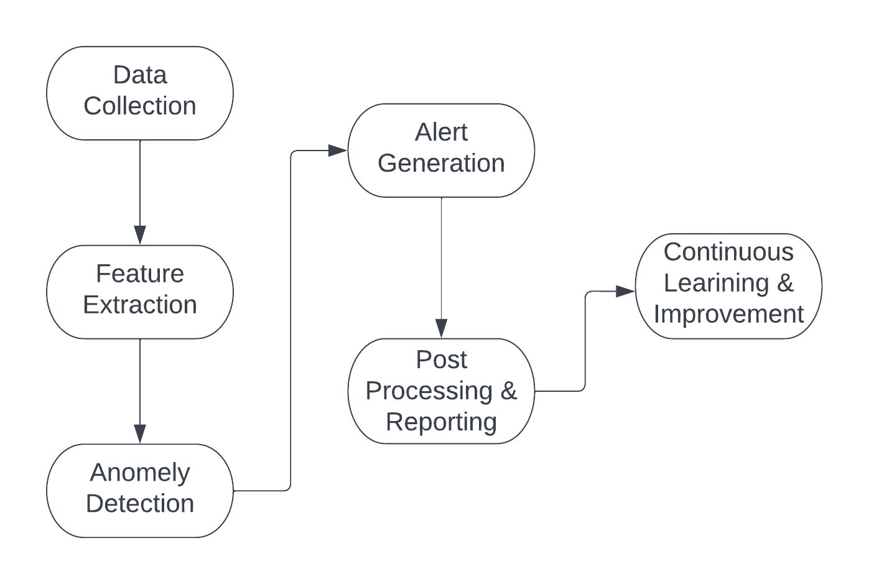

* Novel features

1. Multi-camera analysis: Instead of analyzing footage from individual cameras, this system could analyze data from multiple cameras simultaneously to gain a more comprehensive understanding of the environment and detect anomalies more accurately.
2. Contextual analysis: This system could take into account contextual information, such as time of day, weather conditions, and the presence of people, to better understand the environment and reduce false alarms.
3. Automatic anomaly labeling: This system could automatically label detected anomalies with relevant metadata, such as the type of anomaly, the time and location of detection, and any relevant contextual information.
4. Integration with other systems: This system could be designed to integrate with other security systems, such as access control systems and alarm systems, to provide a more comprehensive security solution.
5. Interactive visualization: This system could provide interactive visualizations that allow security personnel to easily understand and respond to detected anomalies in real-time, such as heat maps.
6. On-device learning: This system could be designed to learn and adapt in real-time on the device itself, without requiring cloud connectivity or sending data to a central server. This could enhance privacy and security while also improving the system's responsiveness and accuracy.
7. Explainability: This system could be designed to provide explanations for detected anomalies, such as highlighting the specific features or behaviors that triggered the detection. This could help to build trust in the system and enable human operators to make more informed decisions.

* Development plan

1. Define the scope: Clarify the project scope and objectives, identifying the specific types of anomalies to be detected and the surveillance settings to be targeted.
2. Collect and preprocess the data: Gather a sufficient amount of video data from surveillance cameras in the chosen setting. Preprocess the data to remove any noise and normalize it for analysis.
3. Develop object detection model: Train and optimize a YOLO (You Only Look Once) model to detect objects in real-time from the preprocessed video. The model should be able to identify people, vehicles, and other objects of interest in the video feed.
4. Extract features using CNNs: Implement a CNN-based feature extractor to extract meaningful features from the preprocessed video. The feature extractor should be able to identify patterns and features in the video, such as motion, texture, and shape.
5. Develop anomaly detection model using ANNs: Implement an ANN-based anomaly detection model to detect unusual patterns and behaviors in the preprocessed video. The model should be trained to learn the patterns of normal behavior and generate alerts when an anomaly occurs.
6. Integrate the models: Integrate the object detection, feature extraction, and anomaly detection models to create a complete system that can analyze video footage in real-time and detect anomalies.
7. Test and refine: Test the system using a range of scenarios and settings, refining and improving the models as needed to enhance accuracy and reduce false alarms.
8. Develop user interface: Develop a user interface for the system that allows security personnel to monitor the video feed and view alerts generated by the system.
9. Deployment: Deploy the system in real-world settings, such as airports, schools, colleges, hospitals, public spaces, and critical infrastructure facilities, to evaluate its effectiveness and refine it based on feedback.
10. Maintenance and improvement: Maintain and improve the system over time, incorporating new features and technologies as they become available to ensure the system remains up-to-date and effective.

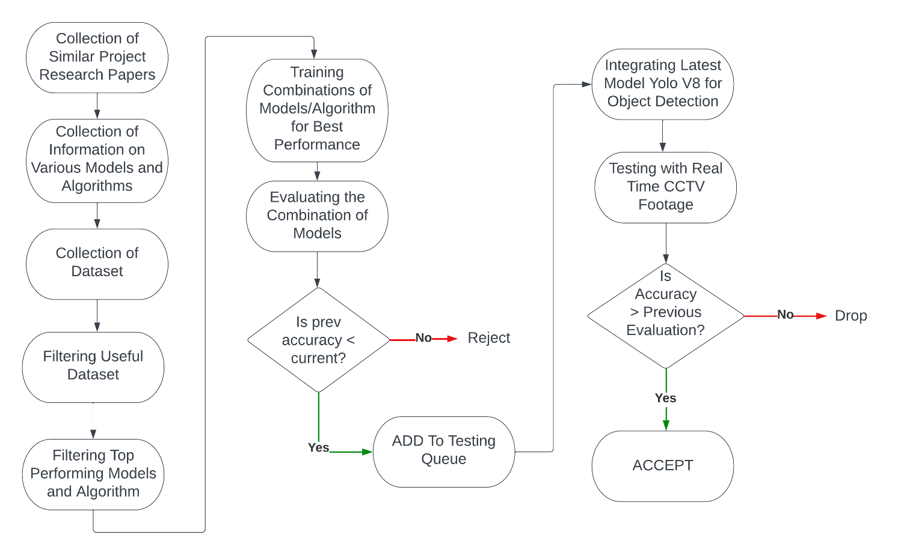

* Testing plan

1. Unit testing: Conduct unit testing to test each component of the system, such as the YOLO model, CNN-based feature extractor, and ANN-based anomaly detection model, to ensure that they function as intended.
2. Integration testing: Conduct integration testing to ensure that the components of the system work together as expected and that the system as a whole can analyze video footage and detect anomalies.
3. Performance testing: Conduct performance testing to evaluate the speed and accuracy of the system under different conditions, such as different lighting, weather, or traffic scenarios.
4. Stress testing: Conduct stress testing to evaluate the system's performance under high load, such as multiple cameras, high traffic, or peak hours.
5. User acceptance testing: Conduct user acceptance testing with security personnel to evaluate the usability of the system and gather feedback on the system's effectiveness in detecting anomalies.
6. Scenario-based testing: Conduct scenario-based testing to evaluate the system's effectiveness in detecting specific types of anomalies, such as seizure attacks, hand symbols, fight/violence, and safety hazards.
7. Edge case testing: Conduct edge case testing to evaluate the system's ability to handle unusual or unexpected situations, such as sudden changes in lighting or unusual behavior patterns.
8. System integration testing: Conduct system integration testing to ensure that the system can be easily integrated with existing surveillance systems in various settings.
9. Regression testing: Conduct regression testing to ensure that the system continues to function as intended after any changes or updates.

* Posting on platform

1. Choose GitHub as platform: GitHub is one of the most widely used and popular platforms for hosting and sharing code.
2. Creating a repository: Create a new repository, giving it a name and adding a brief description of this project.
3. Uploading code and dataset: Uploading project code to the repository by dragging and dropping the files or by using the command line interface (CLI) to push the code and link of drive for dataset.
4. Set up version control: GitHub uses Git as its version control system, so make sure to initialize a Git repository in our local project directory and commit changes using the Git CLI or GitHub Desktop.
5. Adding a README file: Creating a README.md file in the root directory of our project and adding an overview of this project, installation and usage instructions, and any other relevant information.
6. Add a license: Choosing a license for this project and adding it to the repository by creating a LICENSE file. GitHub provides a list of commonly used licenses that we can choose from.
7. Testing code: Before sharing code, test it thoroughly to ensure that it works as expected and is free of bugs and errors.
8. Sharing project: Once completed these steps, sharing this project on GitHub by making it public or sharing the link with others and also can promote this project on social media and other channels to reach a wider audience.

* More novel details features

1. Multi-model approach: Instead of relying on a single machine learning algorithm, this system uses a multi-model approach that combines different techniques like YOLO, ANN, CNN, and others. This can help to improve the accuracy and reliability of the system, as different models can be trained to identify different types of anomalies.
2. Edge computing: To improve the efficiency of the system, using edge computing techniques that allow the machine learning models to run directly on the surveillance cameras or on other edge devices. This can reduce the amount of data that needs to be transmitted to a central server and can speed up the processing of video footage.
3. Explainability and interpretability: In order to build trust in the system and to facilitate human decision-making, we can incorporate techniques for explainability and interpretability. This can help to explain why the system has detected a particular anomaly and can provide insights into the underlying factors that contributed to the detection.
4. Real-time monitoring and alerting: The system can be designed to provide real-time monitoring and alerting capabilities, allowing security personnel to quickly respond to any potential threats. The alerts can be sent to mobile devices or other communication channels, and can be customized based on the severity and type of anomaly detected.
5. Scalability and adaptability: The system can be designed to be scalable and adaptable, allowing it to be deployed in a wide range of settings and to handle varying levels of complexity. The system can also be updated and improved over time, as new data becomes available and new techniques for anomaly detection are developed.
6. Privacy and security: To ensure the privacy and security of individuals who may be captured on video, the system can incorporate techniques for anonymization and encryption. This can help to protect sensitive data and prevent unauthorized access to the system.

* Innovation for features or at model level

1. Transfer learning: Transfer learning is a technique where a model that has been trained on one task is used as a starting point for training a model on a different but related task. By using transfer learning, we can leverage pre-trained models and transfer their knowledge to our specific anomaly detection task. This can save time and resources, and can help to improve the accuracy of the system.
2. Reinforcement learning: Reinforcement learning is a type of machine learning where an agent learns to make decisions by interacting with its environment and receiving feedback in the form of rewards or punishments. By using reinforcement learning, we can train the system to make decisions based on its understanding of the environment and its goals, rather than just on statistical patterns in the data.
3. Generative models: Generative models are a type of machine learning model that can generate new data that is similar to the data it was trained on. By using generative models, we can simulate different scenarios and test the system's ability to detect anomalies in new and unfamiliar situations.
4. Feature engineering: Feature engineering is the process of selecting and transforming the most relevant features in the data to improve the performance of machine learning models. By using advanced feature engineering techniques, such as dimensionality reduction and feature selection, we can help the system to identify the most important patterns and anomalies in the data.
5. Explainable AI: Explainable AI is an emerging field that focuses on building machine learning models that are transparent and explainable. By using explainable AI techniques, we can ensure that the system's decisions are understandable and interpretable by human operators. This can help to build trust in the system and facilitate effective decision-making.

* Other latest trend models can be positive point

1. YOLO V8: YOLOv8, the latest version of the YOLO model, is a cutting-edge tool that can perform tasks such as object detection, image classification, and instance segmentation. Ultralytics, the creators of YOLOv5, have developed YOLOv8 with many upgrades to its architecture and developer experience, making it an even more influential and industry-defining model.
2. Use of GAN Diffusion Generative AI: The use of GAN diffusion generative AI can be a novel and innovative approach for this intelligent surveillance system project. GAN diffusion is a type of generative model that uses diffusion processes to generate realistic and diverse samples from a given data distribution.
3. One-shot learning models: One-shot learning models are a type of machine learning model that can learn from very few examples. These models are particularly useful when there is limited labeled data available, which is often the case in anomaly detection in surveillance footage. By using one-shot learning models, we can potentially improve the system's ability to detect anomalies even when there is limited labeled data available.
4. Reinforcement learning-based models: Reinforcement learning (RL) is a type of machine learning that involves training an agent to make decisions based on rewards and penalties. RL-based models have been successfully used in many applications, including robotics and gaming. In the context of intelligent surveillance systems, RL-based models can be used to train the system to make decisions based on a set of rules and guidelines.

* Implementation details

1. Data collection: Collecting a diverse and representative dataset of surveillance footage is essential for training and testing this model. The dataset should include a variety of scenarios, lighting conditions, and types of anomalies that the system should detect.
2. Pre-processing: Pre-processing the data involves cleaning, normalizing, and augmenting the data to improve the quality and quantity of the training data. This may include techniques such as data cleaning, data normalization, and data augmentation.
3. Model selection and training: Selecting the appropriate machine learning model(s) for this intelligent surveillance system is crucial. The model(s) should be able to accurately detect anomalies in real-time and minimize false alarms. Once the model(s) have been selected, they need to be trained on the pre-processed data.
4. Integration with existing surveillance systems: Integrating this intelligent surveillance system with existing surveillance systems involves configuring the system to work with the hardware and software components of the existing systems. This includes configuring the system to work with the cameras, sensors, and other hardware components, as well as integrating the system with the software used for video recording, storage, and analysis.
5. Testing and evaluation: Testing and evaluating the intelligent surveillance system involves assessing its performance in detecting anomalies in real-world scenarios. This includes evaluating the accuracy and precision of the system, as well as assessing its ability to minimize false alarms and adapt to new and unknown scenarios.
6. Deployment: Deploying this intelligent surveillance system involves installing and configuring the system in the target environment, such as an airport, school, hospital, or public space. This includes configuring the system to work with the existing infrastructure and ensuring that the system is running smoothly.

* Work plan

1. Project kickoff (Data collection and pre-processing) (Week 1)
   * 1. Define project scope and goals
     2. Collect a diverse and representative dataset of surveillance footage
     3. Pre-process the data to improve quality and quantity
2. Model selection and training (Week 2 - 6)
   * 1. Select appropriate machine learning model(s) for anomaly detection
     2. Train the model(s) on the pre-processed data
     3. Evaluate model performance and iterate as needed
3. Integration with existing surveillance systems (Week 7 - 9)
   * 1. Configure the system to work with existing hardware and software components
     2. Integrate the system with video recording, storage, and analysis software
4. Testing and evaluation (Weeks 10 - 12)
   * 1. Conduct extensive testing of the system in real-world scenarios
     2. Evaluate system performance and adaptability
     3. Iterate as needed to optimize performance
5. Deployment (Weeks 13 - 14)
   * 1. Install and configure the system in target environment
     2. Provide user training and support
6. Project wrap-up (Week 15)
   * 1. Finalize project documentation and deliverables
     2. Conduct post-project review and evaluation
     3. Present project results and findings

* Novel aspects

1. Multi-modal anomaly detection: In addition to analyzing video footage, the system can also analyze other sensor data such as audio, temperature, and humidity to detect anomalies. This can improve the accuracy of the system and enable it to detect a wider range of anomalies.
2. Edge computing: The system can be deployed on edge devices such as cameras and network switches to perform real-time processing and analysis of data. This can reduce latency and improve the efficiency of the system.
3. Explainable AI: The system can be designed to provide explanations for its anomaly detection results. This can help users to understand how the system works and build trust in its capabilities.
4. Self-learning: The system can be designed to continuously learn from new data and improve its accuracy over time. This can make the system more effective at detecting anomalies and reduce the need for manual intervention.
5. Privacy-preserving: The system can be designed to ensure that the privacy of individuals is not compromised. This can be achieved by using techniques such as anonymization and encryption to protect sensitive data.
6. Real-time alerting: The system can be designed to provide real-time alerts to users when an anomaly is detected. This can enable users to take immediate action to prevent potential threats.

* Why better from other solutions?

1. Accuracy: By utilizing machine learning algorithms, this system can provide high accuracy in detecting anomalies in real-time. This can reduce false alarms and ensure that potential threats are identified and addressed quickly.
2. Multi-modal detection: Incorporating multiple data sources such as video, audio, temperature, and humidity can enable this system to detect a wider range of anomalies than traditional surveillance systems. The system will use a combination of models such as ResNet, SRU, RCNN, and Reinforcement Learning to achieve the highest accuracy possible.
3. Flexibility: This system can be customized to suit the specific needs of different settings such as airports, schools, colleges, hospitals, public spaces, and critical infrastructure facilities. This can make it more versatile and effective than one-size-fits-all solutions.
4. Scalability: This system can be designed to handle large volumes of data and can be easily scaled up or down depending on the size of the environment it is deployed in.
5. Self-learning: This system can continuously learn from new data and improve its accuracy over time. This can make it more effective and efficient than other solutions that rely on manual intervention.
6. Real-time alerting: This system can provide real-time alerts to users when an anomaly is detected. This can enable users to take immediate action to prevent potential threats and improve safety and security.