1. Angular 2
   1. 1. use Typescript: strongly typed
   2. 2. npm (Node package manager)
      1. AngularCli is a boilerplate for angular
   3. 3. module is namespace, to organize code
   4. 4. component is a template (for view) + metadata using Decorator
   5. 5. Template

# Angular 2 ## 1. use Typescript: strongly typed Typescript type definition files (*.d.ts) And using object ! ## 2. npm (Node package manager) ### AngularCli is a boilerplate for angular ## 3. module is namespace, to organize code how to use? ES 2015 1. create code file: product.ts export class Product { //

}  
2. and another file: product-list.ts  
 import { Product } from  
 '.product'

## 4. component is a template (for view) + metadata using Decorator Decorator is a function that adds metadata to a class, its members, or its method arguments prefixed with an @ Comment: this decorator @Component is right above the export class like attribute in c# we have view layout, binding and directive name used in html Component = Template + Class + Metadaa

Here is the example: 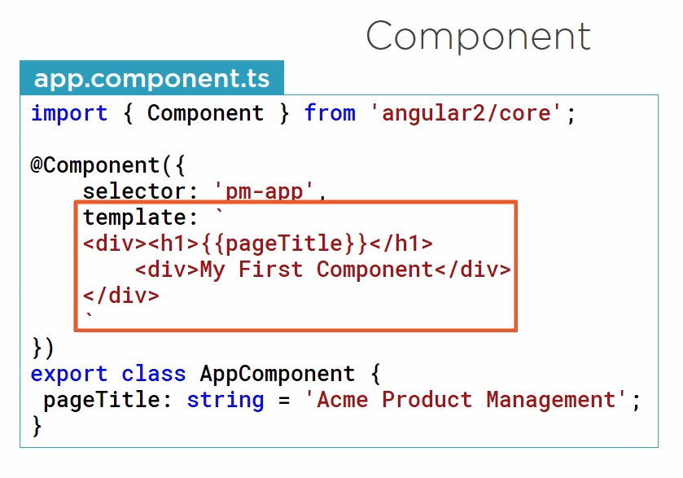

## 5. Template