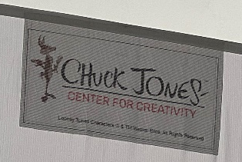
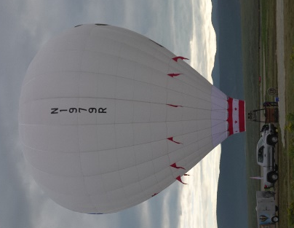
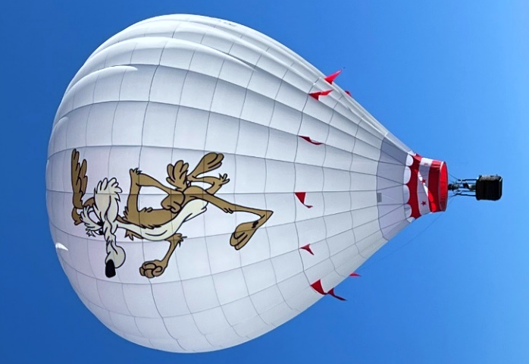
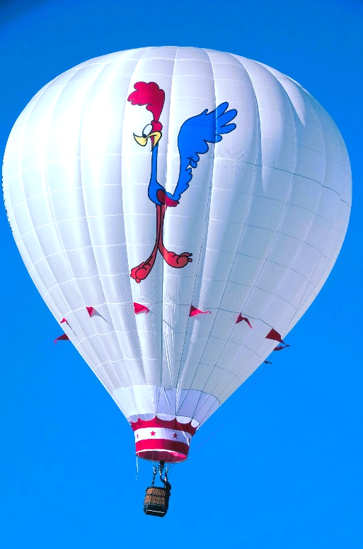
Spirits in the Sky

Spirits in the Sky
Owners/Pilots
Barbara Fricke, Peter Cuneo, Judith Nakamura
The Balloon
FAA Certification: Experimental Homebuilt
Envelope Volume: 90,000 cubic foot
Design: Raven S-57A with panels
Dimensions: 57 ft. wide by 65 ft. high
In celebration of the 50th Albuquerque International Balloon Fiesta and to honor the memory of Balloon Fiesta’s founder, Sid Cutter, Barbara Fricke conceived the bold plan to recreate one of his iconic balloon designs.
The early Roadrunner and Coyote competitions put New Mexico’s unique spin on the more mundane Hare and Hound events and this balloon design symbolizes the never ending competition between New Mexico’s state bird and his eternal rival.
The three owners spent most of 2022 constructing the envelope with graphic experts Bert and Joanie Padelt (Best Aviation) creating the two, inlaid 30-foot tall images.

Many thanks to The Chuck Jones Center for Creative Excellence for permission to reproduce Wile E. Coyote and Road Runner!

