Course Code: IT-15
Course Name: Network Technologies

Credit Scheme |  |  |  | Evaluation Scheme
Lecture | Practical | Credit |  | Internal |  | External | Total
 |  |  | Written | Practical | Tutorial
3 Hrs./Week | - | 3 | 10 | 10 | 5 | 50 | 75

Course Description:

Prerequisite: Students should have fundamental knowledge of computer network.
Course Objectives:
- To understand various computer networks and technologies behind networks
- To study TCP/IP protocol suite, IP addressing schemes and link layer communication
- To study routing concept along with Routing protocols
- To study application layer protocols
- To understand basics of cryptography and socket programming

Course Outcomes:
Student will be able to

CO1: Understand the basic concepts of Computer Network, and principle of layering (Understand)
CO2: Apply the error detection and correction techniques used in data transmission (Apply)
CO3: Apply IP addressing schemes and sub netting (Apply)
CO4: Understand the concept of routing protocols, Application layer protocols and Network Security (Understand)
CO5: Apply the socket programming basics to create a simple chat application
(Apply)

Course Structure:

Sr. No. | Topics Details | Weightage in % | No of Sessions
1 | - Introduction to Data Communication and  Computer Networks  - Internet basics and network components.  [Transmission Media-Guided, Unguided, Network Devices]  - Various types of Networks (only overview)  - Connection Oriented N/Ws Vs Connectionless N/Ws,  - Ethernet- Ethernet standards ZigBee, WiFi, Access Technique -CSMA-CD, | 6 | 3

Negotiation technique Overview
1.2.3. Wireless Network
1.3 Unified Communication –VOIP
Extra Reading: Switching Techniques, CSMA/CA,
CSMA/CD, Unified Communication
2 | - Principle of Layering concept  - Need for layering  - ISO-OSI 7 Layer Model  - TCP/IP model  - OSI Model vs TCP/IP mode  Extra Reading: Data Encapsulation, PDU Formation, network devices | 12 | 8
3 | - Link Layer Communication  - Error detection and correction techniques  - Framing and its types  - Flow and error control  - HDLC protocol  - P2P Protocol  Note: Examples based on 3.1 to be covered  Extra Readings: DLL protocol examples, IEEE 802.2 MAC protocol | 25 | 10
4 | - IP Addressing  - Internet Protocol and IPv4 Packet format,  - Addressing, Physical Addresses, Logical  Addresses  Port Addresses, Specific Addresses  - IP Address- Network Part and Host Part  - Network Masks, Network Addresses and,  Broadcast  Addresses, Loop Back Address  - Address Classes  - TCP and UDP Connections  - TCP Performance in wireless network  - Overview of IPv6  - IP Routing - Types of routing protocol, Border Gateway Protocol (BGP), Routing Information  Protocol (RIP), Open Shortest Path First (OSPF), Routing Table concept  Notes: Examples based on IP addressing and sub netting to be covered  Extra Reading: Network Monitoring Tools –Open NMS,  Putty, Wireshark, Nagios core, Cacti | 25 | 10
5 | - Application Layer Protocols  - DHCP – DHCP Client, DHCP server, DHCP scope  - DNS – Resolution process, Resource Records,  DNS protocol structure  - HTTP – WWW architecture, HTTP: Request and  Response Message  - Email protocols – SMTP, POP3, IMAP4 & MIME  - FTP, Telnet  Extra Reading: Practical on FTP, Telnet, DNS, Putty | 15 | 6
6 | 6. Network Security  6.1Active and Passive attacks  6.2Cryptography (Symmetric and Asymmetric)  6.3Firewall  Extra Reading: Examples on symmetric and asymmetric algorithms | 5 | 2
7 | - Socket Programming  - Introduction  - Berkeley Sockets  - Specifying A Protocol Interface  - The Socket Abstraction  7.4.1 System Data Structures for Sockets  - Specifying an Endpoint Address  - A Generic Address Structure  - Major System Calls Used with Sockets  - Utility Routines for Integer Conversion  - Using Socket Calls in A Program  (The socket can be created in any language)  Extra Reading: Client-Server Architecture and its implementation using Socket programming | 12 | 6
Total: |  | 100 | 45

List of Practical assignments (Socket Programming):

- Write the client and server programs for establishing termination of connection between client and server using TCP. Assume the server can handle only one client.
- Write the client and server programs for simple data (hello) transfer between client and server using UDP. Client will send hello server message to the server program. In its reply the server will send hello client message. The server and client programs should reside on different computers in a network.
- Write the client and server programs for connectionless communication between two different computers in the same TCP/IP network. The server process receives a byte from the client process should and send back an should acknowledgement to the client process.
- Write program for implementing the sliding window protocol of window size 5.
- Write the client and server program for implementing the broadcasting in the local network.

Course References:

Recommended Books:

Text Books:

  - Network Essential Notes GSW MCSE Study Notes
  - Internetworking Technology Handbook CISCO System
  - Data and Computer Communication 8th Edition – William Stallings
  - Official Certification guide CCNA 200-301
  - TCP/IP Sockets in JAVA, Practical Guide for Programmers, Kenneth L Calvert, Michael J Donahoo

Reference Books:
  - Data Communication and Networking Behroz A.Forouzan, TMH, 4th Edition
  - Computer Networks and Internets with Internet Applications Douglas Comer
  - Cryptography and Network Security Atul Kahate, TMH 2nd Edition
  - Internetworking With TCP/IP Vol III: Client-Server Programming And Applications BSD Socket Version Second Edition

Recommended Learning Material:

- https://docs.oracle.com.javase/tutorial/networkingindex.html
- https://docs.oracle.com/javase/tutorial/networking/overview/networking.html

Recommended Certifications:

- CISCO Networking Basics Specialization (Coursera) -
- Network Protocols and Architecture (Coursera)
- Data Communications and Network Services (Coursera)
- Computer Networking-Digital Network Security (www.alison.com/course)
- CCNA (200-301)
- CCNP Enterprise (300-401 ENCOR)
- CCNP Security (300-700 SCOR +concentration exam)
- CCIE Enterprise Infrastructure(300-401 ENCOR + Infrastructure lab v1.0)
- CCIE Enterprise Wireless CCIE +(300-401 ENCOR +wireless lab v1.0)
- Microsoft Networking Fundamentals (98-366) 11. Microsoft Security Fundamentals (98-367)

Topic 1 : Introduction to Data Communication and
Computer Networks
CO1: Understand the basic concepts of Computer Network, and principle of layering
(Understand)

1.2 DATA & INFORMATION



Data refers to the raw facts that are collected while information refers to processed data that enables us to take decisions.
Ex. When result of a particular test is declared it contains data of all students, when you find the marks you have scored you have the information that lets you know whether you have passed or failed.

The word data refers to any information which is presented in a form that is agreed and accepted upon by is creators and users.

1.3 DATA COMMUNICATION




Data Communication is a process of exchanging data or information
In case of computer networks this exchange is done between two devices over a transmission medium.
This process involves a communication system which is made up of hardware and software. The hardware part involves the sender and receiver devices and the intermediate devices through which the data passes. The software part involves certain rules which specify what is to be communicated, how it is to be communicated and when. It is also called as a Protocol.
 The following sections describes the fundamental characteristics that are important for the effective working of data communication process and is followed by the components that make up a data communications system.

1.3.1 Characteristics of Data Communication

The effectiveness of any data communications system depends upon the following four fundamental characteristics:

- Delivery: The data should be delivered to the correct destination and correct user.
- Accuracy: The communication system should deliver the data accurately, without introducing any errors. The data may get corrupted during transmission affecting the accuracy of the delivered data.
- Timeliness: Audio and Video data has to be delivered in a timely manner without any delay; such a data delivery is called real time transmission of data.
- Jitter: It is the variation in the packet arrival time. Uneven Jitter may affect the timeliness of data being transmitted.

1.3.2 Components of Data Communication

A Data Communication system has five components as shown in the diagram below:

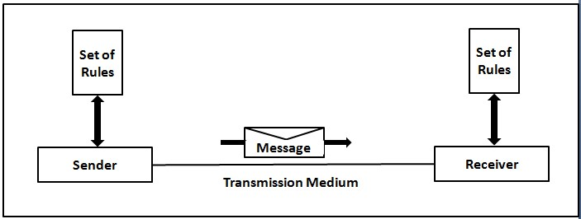

Fig. Components of a Data Communication System

- Message
Message is the information to be communicated by the sender to the receiver.

- Sender
The sender is any device that is capable of sending the data (message).

- Receiver
The receiver is a device that the sender wants to communicate the data (message).

- Transmission Medium
It is the path by which the message travels from sender to receiver.
It can be wired or wireless and many subtypes in both.

- Protocol
 It is an agreed upon set or rules used by the sender and receiver to communicate data.


A protocol is a set of rules that governs data communication.
A Protocol is a necessity in data communications without which the communicating entities are like two persons trying to talk to each other in a different language without know the other language.

1.4 DATA REPRESENTATION

Data is collection of raw facts which is processed to deduce information.

There may be different forms in which data may be represented.
Some of the forms of data used in communications are as follows:

- Text
 Text includes combination of alphabets in small case as well as upper case.
 It is stored as a pattern of bits. Prevalent encoding system : ASCII, Unicode

- Numbers


Numbers include combination of digits from 0 to 9.
It is stored as a pattern of bits. Prevalent encoding system : ASCII, Unicode
- Images  ―An image is worth a thousand words‖ is a very famous saying.
In computers images are digitally stored.

 A Pixel is the smallest element of an image. To put it in simple terms, a picture or image is a matrix of pixel elements.

 The pixels are represented in the form of bits. Depending upon the type of image (black n white or color) each pixel would require different number of bits to represent the value of a pixel.

 The size of an image depends upon the number of pixels (also called resolution) and the bit pattern used to indicate the value of each pixel.

 Example: if an image is purely black and white (two color) each pixel can be represented by a value either 0 or 1, so an image made up of 10 x 10 pixel elements would require only 100 bits in memory to be stored.
 On the other hand an image that includes gray may require 2 bits to represent every pixel value (00 - black, 01 – dark gray, 10
– light gray, 11 –white). So the same 10 x 10 pixel image would now require 200 bits of memory to be stored.

Commonly used Image formats : jpg, png, bmp, etc

- Audio




Data can also be in the form of sound which can be recorded and broadcasted. Example: What we hear on the radio is a source of data or information.
Audio data is continuous, not discrete.

- Video
Video refers to broadcasting of data in form of picture or movie

1.5 DATA FLOW

two devices communicate with each other by sending and receiving data. The data can flow between the two devices in the following ways.
- Simplex
- Half Duplex
- Full Duplex

1.5.1 Simplex

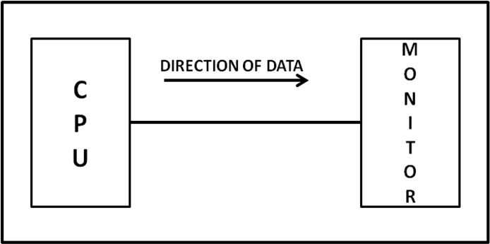

Figure: Simplex mode of communication



In Simplex, communication is unidirectional
Only one of the devices sends the data and the other one only receives the data.
 Example: in the above diagram: a cpu send data while a monitor only receives data.

1.5.2 Half Duplex

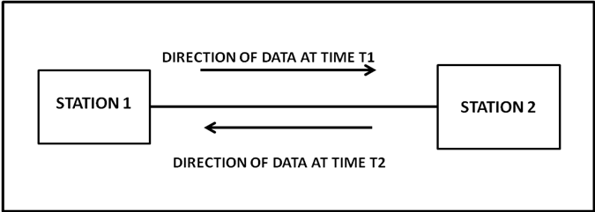

Figure: Half Duplex Mode of Communication

 In half duplex both the stations can transmit as well as receive but not at the same time.
 When one device is sending other can only receive and viceversa (as shown in figure above.)  Example: A walkie-talkie.

1.5.3 Full Duplex

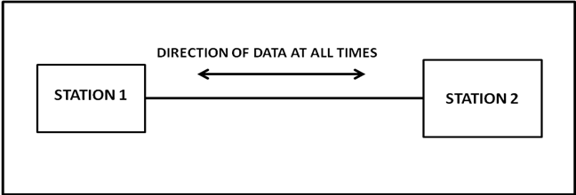

Figure: Full Duplex Mode of Communication



In Full duplex mode, both stations can transmit and receive at the same time.
Example: mobile phones

1.6 COMPUTER NETWORK


Computer Networks are used for data communications

Defina
tion:

A computer network can be defined as a collection of nodes. A node can be any device capable of transmitting or receiving data.
The communicating nodes have to be connected by communication links.



A Compute network should ensure reliability of the data communication process, should c security of the data
performance by achieving higher throughput and smaller
delay times

1.6.1 Categories of Network
Networks are categorized on the basis of their size. The three basic categories of computer networks are:

- Local Area Networks (LAN) is usually limited to a few kilometers of area. It may be privately owned and could be a network inside an office on one of the floor of a building or a LAN could be a network consisting of the computers in a entire building.

- Wide Area Network (WAN) is made of all the networks in a (geographically) large area. The network in the entire state
of Maharashtra could be a WAN

- Metropolitan Area Network (MAN) is of size between LAN & WAN. It is larger than LAN but smaller than WAN. It may comprise the entire network in a city like Mumbai.

1.7 PROTOCOL


A Protocol is one of the components of a data communications system. Without protocol communication cannot occur. The sending device cannot just send the data and expect the receiving device to receive and further interpret it correctly.

 When the sender sends a message it may consist of text, number, images, etc. which are converted into bits and grouped into blocks to be transmitted and often certain additional information called control information is also added to help the receiver interpret the data.

 For successful communication to occur, the sender and receiver must agree upon certain rules called protocol.

 A Protocol is defined as a set of rules that governs data communications.

 A protocol defines what is to be communicated, how it is to be communicated and when it is to be communicated.

1.7.1 Elements of a Protocol
 There are three key elements of a protocol:
- Syntax


It means the structure or format of the data.
It is the arrangement of data in a particular order.

- Semantics
 It tells the meaning of each section of bits and indicates the interpretation of each section.
 It also tells what action/decision is to be taken based on the interpretation.

- Timing
It tells the sender about the readiness of the receiver to receive the data


It tells the sender at what rate the data should be sent to the receiver to avoid overwhelming the receiver.

1.7 STANDARDS IN NETWORKING


Standards are necessary in networking to ensure interconnectivity and interoperability between various networking hardware and software components.

 Without standards we would have proprietary products creating isolated islands of users which cannot interconnect.

1.7.1 Concept of Standard
 Standards provide guidelines to product manufacturers and vendors to ensure national and international interconnectivity.

 Data communications standards are classified into two categories:

- De facto Standard
  - These are the standards that have been traditionally used and mean by fact or by convention
  - These standards are not approved by any organized body but are adopted by widespread use.

- De jure standard o It means by law or by regulation. o These standards are legislated and approved by an body that is officially recognized.

1.7.2 Standard Organizations in field of Networking
- Standards are created by standards creation committees, forums, and government regulatory agencies.

- Examples of Standard Creation Committees :
  - International Organization for Standardization(ISO)
  - International Telecommunications Union –
Telecommunications Standard (ITU-T)
  - American National Standards Institute (ANSI)
  - Institute of Electrical & Electronics Engineers
(IEEE)
  - Electronic Industries Associates (EIA)

- Examples of Forums
  - ATM Forum
  - MPLS Forum
  - Frame Relay Forum

- Examples of Regulatory Agencies:
  - Federal Communications Committee (FCC)

Both guided and unguided media are used to transmit the signals or information. Their mediums are different, but their motive is to transfer the signals. Let’s discuss some more differences between guided and unguided media.

What is Guided Media?
Guided media is like a physical medium via which the signals are transmitted. The guided media is used to provide a conduit from one machine to another that can have twisted-pair, coaxial cable and fibre-optic cable. It is also known as Bounded media.
There are four types of Guided Media which are as follows:
- Open Wire
- Twisted Pair
- Coaxial Cable
- Optical Fibre

What is Unguided Media?
Unguided transmission media are techniques that allow transmission of electromagnetic waves through a wireless medium or we can say without using any physical medium. It provides a mechanism for transferring electromagnetic waves but does not direct them.
There are three types of Unguided Transmission Media which are as follows:
- Microwave Transmission
- Radio Transmission
- Infrared Transmission
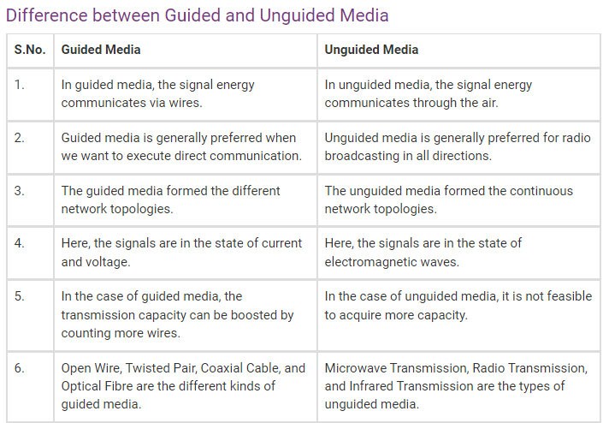

Types Of Guided media:

Twisted pair:
Twisted pair is a physical media made up of a pair of cables twisted with each other. A twisted pair cable is cheap as compared to other transmission media. Installation of the twisted pair cable is easy, and it is a lightweight cable. The frequency range for twisted pair cable is from 0 to 3.5KHz.
A twisted pair consists of two insulated copper wires arranged in a regular spiral pattern.
The degree of reduction in noise interference is determined by the number of turns per foot. Increasing the number of turns per foot decreases noise interference.
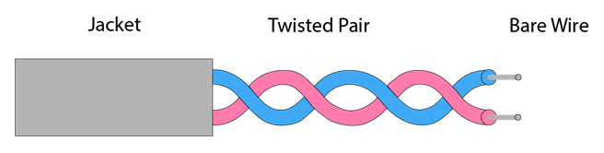

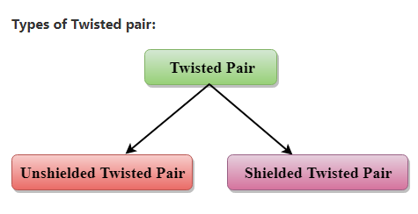

Unshielded Twisted Pair:
An unshielded twisted pair is widely used in telecommunication. Following are the categories of the unshielded twisted pair cable:
- Category 1: Category 1 is used for telephone lines that have low-speed data.
- Category 2: It can support upto 4Mbps.
- Category 3: It can support upto 16Mbps.
- Category 4: It can support upto 20Mbps. Therefore, it can be used for long-distance communication.
- Category 5: It can support upto 200Mbps.
Advantages Of Unshielded Twisted Pair:
- It is cheap.
- Installation of the unshielded twisted pair is easy.
- It can be used for high-speed LAN.
Disadvantage:
- This cable can only be used for shorter distances because of attenuation.

Shielded Twisted Pair
A shielded twisted pair is a cable that contains the mesh surrounding the wire that allows the higher transmission rate.
Characteristics Of Shielded Twisted Pair:
- The cost of the shielded twisted pair cable is not very high and not very low.
- An installation of STP is easy.
- It has higher capacity as compared to unshielded twisted pair cable.
- It has a higher attenuation.
- It is shielded that provides the higher data transmission rate.
Disadvantages
- It is more expensive as compared to UTP and coaxial cable.
- It has a higher attenuation rate.

Coaxial Cable
- Coaxial cable is very commonly used transmission media, for example, TV wire is usually a coaxial cable.
- The name of the cable is coaxial as it contains two conductors parallel to each other.
- It has a higher frequency as compared to Twisted pair cable.
- The inner conductor of the coaxial cable is made up of copper, and the outer conductor is made up of copper mesh. The middle core is made up of non-conductive cover that separates the inner conductor from the outer conductor.
- The middle core is responsible for the data transferring whereas the copper mesh prevents from the EMI(Electromagnetic interference).
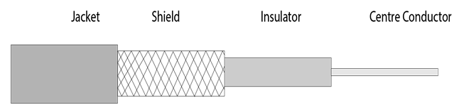
Coaxial cable is of two types:
- Baseband transmission: It is defined as the process of transmitting a single signal at high speed.
- Broadband transmission: It is defined as the process of transmitting multiple signals simultaneously.
Advantages Of Coaxial cable:
- The data can be transmitted at high speed.
- It has better shielding as compared to twisted pair cable.
- It provides higher bandwidth.
Disadvantages Of Coaxial cable:
- It is more expensive as compared to twisted pair cable.
- If any fault occurs in the cable causes the failure in the entire network.

Fibre Optic
- Fibre optic cable is a cable that uses electrical signals for communication.
- Fibre optic is a cable that holds the optical fibres coated in plastic that are used to send the data by pulses of light.
- The plastic coating protects the optical fibres from heat, cold, electromagnetic interference from other types of wiring.
- Fibre optics provide faster data transmission than copper wires.
Diagrammatic representation of fibre optic cable:
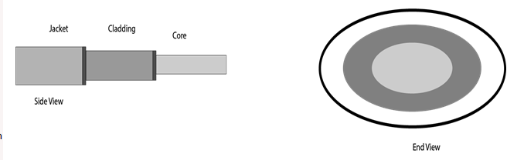
Basic elements of Fibre optic cable:
- ore: The optical fibre consists of a narrow strand of glass or plastic known as a core. A core is a light transmission area of the fibre. The more the area of the core, the more light will be transmitted into the fibre.
- Cladding: The concentric layer of glass is known as cladding. The main functionality of the cladding is to provide the lower refractive index at the core interface as to cause the reflection within the core so that the light waves are transmitted through the fibre.
- Jacket: The protective coating consisting of plastic is known as a jacket. The main purpose of a jacket is to preserve the fibre strength, absorb shock and extra fibre protection.
Following are the advantages of fibre optic cable over copper:
- Greater Bandwidth: The fibre optic cable provides more bandwidth as compared copper. Therefore, the fibre optic carries more data as compared to copper cable.
- Faster speed: Fibre optic cable carries the data in the form of light. This allows the fibre optic cable to carry the signals at a higher speed.
- Longer distances: The fibre optic cable carries the data at a longer distance as compared to copper cable.
- Better reliability: The fibre optic cable is more reliable than the copper cable as it is immune to any temperature changes while it can cause obstruct in the connectivity of copper cable.
- Thinner and Sturdier: Fibre optic cable is thinner and lighter in weight so it can withstand more pull pressure than copper cable.

UnGuided Transmission
- An unguided transmission transmits the electromagnetic waves without using any physical medium. Therefore it is also known as wireless transmission.
- In unguided media, air is the media through which the electromagnetic energy can flow easily.
Unguided transmission is broadly classified into three categories:

Radio waves
- Radio waves are the electromagnetic waves that are transmitted in all the directions of free space.
- Radio waves are omnidirectional, i.e., the signals are propagated in all the directions.
- The range in frequencies of radio waves is from 3Khz to 1 khz.
- In the case of radio waves, the sending and receiving antenna are not aligned, i.e., the wave sent by the sending antenna can be received by any receiving antenna.
- An example of the radio wave is FM radio.

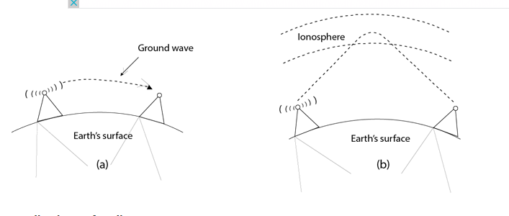

Applications Of Radio waves:
- A Radio wave is useful for multicasting when there is one sender and many receivers.
- An FM radio, television, cordless phones are examples of a radio wave.
Advantages Of Radio transmission:
- Radio transmission is mainly used for wide area networks and mobile cellular phones.
- Radio waves cover a large area, and they can penetrate the walls.
- Radio transmission provides a higher transmission rate.
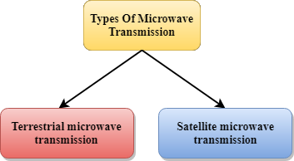

Microwaves are of two types:
- Terrestrial microwave
- Satellite microwave communication.

Terrestrial Microwave Transmission
- Terrestrial Microwave transmission is a technology that transmits the focused beam of a radio signal from one ground-based microwave transmission antenna to another.
- Microwaves are the electromagnetic waves having the frequency in the range from 1GHz to 1000 GHz.
- Microwaves are unidirectional as the sending and receiving antenna is to be aligned, i.e., the waves sent by the sending antenna are narrowly focussed.
- In this case, antennas are mounted on the towers to send a beam to another antenna which is km away.
- It works on the line of sight transmission, i.e., the antennas mounted on the towers are the direct sight of each other.
Characteristics of Microwave:
- Frequency range: The frequency range of terrestrial microwave is from 4-6 GHz to 21-23 GHz.
- Bandwidth: It supports the bandwidth from 1 to 10 Mbps.
- Short distance: It is inexpensive for short distance.
- Long distance: It is expensive as it requires a higher tower for a longer distance.
- Attenuation: Attenuation means loss of signal. It is affected by environmental conditions and antenna size.
Advantages Of Microwave:
- Microwave transmission is cheaper than using cables.
- It is free from land acquisition as it does not require any land for the installation of cables.
- Microwave transmission provides an easy communication in terrains as the installation of cable in terrain is quite a difficult task.
- Communication over oceans can be achieved by using microwave transmission.
Disadvantages of Microwave transmission:
- Eavesdropping: An eavesdropping creates insecure communication. Any malicious user can catch the signal in the air by using its own antenna.
- Out of phase signal: A signal can be moved out of phase by using microwave transmission.
- Susceptible to weather condition: A microwave transmission is susceptible to weather condition. This means that any environmental change such as rain, wind can distort the signal.
- Bandwidth limited: Allocation of bandwidth is limited in the case of microwave transmission.

Satellite Microwave Communication
- A satellite is a physical object that revolves around the earth at a known height.
- Satellite communication is more reliable nowadays as it offers more flexibility than cable and fibre optic systems.
- We can communicate with any point on the globe by using satellite communication.
How Does Satellite work?
The satellite accepts the signal that is transmitted from the earth station, and it amplifies the signal. The amplified signal is retransmitted to another earth station.
Advantages Of Satellite Microwave Communication:
- The coverage area of a satellite microwave is more than the terrestrial microwave.
- The transmission cost of the satellite is independent of the distance from the centre of the coverage area.
- Satellite communication is used in mobile and wireless communication applications.
- It is easy to install.
- It is used in a wide variety of applications such as weather forecasting, radio/TV signal broadcasting, mobile communication, etc.
Disadvantages Of Satellite Microwave Communication:
- Satellite designing and development requires more time and higher cost.
- The Satellite needs to be monitored and controlled on regular periods so that it remains in orbit.
- The life of the satellite is about 12-15 years. Due to this reason, another launch of the satellite has to be planned before it becomes non-functional.

Infrared
- An infrared transmission is a wireless technology used for communication over short ranges.
- The frequency of the infrared in the range from 300 GHz to 400 THz.
- It is used for short-range communication such as data transfer between two cell phones, TV remote operation, data transfer between a computer and cell phone resides in the same closed area.
Characteristics Of Infrared:
- It supports high bandwidth, and hence the data rate will be very high.
- Infrared waves cannot penetrate the walls. Therefore, the infrared communication in one room cannot be interrupted by the nearby rooms.
- An infrared communication provides better security with minimum interference.
- Infrared communication is unreliable outside the building because the sun rays will interfere with the infrared waves.

1.2.1. Connection Oriented N/Ws Vs Connectionless N/Ws

Difference between Connection-Oriented and Connectionless Service
Data communication is a telecommunication network to send and receive data between two or more computers over the same or different network. There are two ways to establish a connection before sending data from one device to another, that are Connection-Oriented and Connectionless Service. Connection-oriented service involves the creation and termination of the connection for sending the data between two or more devices. In contrast, connectionless service does not require establishing any connection and termination process for transferring the data over a network.

Connection-Oriented Service
A connection-oriented service is a network service that was designed and developed after the telephone system. A connection-oriented service is used to create an end to end connection between the sender and the receiver before transmitting the data over the same or different networks. In connection-oriented service, packets are transmitted to the receiver in the same order the sender has sent them. It uses a handshake method that creates a connection between the user and sender for transmitting the data over the network. Hence it is also known as a reliable network service.
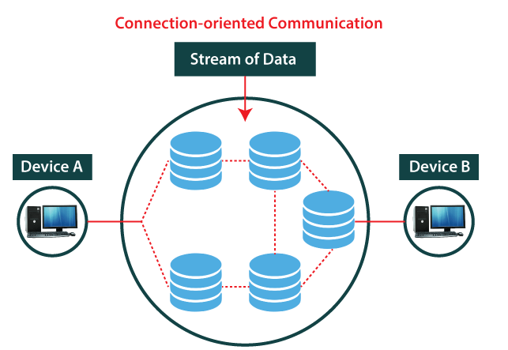
Suppose, a sender wants to send data to the receiver. Then, first, the sender sends a request packet to a receiver in the form of an SYN packet. After that, the receiver responds to the sender's request with an (SYN-ACK) signal/packets. That represents the confirmation is received by the receiver to start the communication between the sender and the receiver. Now a sender can send the message or data to the receiver.
Similarly, a receiver can respond or send the data to the sender in the form of packets. After successfully exchanging or transmitting data, a sender can terminate the connection by sending a signal to the receiver. In this way, we can say that it is a reliable network service.

What is a TCP?
TCP (Transmission Control Protocol) is a connection-oriented protocol that allows communication between two or more computer devices by establishing connections in the same or different networks. It is the most important protocol that uses internet protocol to transfer the data from one end to another. Hence, it is sometimes referred to as TCP/IP. It ensures that the connection is established and maintained until the data packet is transferring between the sender and receiver is complete.

Connectionless Service
A connection is similar to a postal system, in which each letter takes along different route paths from the source to the destination address. Connectionless service is used in the network system to transfer data from one end to another end without creating any connection. So it does not require establishing a connection before sending the data from the sender to the receiver. It is not a reliable network service because it does not guarantee the transfer of data packets to the receiver, and data packets can be received in any order to the receiver. Therefore we can say that the data packet does not follow a defined path. In connectionless service, the transmitted data packet is not received by the receiver due to network congestion, and the data may be lost.
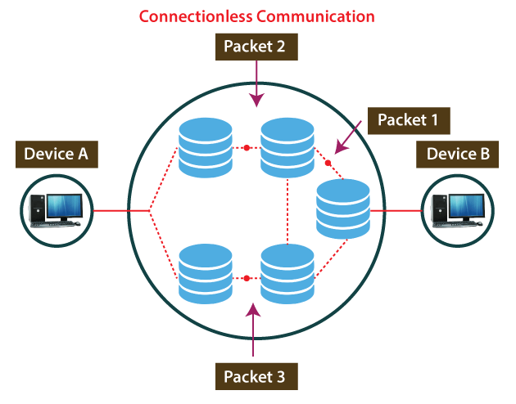 For example, a sender can directly send any data to the receiver without establishing any connection because it is a connectionless service. Data sent by the sender will be in the packet or data streams containing the receiver's address. In connectionless service, the data can be travelled and received in any order. However, it does not guarantee to transfer of the packets to the right destination.

What is UDP?
The UDP (User Datagram Protocol) is a connectionless protocol that allows communication between two or more devices without establishing any connection. In this protocol, a sender sends the data packets to the receiver that holds the destination address. A UDP does not ensure to deliver the data packets to the correct destination, and it does not generate any acknowledgment about the sender's data. Similarly, it does not acknowledge the receiver about the data. Hence, it is an unreliable protocol.

Connection-Oriented vs Connectionless Service

S. No | Comparison Parameter | Connection-oriented Service | Connection Less Service
1. | Related System | It is designed and developed based on the telephone system. | It is service based on the postal system.
2. | Definition | It is used to create an end to end connection between the senders to the receiver before transmitting the data over the same or different network. | It is used to transfer the data packets between senders to the receiver without creating any connection.
3. | Virtual path | It creates a virtual path between the sender and the receiver. | It does not create any virtual connection or path between the sender and the receiver.
4. | Authentication | It requires authentication before transmitting the data packets to the receiver. | It does not require authentication before transferring data packets.
5. | Data Packets Path | All data packets are received in the same order as those sent by the sender. | Not all data packets are received in the same order as those sent by the sender.
6. | Bandwidth Requirement | It requires a higher bandwidth to transfer the data packets. | It requires low bandwidth to transfer the data packets.
7. | Data Reliability | It is a more reliable connection service because it guarantees data packets transfer from one end to the other end with a connection. | It is not a reliable connection service because it does not guarantee the transfer of data packets from one end to another for establishing a connection.
8. | Congestion | There is no congestion as it provides an end-to-end connection between sender and receiver during transmission of data. | There may be congestion due to not providing an end-to-end connection between the source and receiver to transmit of data packets.
9. | Examples | Transmission Control Protocol (TCP) is an example of a connection-oriented service. | User Datagram Protocol (UDP), Internet Protocol (IP), and Internet Control Message Protocol (ICMP) are examples of connectionless service.

Ethernet- Ethernet standards ZigBee

Zigbee is a standards-based wireless technology developed to enable low-cost, low-power wireless machine-to-machine (M2M) and internet of things (IoT) networks. Zigbee is for low-data rate, low-power applications and is an open standard. This, theoretically, enables the mixing of implementations from different manufacturers, but in practice, Zigbee products have been extended and customized by vendors and, thus, plagued by interoperability issues. In contrast to Wi-Fi networks used to connect endpoints to high-speed networks, Zigbee supports much lower data rates and uses a mesh networking protocol to avoid hub devices and create a self-healing architecture.

ZigBee is a Personal Area Network task group with low rate task group 4. It is a technology of home networking. ZigBee is a technological standard created for controlling and sensing the network. As we know that ZigBee is the Personal Area Network of task group 4 so it is based on IEEE 802.15.4 and is created by Zigbee Alliance.

ZigBee is a standard that addresses the need for very low-cost implementation of Low power devices with Low data rates for short-range wireless communications.
Why another short-range communication standard??

Types of ZigBee Devices:
- Zigbee Coordinator Device: It communicates with routers. This device is used for connecting the devices.
- Zigbee Router: It is used for passing the data between devices.
- Zigbee End Device: It is the device that is going to be controlled.

General Characteristics of Zigbee Standard:
- Low Power Consumption
- Low Data Rate (20- 250 kbps)
- Short-Range (75-100 meters)
- Network Join Time (~ 30 msec)
- Support Small and Large Networks (up to 65000 devices (Theory); 240 devices (Practically))
- Low Cost of Products and Cheap Implementation (Open Source Protocol)
- Extremely low-duty cycle.
- 3 frequency bands with 27 channels.
Operating Frequency Bands (Only one channel will be selected for use in a network):
- Channel 0: 868 MHz (Europe)
- Channel 1-10: 915 MHz (the US and Australia)
- Channel 11-26: 2.4 GHz (Across the World)
Advantages of Zigbee:
- Designed for low power consumption.
- Provides network security and application support services operating on the top of IEEE.
- Zigbee makes possible completely networks homes where all devices are able to communicate and be
- Use in smart home
- Easy implementation
- Adequate security features.
- Low cost: Zigbee chips and modules are relatively inexpensive, which makes it a cost-effective solution for IoT applications.
- Mesh networking: Zigbee uses a mesh network topology, which allows for devices to communicate with each other without the need for a central hub or router. This makes it ideal for use in smart home applications where devices need to communicate with each other and with a central control hub.
- Reliability: Zigbee protocol is designed to be highly reliable, with robust mechanisms in place to ensure that data is delivered reliably even in adverse conditions.
Disadvantages of Zigbee :
- Limited range: Zigbee has a relatively short range compared to other wireless communications protocols, which can make it less suitable for certain types of applications or for use in large buildings.
- Limited data rate: Zigbee is designed for low-data-rate applications, which can make it less suitable for applications that require high-speed data transfer.
- Interoperability: Zigbee is not as widely adopted as other IoT protocols, which can make it difficult to find devices that are compatible with each other.
- Security: Zigbee’s security features are not as robust as other IoT protocols, making it more vulnerable to hacking and other security threats.

Zigbee Network Topologies:
- Star Topology (ZigBee Smart Energy): Consists of a coordinator and several end devices, end devices communicate only with the coordinator.
- Mesh Topology (Self Healing Process): Mesh topology consists of one coordinator, several routers, and end devices.
- Tree Topology: In this topology, the network consists of a central node which is a coordinator, several routers, and end devices. the function of the router is to extend the network coverage.

Architecture of Zigbee:
Zigbee architecture is a combination of 6 layers.
- Application Layer
- Application Interface Layer
- Security Layer
- Network Layer
- Medium Access Control Layer
- Physical Layer

- Physical layer: The lowest two layers i.e the physical and the MAC (Medium Access Control) Layer are defined by the IEEE 802.15.4 specifications. The Physical layer is closest to the hardware and directly controls and communicates with the Zigbee radio. The physical layer translates the data packets in the over-the-air bits for transmission and vice-versa during the reception.
- Medium Access Control layer (MAC layer): The layer is responsible for the interface between the physical and network layer. The MAC layer is also responsible for providing PAN ID and also network discovery through beacon requests.
- Network layer: This layer acts as an interface between the MAC layer and the application layer. It is responsible for mesh networking.
- Application layer: The application layer in the Zigbee stack is the highest protocol layer and it consists of the application support sub-layer and Zigbee device object. It contains manufacturer-defined applications.
Channel Access:
- Contention Based Method (Carrier-Sense Multiple Access With Collision Avoidance Mechanism)
- Contention Free Method (Coordinator dedicates a specific time slot to each device (Guaranteed Time Slot (GTS)))

Zigbee Applications:
- Home Automation
- Medical Data Collection
- Industrial Control Systems
- meter reading system
- light control system
- Commercial
- Government Markets Worldwide
- Home Networking
Multiple access schemes are used to allow many mobile users to share simultaneously a finite amount of radio spectrum.

Multiple Access Techniques
In wireless communication systems, it is often desirable to allow the subscriber to send information simultaneously from the mobile station to the base station while receiving information from the base station to the mobile station.
A cellular system divides any given area into cells where a mobile unit in each cell communicates with a base station. The main aim in the cellular system design is to be able to increase the capacity of the channel, i.e., to handle as many calls as possible in a given bandwidth with a sufficient level of quality of service.
There are several different ways to allow access to the channel. These includes mainly the following −
- Frequency division multiple-access (FDMA)
- Time division multiple-access (TDMA)
- Code division multiple-access (CDMA)
- Space division multiple access (SDMA)
Depending on how the available bandwidth is allocated to the users, these techniques can be classified as narrowband and wideband systems.

Narrowband Systems
Systems operating with channels substantially narrower than the coherence bandwidth are called as Narrow band systems. Narrow band TDMA allows users to use the same channel but allocates a unique time slot to each user on the channel, thus separating a small number of users in time on a single channel.
Narrowband Systems
Systems operating with channels substantially narrower than the coherence bandwidth are called as Narrow band systems. Narrow band TDMA allows users to use the same channel but allocates a unique time slot to each user on the channel, thus separating a small number of users in time on a single channel.

Wideband Systems
In wideband systems, the transmission bandwidth of a single channel is much larger than the coherence bandwidth of the channel. Thus, multipath fading doesn’t greatly affect the received signal within a wideband channel, and frequency selective fades occur only in a small fraction of the signal bandwidth.

Frequency Division Multiple Access (FDMA)
FDMA is the basic technology for advanced mobile phone services. The features of FDMA are as follows.

FDMA allots a different sub-band of frequency to each different user to access the network.
If FDMA is not in use, the channel is left idle instead of allotting to the other users.
FDMA is implemented in Narrowband systems and it is less complex than TDMA.
Tight filtering is done here to reduce adjacent channel interference.
The base station BS and mobile station MS, transmit and receive simultaneously and continuously in FDMA.
Time Division Multiple Access (TDMA)
In the cases where continuous transmission is not required, there TDMA is used instead of FDMA. The features of TDMA include the following.

TDMA shares a single carrier frequency with several users where each users makes use of non-overlapping time slots.
Data transmission in TDMA is not continuous, but occurs in bursts. Hence handsoff process is simpler.
TDMA uses different time slots for transmission and reception thus duplexers are not required.
TDMA has an advantage that is possible to allocate different numbers of time slots per frame to different users.
Bandwidth can be supplied on demand to different users by concatenating or reassigning time slot based on priority.
Code Division Multiple Access (CDMA)
Code division multiple access technique is an example of multiple access where several transmitters use a single channel to send information simultaneously. Its features are as follows.

In CDMA every user uses the full available spectrum instead of getting allotted by separate frequency.
CDMA is much recommended for voice and data communications.
While multiple codes occupy the same channel in CDMA, the users having same code can communicate with each other.
CDMA offers more air-space capacity than TDMA.
The hands-off between base stations is very well handled by CDMA.
Space Division Multiple Access (SDMA)
Space division multiple access or spatial division multiple access is a technique which is MIMO (multiple-input multiple-output) architecture and used mostly in wireless and satellite communication. It has the following features.
All users can communicate at the same time using the same channel.
SDMA is completely free from interference.
A single satellite can communicate with more satellites receivers of the same frequency.
The directional spot-beam antennas are used and hence the base station in SDMA, can track a moving user.
Controls the radiated energy for each user in space.
Spread Spectrum Multiple Access
Spread spectrum multiple access (SSMA) uses signals which have a transmission bandwidth whose magnitude is greater than the minimum required RF bandwidth.
There are two main types of spread spectrum multiple access techniques −
Frequency hopped spread spectrum (FHSS)
Direct sequence spread spectrum (DSSS)
Frequency Hopped Spread Spectrum (FHSS)
This is a digital multiple access system in which the carrier frequencies of the individual users are varied in a pseudo random fashion within a wideband channel. The digital data is broken into uniform sized bursts which is then transmitted on different carrier frequencies.
Direct Sequence Spread Spectrum (DSSS)
This is the most commonly used technology for CDMA. In DS-SS, the message signal is multiplied by a Pseudo Random Noise Code. Each user is given his own code word which is orthogonal to the codes of other users and in order to detect the user, the receiver must know the code word used by the transmitter.
The combinational sequences called as hybrid are also used as another type of spread spectrum. Time hopping is also another type which is rarely mentioned.
Since many users can share the same spread spectrum bandwidth without interfering with one another, spread spectrum systems become bandwidth efficient in a multiple user environment.
Computer networks that are not connected by cables are called wireless networks. They generally use radio waves for communication between the network nodes. They allow devices to be connected to the network while roaming around within the network coverage.
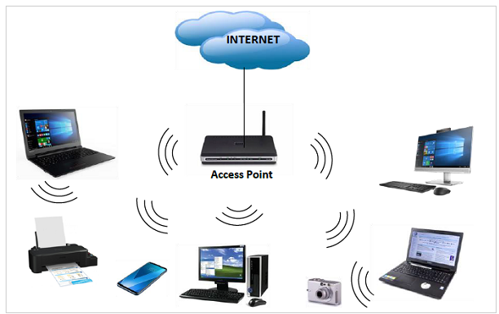

Types of Wireless Networks
- Wireless LANs − Connects two or more network devices using wireless distribution techniques.
- Wireless MANs − Connects two or more wireless LANs spreading over a metropolitan area.
- Wireless WANs − Connects large areas comprising LANs, MANs and personal networks.

Advantages of Wireless Networks
- It provides clutter-free desks due to the absence of wires and cables.
- It increases the mobility of network devices connected to the system since the devices need not be connected to each other.
- Accessing network devices from any location within the network coverage or Wi-Fi hotspot becomes convenient since laying out cables is not needed.
- Installation and setup of wireless networks are easier.
- New devices can be easily connected to the existing setup since they needn’t be wired to the present equipment. Also, the number of equipment that can be added or removed to the system can vary considerably since they are not limited by the cable capacity. This makes wireless networks very scalable.
- Wireless networks require very limited or no wires. Thus, it reduces the equipment and setup costs.

Examples of wireless networks
- Mobile phone networks
- Wireless sensor networks
- Satellite communication networks
- Terrestrial microwave networks

What is VoIP?
VoIP is a name for internet telephony, allowing you to use the internet to place and receive calls. Instead of using your desk phone or your mobile phone to make calls, you can use an application on your computer or an app on your phone to make calls. It’s a fairly well known technology, especially when it comes to those looking to run a business, control costs, and provide communication tools to a large team. The cost savings and rich feature set are enticing to savvy business leaders.

VoIP and Unified Communications
If you’re a modern business, your organization likely needs more than just a telephone. In that case, you’re likely interested in a richer feature set including; instant messaging, video calls, media distribution (sending files and images), conferencing and more. You will likely be very interested in a new protocol SIP – that builds on the framework of VOIP but also provides this additional functionality and more.

Why would you use VoIP & Unified Communications?
When considering making a change, it’s important to understand the value of the new solution. In order to make a solid business case to make a change in your organization you should ensure there are strong reasons to support the change. A few of the key reasons to adopt a VoIP or SIP-based Unified Communications platform are as follows:

Affordability of VoIP & Unified Communications
The cost of provisioning is much lower with a VoIP or SIP-based solution. International or long distance calls are significantly less expensive. Today, many mobile providers block international calls by default as a courtesy, but it can be challenging to enable long-distance on certain corporate accounts.

Scalability of VoIP & Unified Communications
Your network administrator can provision and remove accounts quickly and simply through an admin interface. You don’t need to call in a service person to install lines, or reroute lines – everything is digital. Your admin team can make changes from anywhere in the world. A cloud-based provider also means you have powerful scalability behind your technical infrastructure.

Reliability of VoIP & Unified Communications
You can identify the right balance of reliability and cost for your business. There is a wide variety of providers that ensure a high Quality of Service, and you have the control to make changes to your provider to ensure your team gets an excellent experience.

Independent Network Access
Unlike dedicated services that fix your phone service to a specific address, you can take your number, your configurations, and your settings to a wide variety of partners. You have control of where your network goes and what provider connects your team to your customers.

Redundancy and Disaster Recovery
The SIP protocol has re-routing built right in, and most providers have highly redundant environments that can be managed from anywhere in the world.

What are VoIP providers?
VoIP providers are companies and services that allow you to connect and make calls. You need to download software on your phone or computer and connect to a VoIP provider in order to place and accept calls. Rather than sourcing software and finding a provider and exploring if the combination is a match, CounterPath provides many ways you can quickly and easily download and go with their tools. As a small business, you can download Bria Teams and quickly and easily get up and running and bring the rest of your team on the account. If you’re an enterprise or large business, implementing the Stretto Platform by CounterPath allows you to have a centralized admin for creating and rolling out new accounts. Your admin team can have full control of all settings and configurations and roll out new accounts based on roles and pre-configured settings. Your team just has to download the software, log in, and everything auto-configures for them according to your specifications. They just download, login and they’re ready to go.

Topic 2 : Principle of Layering concept

1 INTRODUCTION

In the study of computer networks it is essential to study the way our networks work. Computer networks are operated by network models; most prominently the OSIRM and the TCP/ IP Model. This chapter gives the understanding of the OSI reference model.

4.2 CONCEPT OF LAYERED TASK

- The main objective of a computer network is to be able to transfer the data from sender to receiver. This task can be done by breaking it into small sub tasks, each of which are well defined.
- Each subtask will have its own process or processes to do and will take specific inputs and give specific outputs to the subtask before or after it. In more technical terms we can call these sub tasks as layers.

- In general, every task or job can be done by dividing it into sub task or layers. Consider the example of sending a letter where the sender is in City A and receiver is in city B.

- The process of sending letter is shown below:

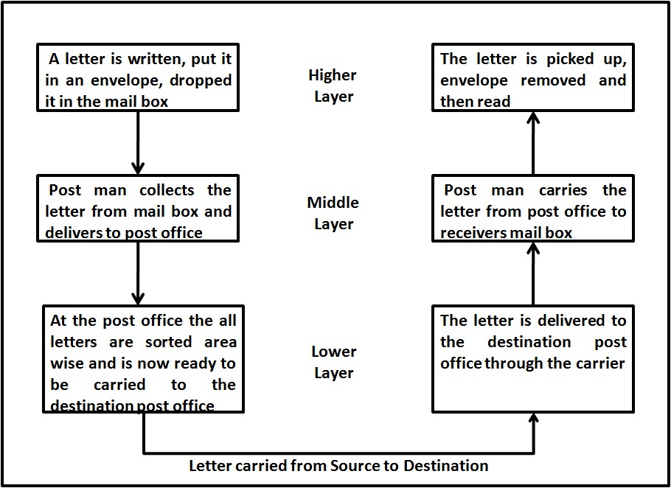

Fig: Concept of layer task: sending a letter

- The above figure shows
  - Sender, Receiver & Carrier
  - Hierarchy of layers

- At the sender site, the activities take place in the following descending order:
  - Higher Layer: The sender writes the letter along with the sender and receivers address and put it in an envelope and drop it in the mailbox.
  - Middle Layer: The letter is picked up by the post man and delivered to the post office
  - Lower Layer: The letters at the post office are sorted and are ready to be transported through a carrier.

- During transition the letter may be carried by truck, plane or ship or a combination of transport modes before it reaches the destination post office.

- At the Receiver site, the activities take place in the following ascending order:
  - Lower Layer: The carrier delivers the letter to the destination post office
  - Middle Layer: After sorting, the letter is delivered to the receivers mail box
  - Higher Layer: The receiver picks up the letter, opens the envelope and reads it.

- Hierarchy of layers: The activities in the entire task are organized into three layers. Each activity at the sender or receiver side occurs in a particular order at the hierarchy.

- The important and complex activities are organized into the Higher Layer and the simpler ones into middle and lower layer.

4.3 OPEN SYSTEMS INTER CONNECTION REFERENCE MODEL (OSIRM )

4.3.1 Introduction to OSI Model & its layers
The Open Systems Interconnection (OSI) Model was developed by International Organization for
Standardization (ISO).
ISO is the organization, OSI is the model





It was developed to allow systems with different platforms to communicate with each other. Platform could mean hardware, software or operating system.
It is a network model that defines the protocols for network communications.
It is a hierarchical model that groups its processes into layers. It has 7 layers as follows: (Top to Bottom)
- Application Layer
- Presentation Layer
- Session Layer
- Transport Layer
- Network Layer
- Data Link Layer
- Physical Layer
 Each layer has specific duties to perform and has to cooperate with the layers above and below it.

4.3.2 Layered Architecture of OSI Model

 The OSI model has 7 layers each with its own dedicated task.

 A message sent from Device A to Device B passes has to pass through all layers at A from top to bottom then all layers at B from bottom to top as shown in the figure below.

 At Device A, the message is sent from the top layer i.e Application Layer A then all the layers till it reaches its physical layer and then it is transmitted through the transmission medium.

 At Device B, the message received by the physical layer passes through all its other layers and moves upwards till it reaches its Application Layer.
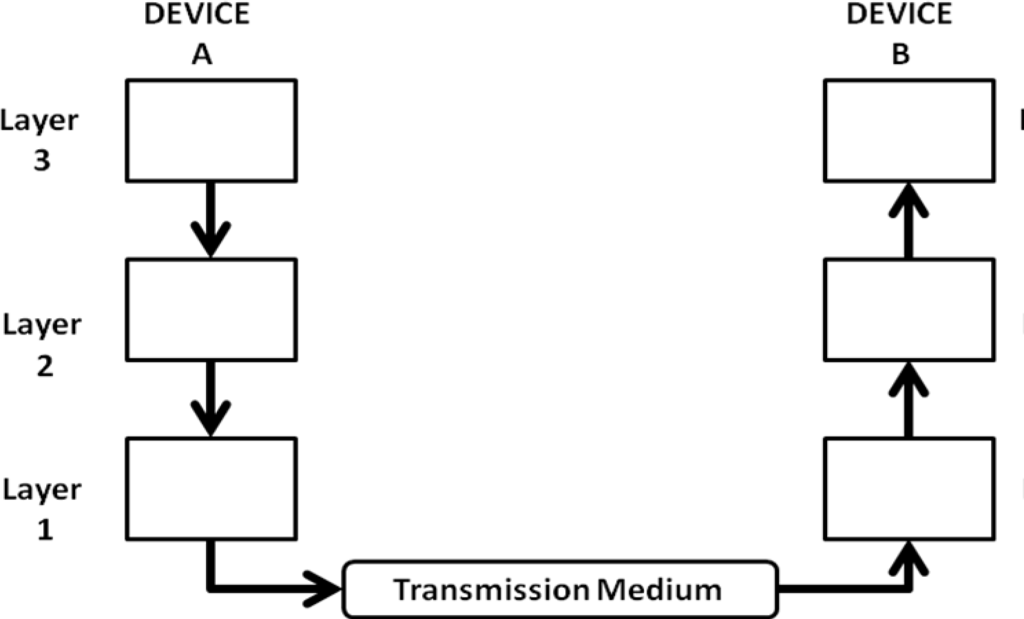

Fig: Flow of Data from Device A to Device B through various layers

 As the message travels from device A to device B, it may pass through many intermediate nodes. These intermediate nodes usually involve only the first three layers of the OSI model as shown below.

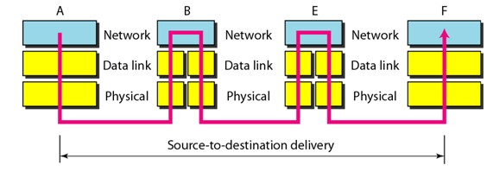

Fig: Data Transfer through Intermediate nodes

 The Data Link layer determines the next node where the message is supposed to be forwarded and the network layer determines the final recipient.

4.3.3 Communication & Interfaces

 For communication to occur, each layer in the sending device adds its own information to the message it receives from the layer just above it and passes the whole package to the layer just below it. Each layer in the receiving device removes the information added at the corresponding layer and sends the obtained data to the layer above it.

 Every Layer has its own dedicated function or services and is different from the function of the other layers.

 On every sending device, each layer calls upon the service offered by the layer below it.

 On every receiving device, each layer calls upon the service offered by the layer above it.

 Between two devices, the layers at corresponding levels communicate with each other .i.e layer 2 at receiving end can communicate and understand data from layer 2 of sending end. This is called peer –to – peer communication.

 For this communication to be possible between every two adjacent layers there is an interface. An interface defines the service that a layer must provide. Every layer has an interface to the layer above and below it as shown in the figure below

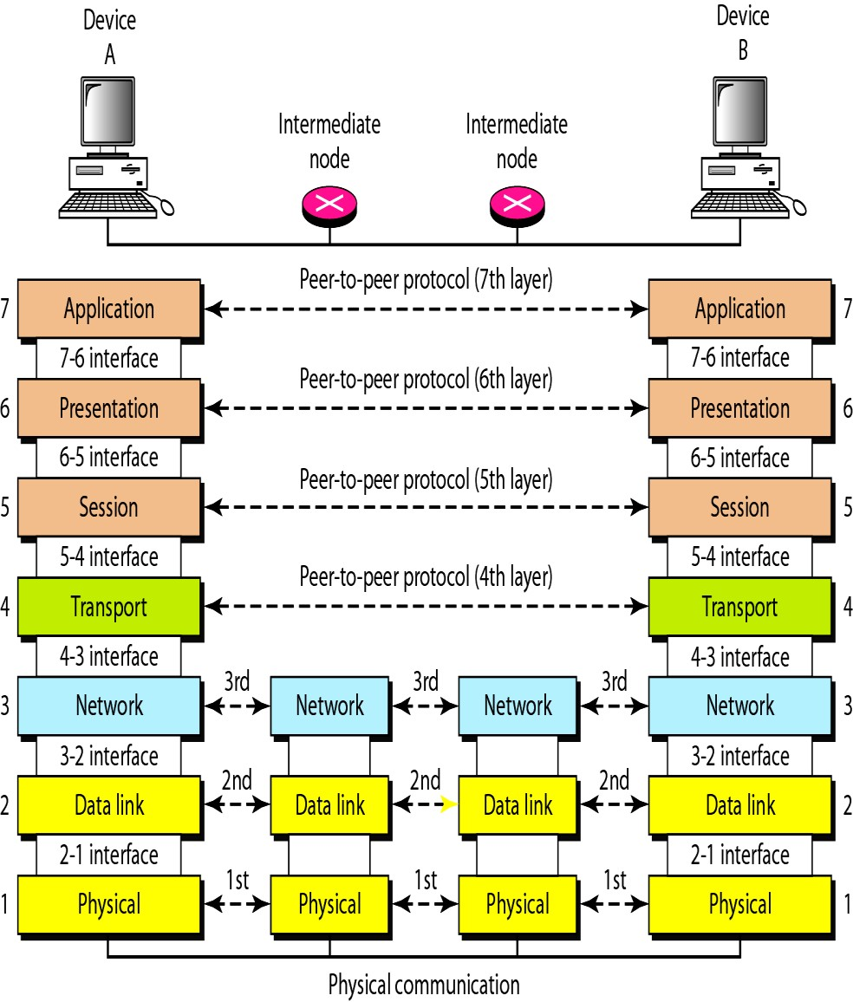

Fig: Communication & Interfaces in the OSI model

4.3.4 Encapsulation of Data

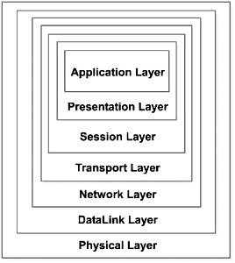

Fig: Encapsulation
 As shown in the figure above the data at layer 7 i.e the Application layer along with the header added at layer 7 is given to layer 6, the Presentation layer. This layer adds Its header and passed the whole package to the layer below.

 The corresponding layers at the receiving side removes the corresponding header added at that layer and sends the remaining data to the above layer.

 The above process is called encapsulation

4.3.5 Description of Layers in the OSI Model
4.3.5.1 Physical Layer
- The Physical Layer provides a standardized interface to physical transmission media, including :
    - Mechanical specification of electrical connectors and cables, for example maximum cable length
    - Electrical specification of transmission line
    - Bit-by-bit or symbol-by-symbol delivery

- On the sender side, the physical layer receives the data from Data Link Layer and encodes it into signals to be transmitted onto the medium. On the receiver side, the physical layer receives the signals from the transmission medium decodes it back into data and sends it to the Data Link Layer as shown in the figure below:
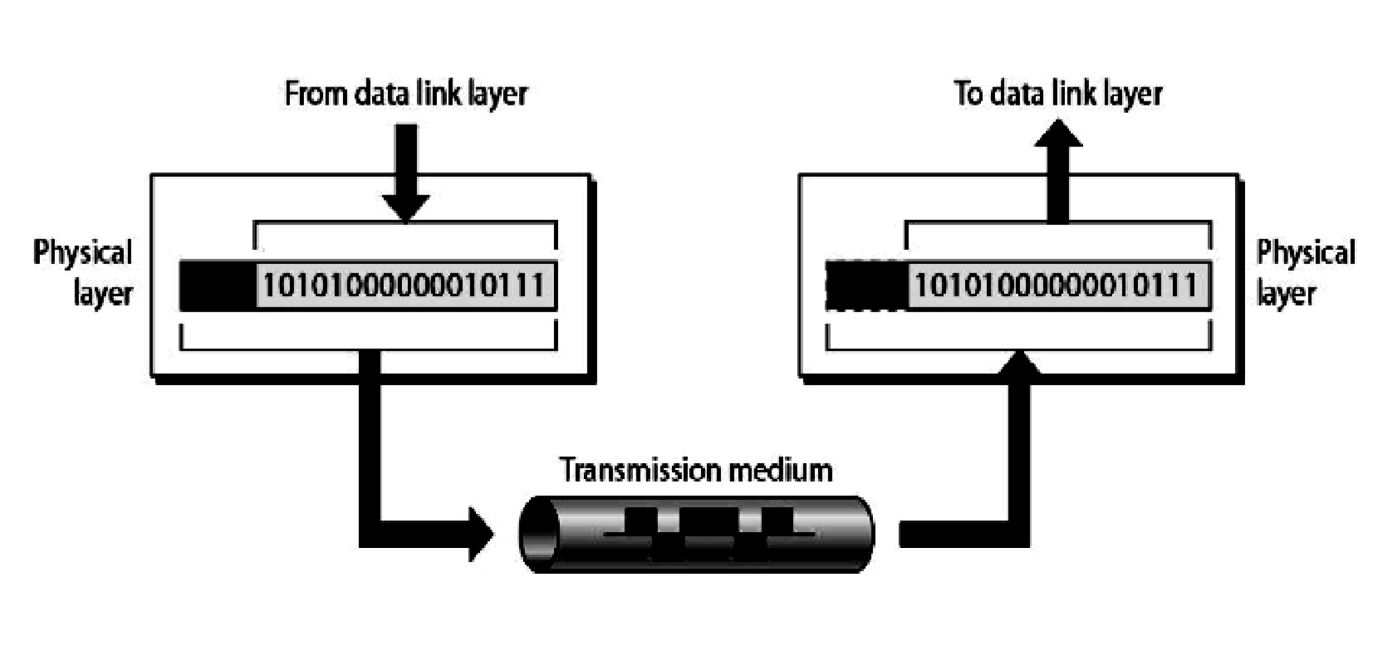

Fig: Transmission of data to and from Physical Layer

- Interface
The Physical Layer defines the characteristics of interfaces between the devices & transmission medium.

- Representation of bits
The physical layer is concerned with transmission of signals from one device to another which involves converting data (1‘s & 0‘s) into signals and vice versa. It is not concerned with the meaning or interpretation of bits.

- Data rate
The physical layer defines the data transmission rate i.e. number of bits sent per second. It is the responsibility of the physical layer to maintain the defined data rate.

- Synchronization of bits
To interpret correct and accurate data the sender and receiver have to maintain the same bit rate and also have synchronized clocks.

- Line configuration
The physical layer defines the nature of the connection .i.e. a point to point link, or a multi point link.

- Physical Topology
The physical layer defines the type of topology in which the device is connected to the network. In a mesh topology it uses a multipoint connection and other topologies it uses a point to point connection to send data.

- Transmission mode
The physical layer defines the direction of data transfer between the sender and receiver. Two devices can transfer the data in simplex, half duplex or full duplex mode

- Main responsibility of the physical layer Transmission of bits from one hop to the next.

4.3.5.2 Data Link Layer
  - The Data Link layer adds reliability to the physical layer by providing error detection and correction mechanisms.

  - On the sender side, the Data Link layer receives the data from Network Layer and divides the stream of bits into fixed size manageable units called as Frames and sends it to the physical layer. On the receiver side, the data link layer receives the stream of bits from the physical layer and regroups them into frames and sends them to the Network layer. This process is called Framing. It is shown in the figure below:

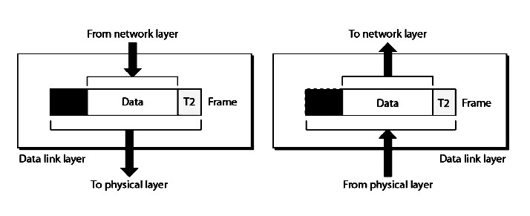

Fig: Data Link Layer: The process of Framing

  - Physical Addressing (inside / outside senders network)
    - The Data link layer appends the physical address in the header of the frame before sending it to physical layer.

    - The physical address contains the address of the sender and receiver.

    - In case the receiver happens to be on the same physical network as the sender; the receiver is at only one hop from the sender and the receiver address contains the receiver‘s physical address.
    - In case the receiver is not directly connected to the sender, the physical address is the address of the next node where the data is supposed to be delivered.

  - Flow control
    - The data link layer makes sure that the sender sends the data at a speed at which the receiver can receive it else if there is an overflow at the receiver side the data will be lost.

    - The data link layer imposes flow control mechanism over the sender and receiver to avoid overwhelming of the receiver.

  - Error control
    - The data link layer imposes error control mechanism to identify lost or damaged frames, duplicate frames and then retransmit them.
    - Error control information is present in the trailer of a frame.
  - Access Control
    - The data link layer imposes access control mechanism to determine which device has right to send data in an multipoint connection scenario.

  - Main Responsibility
i. The main responsibility of the data link layer is hop to hop transmission of frames.

4.3.5.3 Network Layer
- The network layer makes sure that the data is delivered to the receiver despite multiple intermediate devices.

- The network layer at the sending side accepts data from the transport layer, divides it into packets, adds addressing information in the header and passes it to the data link layer. At the receiving end the network layer receives the frames sent by data link layer, converts them back into packets, verifies the physical address (verifies if the receiver address matches with its own address) and the send the packets to the transport layer.
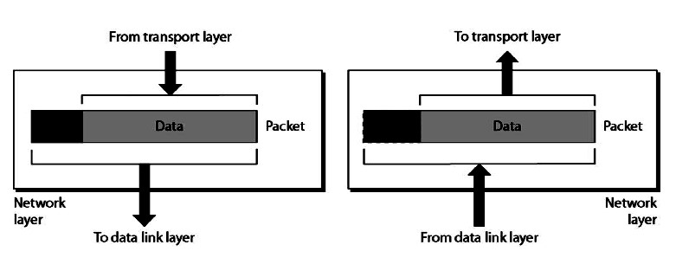

Fig: Network Layer

- The network layer is responsible for source to destination of delivery of data. Hence it may have to route the data through multiple networks via multiple intermediate devices. In order to achieve this the network layer relies on two things:
  - Logical Addressing
  - Routing

- Logical Addressing
 The network layer uses logical address commonly known as IP address to recognize devices on the network.

 An IP address is a universally unique address which enables the network layer to identify devices outside the sender‘s network.
 The header appended by the network layer contains the actual sender and receiver IP address.

 At every hop the network layer of the intermediate node check the IP address in the header, if its own IP address does not match with the IP address of the receiver found in the header, the intermediate node concludes that it is not the final node but an intermediate node and passes the packet to the data link layer where the data is forwarded to the next node.

V. Routing
 VI. The network layer divides data into units called packets of equal size and bears a sequence number for rearranging on the receiving end.

 Each packet is independent of the other and may travel using different routes to reach the receiver hence may arrive out of turn at the receiver.

 Hence every intermediate node which encounters a packet tries to compute the best possible path for the packet. The best possible path may depend on several factors such as congestion, number of hops, etc

 This process of finding the best path is called as Routing.
It is done using routing algorithms.

- The Network layer does not perform any flow control or error control

- Main Responsibility
 The main responsibility of Network Layer is transmission of packets from source to destination

4.3.5.4 Transport Layer
  - A logical address at network layer facilitates the transmission of data from source to destination device. But the source and the destination both may be having multiple processes communicating with each other. Hence it is important to deliver the data not only from the sender to the receiver but from the correct process on the sender to the correct process on the receiver. The transport layer takes care of process to process delivery of data and makes sure that it is intact and in order.

  - At the sending side, the transport layer receives data from the session layer, divides it into units called segments and sends it to the network layer. At the receiving side, the transport layer receives packets from the network layer, converts and arranges into proper sequence of segments and sends it to the session layer.
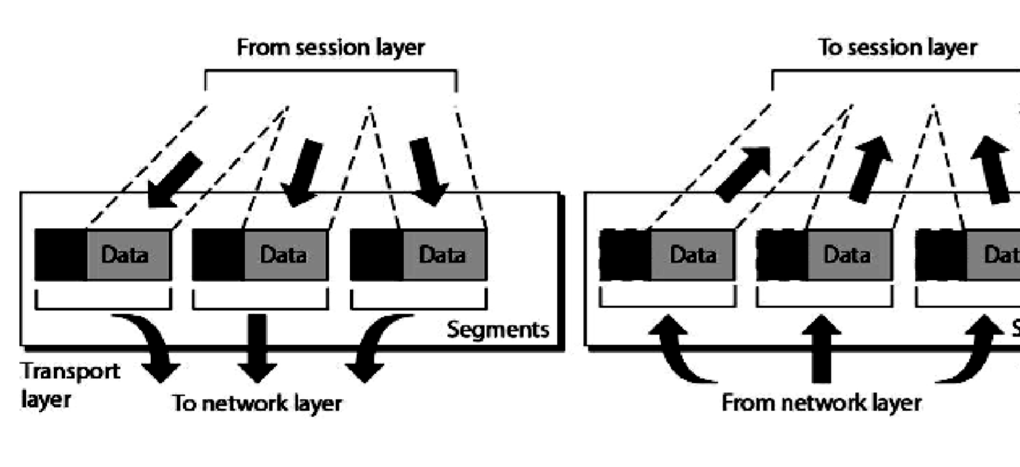

Fig: Transport Layer

  - To ensure process to process delivery the transport layer makes use of port address to identify the data from the sending and receiving process. A Port Address is the name or label given to a process. It is a 16 bit address. Ex. TELNET uses port address 23, HTTP uses port address 80. Port address is also
called as Service Point Address

  - The data can be transported in a connection oriented or connectionless manner. If the connection is connection oriented then all segments are received in order else they are independent of each other and are received out of order and have to be rearranged.

  - The Transport layer is responsible for segmentation and reassembly of the message into segments which bear sequence numbers. This numbering enables the receiving transport layer to rearrange the segments in proper order.

  - Flow Control & Error control: the transport layer also carries out flow control and error control functions; but unlike data link layer these are end to end rather than node to node.

  - Main Responsibility
 The main responsibility of the transport layer is process to process delivery of the entire message.
4.3.5.5 Session Layer
    - The session layer establishes a session between the communicating devices called dialog and synchronizes their interaction. It is the responsibility of the session layer to establish and synchronize the dialogs. It is also called the network dialog controller.

    - The session layer at the sending side accepts data from the presentation layer adds checkpoints to it called syn bits and passes the data to the transport layer. At the receiving end the session layer receives data from the transport layer removes the checkpoints inserted previously and passes the data to the presentation layer.

    - The checkpoints or synchronization points is a way of informing the status of the data transfer. Ex. A checkpoint after first 500 bits of data will ensure that those 500 bits are not sent again in case of retransmission at 650th bit.
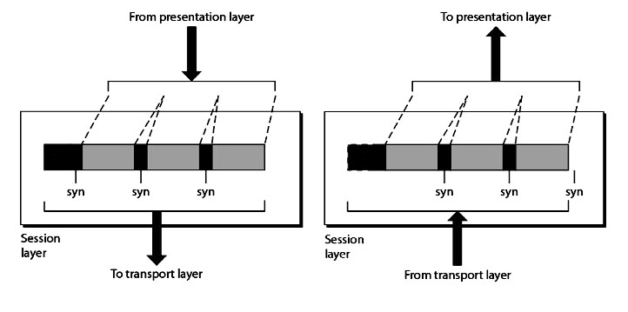

    - Main responsibility of session layer is dialog control and synchronizatoin

4.3.5.6 Presentation Layer
- The communicating devices may be having different platforms. The presentation layer performs translation, encryption and compression of data.

- The presentation layer at sending side receives the data from the application layer adds header which contains information related to encryption and compression and sends it to the session layer. At the receiving side, the presentation layer receives data from the session layer decompresses and decrypts the data as required and translates it back as per the encoding scheme used at the receiver.
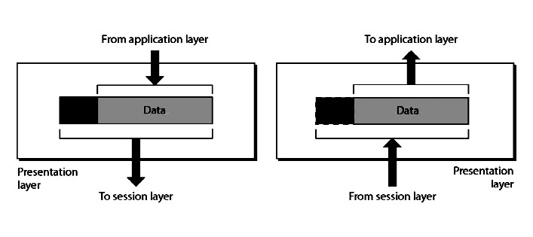

Fig : Presentation Layer

- Translation
The sending and receiving devices may run on different platforms (hardware, software and operating system). Hence it is important that they understand the messages that are used for communicating. Hence a translation service may be required which is provided by the Presentation layers

- Compression
Compression ensures faster data transfer. The data compressed at sender has to be decompressed at the receiving end, both performed by the Presentation layer.

- Encryption
It is the process of transforming the original message to change its meaning before sending it. The reverse process called decryption has to be performed at the receiving end to recover the original message from the encrypted message.

- Main responsibility
The main responsibility of the Presentation layer is translation, compression and encryption.

4.3.5.7Application Layer
    - The application layer enables the user to communicate its data to the receiver by providing certain services. For ex. Email is sent using X.400 service.
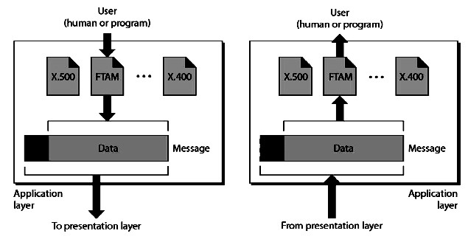

Fig : Application Layer

    - X500 is a directory service used to provide
information and access to distributed objects

    - X400 is services that provides basis for mail storage and forwarding

    - FTAM (File transfer, access and management) provides access to files stored on remote computers and mechanism for transfer and manage them locally.

    - Main Responsibility
Main Responsibility of Application layer is to provide access to network resources.

What is the TCP/IP Model?
TCP/IP Model helps you to determine how a specific computer should be connected to the internet and how data should be transmitted between them. It helps you to create a virtual network when multiple computer networks are connected together. The purpose of TCP/IP model is to allow communication over large distances.
TCP/IP stands for Transmission Control Protocol/ Internet Protocol. TCP/IP Stack is specifically designed as a model to offer highly reliable and end-to-end byte stream over an unreliable internetwork.

TCP Characteristics
Here, are the essential characteristics of TCP IP protocol:
- Support for a flexible TCP/IP architecture
- Adding more system to a network is easy.
- In TCP IP protocols suite, the network remains intact until the source, and destination machines were functioning properly.
- TCP is a connection-oriented protocol.
- TCP offers reliability and ensures that data which arrives out of sequence should put back into order.
- TCP allows you to implement flow control, so sender never overpowers a receiver with data.

Four Layers of TCP/IP model
In this TCP/IP tutorial, we will explain different layers and their functionalities in TCP/IP model:
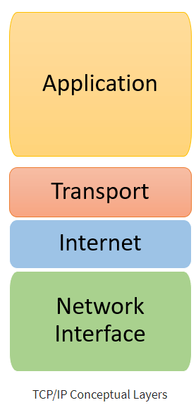
The functionality of the TCP IP model is divided into four layers, and each includes specific protocols.
TCP/IP is a layered server architecture system in which each layer is defined according to a specific function to perform. All these four TCP IP layers work collaboratively to transmit the data from one layer to another.
- Application Layer
- Transport Layer
- Internet Layer
- Network Interface
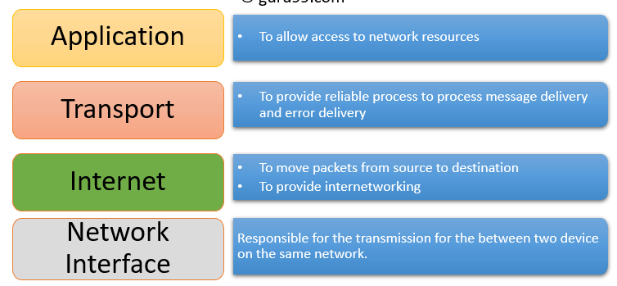

Application Layer
Application layer interacts with an application program, which is the highest level of OSI model. The application layer is the OSI layer, which is closest to the end-user. It means the OSI application layer allows users to interact with other software application.
Application layer interacts with software applications to implement a communicating component. The interpretation of data by the application program is always outside the scope of the OSI model.
Example of the application layer is an application such as file transfer, email, remote login, etc.

The function of the Application Layers are:
- Application-layer helps you to identify communication partners, determining resource availability, and synchronizing communication.
- It allows users to log on to a remote host
- This layer provides various e-mail services
- This application offers distributed database sources and access for global information about various objects and services.

Transport Layer
Transport layer builds on the network layer in order to provide data transport from a process on a source system machine to a process on a destination system. It is hosted using single or multiple networks, and also maintains the quality of service functions.
It determines how much data should be sent where and at what rate. This layer builds on the message which are received from the application layer. It helps ensure that data units are delivered error-free and in sequence.
Transport layer helps you to control the reliability of a link through flow control, error control, and segmentation or de-segmentation.
The transport layer also offers an acknowledgment of the successful data transmission and sends the next data in case no errors occurred. TCP is the best-known example of the transport layer.

Important functions of Transport Layers:
- It divides the message received from the session layer into segments and numbers them to make a sequence.
- Transport layer makes sure that the message is delivered to the correct process on the destination machine.
- It also makes sure that the entire message arrives without any error else it should be retransmitted.

Internet Layer
An internet layer is a second layer of TCP/IP layes of the TCP/IP model. It is also known as a network layer. The main work of this layer is to send the packets from any network, and any computer still they reach the destination irrespective of the route they take.
The Internet layer offers the functional and procedural method for transferring variable length data sequences from one node to another with the help of various networks.
Message delivery at the network layer does not give any guaranteed to be reliable network layer protocol.
Layer-management protocols that belong to the network layer are:
- Routing protocols
- Multicast group management
- Network-layer address assignment.

The Network Interface Layer
Network Interface Layer is this layer of the four-layer TCP/IP model. This layer is also called a network access layer. It helps you to defines details of how data should be sent using the network.
It also includes how bits should optically be signaled by hardware devices which directly interfaces with a network medium, like coaxial, optical, coaxial, fiber, or twisted-pair cables.
A network layer is a combination of the data line and defined in the article of OSI reference model. This layer defines how the data should be sent physically through the network. This layer is responsible for the transmission of the data between two devices on the same network.
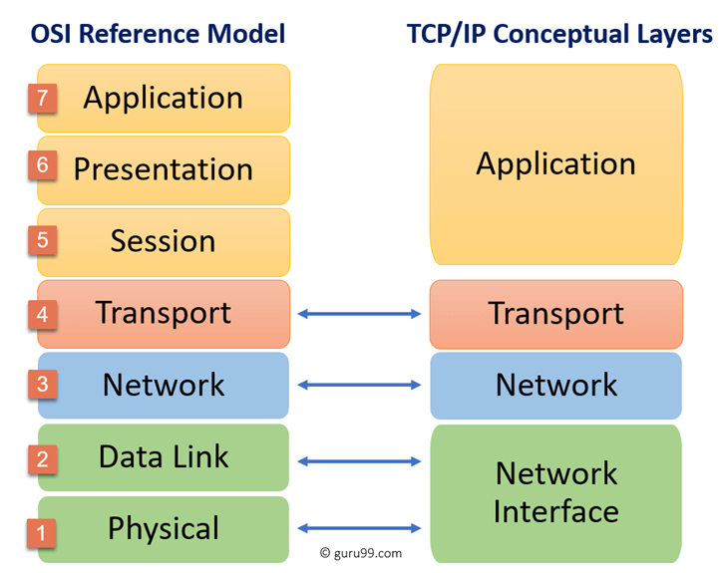

Here, are some important differences between the OSI and TCP/IP model:
OSI Model | TCP/IP model
It is developed by ISO (International Standard Organization) | It is developed by ARPANET (Advanced Research Project Agency Network).
OSI model provides a clear distinction between interfaces, services, and protocols. | TCP/IP doesn’t have any clear distinguishing points between services, interfaces, and protocols.
OSI refers to Open Systems Interconnection. | TCP refers to Transmission Control Protocol.
OSI uses the network layer to define routing standards and protocols. | TCP/IP uses only the Internet layer.
OSI follows a vertical approach. | TCP/IP follows a horizontal approach.
OSI model use two separate layers physical and data link to define the functionality of the bottom layers. | TCP/IP uses only one layer (link).
OSI layers have seven layers. | TCP/IP has four layers.
OSI model, the transport layer is only connection-oriented. | A layer of the TCP/IP model is both connection-oriented and connectionless.
In the OSI model, the data link layer and physical are separate layers. | In TCP, physical and data link are both combined as a single host-to-network layer.
Session and presentation layers are not a part of the TCP model. | There is no session and presentation layer in TCP model.
It is defined after the advent of the Internet. | It is defined before the advent of the internet.
The minimum size of the OSI header is 5 bytes. | Minimum header size is 20 bytes.

Most Common TCP/IP Protocols
Some widely used most common TCP/IP protocol are:

TCP:
Transmission Control Protocol is an internet protocol suite which breaks up the message into TCP Segments and reassembling them at the receiving side.

IP:
An Internet Protocol address that is also known as an IP address is a numerical label. It is assigned to each device that is connected to a computer network which uses the IP for communication. Its routing function allows internetworking and essentially establishes the Internet. Combination of IP with a TCP allows developing a virtual connection between a destination and a source.

HTTP:
The Hypertext Transfer Protocol is a foundation of the World Wide Web. It is used for transferring webpages and other such resources from the HTTP server or web server to the web client or the HTTP client. Whenever you use a web browser like Google Chrome or Firefox, you are using a web client. It helps HTTP to transfer web pages that you request from the remote servers.

SMTP:
SMTP stands for Simple mail transfer protocol. This protocol supports the e-mail is known as a simple mail transfer protocol. This protocol helps you to send the data to another e-mail address.

SNMP:
SNMP stands for Simple Network Management Protocol. It is a framework which is used for managing the devices on the internet by using the TCP/IP protocol.

DNS:
DNS stands for Domain Name System. An IP address that is used to identify the connection of a host to the internet uniquely. However, users prefer to use names instead of addresses for that DNS.

TELNET:
TELNET stands for Terminal Network. It establishes the connection between the local and remote computer. It established connection in such a manner that you can simulate your local system at the remote system.

FTP:
FTP stands for File Transfer Protocol. It is a mostly used standard protocol for transmitting the files from one machine to another.

Advantages of the TCP/IP model
Here, are pros/benefits of using the TCP/IP model:
- It helps you to establish/set up a connection between different types of computers.
- It operates independently of the operating system.
- It supports many routing-protocols.
- It enables the internetworking between the organizations.
- TCP/IP model has a highly scalable client-server architecture.
- It can be operated independently.
- Supports a number of routing protocols.
- It can be used to establish a connection between two computers.

Disadvantages of the TCP/IP model
Here, are few drawbacks of using the TCP/IP model:
- TCP/IP is a complicated model to set up and manage.
- The shallow/overhead of TCP/IP is higher-than IPX (Internetwork Packet Exchange).
- In this, model the transport layer does not guarantee delivery of packets.
- Replacing protocol in TCP/IP is not easy.
- It has no clear separation from its services, interfaces, and protocols.
- DNS stands for Domain Name System.
- TELNET stands for Terminal Network. It establishes the connection between the local and remote computer
- FTP stands for File Transfer Protocol. It is a mostly used standard protocol for transmitting the files from one machine to another.
- The biggest benefit of TCP/IP model is that it helps you to establish/set up a connection between different types of computers.
- TCP/IP is a complicated model to set up and manage.
- What are the different types of TCP/IP layers?
There are four types of TCP/IP layers.
  - Application layer
  - Transport layer
  - Internet layer
  - Network interface
Topic 3 : Link Layer Communication

Data Link Layer is second layer of OSI Layered Model. This layer is one of the most complicated layers and has complex functionalities and liabilities. Data link layer hides the details of underlying hardware and represents itself to upper layer as the medium to communicate.
Data link layer works between two hosts which are directly connected in some sense. This direct connection could be point to point or broadcast. Systems on broadcast network are said to be on same link. The work of data link layer tends to get more complex when it is dealing with multiple hosts on single collision domain.
Data link layer is responsible for converting data stream to signals bit by bit and to send that over the underlying hardware. At the receiving end, Data link layer picks up data from hardware which are in the form of electrical signals, assembles them in a recognizable frame format, and hands over to upper layer.
Data link layer has two sub-layers:
- Logical Link Control: It deals with protocols, flow-control, and error control
- Media Access Control: It deals with actual control of media

Functionality of Data-link Layer
Data link layer does many tasks on behalf of upper layer. These are:
- Framing
Data-link layer takes packets from Network Layer and encapsulates them into Frames.Then, it sends each frame bit-by-bit on the hardware. At receiver’ end, data link layer picks up signals from hardware and assembles them into frames.
- Addressing
Data-link layer provides layer-2 hardware addressing mechanism. Hardware address is assumed to be unique on the link. It is encoded into hardware at the time of manufacturing.
- Synchronization
When data frames are sent on the link, both machines must be synchronized in order to transfer to take place.
- Error Control
Sometimes signals may have encountered problem in transition and the bits are flipped.These errors are detected and attempted to recover actual data bits. It also provides error reporting mechanism to the sender.
- Flow Control
Stations on same link may have different speed or capacity. Data-link layer ensures flow control that enables both machine to exchange data on same speed.
- Multi-Access
When host on the shared link tries to transfer the data, it has a high probability of collision. Data-link layer provides mechanism such as CSMA/CD to equip capability of accessing a shared media among multiple Systems.

Error detection and correction techniques

3.1.1 Types of Errors
- When bits flow from 1 point to another, they are subject to unpredictable-changes ‘.’ of interference.
- The interference can change the shape of the signal.
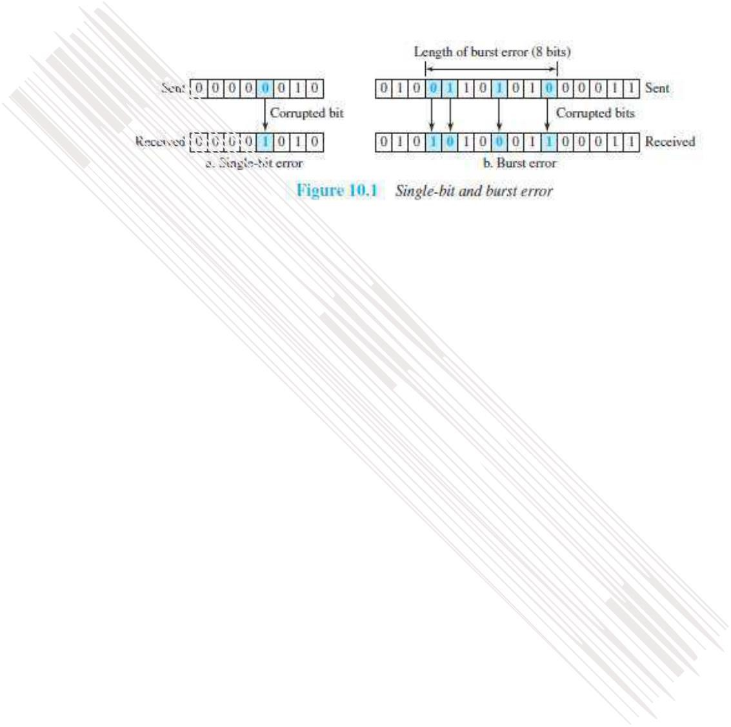
•

Two types of errors: 1)
Single
-
bit error 2) Burst
-
error.

1)
Single
-
Bit Error

Only 1 bit of a given data is changed

→

from 1 to 0 or

→

from 0 to 1
(
Figure 10.1a
).

2)

Burst Error

→

from 1 to 0 or

→

from 0 to 1 (Figure 10.1b).

→

data
-
rate and

→

duration of noise.

3.1.2
Redundancy

•

The central concept in detecting/correcting errors is
redundancy
.

•

Some extra
-
bits along with the data have to be sent to detect/correct errors. These extra bits are
called redundant
-
bits.

•

The redundant
-
bits are

→

adde
d by the sender and

→

removed by the receiver.

•

The presence of redundant
-
bits allows the receiver to detect/correct errors.

3.1.3 Error Detection vs. Error Correction
- Error-correction is more difficult than error-detection.

1) Error Detection
Here, we are checking whether any error has occurred or not.
The answer is a simple YES or NO.
We are not interested in the number of corrupted-bits.
2) Error Correction
Here, we need to know
→ exact number of corrupted-bits and
→ location of bits in the message.
Two important factors to be considered:
- Number of errors and
- Message-size.

3-3

3.1.4 Coding
- Redundancy is achieved through various coding-schemes.
  - Sender adds redundant-bits to the data-bits. This process creates a relationship between → redundant-bits and
→ data-bits.
  - Receiver checks the relationship between redundant-bits & data-bits to detect/correct errors.
- Two important factors to be considered:
  - Ratio of redundant-bits to the data-bits and 2) Robustness of the process.
- Two broad categories of coding schemes: 1) Block-coding and 2) Convolution coding.

3.2 Block Coding
- The message is divided into k-bit blocks. These blocks are called data-words.
- Here, r-redundant-bits are added to each block to make the length n=k+r.
- The resulting n-bit blocks are called code-words.
- Since n>k, the number of possible code-words is larger than the number of possible data-words.
- Block-coding process is 1-to-1; the same data-word is always encoded as the same code-word.
- Thus, we have 2^{n}-2^{k} code-words that are not used. These code-words are invalid or illegal.

3.2.1 Error Detection
- If the following 2 conditions are met, the receiver can detect a change in the original code-word:
  - The receiver has a list of valid code-words.
  - The original code-word has changed to an invalid code-words.

- Here is how it works (Figure 10.2):

1) At Sender
- The sender creates code-words out of data-words by using a generator. The generator applies the rules and procedures of encoding.
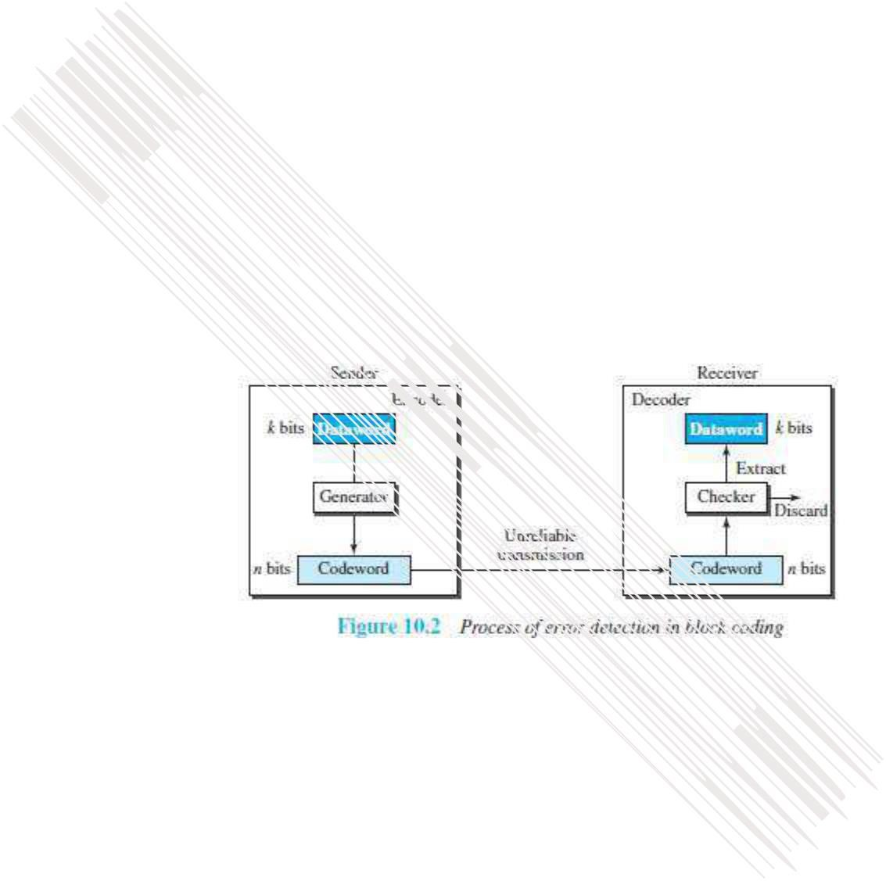
- During transmission, each code-word sent to the receiver may change.

2) At Receiver
- a) If the received code-word is the same as one of the valid code-words, the code-word is accepted;
the corresponding data-word is extracted for use.
b) If the received code-word is invalid, the code-word is discarded.
- However, if the code-word is corrupted but the received code-word still matches a valid
codeword, the error remains undetected.
• An error-detecting code can detect only the types of errors for which it is designed; other types of errors may remain undetected.

In the physical layer, data transmission involves synchronised transmission of bits from the source to the destination. The data link layer packs these bits into frames.
Data-link layer takes the packets from the Network Layer and encapsulates them into frames. If the frame size becomes too large, then the packet may be divided into small sized frames. Smaller sized frames makes flow control and error control more efficient.
Then, it sends each frame bit-by-bit on the hardware. At receiver’s end, data link layer picks up signals from hardware and assembles them into frames.
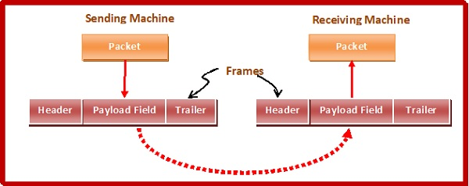

Parts of a Frame
A frame has the following parts −
- Frame Header − It contains the source and the destination addresses of the frame.
- Payload field − It contains the message to be delivered.
- Trailer − It contains the error detection and error correction bits.
- Flag − It marks the beginning and end of the frame.
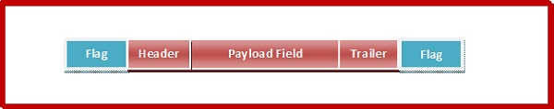

Types of Framing
Framing can be of two types, fixed sized framing and variable sized framing.
Fixed-sized Framing
Here the size of the frame is fixed and so the frame length acts as delimiter of the frame. Consequently, it does not require additional boundary bits to identify the start and end of the frame.
Example − ATM cells.
Variable – Sized Framing
Here, the size of each frame to be transmitted may be different. So additional mechanisms are kept to mark the end of one frame and the beginning of the next frame.
It is used in local area networks.
Two ways to define frame delimiters in variable sized framing are −
- Length Field − Here, a length field is used that determines the size of the frame. It is used in Ethernet (IEEE 802.3).
- End Delimiter − Here, a pattern is used as a delimiter to determine the size of frame. It is used in Token Rings. If the pattern occurs in the message, then two approaches are used to avoid the situation −
  - Byte – Stuffing − A byte is stuffed in the message to differentiate from the delimiter. This is also called character-oriented framing.
  - Bit – Stuffing − A pattern of bits of arbitrary length is stuffed in the message to differentiate from the delimiter. This is also called bit – oriented framing.

What is HDLC (High-level Data Link Control)?
HDLC (High-level Data Link Control) is a group of protocols or rules for transmitting data between network points (sometimes called nodes).
In more technical terms, HDLC is a bit-oriented, synchronous data link layer protocol created by the International Organization for Standardization (ISO). The standard for HDLC is ISO/IEC 13239:2002. ECI stands for the International Electrotechnical Commission, an international electrical and electronic standards body that often works with the ISO.

How is HDLC used in IT networks?
HDLC is based on IBM's synchronous data link control (SDLC) protocol, which is widely used by IBM's large customer base in mainframe computing environments. In HDLC, the protocol that is essentially SDLC is known as Normal Response Mode.
The networking industry has used HDLC to derive several other standards used today, such as frame relay protocols like the ISDN protocol stack known as Link Access Procedure Balanced (LAPB). It is also the basis for the framing mechanism that utilizes Point-to-Point Protocol (PPP) on synchronous lines used to connect multiple servers to a WAN (wide area network) internet link, as well as Cisco HDLC framing techniques that add protocol fields to the HDLC header.
In Normal Response Mode, a primary station -- usually at the mainframe computer -- sends data to secondary stations that may be local or may be at remote locations on dedicated leased lines in what is called a multidrop or multipoint network. (This is not the network we usually think of; it's a nonpublic closed network. In this arrangement, communication is usually half-duplex.)
Variations of HDLC are also used for the public networks that use the X.25 communications protocol and for frame relay, a protocol used in both and WANs -- public and private.
In the X.25 version of HDLC, the data frame contains a packet. (An X.25 network is one in which packets of data are moved to their destination along routes determined by network conditions as perceived by routers and reassembled in the right order at the ultimate destination.)
P2P Protocol :

What is a Peer-to-Peer Network?
It’s a network in which the computers are managed independently of one another and have equal rights for initiating communication with each other, sharing resources, and validating users.
Peer to Peer Network

How It Works
A peer-to-peer network has no special server for authenticating users. Each computer manages its own security, so a separate user account might need to be created for each computer that a user needs to access. Users usually store files on their own computers and are responsible for ensuring that those files are appropriately backed up. In a peer-to-peer network, each computer typically runs both client and server software and can be used to make resources available to other users or to access shared resources on the network.
Peer-to-peer networks are simple to set up and are often ideal for small businesses that have fewer than 10 computers and that cannot afford a server-based solution. The disadvantages of peer-to-peer networks are poor security and lack of centralized file storage and backup facilities.

Peer-to-Peer network architecture
A peer-to-peer network is designed around the notion of equal peer nodes simultaneously functioning as both “clients” and “servers” to the other nodes on the network. This model of network arrangement differs from the client–server model where communication is usually to and from a central server. A typical example of a file transfer that uses the client-server model is the File Transfer Protocol (FTP) service in which the client and server programs are distinct: the clients initiate the transfer, and the servers satisfy these requests.
Peer-to-peer networks generally implement some form of virtual overlay network on top of the physical network topology, where the nodes in the overlay form a subset of the nodes in the physical network. Data is still exchanged directly over the underlying TCP/IP network, but at the application layer peers are able to communicate with each other directly, via the logical overlay links (each of which corresponds to a path through the underlying physical network). Overlays are used for indexing and peer discovery and make the P2P system independent from the physical network topology. Based on how the nodes are linked to each other within the overlay network, and how resources are indexed and located, we can classify networks as unstructured or structured (or as a hybrid between the two).

Unstructured networks
Unstructured peer-to-peer networks do not impose a particular structure on the overlay network by design, but rather are formed by nodes that randomly form connections to each other. (Gnutella, Gossip, and Kazaa are examples of unstructured P2P protocols).
Because there is no structure globally imposed upon them, unstructured networks are easy to build and allow for localized optimizations to different regions of the overlay. Also, because the role of all peers in the network is the same, unstructured networks are highly robust in the face of high rates of “churn” – that is, when large numbers of peers are frequently joining and leaving the network.
Unstructured Peer-to-Peer (P2P) network diagram
However, the primary limitations of unstructured networks also arise from this lack of structure. In particular, when a peer wants to find the desired piece of data in the network, the search query must be flooded through the network to find as many peers as possible that share the data. Flooding causes a very high amount of signaling traffic in the network, uses more CPU/memory (by requiring every peer to process all search queries), and does not ensure that search queries will always be resolved. Furthermore, since there is no correlation between a peer and the content managed by it, there is no guarantee that flooding will find a peer that has the desired data. Popular content is likely to be available at several peers and any peer searching for it is likely to find the same thing. But if a peer is looking for rare data shared by only a few other peers, then it is highly unlikely that search will be successful.

Structured networks
In structured peer-to-peer networks, the overlay is organized into a specific topology, and the protocol ensures that any node can efficiently search the network for a file/resource, even if the resource is extremely rare.
The most common type of structured P2P networks implements a distributed hash table (DHT), in which a variant of consistent hashing is used to assign ownership of each file to a particular peer. This enables peers to search for resources on the network using a hash table: that is, (key, value) pairs are stored in the DHT, and any participating node can efficiently retrieve the value associated with a given key.

