Chapter 3: Tree

Q1)What is tree?
- A tree is also one of the data structures that represent hierarchical data.
- Suppose we want to show the employees and their positions in the hierarchical form.
- In the Tree data structure, the topmost node is known as a root node. Each node contains some data, and data can be of any type.
- Each node contains some data and the link or reference of other nodes that can be called children.
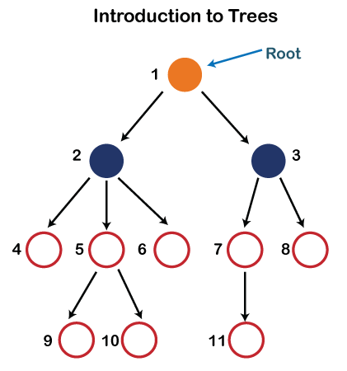
- Root: The root node is the topmost node in the tree hierarchy. In other words, the root node is the one that doesn't have any parent. In the above structure, node numbered 1 is the root node of the tree. If a node is directly linked to some other node, it would be called a parent-child relationship.
- Child node: If the node is a descendant of any node, then the node is known as a child node.
- Parent: If the node contains any sub-node, then that node is said to be the parent of that sub-node.
- Sibling: The nodes that have the same parent are known as siblings.
- Leaf Node:- The node of the tree, which doesn't have any child node, is called a leaf node. A leaf node is the bottom-most node of the tree. There can be any number of leaf nodes present in a general tree. Leaf nodes can also be called external nodes.
- Internal nodes: A node has atleast one child node known as an internal
- Ancestor node:- An ancestor of a node is any predecessor node on a path from the root to that node. The root node doesn't have any ancestors. In the tree shown in the above image, nodes 1, 2, and 5 are the ancestors of node 10.
- Descendant: The immediate successor of the given node is known as a descendant of a node. In the above figure, 10 is the descendant of node 5.
2)Representation of tree:
- The left subtree can be further split into subtrees shown in three different colors.
- Recursion means reducing something in a self-similar manner. So, this recursive property of the tree data structure is implemented in various applications.
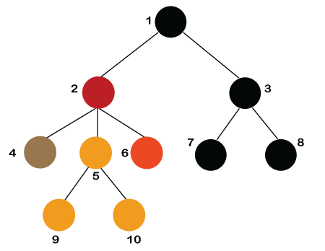

- Number of edges: If there are n nodes, then there would n-1 edges. Each arrow in the structure represents the link or path.
- Each node, except the root node, will have atleast one incoming link known as an edge. There would be one link for the parent-child relationship.
- Depth of node x: The depth of node x can be defined as the length of the path from the root to the node x.
- One edge contributes one-unit length in the path.
- So, the depth of node x can also be defined as the number of edges between the root node and the node x. The root node has 0 depth.
- Height of node x: The height of node x can be defined as the longest path from the node x to the leaf node.
- The tree data structure can be created by creating the nodes dynamically with the help of the pointers. The tree in the memory can be represented as shown below:
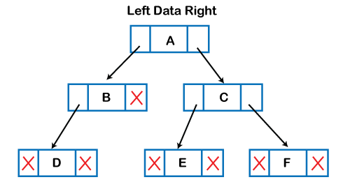
3) Types of Tree data structure
A)General tree: The general tree is one of the types of tree data structure. In the general tree, a node can have either 0 or maximum n number of nodes.
- There is no restriction imposed on the degree of the node (the number of nodes that a node can contain).
- The topmost node in a general tree is known as a root node. The children of the parent node are known as subtrees.
- There can be n number of subtrees in a general tree.
- In the general tree, the subtrees are unordered as the nodes in the subtree cannot be ordered.
Every non-empty tree has a downward edge, and these edges are connected to the nodes known as child nodes.
- The root node is labeled with level 0. The nodes that have the same parent are known as siblings.

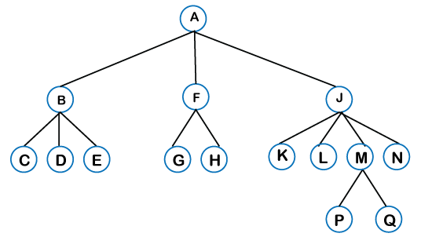
B)Binary Tree
- The Binary tree means that the node can have maximum two children. Here, binary name itself suggests that 'two'; therefore, each node can have either 0, 1 or 2 children.
- The Binary tree means that the node can have maximum two children.
- Here, binary name itself suggests that 'two'; therefore, each node can have either 0, 1 or 2 children.
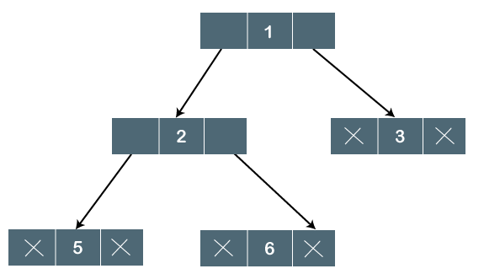
Properties of Binary Tree:
- At each level of i, the maximum number of nodes is 2^{i}.
- The height of the tree is defined as the longest path from the root node to the leaf node.
- The tree which is shown above has a height equal to 3. Therefore, the maximum number of nodes at height 3 is equal to (1+2+4+8) = 15. In general, the maximum number of nodes possible at height h is (2⁰ + 2¹ + 2²+….2^{h}) = 2^{h+1} -1.
- The minimum number of nodes possible at height h is equal to h+1.
- If the number of nodes is minimum, then the height of the tree would be maximum. Conversely, if the number of nodes is maximum, then the height of the tree would be minimum.
4) Types of Binary Tree:
- Full Binary Tree
- Degenerate Binary Tree
- Skewed Binary Trees

Full Binary Tree
- A Binary Tree is a full binary tree if every node has 0 or 2 children. The following are examples of a full binary tree. We can also say a full binary tree is a binary tree in which all nodes except leaf nodes have two children.
- A full Binary tree is a special type of binary tree in which every parent node/internal node has either two or no children. It is also known as a proper binary tree.
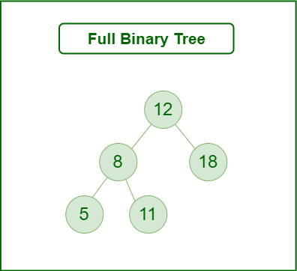
Skewed Binary Tree:
- A skewed binary tree is a pathological/degenerate tree in which the tree is either dominated by the left nodes or the right nodes.
- Thus, there are two types of skewed binary tree: left-skewed binary tree and right-skewed binary tree.

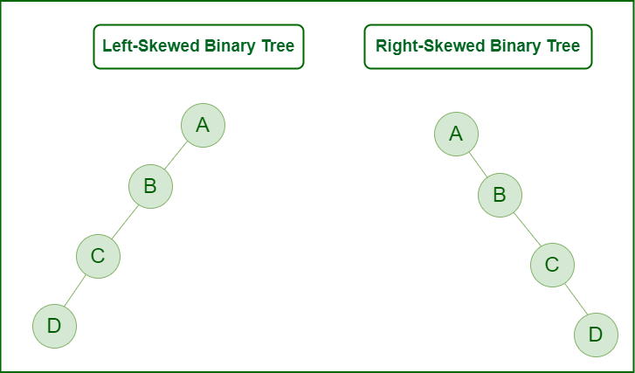
- Types of Binary Tree On the basis of the completion of levels:
a)Complete Binary Tree
b)Perfect Binary Tree
c)Balanced Binary Tree

Complete Binary Tree:
- A binary tree is said to be a complete binary tree when all the levels are completely filled except the last level, which is filled from the left..
- The complete binary tree is similar to the full binary tree except for the two differences which are given below:
- The filling of the leaf node must start from the leftmost side.
- It is not mandatory that the last leaf node must have the right sibling.
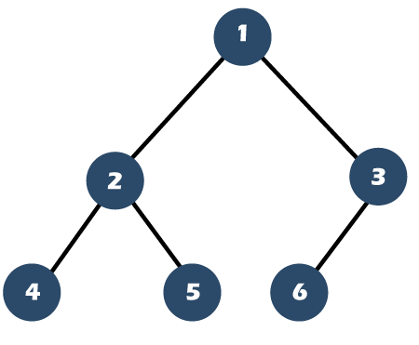
Perfect Binary Tree:
- A Binary tree is a Perfect Binary Tree in which all the internal nodes have two children and all leaf nodes are at the same level.
- The following are examples of Perfect Binary Trees.
- A perfect binary tree is a type of binary tree in which every internal node has exactly two child nodes and all the leaf nodes are at the same level.
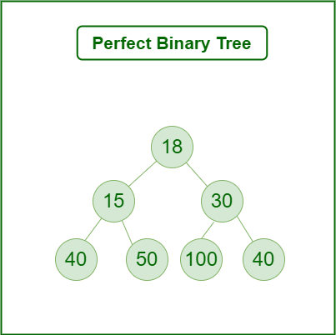

Balanced Binary Tree:
- A binary tree is balanced if the height of the tree is O(Log n) where n is the number of nodes.
- For Example, the AVL tree maintains O(Log n) height by making sure that the difference between the heights of the left and right subtrees is at most 1.
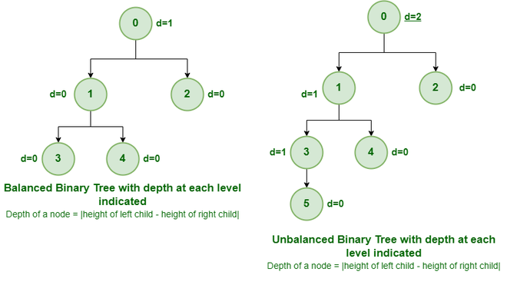

Binary Tree:
- A binary tree is a tree data structure composed of nodes, each of which has at most, two children, referred to as left and right nodes and the tree begins from root node.
- Representation of Binary Tree:
- Each node in the tree contains the following:
- Data,Pointer to the left child and Pointer to the right child
Various Operations:
- Inserting an element.
- Removing an element.
- Searching for an element.
- Deletion for an element.
- Traversing an element (DFS and BFS)
Traversal in Binary Tree:
- Preorder Traversal (current-left-right: Visit the current node before visiting any nodes inside the left or right subtrees. Here, the traversal is root – left child – right child. It means that the root node is traversed first then its left child and finally the right child.
- Algorithm for preorder traversal
Step 1 : Start from the Root.
Step 2 : Then, go to the Left Subtree.
Step 3 : Then, go to the Right Subtree.
- \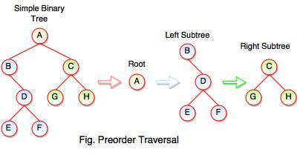
- Preorder Traversal : A B C D E F G H

- Inorder Traversal (left-current-right): Visit the current node after visiting all nodes inside the left subtree but before visiting any node within the right subtree. Here, the traversal is left child – root – right child. It means that the left child is traversed first then its root node and finally the right child.
- Algorithm for inorder traversal
Step 1 : Start from the Left Subtree.
Step 2 : Then, visit the Root.
Step 3 : Then, go to the Right Subtree.
- 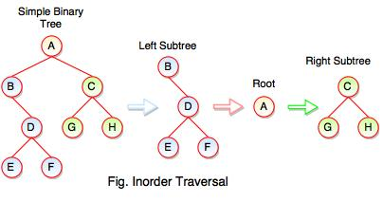
- Inorder Traversal : B E D F A G C H
Postorder Traversal (left-right-current): Visit the current node after visiting all the nodes of the left and right subtrees. Here, the traversal is left child – right child – root. It means that the left child has traversed first then the right child and finally its root node.
Algorithm for postorder traversal
Step 1 : Start from the Left Subtree (Last Leaf).
Step 2 : Then, go to the Right Subtree.
Step 3 : Then, go to the Root.
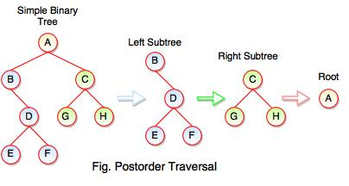
- Level Order Traversal: Visit nodes level-by-level and left-to-right fashion at the same level. Here, the traversal is level-wise. It means that the most left child has traversed first and then the other children of the same level from left to right have traversed.


Level Order Traversal:
18-15-30-40-50-100-40
Binary Search Tree:
- A binary search tree follows some order to arrange the elements. In a Binary search tree, the value of left node must be smaller than the parent node, and the value of right node must be greater than the parent node.
- This rule is applied recursively to the left and right subtrees of the root.
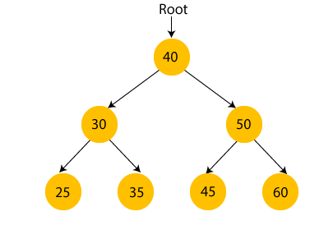
Operations:
a)Insert
b)Delete
c)Search

Example of creating a binary search tree
Now, let's see the creation of binary search tree using an example.
Suppose the data elements are - 45, 15, 79, 90, 10, 55, 12, 20, 50
- First, we have to insert 45 into the tree as the root of the tree.
- Then, read the next element; if it is smaller than the root node, insert it as the root of the left subtree, and move to the next element.
- Otherwise, if the element is larger than the root node, then insert it as the root of the right subtree.
Now, let's see the process of creating the Binary search tree using the given data element. The process of creating the BST is shown below -
Step 1 - Insert 45.
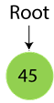
Step 2 - Insert 15.
As 15 is smaller than 45, so insert it as the root node of the left subtree.
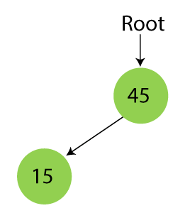
Step 3 - Insert 79.
As 79 is greater than 45, so insert it as the root node of the right subtree.
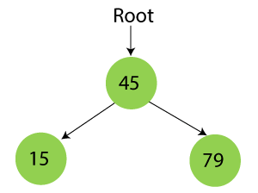
Step 4 - Insert 90.
90 is greater than 45 and 79, so it will be inserted as the right subtree of 79.
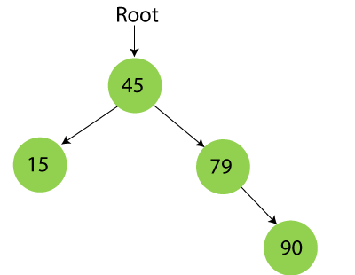
Step 5 - Insert 10.
10 is smaller than 45 and 15, so it will be inserted as a left subtree of 15.
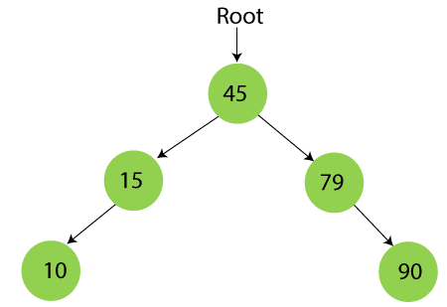
Step 6 - Insert 55.
55 is larger than 45 and smaller than 79, so it will be inserted as the left subtree of 79.
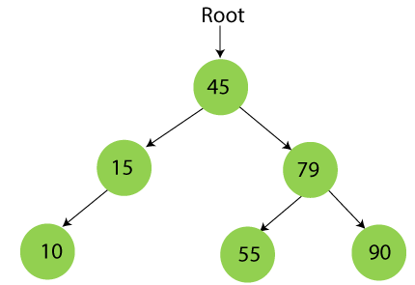
Step 7 - Insert 12.
12 is smaller than 45 and 15 but greater than 10, so it will be inserted as the right subtree of 10.
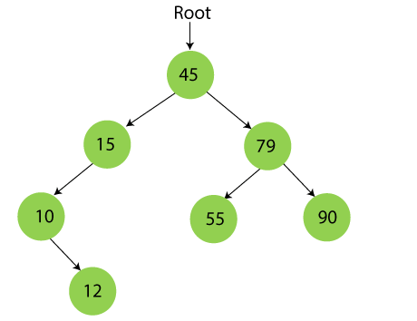

Step 8 - Insert 20.
20 is smaller than 45 but greater than 15, so it will be inserted as the right subtree of 15.
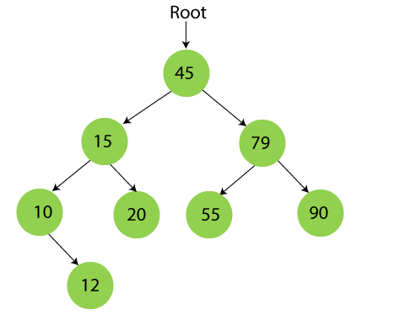
Step 9 - Insert 50.
50 is greater than 45 but smaller than 79 and 55. So, it will be inserted as a left subtree of 55.
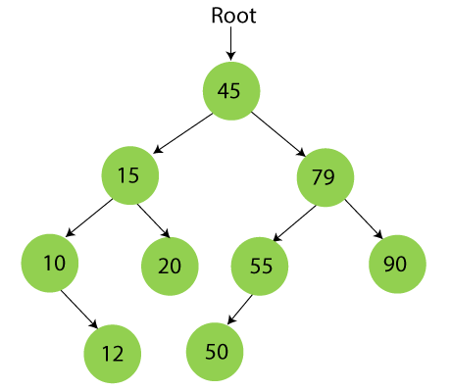

Searching in Binary search tree
Searching means to find or locate a specific element or node in a data structure. In Binary search tree, searching a node is easy because elements in BST are stored in a specific order. The steps of searching a node in Binary Search tree are listed as follows -
- First, compare the element to be searched with the root element of the tree.
- If root is matched with the target element, then return the node's location.
- If it is not matched, then check whether the item is less than the root element, if it is smaller than the root element, then move to the left subtree.
- If it is larger than the root element, then move to the right subtree.
- Repeat the above procedure recursively until the match is found.
- If the element is not found or not present in the tree, then return NULL.
Now, let's understand the searching in binary tree using an example. We are taking the binary search tree formed above. Suppose we have to find node 20 from the below tree.
Step1:
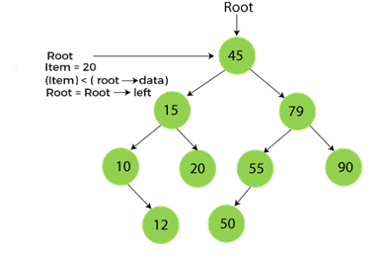
Step2:
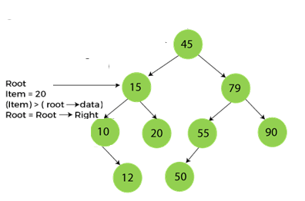
Step3:
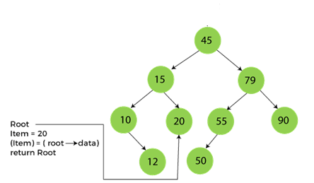

Deletion in Binary Search tree
In a binary search tree, we must delete a node from the tree by keeping in mind that the property of BST is not violated. To delete a node from BST, there are three possible situations occur -
- The node to be deleted is the leaf node, or,
- The node to be deleted has only one child, and,
- The node to be deleted has two children
We will understand the situations listed above in detail.
When the node to be deleted is the leaf node
It is the simplest case to delete a node in BST. Here, we have to replace the leaf node with NULL and simply free the allocated space.
We can see the process to delete a leaf node from BST in the below image. In below image, suppose we have to delete node 90, as the node to be deleted is a leaf node, so it will be replaced with NULL, and the allocated space will free.
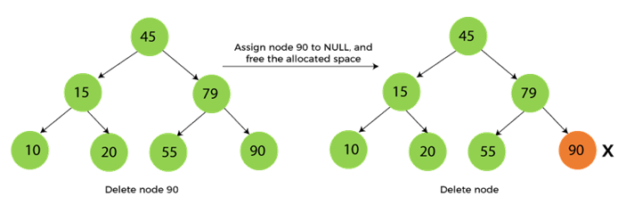
When the node to be deleted has only one child
In this case, we have to replace the target node with its child, and then delete the child node. It means that after replacing the target node with its child node, the child node will now contain the value to be deleted. So, we simply have to replace the child node with NULL and free up the allocated space.
We can see the process of deleting a node with one child from BST in the below image. In the below image, suppose we have to delete the node 79, as the node to be deleted has only one child, so it will be replaced with its child 55.
So, the replaced node 79 will now be a leaf node that can be easily deleted.
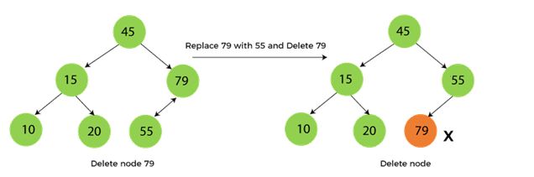
When the node to be deleted has two children
This case of deleting a node in BST is a bit complex among other two cases. In such a case, the steps to be followed are listed as follows -
- First, find the inorder successor of the node to be deleted.
- After that, replace that node with the inorder successor until the target node is placed at the leaf of tree.
- And at last, replace the node with NULL and free up the allocated space.
The inorder successor is required when the right child of the node is not empty. We can obtain the inorder successor by finding the minimum element in the right child of the node.
We can see the process of deleting a node with two children from BST in the below image. In the below image, suppose we have to delete node 45 that is the root node, as the node to be deleted has two children, so it will be replaced with its inorder successor. Now, node 45 will be at the leaf of the tree so that it can be deleted easily.
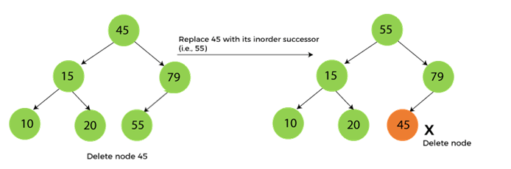
AVL Tree:
AVL Tree is invented by GM Adelson - Velsky and EM Landis in 1962. The tree is named AVL in honour of its inventors.
AVL Tree can be defined as height balanced binary search tree in which each node is associated with a balance factor which is calculated by subtracting the height of its right sub-tree from that of its left sub-tree.
Tree is said to be balanced if balance factor of each node is in between -1 to 1, otherwise, the tree will be unbalanced and need to be balanced.

Balance Factor (k) = height (left(k)) - height (right(k))
If balance factor of any node is 1, it means that the left sub-tree is one level higher than the right sub-tree.
If balance factor of any node is 0, it means that the left sub-tree and right sub-tree contain equal height.
If balance factor of any node is -1, it means that the left sub-tree is one level lower than the right sub-tree.
An AVL tree is given in the following figure. We can see that, balance factor associated with each node is in between -1 and +1. therefore, it is an example of AVL tree.

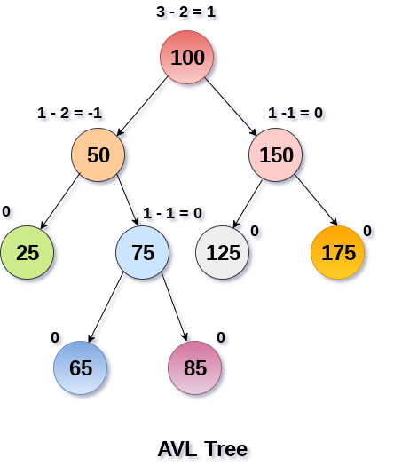
Rotations in AVL Tree:
We perform rotation in AVL tree only in case if Balance Factor is other than -1, 0, and 1.
There are basically four types of rotations which are as follows:
- L L rotation: Inserted node is in the left subtree of left subtree of A
- R R rotation : Inserted node is in the right subtree of right subtree of A
- L R rotation : Inserted node is in the right subtree of left subtree of A
- R L rotation : Inserted node is in the left subtree of right subtree of A

RR Rotation
- When BST becomes unbalanced, due to a node is inserted into the right subtree of the right subtree of A, then we perform RR rotation, RR rotation is an anticlockwise rotation, which is applied on the edge below a node having balance factor -2
- 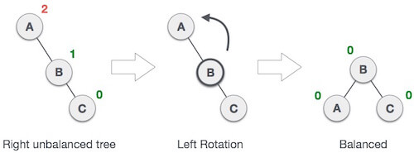
- In above example, node A has balance factor -2 because a node C is inserted in the right subtree of A right subtree. We perform the RR rotation on the edge below A.

LL Rotation
- When BST becomes unbalanced, due to a node is inserted into the left subtree of the left subtree of C, then we perform LL rotation, LL rotation is clockwise rotation, which is applied on the edge below a node having balance factor 2.
- 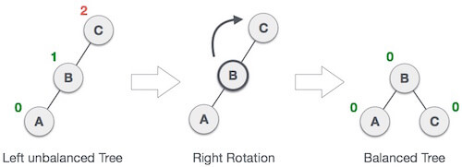
- In above example, node C has balance factor 2 because a node A is inserted in the left subtree of C left subtree. We perform the LL rotation on the edge below A.

LR Rotation
- Double rotations are bit tougher than single rotation which has already explained above. LR rotation = RR rotation + LL rotation, i.e., first RR rotation is performed on subtree and then LL rotation is performed on full tree, by full tree we mean the first node from the path of inserted node whose balance factor is other than -1, 0, or 1.
State |  | Action
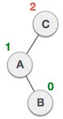 |  | A node B has been inserted into the right subtree of A the left subtree of C,  because of which C has become an unbalanced node having balance  factor 2. This case is L R rotation where: Inserted node is in the right  subtree of left subtree of C
 | 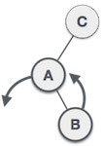 | As LR rotation = RR + LL rotation, hence RR (anticlockwise) on  subtree rooted at A is performed first. By doing RR rotation,  node A, has become the left subtree of B.
 | 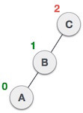 | After performing RR rotation, node C is still unbalanced, i.e.,  having balance factor 2, as inserted node A is in the left of left of C
 | 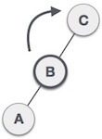 | Now we perform LL clockwise rotation on full tree, i.e. on node C.  node C has now become the right subtree of node B, A is left subtree of B
 | 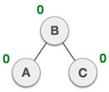 | Balance factor of each node is now either -1, 0, or 1, i.e. BST is balanced now.

RL Rotation
As already discussed, that double rotations are bit tougher than single rotation which has already explained above. R L rotation = LL rotation + RR rotation, i.e., first LL rotation is performed on subtree and then RR rotation is performed on full tree, by full tree we mean the first node from the path of inserted node whose balance factor is other than -1, 0, or 1.
State | Action
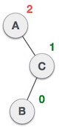 | A node B has been inserted into the left subtree of C the right subtree  of A, because of which A has become an unbalanced node having balance  factor - 2. This case is RL rotation where: Inserted node is in the left  subtree of right subtree of A
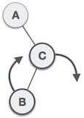 | As RL rotation = LL rotation + RR rotation, hence, LL (clockwise) on  subtree rooted at C is performed first. By doing RR rotation, node C has  become the right subtree  of B.
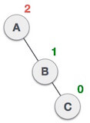 | After performing LL rotation, node A is still unbalanced, i.e. having  balance factor -2, which is because of the right-subtree of the right-subtree  node A.
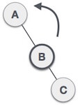 | Now we perform RR rotation (anticlockwise rotation) on full tree, i.e. on  node A. node C has now become the right subtree of node B, and node A has become the left subtree of B.
 | Balance factor of each node is now either -1, 0, or 1, i.e., BST is  balanced now.

Construct AVL Tree:
H, I, J, B, A, E, C, F, D, G, K, L
1. Insert H, I, J
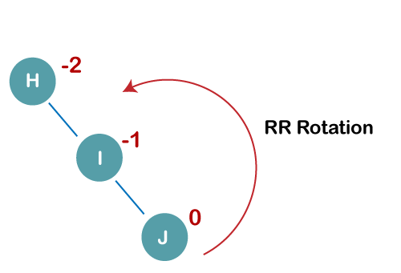
On inserting the above elements, especially in the case of H, the BST becomes unbalanced as the Balance Factor of H is -2. Since the BST is right-skewed, we will perform RR Rotation on node H.
The resultant balance tree is:
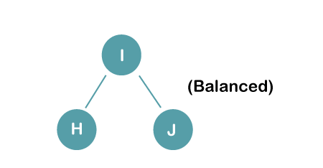
2. Insert B, A
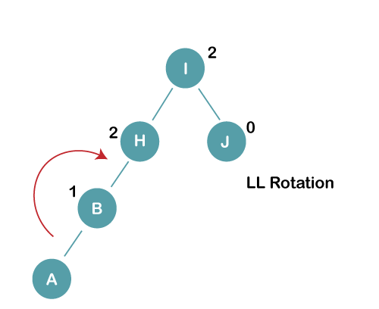
On inserting the above elements, especially in case of A, the BST becomes unbalanced as the Balance Factor of H and I is 2, we consider the first node from the last inserted node i.e. H. Since the BST from H is left-skewed, we will perform LL Rotation on node H.
The resultant balance tree is:
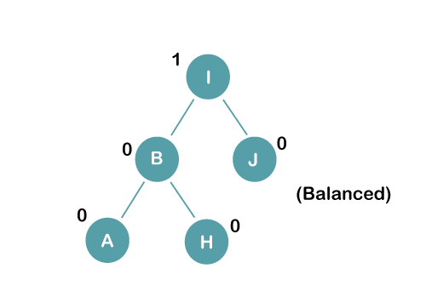
3. Insert E
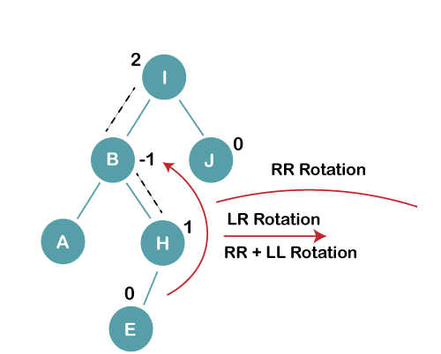
On inserting E, BST becomes unbalanced as the Balance Factor of I is 2, since if we travel from E to I we find that it is inserted in the left subtree of right subtree of I, we will perform LR Rotation on node I. LR = RR + LL rotation
3 a) We first perform RR rotation on node B
The resultant tree after RR rotation is:
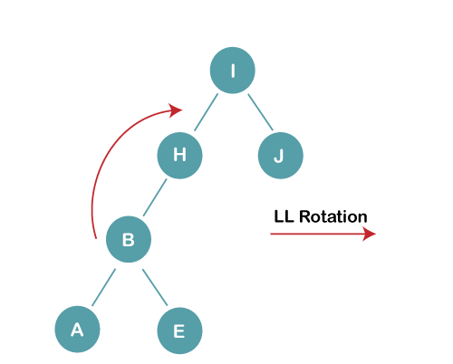
3b) We first perform LL rotation on the node I
The resultant balanced tree after LL rotation is:
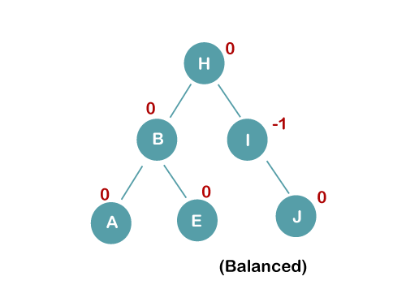
4. Insert C, F, D
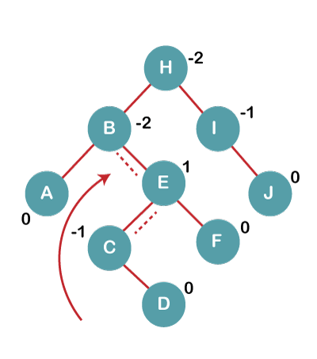
On inserting C, F, D, BST becomes unbalanced as the Balance Factor of B and H is -2, since if we travel from D to B we find that it is inserted in the right subtree of left subtree of B, we will perform RL Rotation on node I. RL = LL + RR rotation.
4a) We first perform LL rotation on node E
The resultant tree after LL rotation is:
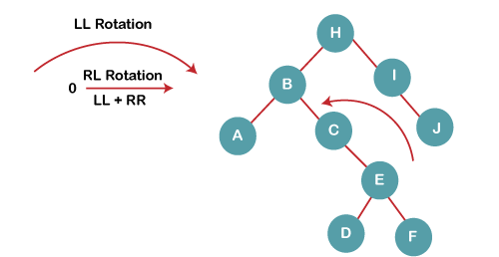
4b) We then perform RR rotation on node B
The resultant balanced tree after RR rotation is:
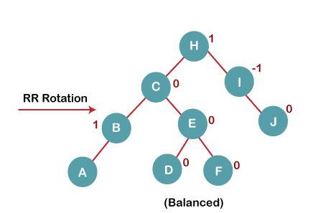
5. Insert G
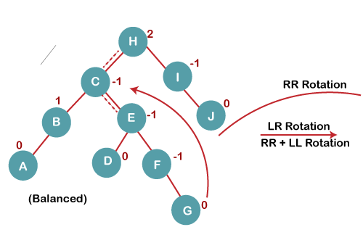
On inserting G, BST become unbalanced as the Balance Factor of H is 2, since if we travel from G to H, we find that it is inserted in the left subtree of right subtree of H, we will perform LR Rotation on node I. LR = RR + LL rotation.
5 a) We first perform RR rotation on node C
The resultant tree after RR rotation is:
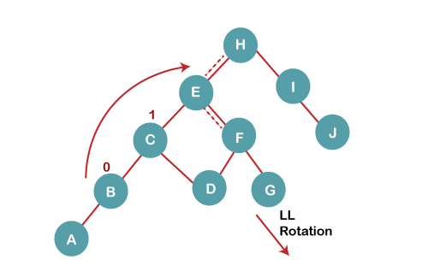
5 b) We then perform LL rotation on node H
The resultant balanced tree after LL rotation is:
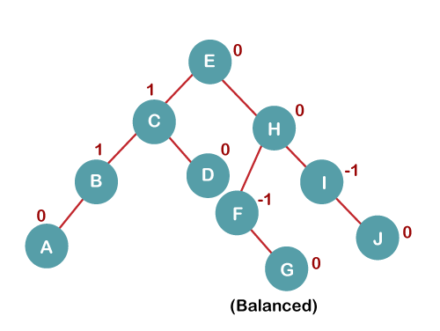
6. Insert K
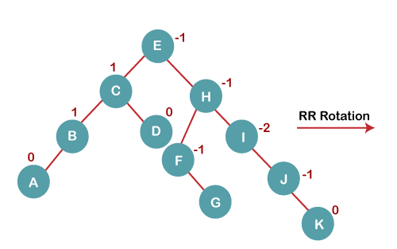
On inserting K, BST becomes unbalanced as the Balance Factor of I is -2. Since the BST is right-skewed from I to K, hence we will perform RR Rotation on the node I.
The resultant balanced tree after RR rotation is:
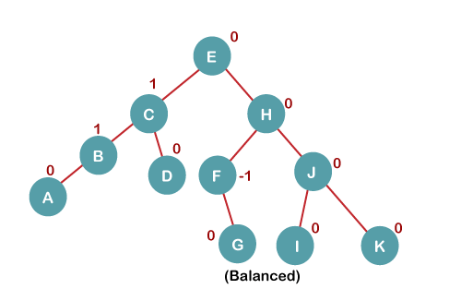
7. Insert L
On inserting the L tree is still balanced as the Balance Factor of each node is now either, -1, 0, +1. Hence the tree is a Balanced AVL tree
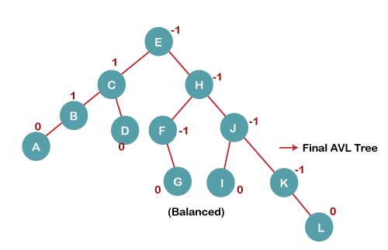
Deletion in AVL Tree:
Deleting a node from an AVL tree is similar to that in a binary search tree.
Deletion may disturb the balance factor of an AVL tree and therefore the tree needs to be rebalanced in order to maintain the AVLness.
For this purpose, we need to perform rotations.
The two types of rotations are L rotation and R rotation. Here, we will discuss R rotations. L rotations are the mirror images of them.
If the node which is to be deleted is present in the left sub-tree of the critical node, then L rotation needs to be applied else if, the node which is to be deleted is present in the right sub-tree of the critical node, the R rotation will be applied.
Example:
Delete the node 30 from the AVL tree
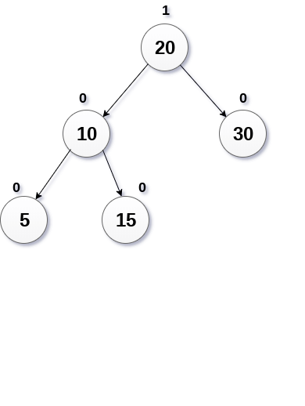

Solution
In this case, the node B has balance factor 0, therefore the tree will be rotated by using R0 rotation as shown in the following image. The node B(10) becomes the root, while the node A is moved to its right. The right child of node B will now become the left child of node A.
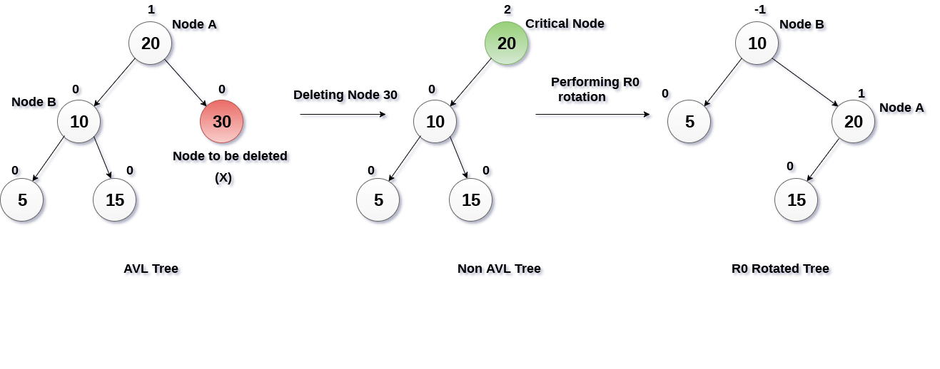

R1 Rotation (Node B has balance factor 1)
R1 Rotation is to be performed if the balance factor of Node B is 1. In R1 rotation, the critical node A is moved to its right having sub-trees T2 and T3 as its left and right child respectively. T1 is to be placed as the left sub-tree of the node B.
The process involved in R1 rotation is shown in the following image.
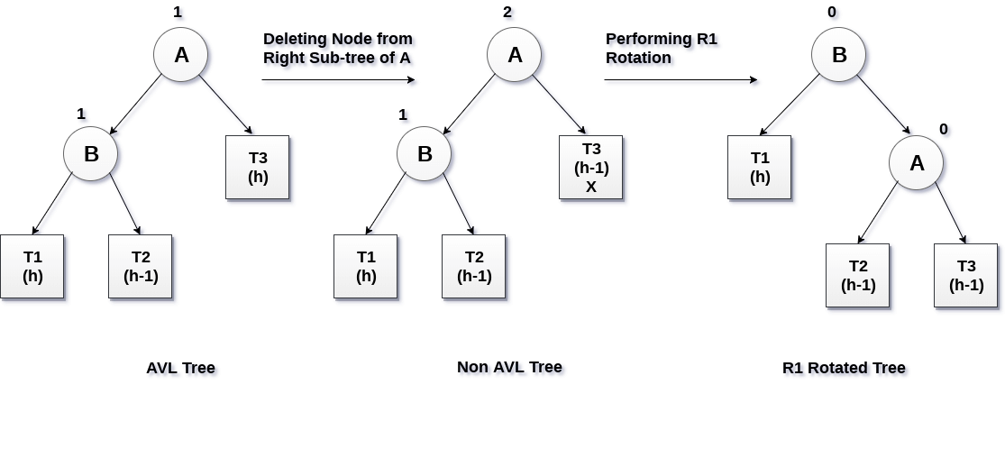
Red and Black tree:
The red-Black tree is a binary search tree. The prerequisite of the red-black tree is that we should know about the binary search tree.
In a binary search tree, the values of the nodes in the left subtree should be less than the value of the root node, and the values of the nodes in the right subtree should be greater than the value of the root node.
Each node in the Red-black tree contains an extra bit that represents a color to ensure that the tree is balanced during any operations performed on the tree like insertion, deletion, etc. In a binary search tree, the searching, insertion and deletion take O(log2n) time in the average case, O(1) in the best case and O(n) in the worst case.
Red-Black tree is a self-balanced binary search tree. Now, the question arises that why do we require a Red-Black tree if AVL is also a height-balanced tree.
The Red-Black tree is used because the AVL tree requires many rotations when the tree is large, whereas the Red-Black tree requires a maximum of two rotations to balance the tree.
The main difference between the AVL tree and the Red-Black tree is that the AVL tree is strictly balanced, while the Red-Black tree is not completely height-balanced.
So, the AVL tree is more balanced than the Red-Black tree, but the Red-Black tree guarantees O(log2n) time for all operations like insertion, deletion, and searching.
Insertion is easier in the AVL tree as the AVL tree is strictly balanced, whereas deletion and searching are easier in the Red-Black tree as the Red-Black tree requires fewer rotations.

Properties of Red-Black tree
- It is a self-balancing Binary Search tree. Here, self-balancing means that it balances the tree itself by either doing the rotations or recoloring the nodes.
- This tree data structure is named as a Red-Black tree as each node is either Red or Black in color. Every node stores one extra information known as a bit that represents the color of the node. For example, 0 bit denotes the black color while 1 bit denotes the red color of the node. Other information stored by the node is similar to the binary tree, i.e., data part, left pointer and right pointer.
- In the Red-Black tree, the root node is always black in color.
- In a binary tree, we consider those nodes as the leaf which have no child. In contrast, in the Red-Black tree, the nodes that have no child are considered the internal nodes and these nodes are connected to the NIL nodes that are always black in color. The NIL nodes are the leaf nodes in the Red-Black tree.
- If the node is Red, then its children should be in Black color. In other words, we can say that there should be no red-red parent-child relationship.
- Every path from a node to any of its descendant's NIL node should have same number of black nodes.
Insertion in Red Black tree
The following are some rules used to create the Red-Black tree:
- If the tree is empty, then we create a new node as a root node with the color black.
- If the tree is not empty, then we create a new node as a leaf node with a color red.
- If the parent of a new node is black, then exit.
- If the parent of a new node is Red, then we have to check the color of the parent's sibling of a new node.
4a) If the color is Black, then we perform rotations and recoloring.
4b) If the color is Red then we recolor the node. We will also check whether the parents' parent of a new node is the root node or not; if it is not a root node, we will recolor and recheck the node.
Let's understand the insertion in the Red-Black tree.
10, 18, 7, 15, 16, 30, 25, 40, 60
Step 1: Initially, the tree is empty, so we create a new node having value 10. This is the first node of the tree, so it would be the root node of the tree. As we already discussed, that root node must be black in color, which is shown below:

Step 2: The next node is 18. As 18 is greater than 10 so it will come at the right of 10 as shown below.
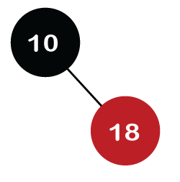
We know the second rule of the Red Black tree that if the tree is not empty then the newly created node will have the Red color. Therefore, node 18 has a Red color, as shown in the below figure:
Now we verify the third rule of the Red-Black tree, i.e., the parent of the new node is black or not. In the above figure, the parent of the node is black in color; therefore, it is a Red-Black tree.
Step 3: Now, we create the new node having value 7 with Red color. As 7 is less than 10, so it will come at the left of 10 as shown below.
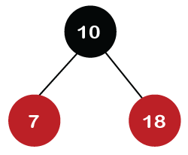
Now we verify the third rule of the Red-Black tree, i.e., the parent of the new node is black or not. As we can observe, the parent of the node 7 is black in color, and it obeys the Red-Black tree's properties.
Step 4: The next element is 15, and 15 is greater than 10, but less than 18, so the new node will be created at the left of node 18. The node 15 would be Red in color as the tree is not empty.
The above tree violates the property of the Red-Black tree as it has Red-red parent-child relationship. Now we have to apply some rule to make a Red-Black tree. The rule 4 says that if the new node's parent is Red, then we have to check the color of the parent's sibling of a new node. The new node is node 15; the parent of the new node is node 18 and the sibling of the parent node is node 7. As the color of the parent's sibling is Red in color, so we apply the rule 4a. The rule 4a says that we have to recolor both the parent and parent's sibling node. So, both the nodes, i.e., 7 and 18, would be recolored as shown in the below figure.
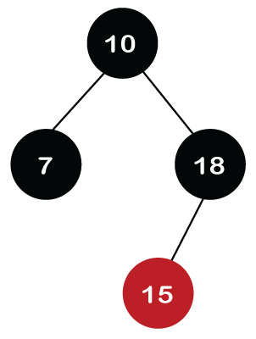
We also have to check whether the parent's parent of the new node is the root node or not. As we can observe in the above figure, the parent's parent of a new node is the root node, so we do not need to recolor it.
Step 5: The next element is 16. As 16 is greater than 10 but less than 18 and greater than 15, so node 16 will come at the right of node 15. The tree is not empty; node 16 would be Red in color, as shown in the below figure:
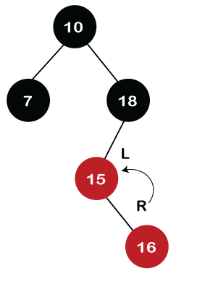
In the above figure, we can observe that it violates the property of the parent-child relationship as it has a red-red parent-child relationship. We have to apply some rules to make a Red-Black tree. Since the new node's parent is Red color, and the parent of the new node has no sibling, so rule 4a will be applied. The rule 4a says that some rotations and recoloring would be performed on the tree.
Since node 16 is right of node 15 and the parent of node 15 is node 18. Node 15 is the left of node 18. Here we have an LR relationship, so we require to perform two rotations. First, we will perform left, and then we will perform the right rotation. The left rotation would be performed on nodes 15 and 16, where node 16 will move upward, and node 15 will move downward. Once the left rotation is performed, the tree looks like as shown in the below figure:
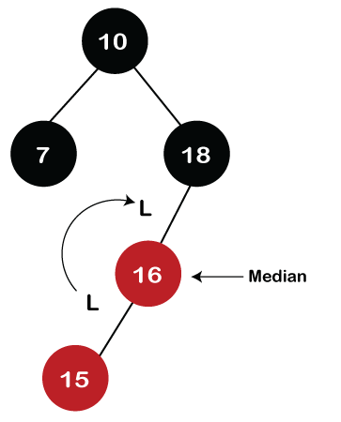
In the above figure, we can observe that there is an LL relationship. The above tree has a Red-red conflict, so we perform the right rotation. When we perform the right rotation, the median element would be the root node. Once the right rotation is performed, node 16 would become the root node, and nodes 15 and 18 would be the left child and right child, respectively, as shown in the below figure.
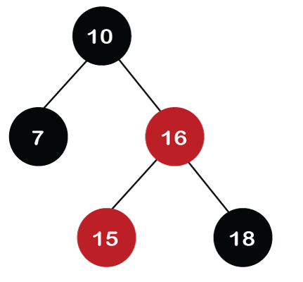
After rotation, node 16 and node 18 would be recolored; the color of node 16 is red, so it will change to black, and the color of node 18 is black, so it will change to a red color as shown in the below figure:
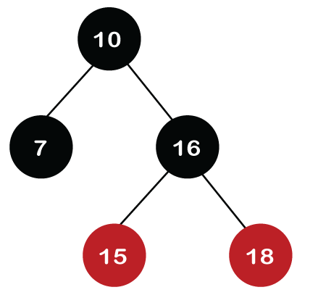
Step 6: The next element is 30. Node 30 is inserted at the right of node 18. As the tree is not empty, so the color of node 30 would be red.
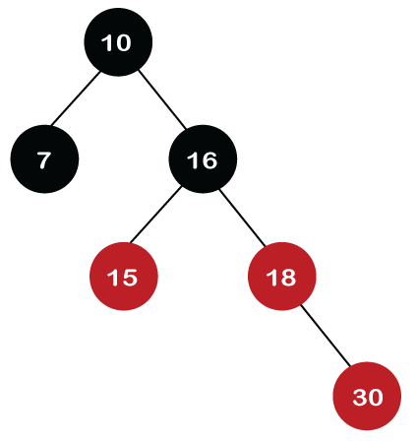
The color of the parent and parent's sibling of a new node is Red, so rule 4b is applied. In rule 4b, we have to do only recoloring, i.e., no rotations are required. The color of both the parent (node 18) and parent's sibling (node 15) would become black, as shown in the below image.
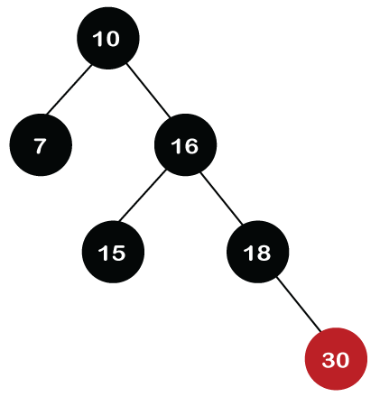
We also have to check the parent's parent of the new node, whether it is a root node or not. The parent's parent of the new node, i.e., node 30 is node 16 and node 16 is not a root node, so we will recolor the node 16 and changes to the Red color. The parent of node 16 is node 10, and it is not in Red color, so there is no Red-red conflict.
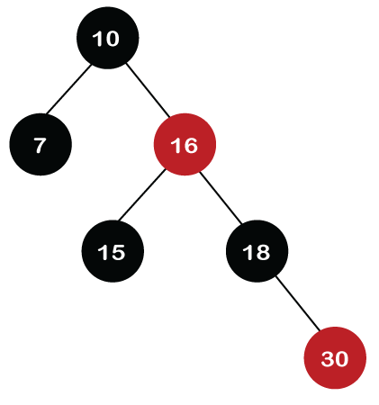
Step 7: The next element is 25, which we have to insert in a tree. Since 25 is greater than 10, 16, 18 but less than 30; so, it will come at the left of node 30. As the tree is not empty, node 25 would be in Red color. Here Red-red conflict occurs as the parent of the newly created is Red color.
Since there is no parent's sibling, so rule 4a is applied in which rotation, as well as recoloring, are performed. First, we will perform rotations. As the newly created node is at the left of its parent and the parent node is at the right of its parent, so the RL relationship is formed. Firstly, the right rotation is performed in which node 25 goes upwards, whereas node 30 goes downwards, as shown in the below figure.
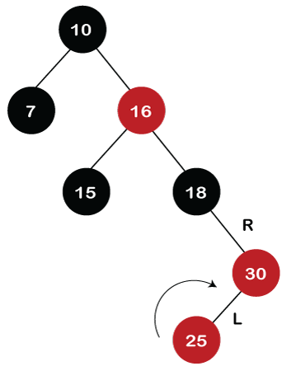
After the first rotation, there is an RR relationship, so left rotation is performed. After right rotation, the median element, i.e., 25 would be the root node; node 30 would be at the right of 25 and node 18 would be at the left of node 25.
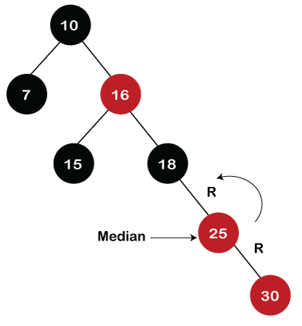
Now recoloring would be performed on nodes 25 and 18; node 25 becomes black in color, and node 18 becomes red in color.
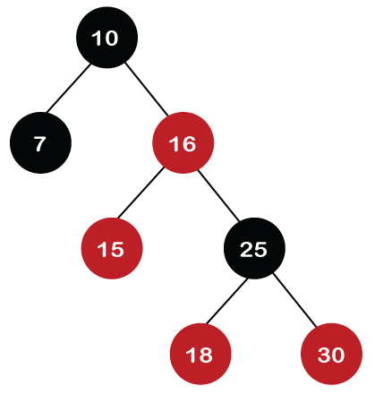
Step 8: The next element is 40. Since 40 is greater than 10, 16, 18, 25, and 30, so node 40 will come at the right of node 30. As the tree is not empty, node 40 would be Red in color. There is a Red-red conflict between nodes 40 and 30, so rule 4b will be applied.
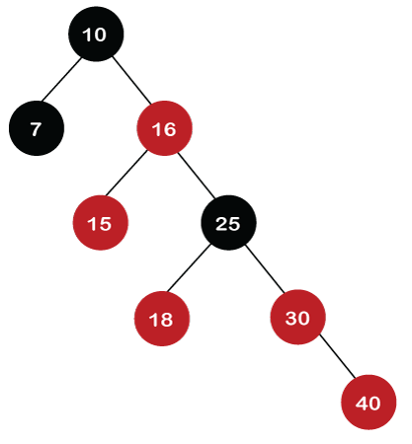
As the color of parent and parent's sibling node of a new node is Red so recoloring would be performed. The color of both the nodes would become black, as shown in the below image.
After recoloring, we also have to check the parent's parent of a new node, i.e., 25, which is not a root node, so recoloring would be performed, and the color of node 25 changes to Red.
After recoloring, red-red conflict occurs between nodes 25 and 16. Now node 25 would be considered as the new node. Since the parent of node 25 is red in color, and the parent's sibling is black in color, rule 4a would be applied. Since 25 is at the right of the node 16 and 16 is at the right of its parent, so there is an RR relationship. In the RR relationship, left rotation is performed. After left rotation, the median element 16 would be the root node, as shown in the below figure.
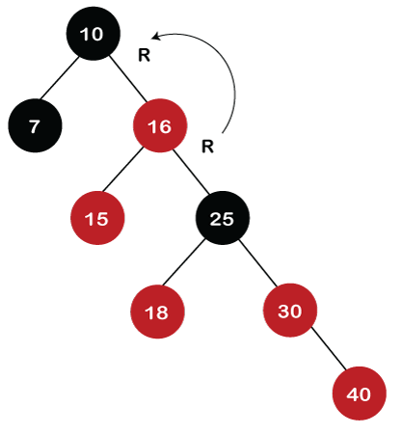
After rotation, recoloring is performed on nodes 16 and 10. The color of node 10 and node 16 changes to Red and Black, respectively as shown in the below figure.
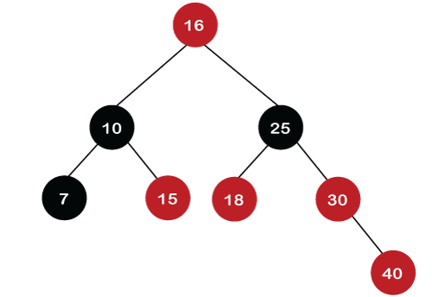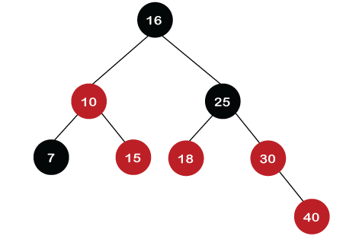
Step 9: The next element is 60. Since 60 is greater than 16, 25, 30, and 40, so node 60 will come at the right of node 40. As the tree is not empty, the color of node 60 would be Red.
As we can observe in the above tree that there is a Red-red conflict occurs. The parent node is Red in color, and there is no parent's sibling exists in the tree, so rule 4a would be applied. The first rotation would be performed. The RR relationship exists between the nodes, so left rotation would be performed.
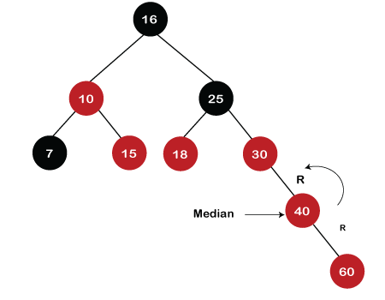
When left rotation is performed, node 40 will come upwards, and node 30 will come downwards, as shown in the below figure:
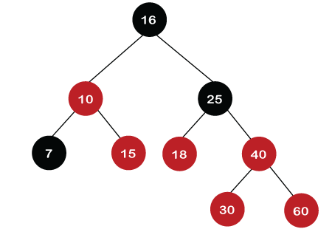
After rotation, the recoloring is performed on nodes 30 and 40. The color of node 30 would become Red, while the color of node 40 would become black.
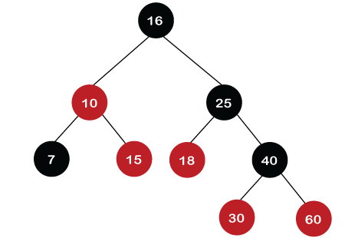
The above tree is a Red-Black tree as it follows all the Red-Black tree properties.

Deletion in Red Back tree
Let's understand how we can delete the particular node from the Red-Black tree. The following are the rules used to delete the particular node from the tree:
Step 1: First, we perform BST rules for the deletion.
Step 2:
Case 1: if the node is Red, which is to be deleted, we simply delete it.
Let's understand case 1 through an example.
Suppose we want to delete node 30 from the tree, which is given below.
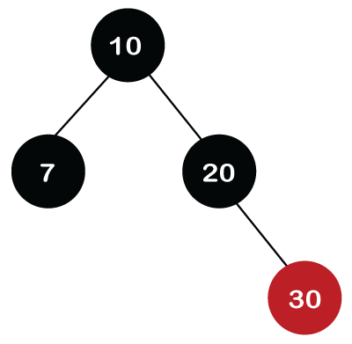
Initially, we are having the address of the root node. First, we will apply BST to search the node. Since 30 is greater than 10 and 20, which means that 30 is the right child of node 20. Node 30 is a leaf node and Red in color, so it is simply deleted from the tree.
If we want to delete the internal node that has one child. First, replace the value of the internal node with the value of the child node and then simply delete the child node.
Let's take another example in which we want to delete the internal node, i.e., node 20.
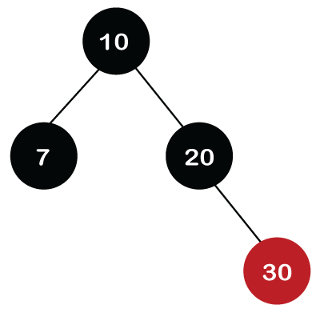
We cannot delete the internal node; we can only replace the value of that node with another value. Node 20 is at the right of the root node, and it is having only one child, node 30. So, node 20 is replaced with a value 30, but the color of the node would remain the same, i.e., Black. In the end, node 20 (leaf node) is deleted from the tree.
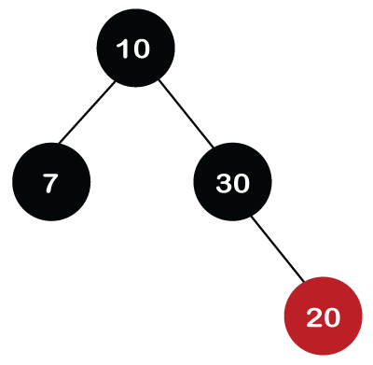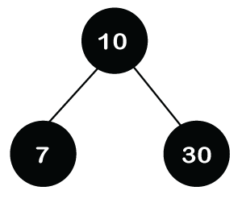
If we want to delete the internal node that has two child nodes. In this case, we have to decide from which we have to replace the value of the internal node (either left subtree or right subtree). We have two ways:
- Inorder predecessor: We will replace with the largest value that exists in the left subtree.
- Inorder successor: We will replace with the smallest value that exists in the right subtree.
Suppose we want to delete node 30 from the tree, which is shown below:
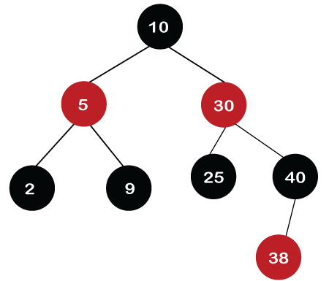
Node 30 is at the right of the root node. In this case, we will use the inorder successor. The value 38 is the smallest value in the right subtree, so we will replace the value 30 with 38, but the node would remain the same, i.e., Red. After replacement, the leaf node, i.e., 30, would be deleted from the tree. Since node 30 is a leaf node and Red in color, we need to delete it (we do not have to perform any rotations or any recoloring).
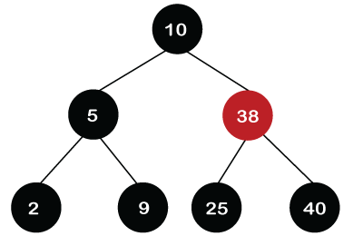
Case 2: If the root node is also double black, then simply remove the double black and make it a single black.
Case 3: If the double black's sibling is black and both its children are black.
- Remove the double black node.
- Add the color of the node to the parent (P) node.
- If the color of P is red then it becomes black.
- If the color of P is black, then it becomes double black.
- The color of double black's sibling changes to red.
- If still double black situation arises, then we will apply other cases.
Let's understand this case through an example.
Suppose we want to delete node 15 in the below tree.
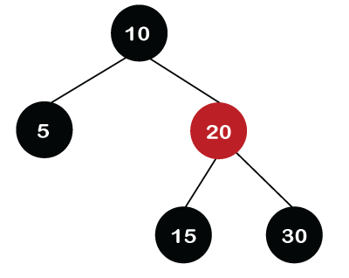
We cannot simply delete node 15 from the tree as node 15 is Black in color. Node 15 has two children, which are nil. So, we replace the 15 value with a nil value. As node 15 and nil node are black in color, the node becomes double black after replacement, as shown in the below figure.
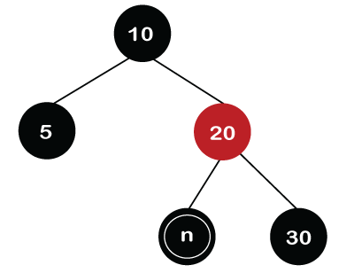
In the above tree, we can observe that the double black's sibling is black in color and its children are nil, which are also black. As the double black's sibling and its children have black so it cannot give its black color to neither of these. Now, the double black's parent node is Red so double black's node add its black color to its parent node. The color of the node 20 changes to black while the color of the nil node changes to a single black as shown in the below figure.
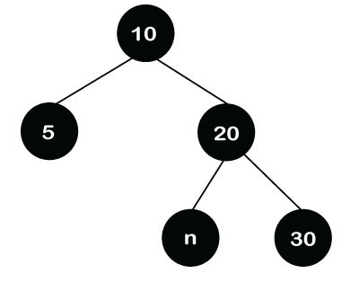
After adding the color to its parent node, the color of the double black's sibling, i.e., node 30 changes to red as shown in the below figure.
In the above tree, we can observe that there is no longer double black's problem exists, and it is also a Red-Black tree.
Case 4: If double black's sibling is Red.
- Swap the color of its parent and its sibling.
- Rotate the parent node in the double black's direction.
- Reapply cases.
Let's understand this case through an example.
Suppose we want to delete node 15.
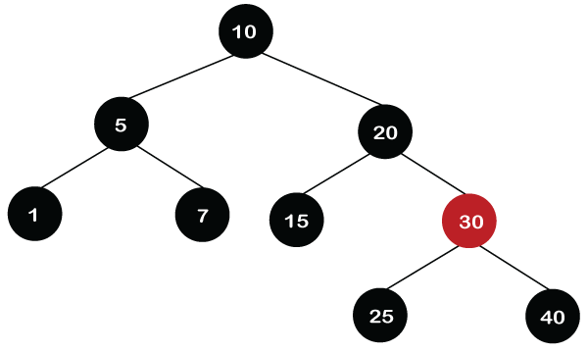
Initially, the 15 is replaced with a nil value. After replacement, the node becomes double black. Since double black's sibling is Red so color of the node 20 changes to Red and the color of the node 30 changes to Black.
Once the swapping of the color is completed, the rotation towards the double black would be performed. The node 30 will move upwards and the node 20 will move downwards as shown in the below figure.
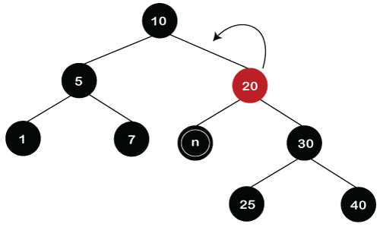
In the above tree, we can observe that double black situation still exists in the tree. It satisfies the case 3 in which double black's sibling is black as well as both its children are black. First, we remove the double black from the node and add the black color to its parent node. At the end, the color of the double black's sibling, i.e., node 25 changes to Red as shown in the below figure.
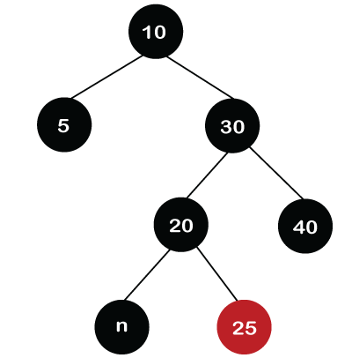
In the above tree, we can observe that the double black situation has been resolved. It also satisfies the properties of the Red Black tree.
Case 5: If double black's sibling is black, sibling's child who is far from the double black is black, but near child to double black is red.
- Swap the color of double black's sibling and the sibling child which is nearer to the double black node.
- Rotate the sibling in the opposite direction of the double black.
- Apply case 6
Suppose we want to delete the node 1 in the below tree.
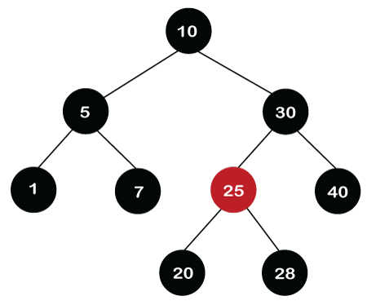
First, we replace the value 1 with the nil value. The node becomes double black as both the nodes, i.e., 1 and nil are black. It satisfies the case 3 that implies if DB's sibling is black and both its children are black. First, we remove the double black of the nil node. Since the parent of DB is Black, so when the black color is added to the parent node then it becomes double black. After adding the color, the double black's sibling color changes to Red as shown below.
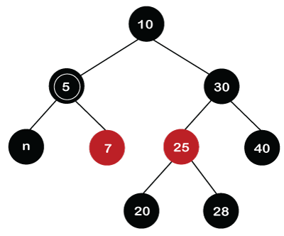
We can observe in the above screenshot that the double black problem still exists in the tree. So, we will reapply the cases. We will apply case 5 because the sibling of node 5 is node 30, which is black in color, the child of node 30, which is far from node 5 is black, and the child of the node 30 which is near to node 5 is Red. In this case, first we will swap the color of node 30 and node 25 so the color of node 30 changes to Red and the color of node 25 changes to Black as shown below.
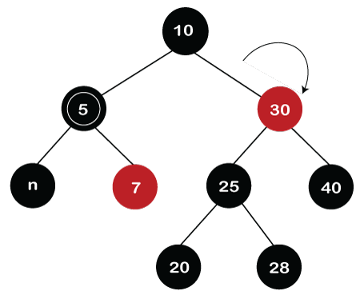
Once the swapping of the color between the nodes is completed, we need to rotate the sibling in the opposite direction of the double black node. In this rotation, the node 30 moves downwards while the node 25 moves upwards as shown below.
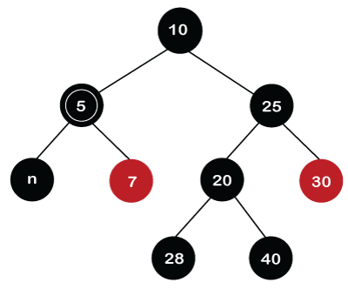
As we can observe in the above tree that double black situation still exists. So, we need to case 6. Let's first see what is case 6.
Case 6: If double black's sibling is black, far child is Red
- Swap the color of Parent and its sibling node.
- Rotate the parent towards the Double black's direction
- Remove Double black
- Change the Red color to black.
Now we will apply case 6 in the above example to solve the double black's situation.
In the above example, the double black is node 5, and the sibling of node 5 is node 25, which is black in color. The far child of the double black node is node 30, which is Red in color as shown in the below figure:

First, we will swap the colors of Parent and its sibling. The parent of node 5 is node 10, and the sibling node is node 25. The colors of both the nodes are black, so there is no swapping would occur.
In the second step, we need to rotate the parent in the double black's direction. After rotation, node 25 will move upwards, whereas node 10 will move downwards. Once the rotation is performed, the tree would like, as shown in the below figure:
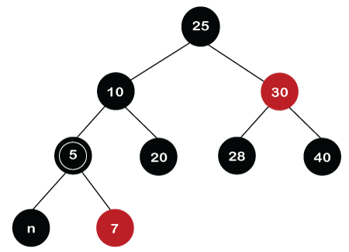
In the next step, we will remove double black from node 5 and node 5 will give its black color to the far child, i.e., node 30. Therefore, the color of node 30 changes to black as shown in the below figure.
