Report on CO2 emissions in electricity sector in Georgia and it’s comparison with selected states.
STUDENT NAME: Keerthi Teja Merugumala

1. Purpose and Data
The goal of this analysis is to compare Georgia’s CO2 emissions from electricity sector to three other US states namely: Tennessee, Texas, California, and with the CO2 emissions from the same sector for United States as a whole.
The main goal was to calculate:
- The share of various energy sources used to generate electricity (fuel mix), and
- The resulting CO₂ emissions from the electric power sector.

All data come from the EIA’s State Energy Data System (SEDS) complete file which was provided to us in the class. I used the electric power sector input (EI) variable from the dataset, which is measured in billion BTU, converted it to Quadrillions of BTU, and merged with fuel code descriptions.
CO₂ emissions are estimated by applying fuel-specific CO2 equivalent emission factors (in million metric tons CO₂ per quad) to each fuel used in electric sector, then summing across fuels by state and year.
I focused mainly on trends from 1990–2023 and on 2023 as the most recent year for cross-sectional comparisons.

2. Electricity Fuel Mix – Georgia vs other states:
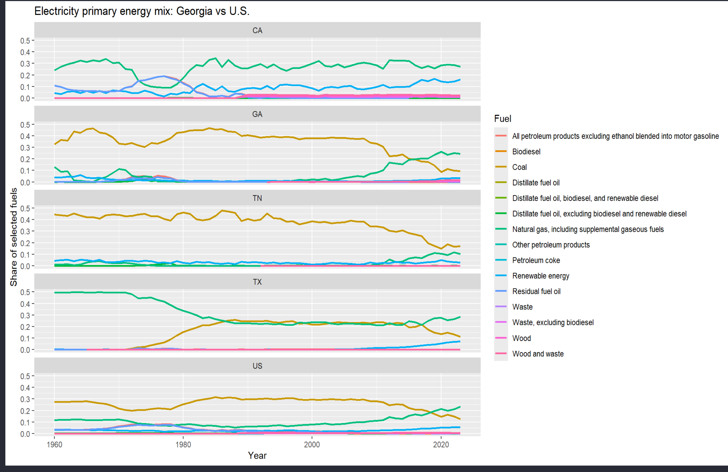
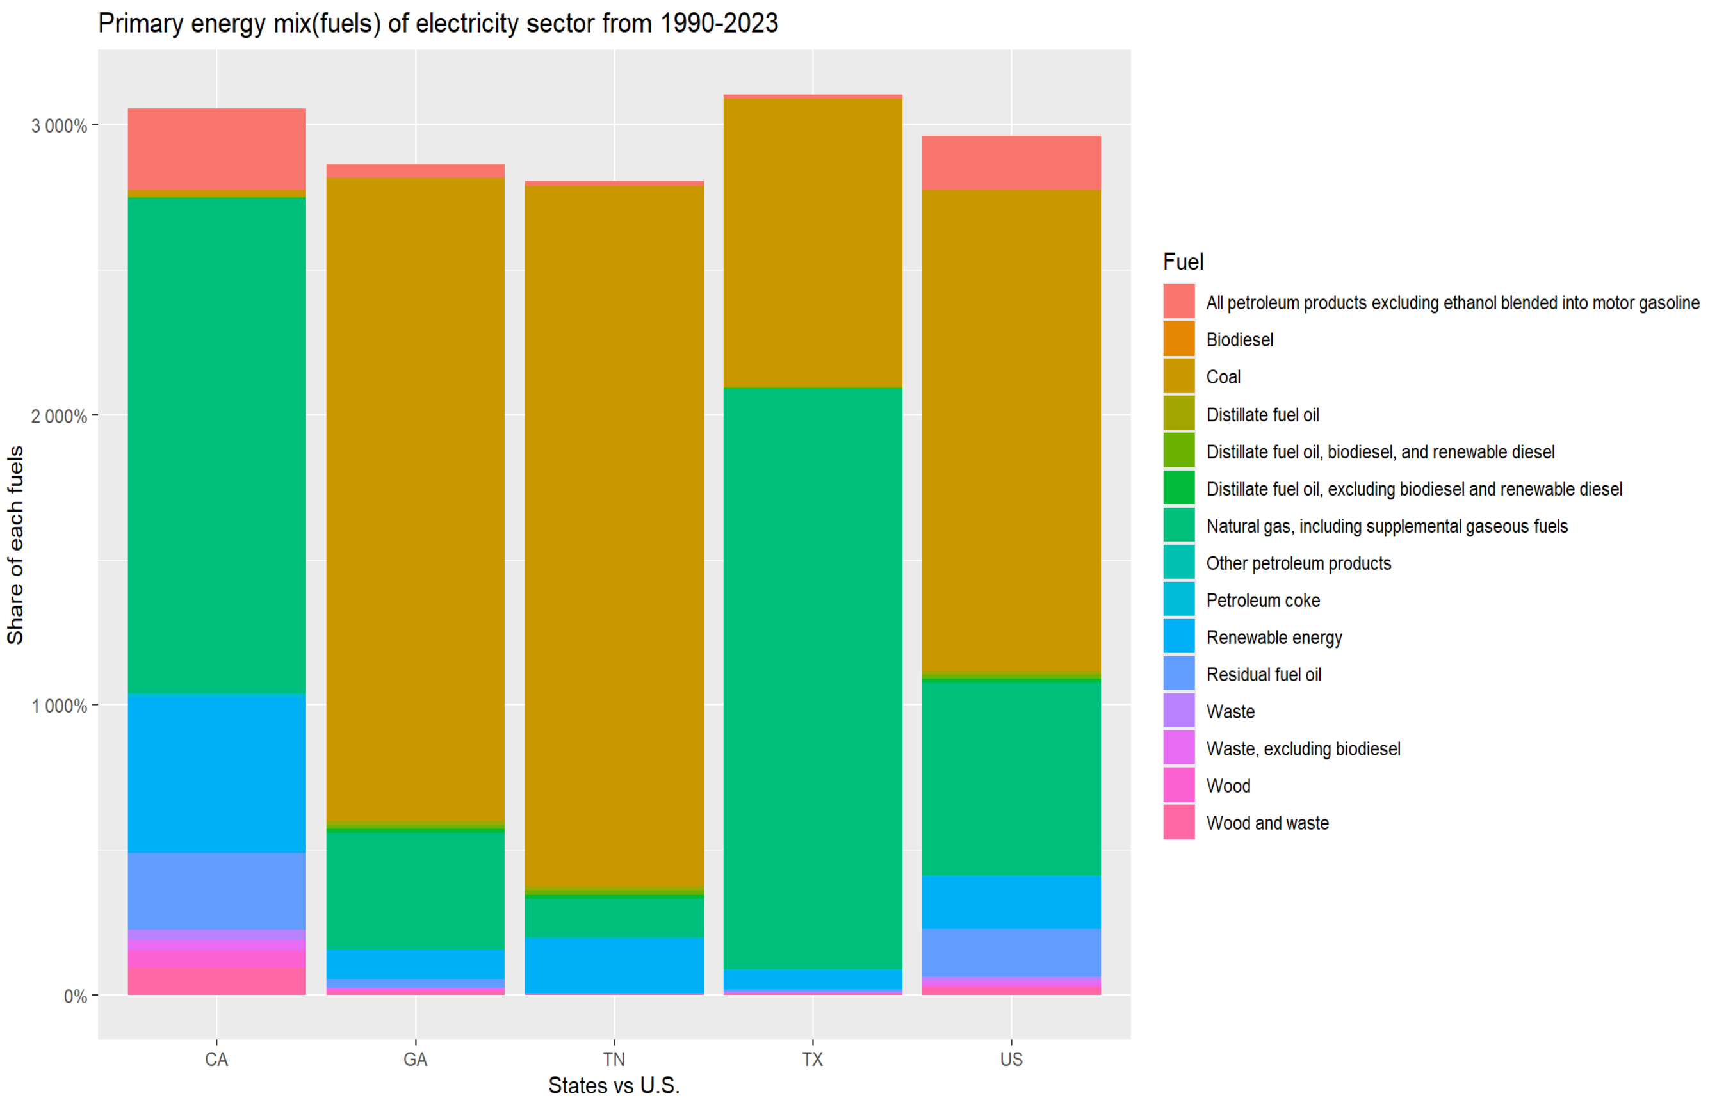

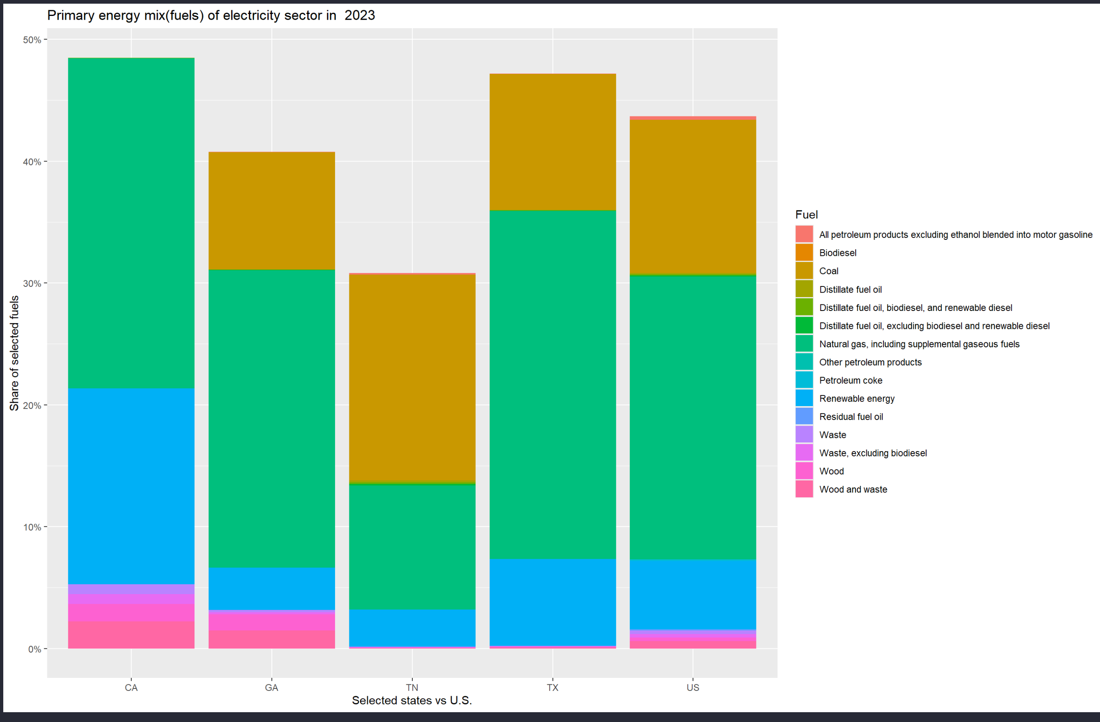
Georgia (GA)
- Early in the period the top line is the coal share, starting around 40–50% of Georgia’s electric input.
- That coal line stays high through the 1980s/1990s, then drops sharply after about 2005.
- At the same time, the natural gas line rises from near zero to become Georgia’s dominant fossil fuel in recent years.
- Nuclear and other non-fossil lines are present but remain smaller than the combined coal+gas share.
Georgia historically ran a coal-heavy system, but in the last ~15–20 years it has been replacing coal with natural gas and some nuclear, so the fuel mix is cleaner than it used to be but still quite fossil-heavy.

Tennessee (TN)
- Tennessee also starts with a big coal share, but we can see a larger share of non-fossil lines (nuclear and hydro) compared with Georgia.
- Over time, coal declines, and the low-carbon lines occupy a bigger part of the plot.
- Natural gas is present, but its share never rises as high as in Georgia.
Tennessee’s situation is a bit similar to Georgia in that it moves away from coal, but it leans more on nuclear and hydro and less on gas.
Texas (TX)
- The Texas plot shows a very strong natural-gas line for most of the period.
- Coal has also been important for many years, but its share has declined more recently.
- In the later years, we can see renewables (especially wind) rising; this is the extra line creeping up while coal shrinks.
Texas is gas-heavy and diverse, with coal declining and wind (and some solar) coming in strongly. It burns a lot of fuel overall, which is why its emissions are so big, but its mix is evolving.

California (CA)
- California’s coal share is basically at or near zero in the later years.
- The main fossil line is natural gas, which makes up most of the fuel input.
- We can see non-fossil lines (hydro, nuclear historically, and renewables) playing visible roles, especially in more recent years.
California is the low-coal, higher-renewables outlier. It relies heavily on gas and non-fossil sources, and essentially no coal in the modern period, which sets it apart from Georgia and especially from Texas.
United States (US)
- The U.S. panel is the “average story”: historically heavy coal, then a big swing toward natural gas starting around the 2000s, and rising renewables.
- Georgia’s path looks broadly similar, but Georgia’s coal stays important a bit longer and its renewable line is smaller than the national one.

3. CO₂ Emissions – Levels, Trends, and Per Capita
3.1 Total Emissions
Using the CO2 equivalent emission factors, I computed total CO₂ emissions (mmt) for each state and year.
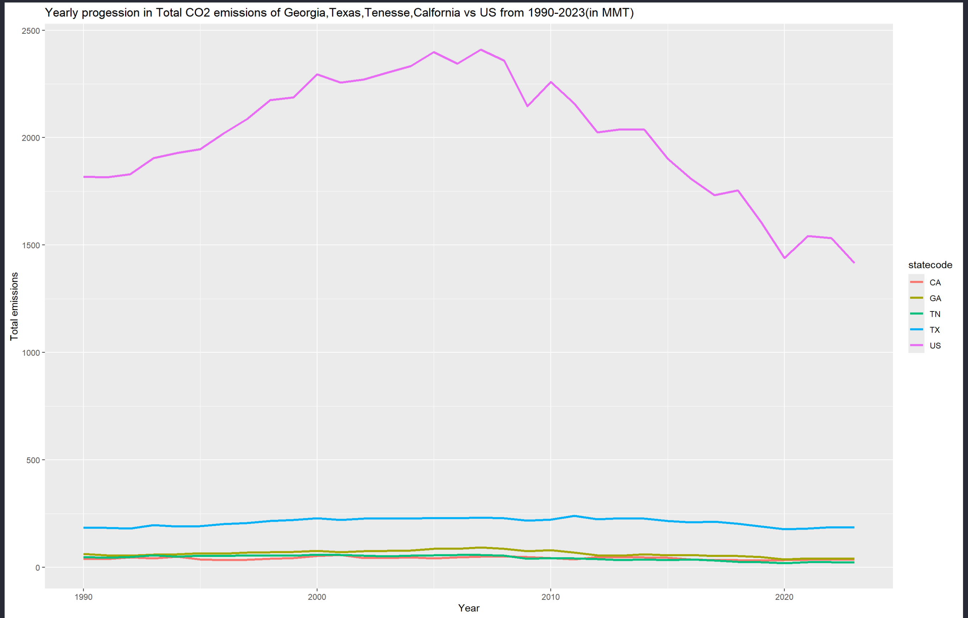

The results show:
- Texas has by far the highest total emissions among the four states, reflecting both its large population and energy-intensive economy. Texas’ emissions peaked earlier and have begun to decline as coal retires and wind/gas expand, but it still dominates in absolute terms.
- Georgia and Tennessee have moderate emissions. Both have declined in recent years, especially as coal is replaced by gas and nuclear. Georgia’s total emissions are somewhat higher than Tennessee’s.
- California has lower total emissions than Texas and often similar or lower than Georgia, despite its much larger population. This reflects its lower coal dependence and strong renewables and efficiency.
- The U.S. total peaks around the mid-2000s and declines afterward, driven by nationwide coal retirements and fuel switching to gas and renewables.
Line plots of emissions over time show Georgia’s emissions rising with electricity demand, then flattening and falling in the last decade as coal declines.
3.2 Georgia vs Each State and U.S:
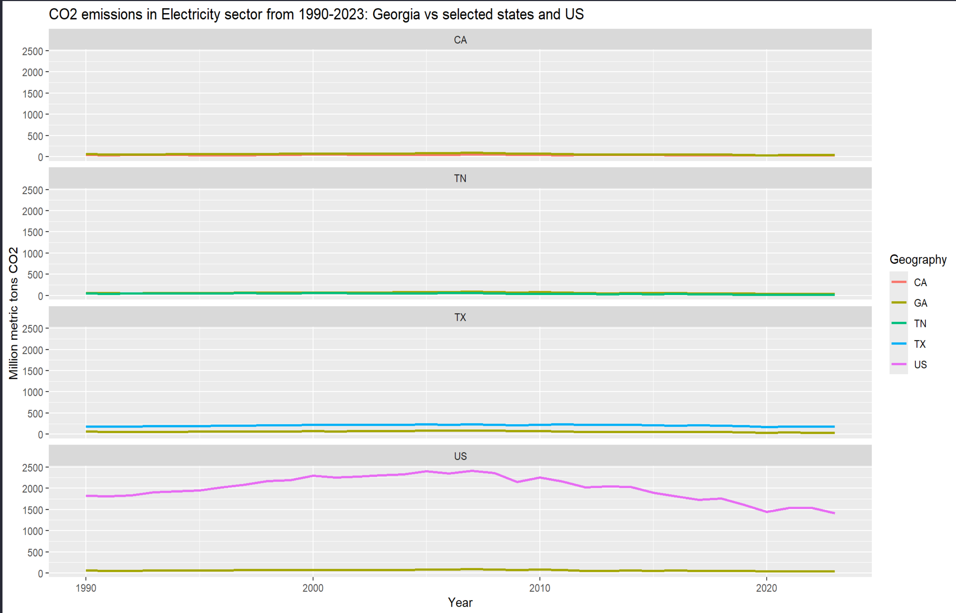
When plotting Georgia against each comparison state and the U.S. separately:
- Georgia vs Tennessee: Both follow similar shapes, but Tennessee’s greater reliance on nuclear and hydro leads to somewhat lower emissions, especially in recent years.
- Georgia vs Texas: Texas’ curve lies well above Georgia’s for the entire period. Even as Texas adds wind, its massive scale keeps emissions high. Georgia appears comparatively smaller but still significant.
- Georgia vs California: In many years, California’s emissions are comparable to or lower than Georgia’s, despite a much larger population, due to its low coal share and high renewables.
- Georgia vs United States: Georgia’s trend mirrors the national curve but at a smaller magnitude. The turning point away from coal in Georgia is slightly later than the U.S. average.
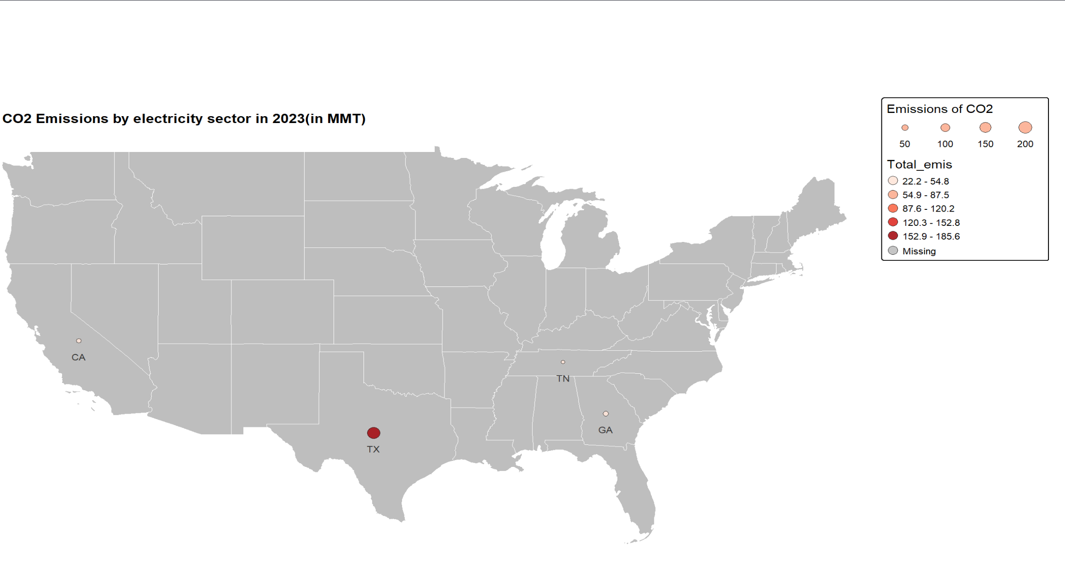
A map of state-level emissions for the most recent year (2023 is the latest year available in dataset) reinforces this picture visually: a large red circle over Texas, medium circles for Georgia and Tennessee, and a smaller circle for California.
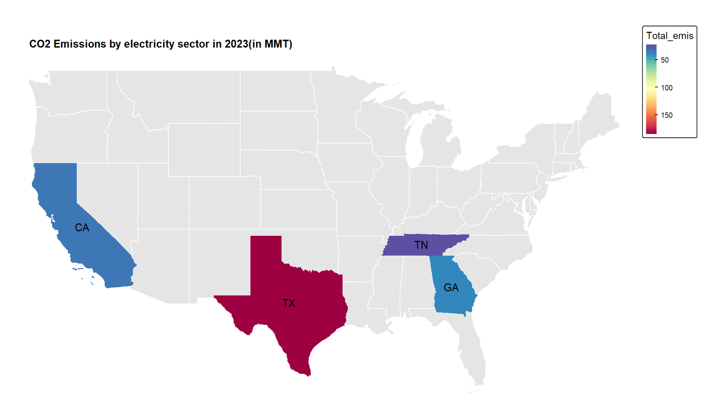
Same map showing emissions as continuous variables instead of intensity bubbles.


3.3 Per-Capita Emissions:
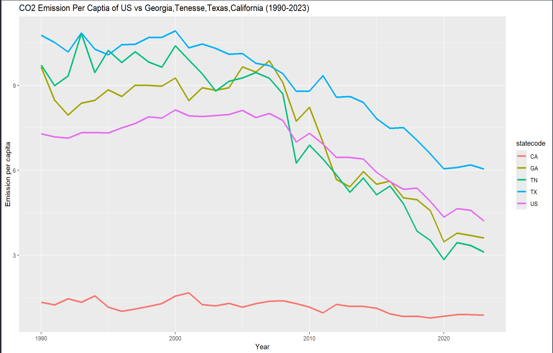
Dividing total emissions by state population shows:
- Georgia’s per-capita electricity CO₂ is higher than that of California, often similar to or slightly above Tennessee’s.
- Texas has the highest per-capita emissions among the selected states, reflecting both intensive industrial activity and heavy reliance on fossil fuels.
- The U.S. average lies between low-emission California and higher-emission Texas, with Georgia toward the higher end among these four.

4. Similarities and Differences:
Similarities:
- All selected states show a long-term transition away from coal, driven by economics, environmental regulation, and the availability of natural gas and renewables.
- Georgia, Tennessee, and the U.S. as a whole share a broad pattern: coal dominance to mixed coal/gas/nuclear to gas + nuclear + some renewables.
- Recent years show declining electric sector CO₂ emissions in all four states and nationally.
Differences:
- Speed and nature of decarbonization:
  - Georgia moves away from coal relatively late and substitutes heavily toward natural gas and is with modest renewables.
  - Tennessee achieves lower emissions via nuclear and hydro power, relying less on natural gas.
  - Texas remains fossil fuel-intensive but supplements this with large-scale wind; its absolute emissions continue to be much larger than Georgia’s.
  - California stands out for minimal coal, high renewables, and relatively low emissions, especially per capita.
- Scale
  - Texas and the U.S. have much larger absolute emissions simply due to size.
  - Georgia is mid-range: more emissions than Tennessee, fewer than Texas, broadly similar magnitude to California despite California’s larger population.
- Fuel mix diversity
  - Georgia’s mix is concentrated in coal, natural gas, and nuclear, whereas Texas and California have more diverse portfolios with significant wind and solar.
  - Tennessee is somewhat less diversified, relying heavily on nuclear and hydro, which helps keep emissions down but may raise concerns about resilience if those sources are disrupted.

5. Conclusion:
Overall, One can say that Georgia’s electricity system is in the midst of a transition. Historically coal-heavy, it has shifted toward natural gas and nuclear, producing clear declines in CO₂ emissions in recent years. However, compared to California and even elements of the national average, Georgia’s adoption of renewables remains limited, and its continued reliance on gas keeps its emissions higher than they could be under a more diversified low-carbon mix.
Relative to Tennessee, Georgia has similar historical roots but somewhat higher emissions, partly because Tennessee leans more heavily on low-carbon nuclear and hydro.
Compared to Texas, Georgia is smaller and less emission-intensive, but Texas’ experience with large-scale wind and growing solar demonstrates the potential for Georgia to expand renewables further.
California illustrates what a low-coal, high-renewables system can look like, while the U.S. average provides a benchmark showing that Georgia is broadly on the same path but has room to accelerate the decarbonization of its electricity sector.

.

