Description: Unit test case for To-Do Page.

|  |  |  |  |  |  |
| --- | --- | --- | --- | --- | --- |
| Test case | Description | Test value | Expected result | Test result | Remarks |
| 4.1.0 | To test if owner name of To_do item displayed matches the user that log in | User: marcus@abc.com | Owner: [marcus@abc.com](mailto:marcus@abc.com)  Item: To_do_test1  To_do_test2 | Failed | Have not code |
| 4.1.1 | To Test if owner is auto filled in by system when adding new To_do | User: marcus@abc.com | Owner: marcus@abc.com | Failed | Have not code |
| 4.1.2 | To test if owner name is able to change in add new item | User: testuser1 | Owner: marcus@abc.com | Failed | Newly added |
| 4.1.3 | To test if To_do item can be created with null input in item name | owner: [marcus@abc.com](mailto:marcus@abc.com)  Name: “ ” | Item not created | Passed | Similar test as sprint 1, such that no additional item is created |
| 4.1.4 | To test if to do item created has timestamp auto added by system | owner: [marcus@abc.com](mailto:marcus@abc.com)  Name: to_do_test | owner: [marcus@abc.com](mailto:marcus@abc.com)  Name: to_do_test  Timecreated: date time | Failed | Have not code |

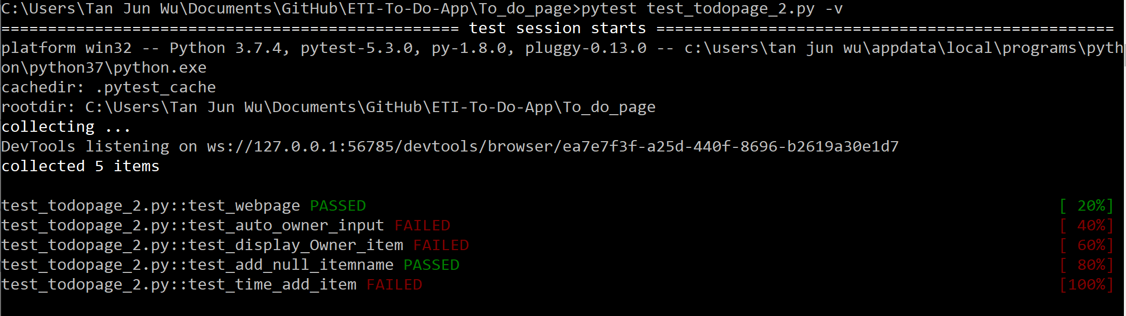before coding sprint 2:

Description: Unit test case for To-Do Page.

|  |  |  |  |  |  |
| --- | --- | --- | --- | --- | --- |
| Test case | Description | Test value | Expected result | Test result | Remarks |
| 4.1.0 | To test if owner name of To_do item displayed matches the user that log in | User: marcus@abc.com | Owner: [marcus@abc.com](mailto:marcus@abc.com)  Item: To_do_test1  To_do_test2 | Passed |  |
| 4.1.1 | To Test if owner is auto filled in by system when adding new To_do | User: marcus@abc.com | Owner: marcus@abc.com | Passed |  |
| 4.1.2 | To test if owner name is able to change in add new item | User: testuser1 | Owner: marcus@abc.com | Passed |  |
| 4.1.3 | To test if To_do item can be created with null input in item name | owner: [marcus@abc.com](mailto:marcus@abc.com)  Name: “ ” | Item not created | Passed |  |
| 4.1.4 | To test if to do item created has timestamp auto added by system | owner: [marcus@abc.com](mailto:marcus@abc.com)  Name: to_do_test | owner: [marcus@abc.com](mailto:marcus@abc.com)  Name: to_do_test  Timecreated: date time | Passed |  |

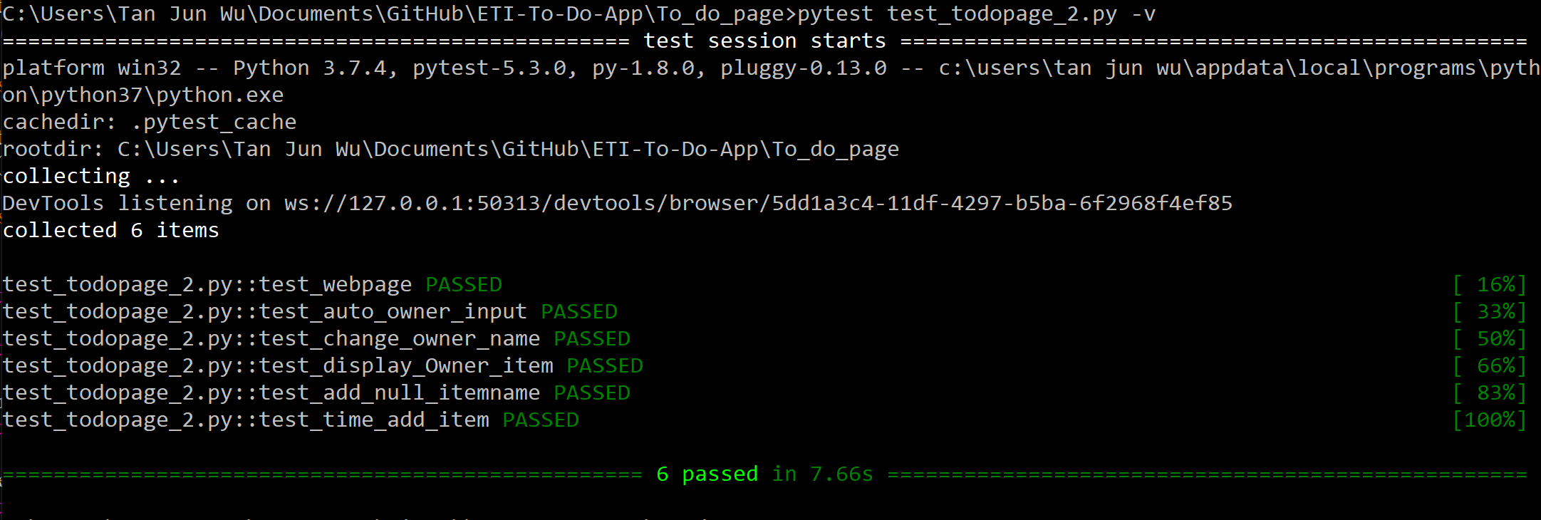After coding sprint 2: