House Price Prediction — Summary of Findings
Regression analysis of 545 houses — Linear Regression vs. Random Forest — Internship Project, Week 1

Overview
This project analyzed the Kaggle Housing Prices dataset (545 houses, 12 features) to predict sale price from property attributes such as area, bedrooms, bathrooms, stories, and amenities (air conditioning, parking, furnishing status, etc.). The data required no missing-value treatment and had zero duplicate rows. Categorical yes/no fields were mapped to 1/0, and the multi-class furnishing status was one-hot encoded before modeling.

Model Performance (80/20 train-test split)
Model | MAE (₹) | RMSE (₹) | R² Score
Linear Regression | 9,70,043 | 13,24,507 | 0.653
Random Forest | 10,19,598 | 13,99,213 | 0.613
Linear Regression slightly outperformed Random Forest on this dataset, explaining about 65% of price variation (R² = 0.653) with an average error of roughly ₹9.7 lakh. This is a useful, mildly counter-intuitive result: with only 545 rows and largely linear, monotonic relationships (more area → more bathrooms → higher price), the simpler model generalized just as well as the more complex one.

Key Charts
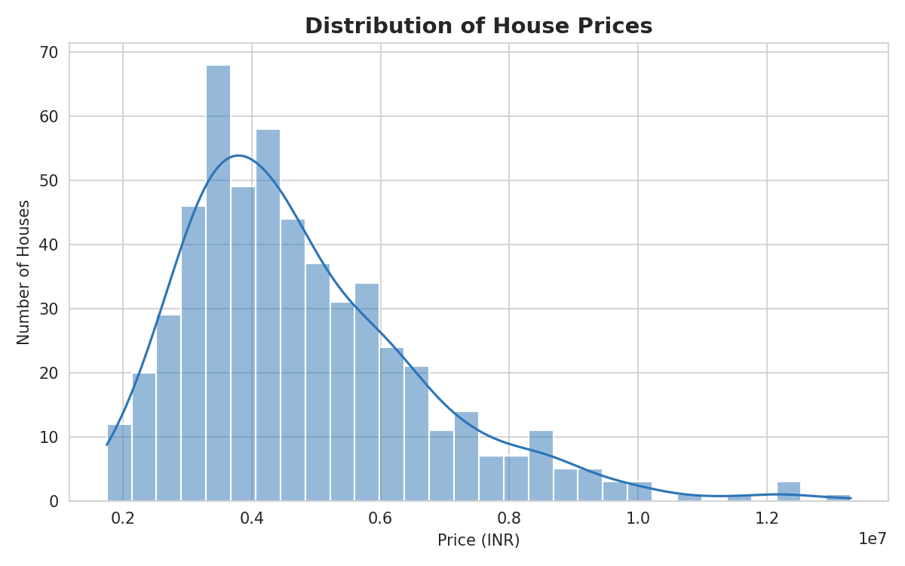
Fig 1. Price distribution is right-skewed — most homes fall between ₹30L–₹70L.
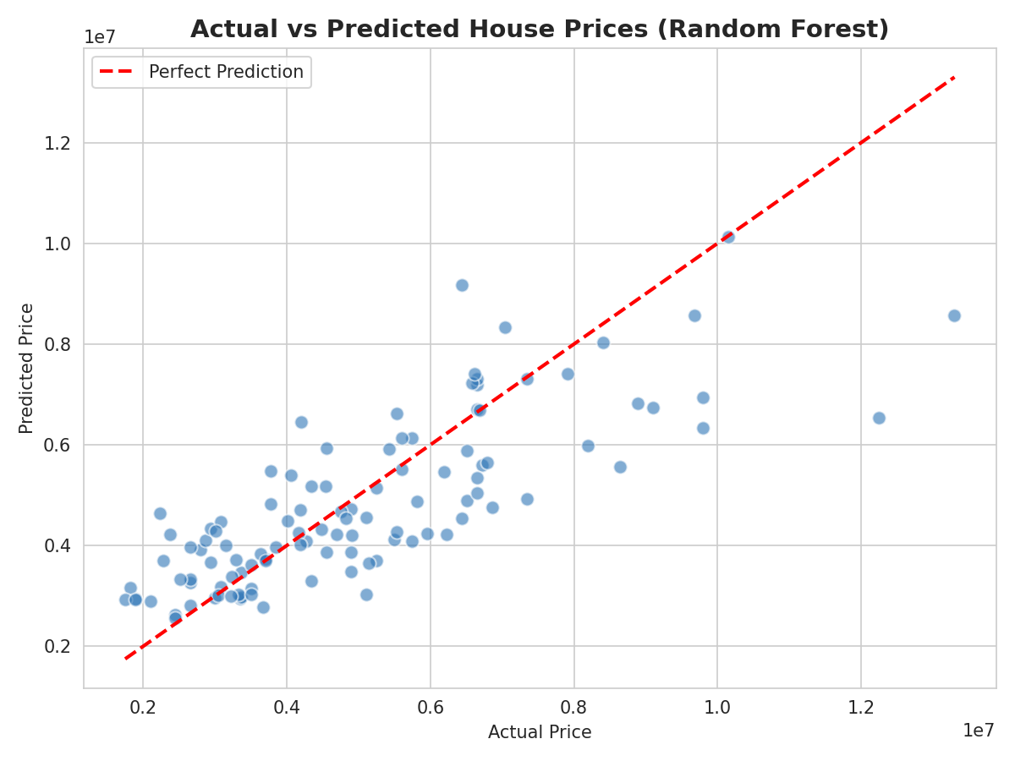
Fig 2. Actual vs. predicted prices (Random Forest) — points near the red line are accurate predictions.

Key Insights
- Area is the single strongest driver of price, followed by bathrooms, air conditioning, and stories.
- Model accuracy is moderate (R² ≈ 0.65) — good for an initial estimate, not a full valuation.
- Random Forest did not outperform Linear Regression — simpler models can match complex ones on small, mostly-linear data.
- Unfurnished homes are consistently cheaper, even after controlling for size.

Recommendation
Real estate businesses should prioritize area, bathroom count, and air conditioning in pricing and marketing strategy — these are the biggest, most controllable levers on perceived value. Upgrading furnishing status or adding air conditioning appears to offer a better return on investment than smaller cosmetic renovations.

