EXPORT VALUE DECLARATION

(See Rule 7 of Custom Valuation (Determination of Value of Export Goods) Rules, 2007)
1. | Shipping Bill NO. $ Date :-

2. | Invoices NO. $ Date:-

3. | Nature Of Transaction

Sale |  | Sale on Consignment Basis |  | Gift

Sample |  | Other

4. | Method of Valuation | Rule 3 |  | Rule 4 |  | Rule 5 |  | Rule 6
 | (See Export Valuation Rules)

5. | Whether seller and buyer are related | Yes |  | No

6. | If yes, whether relationship has | Yes |  | No
 | Influenced the price

7. | Terms of payment

8. | Terms of Delivery

9. | Previous exports of identical / similar goods, if any

Shipping Bill No. And date:

10. | Any other relevant information (Attach separate sheet, if necessary)

DECLARATION
1. | I/ We hereby declare that the information furnished above is true, complete and correct in every respect
2. | I/ We also undertake to bring to the notice of proper officer any particulars which subsequently come to my/our knowledge which will have bearing on a valuation

Place:
FOR

Authorise Signatory

Date: MUMBAI | Mr.
SIGNATURE OF THE EXPORTER | NAME OF THE SIGNATORY

Acknowledgment for LUT

You have ﬁled the application successfully and the particulars of the application are given as
under :

Application Reference Number (ARN) | AD270326080436X
Date of ﬁling | 25/03/2026
Time of ﬁling | 17:29
Goods and Services Tax Identiﬁcation Number  (GSTIN) | 27AAEFK1088J1Z5
Legal Name | KAUSTUBHA UDYOG
Trade Name (if available) | KAUSTUBH UDYOG
Center Jurisdiction | RANGE-II
State Jurisdiction | SHANIWAR-PETH_701
Filed By | RAVINDRA MOHOLKAR

Acknowledgement for ﬁling of LUT will be transmitted to the concerned Tax authority online.

It is a system generated acknowledgement and does not require any signature.

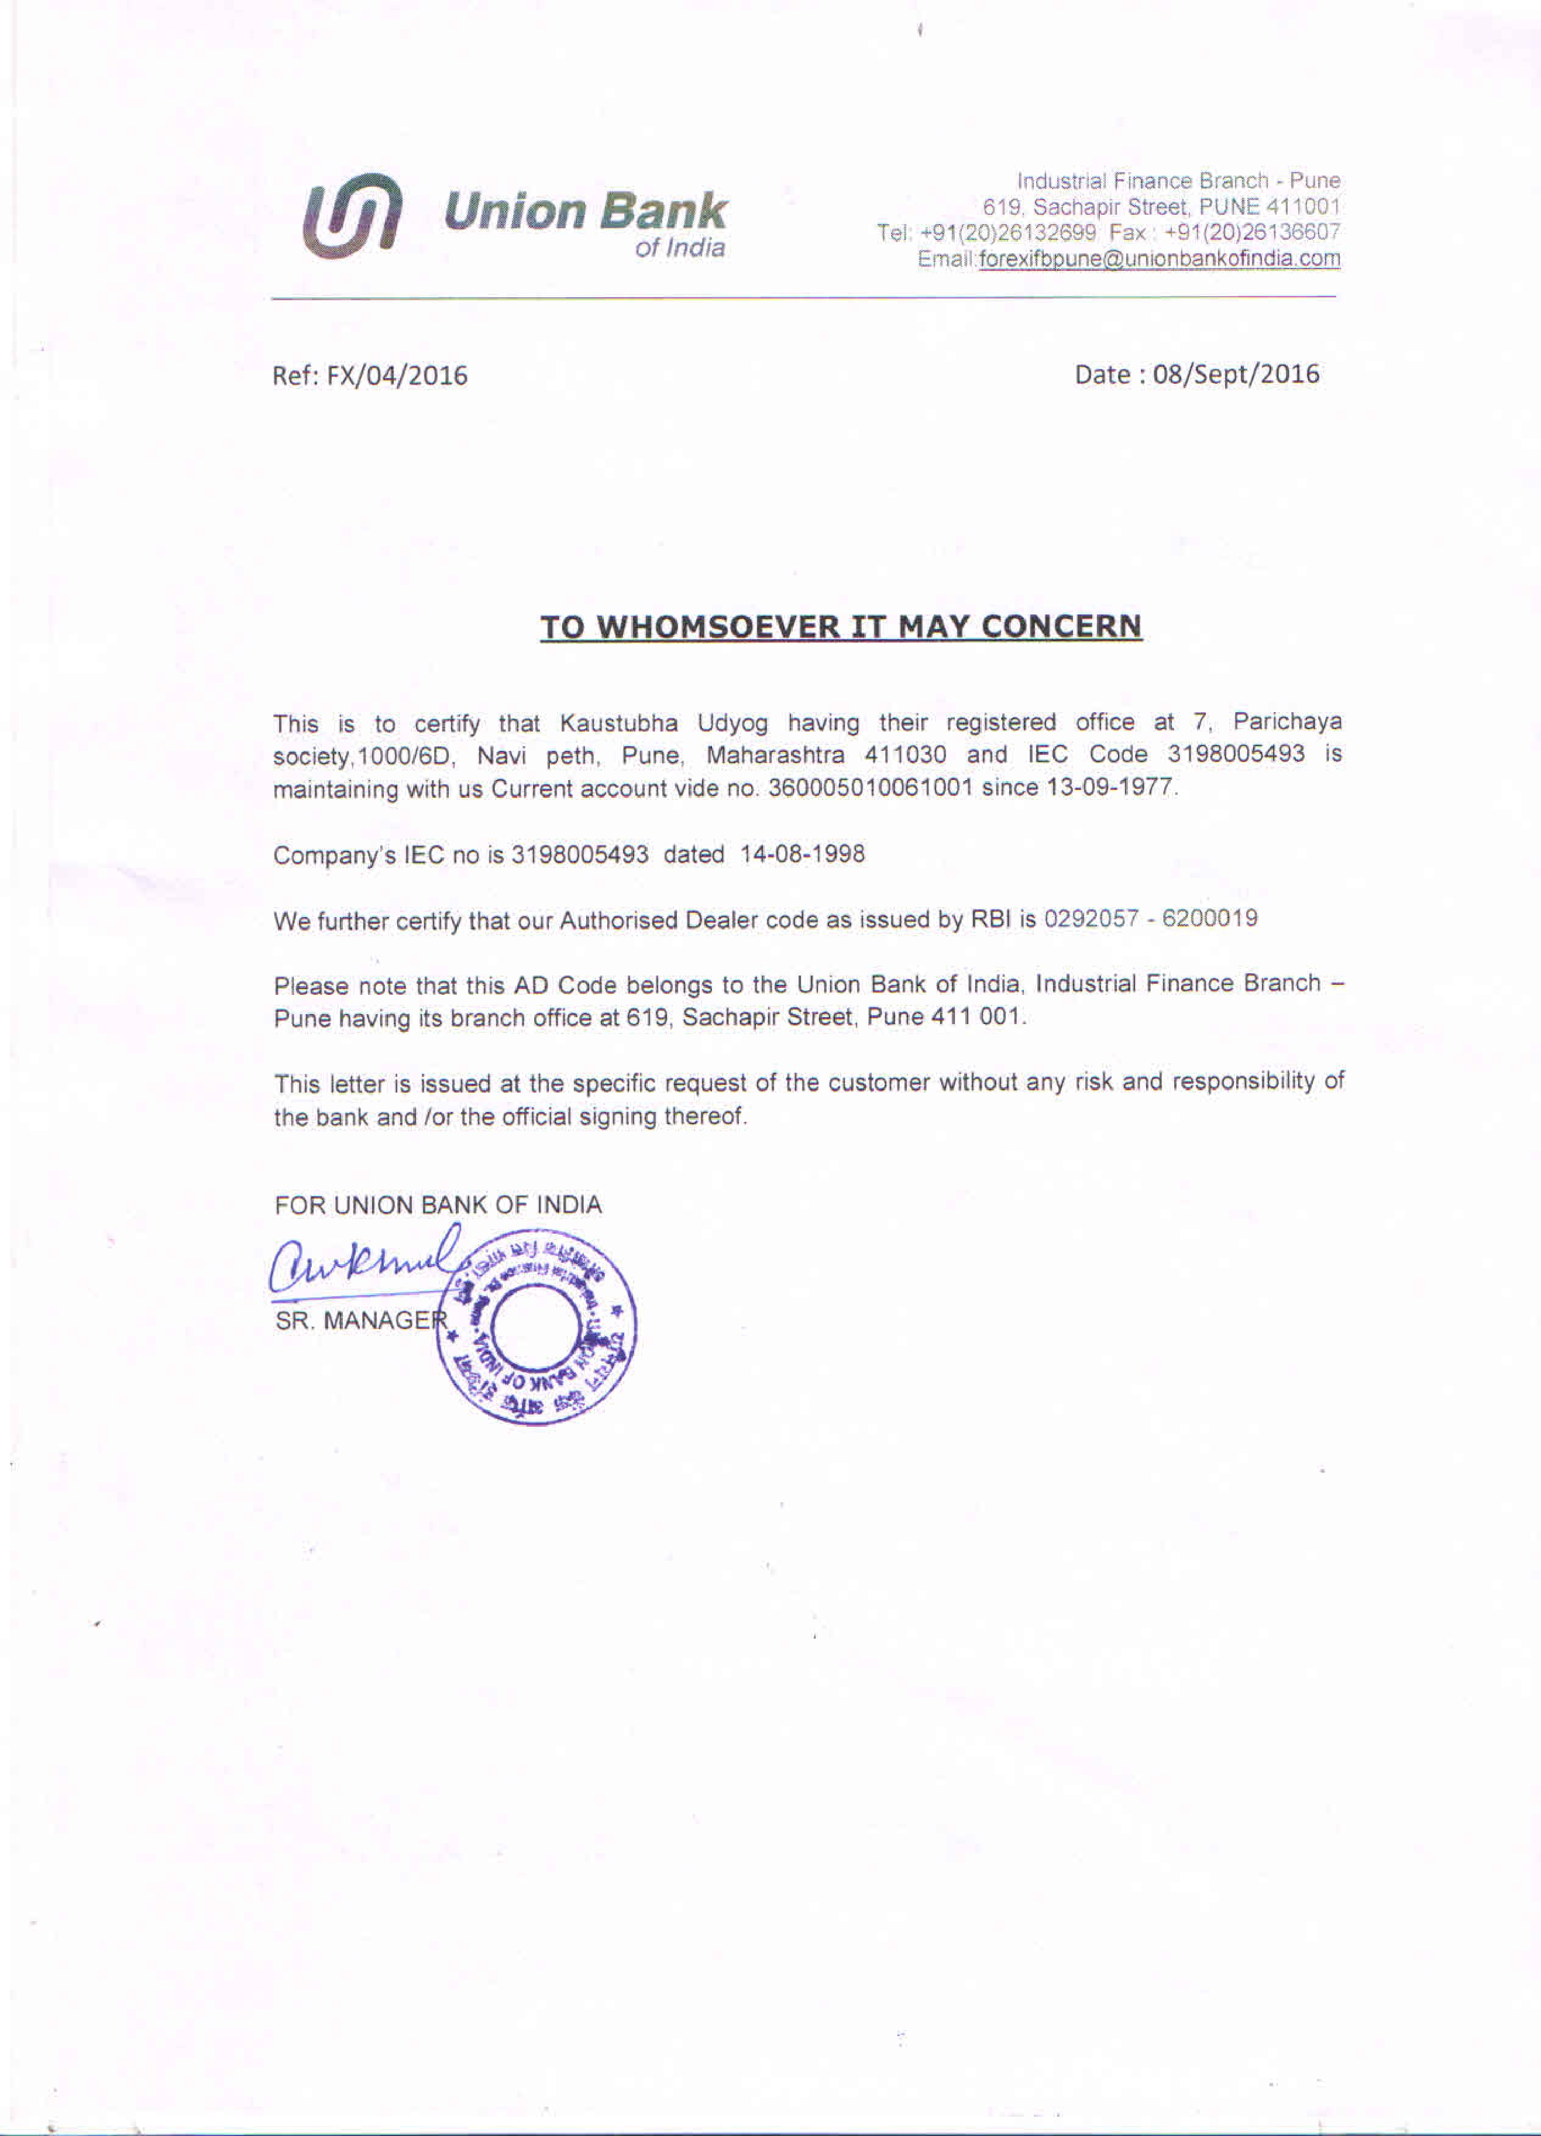
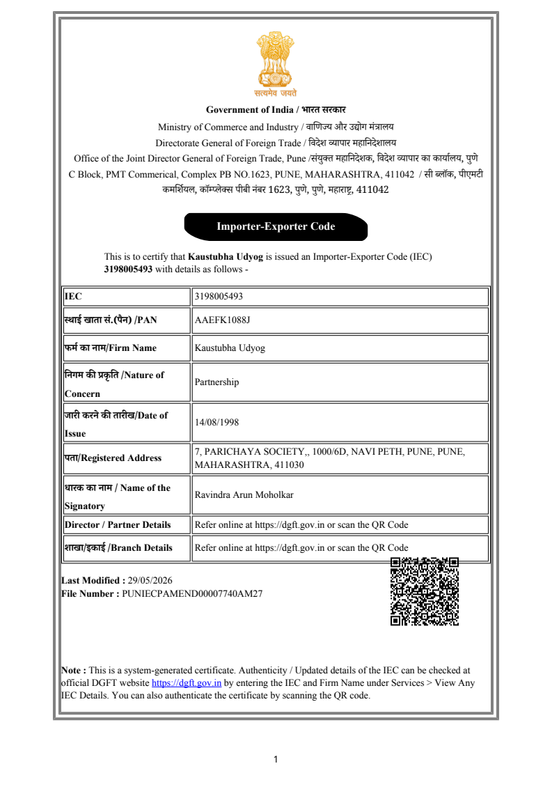
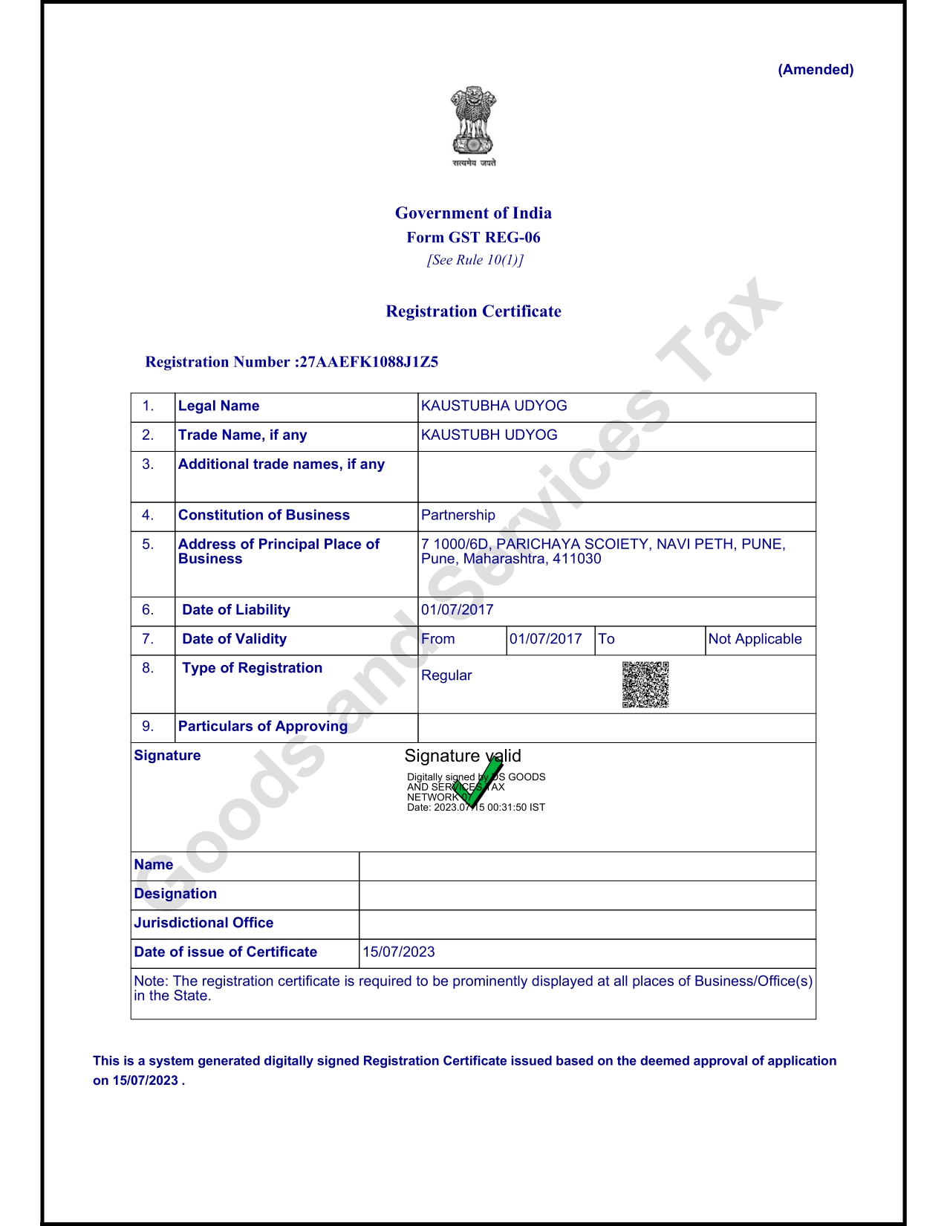
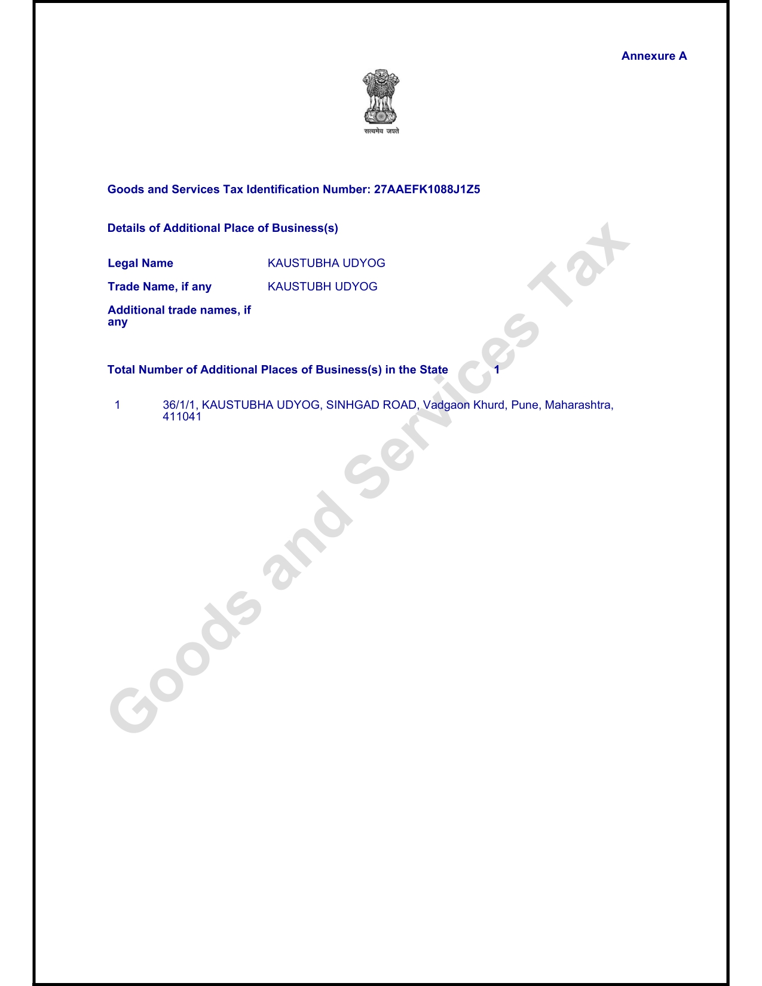
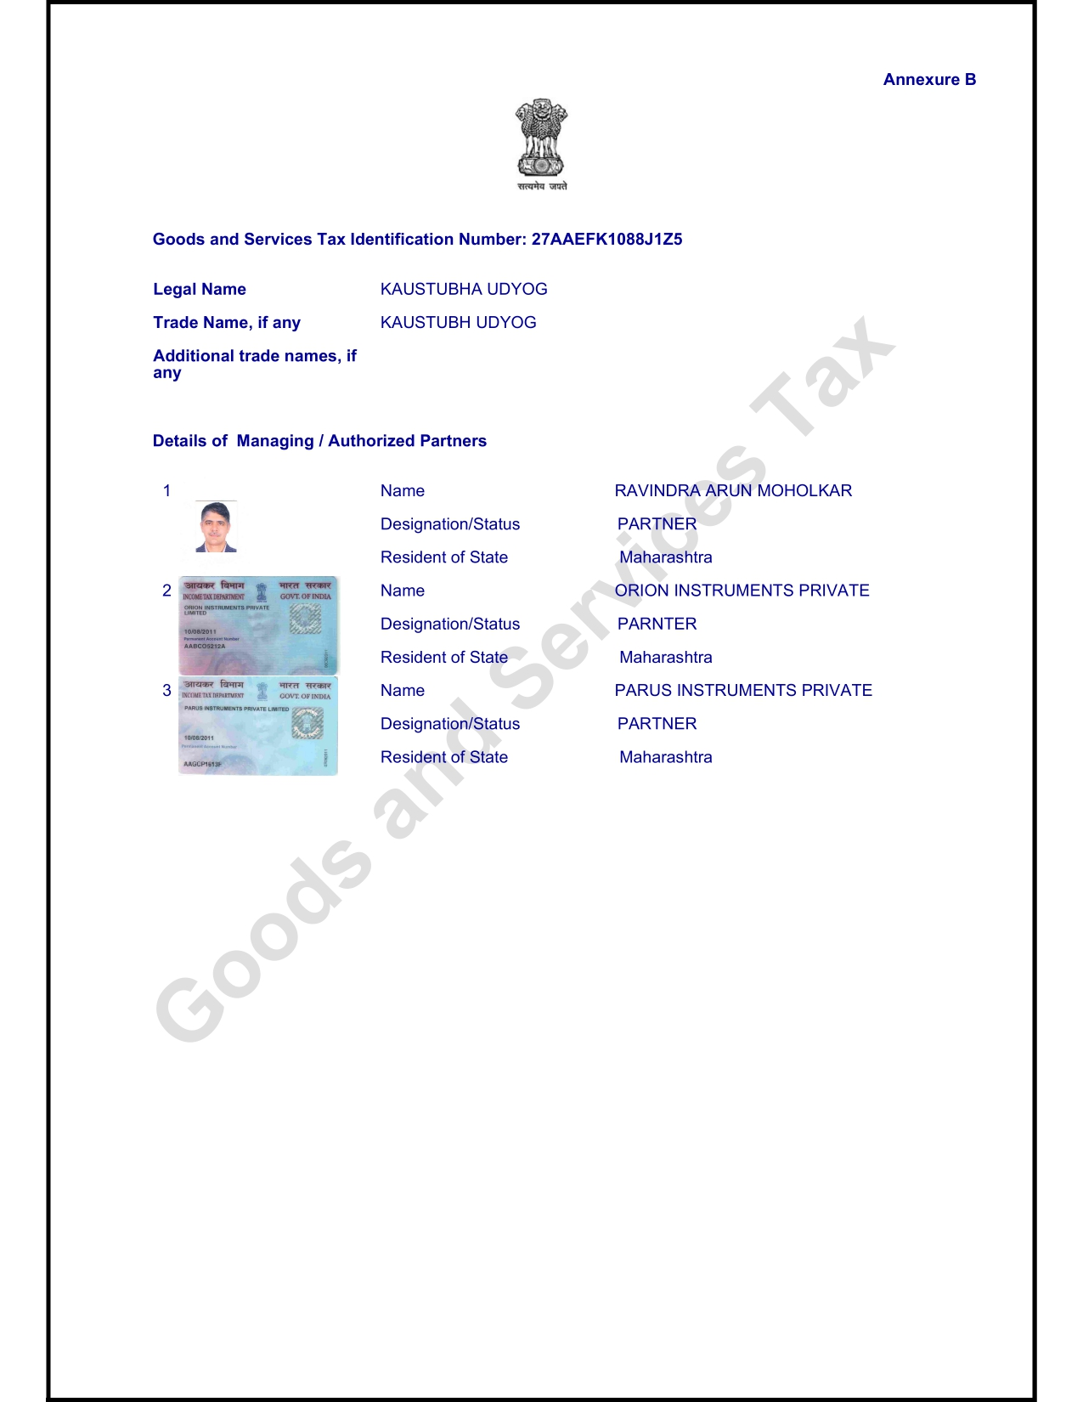

SHIPPER’S LETTER OF INSTRUCTION
Shipper Name: |  | KAUSTUBHA UDYOG |  |  |  |  |  |  |  |  |  |  | Date: |  |  |  | invoice date
Consignee Name: |  | Name of Buyer |  |  |  |  |  |  |  |  |  |  | Invoice NO: |  |  |  | invoice number
IE CODE NO (10 DIGIT) :
PAN NUMBER
GSTIN NUMBER
IGST PAID ? | YES |  |  |  | NO
UT / Bond | YES |  |  |  | NO
BANK AD CODE # (PART I & II) :
CURRENCY OF INVOICE
INCOTERMS : F O B / C & F / C & I / C I F :
NATURE OF PAYMENT * : D P / D A / A P / OTHERS
Details to be declared for preparation of Shipping Bill
FOB VALUE |  |  |  |  |  |  | :
FREIGHT (IF ANY) |  |  |  |  |  |  | :
INSURANCE (IF ANY) |  |  |  |  |  |  | :
COMMISSION (IF ANY) |  |  |  |  |  |  | :
DISCOUNT (IF ANY) |  |  |  |  |  |  | :
Description of Goods to be declared on Shipping Bill |  |  |  |  |  |  |  |  |  | NO. OF PKGS. : |  |  |  |  |  | function="objects.invoice_line_ids[0].sale_line_ids[0].order_id.no_of_packages"
Sample Shipment |  |  |  |  |  |  |  |  |  | NET WT. : |  |  |  |  |  | net weight
 |  |  |  |  |  |  |  |  |  | GROSS WT. : |  |  |  |  |  | gross weight
Description of Goods to be declared on AWB |  |  |  |  |  |  |  |  |  | VOLUME WT. :
PRESSURE SWITCHES |  |  |  |  |  |  |  |  |  | DIMENSION (IN CMS) of each pkg.
Special Instructon, If any
DBK 003 & End use code GNX-200
(We intend to claim rewards under Marks and Numbers- RoDTEP Scheme)
TYPE OF SHIPPING BILL ( CIRCLE YES or NO) |  |  |  |  |  |  |  |  |  | BELOW DOCUMENTS REQUIRED WITH SHIPMENT
a) FREE TRADE SAMPLE (NON-COMM) |  |  |  |  |  | YES / NO |  |  |  | FREE TRADE SAMPLE - VALUE FOR CUSTOMS - NOT FOR SALE
b) DUTY FREE COMMERCIAL |  |  |  |  |  | YES / NO |  |  |  | NOTHING SPECIFIC
c) EOU SHIPPING BILL |  |  |  |  |  | YES / NO |  |  |  | ANNEX C1 & ARE-1 & SDF FORM
d) DUTY DRAWBACK |  |  |  |  |  | YES / NO |  |  |  | DBK SL NO, ANNEX I, II, III, SDF FORM,(LEATHER DECLARATION) : DBK 003
e) DUTIABLE SHIPPING BILL |  |  |  |  |  | YES / NO |  |  |  | RATE OF CESS/ DUTY TO BE PAID AT CUSTOMS
f) DEPB SHIPPING BILL |  |  |  |  |  | YES / NO |  |  |  | DEPB GROUP CODE/SL NO., SDF FORM, DEPB DECL
g) DFIA |  |  |  |  |  | YES / NO |  |  |  | DFIA LIC/RECEIPT NO., FORM SDF, CONSUMPTION SHEET, SION NO.
h) EPCG SHIPPING BILL |  |  |  |  |  | YES / NO |  |  |  | REGN NO. & DT OF EPCG LIC, COPY OF EPCG LIC/REGN COPY,SDF FORM
i) ADVANCE LICENCE SHIPPING BILL |  |  |  |  |  | YES / NO |  |  |  | REGN NO. & DT OF ADV LIC, COPY OF LIC/REGN COPY,CONSUMPTION SHEET/SDF FORM
j) REPAIR & RETURN |  |  |  |  |  | YES / NO |  |  |  | ORGINAL B/E, IMP INV/PKG LIST/GR WAIVER ON GR FORM,CHARTERED ENGG CERTIFICATE, EXPORT INVOICE/PKG LIST
k) DUTY DRAWBACK (SECTION 74) |  |  |  |  |  | YES / NO |  |  |  | ORIGINAL B/E, IMP INV/PKG LIST/GR WAIVER, EXPORT INV/PKG LIST,AUTHORITY LETTER ADDRESSED TO DEP. COMMISSIONER.
1. INVOICE (4 COPIES) |  |  |  | 7. ARE-1 FORM IN DUPLICATE |  |  |  |  |  |  |  |  |  |  | 13. APPENDIX III
2. PACKING LIST (4 COPIES) |  |  |  | 8. VISA/AEPC ENDORSEMENT |  |  |  |  |  |  |  |  |  |  | 14.ANNEXURE 1
3. SDF FORM IN DUPLICATE |  |  |  | 9. LAB ANALYSIS REPORT |  |  |  |  |  |  |  |  |  |  | 15. LETTER TO DC
4. NON-DG DECLARATION |  |  |  | 10. MSDS |  |  |  |  |  |  |  |  |  |  | 16. PATMENT ADVICE
5. PURCHASE ORDER COPY |  |  |  | 11. PHYTOSANITARY CERT |  |  |  |  |  |  |  |  |  |  | 17.
6. GR FORM/GR WAIVER |  |  |  | 12. GSP CERTIFICATE |  |  |  |  |  |  |  |  |  |  | 18.
Please indicate API (As per Invoice) if any detail is mentioned in the Invoice.
We hereby confirm that the above details declared are true and correct.
We confirm that our company's IEC & Bank AD Code Details
are registered with EDI System of Air Cargo where the clearance is being done.
 |  |  |  |  |  |  |  |  |  |  |  | SIGNATURE OF EXPORTER/STAMP

